1. Select the “APPS” tab, and click on the “show more” arrow on the far right side. Click on “Database Explorer” under “Database Connectivity and Reporting”.

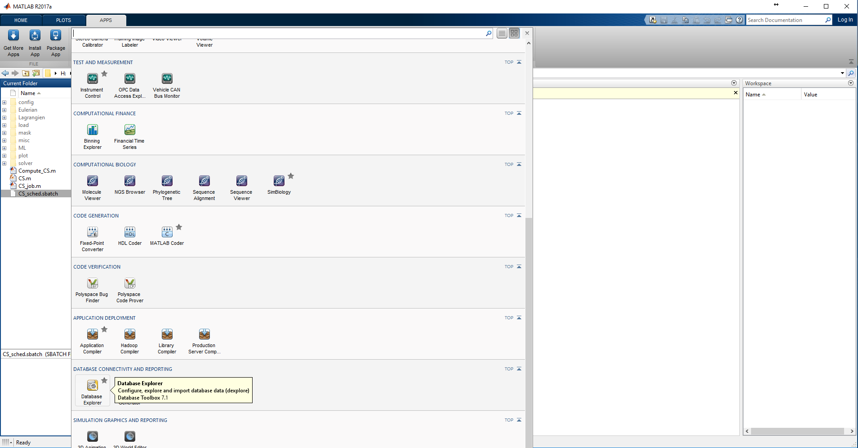

1. Click on the “New” menu and click on “ODBC”.

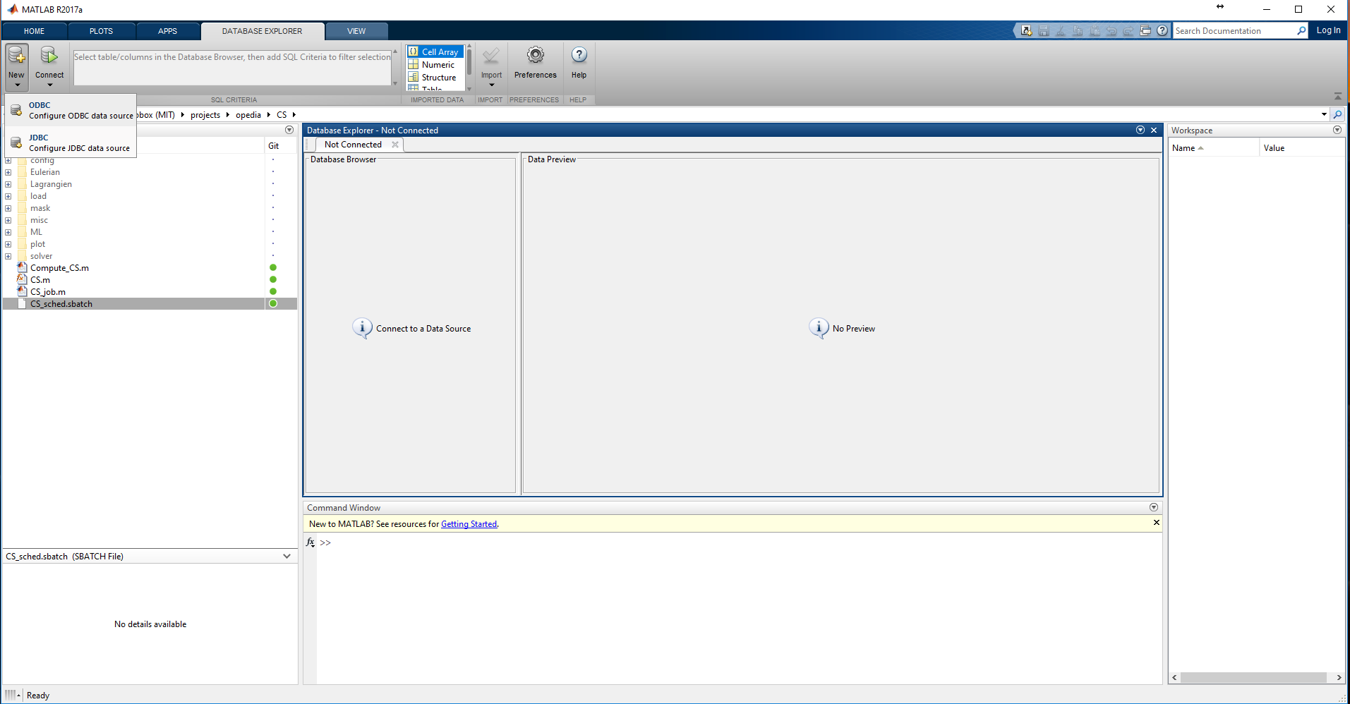

1. Select the “System DSN” and click on the “Add” button.

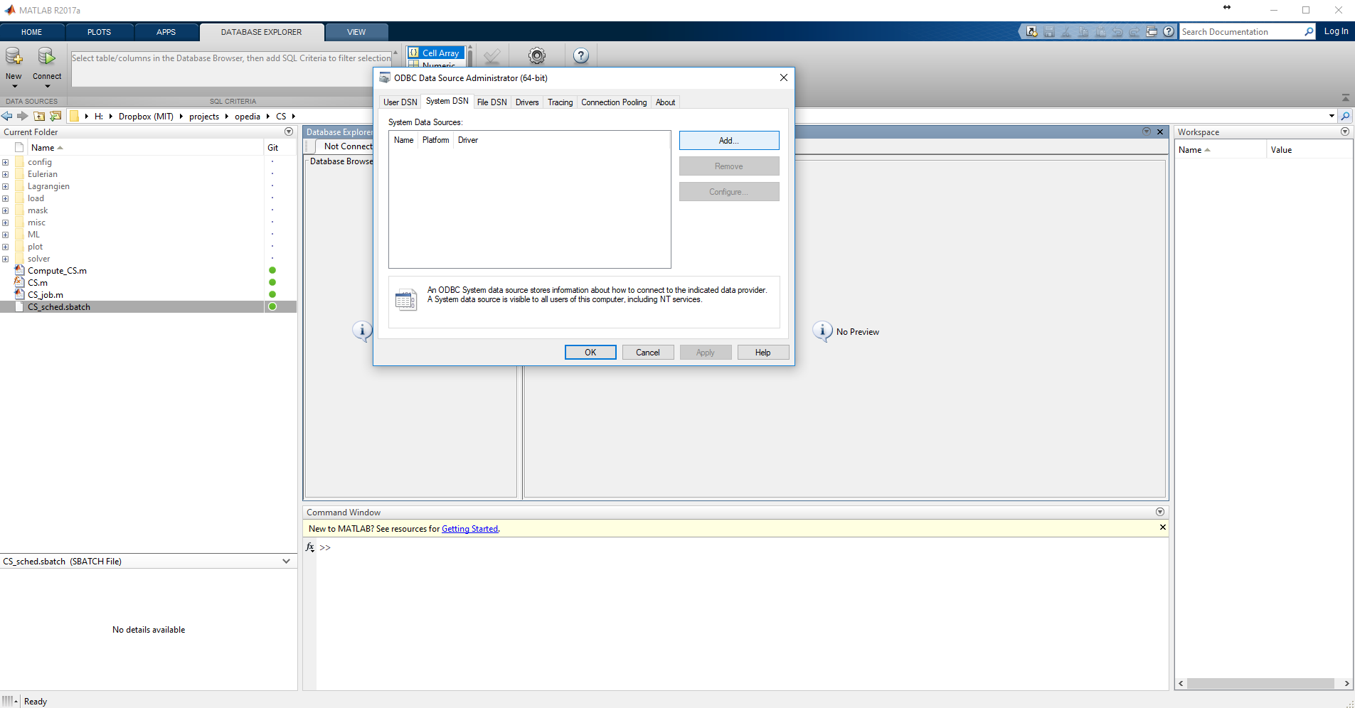

1. Select “SQL Server” from the list of drivers, and click “Finish”.

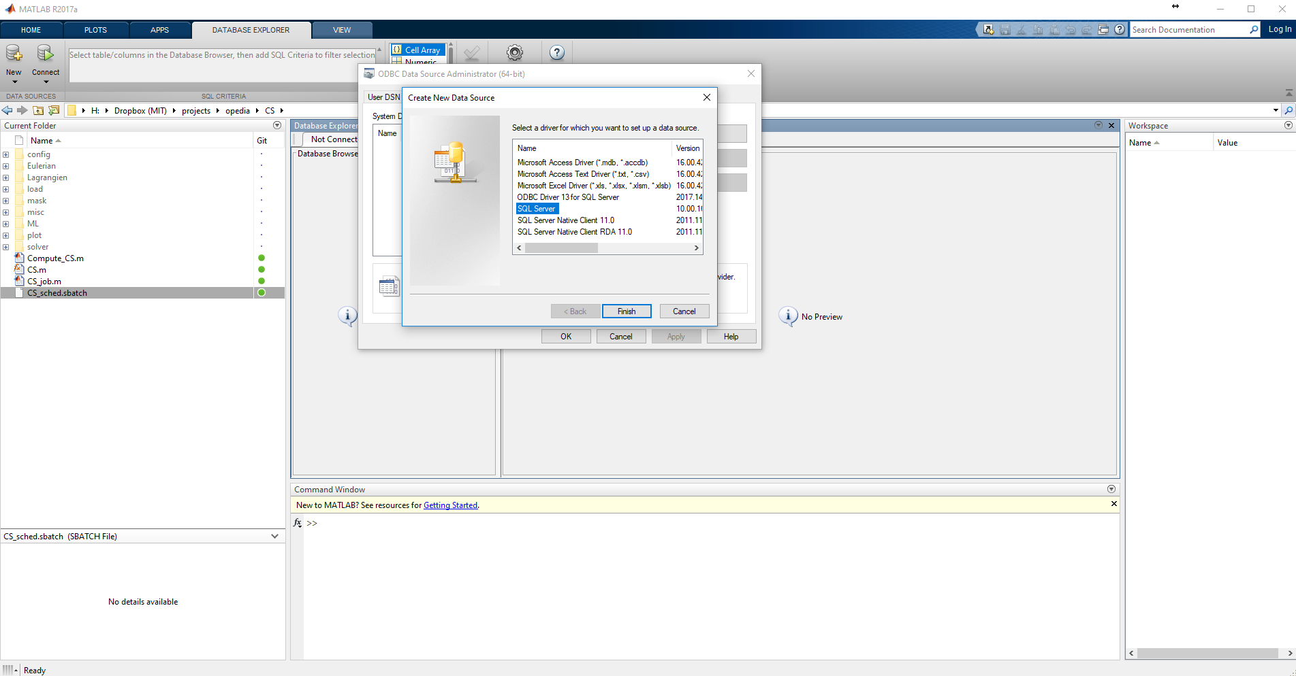

1. Set the “Name” (Opedia) and “Server” (128.208.239.15,1433) fields as shown, and click “Next”.

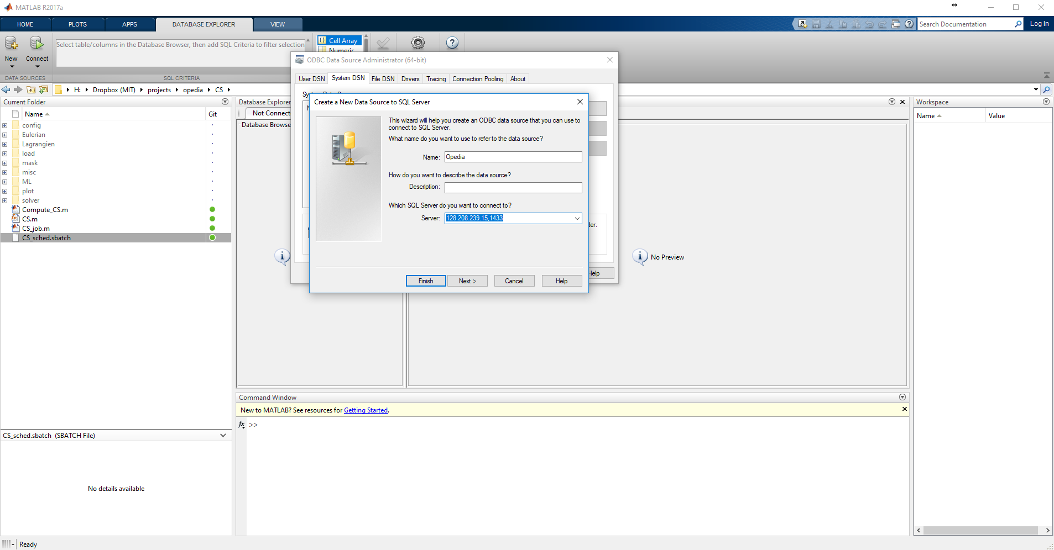

1. Select the “With SQL Server authentication …” radio button and fill the Login ID (“ArmLab”) and Password fields (“ArmLab2018”). Click “Next”.

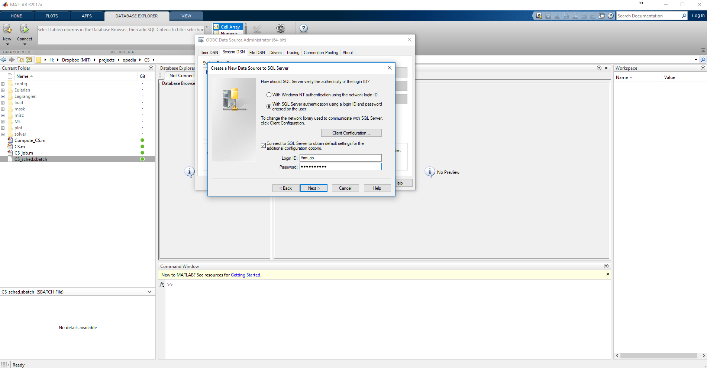

1. Make sure “Change the default database to:” is checked. Select the “Opedia” database from the list. Click “Next”.

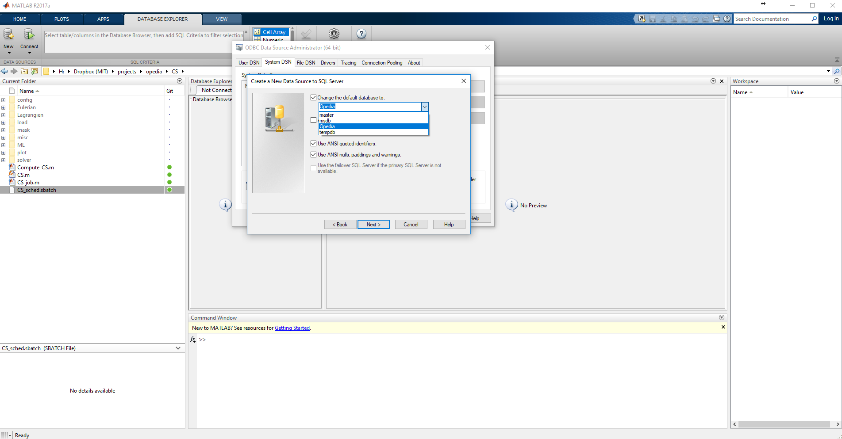

1. Click “Finish”.

