KuStudio User Guide

Version 1.64 OSX/Windows

**Introduction**

KuStudio is an OSC editor, recorder and player, aimed to create timeline on an audiotrack.

It can be used as core timeline module in interactive audiovisual and dance/vocal performances.

KuStudio lets create, record and OSC tracks, synchronized with given audio track. Audiotrack can be WAV or AIFF file.

KuStudio is inspired by famous Duration OSC editor, but has different philosophy: KuStudio stores all OSC tracks as discrete arrays, not curves, that allows to record and edit them freely. Also, KuStudio performs very stable for 10 min and longer projects.

OSC tracks are float-valued. They can be drawn and edited by mouse, or recorded from external programs such as TouchOSC, Max/MSP.

OSC tracks values can be send up to 4 OSC receivers.

OSC receivers includes: Processing apps, openFrameworks apps, VDMX projects, Resolume projects, Max/MSP patches.

KuStudio is made with openFrameworks.

Binaries: <https://sourceforge.net/projects/kustudio/>

Source codes: <https://github.com/kuflex/KuStudio>

For any questions: write to <perevalovds@gmail.com>

**Installation and Running**

**OSX**

Unzip archive and run KuStudio.

During the first run you will get security warning such this:

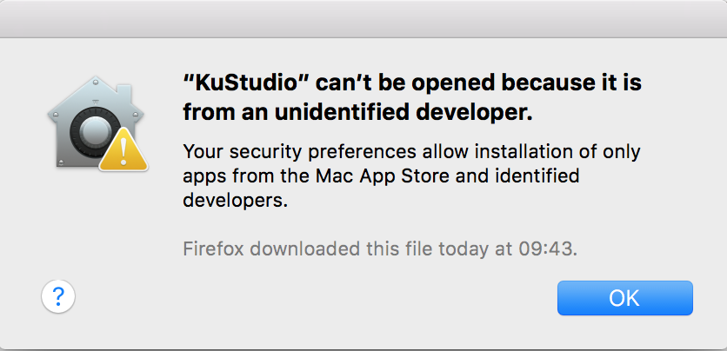

Then right-click KuStudio to show context menu and click there "Open". You will see security dialog, but with two buttons, "Open" and "Cancel". Choose "Open" to start KuStudio.

**Windows**

Before running KuStudio, install Microsoft Visual C++ 2015 Redisrtibutable (x86).

It's installation file is placed in **install_windows** folder of KuStudio (also, you can download it from Microsoft website).

**Using KuStudio**

To start using KuStudio you need to choose audio track - WAV or AIFF file.

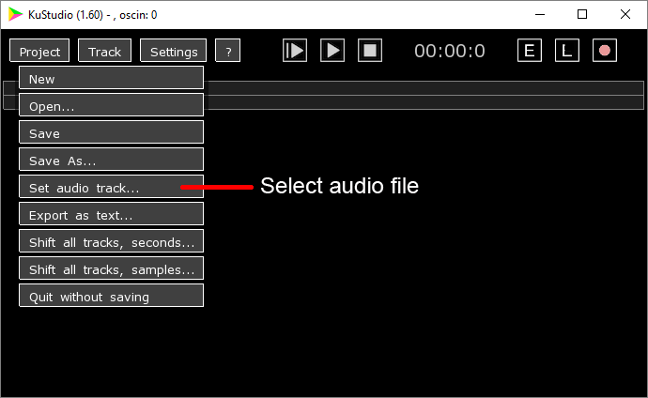

After setting ausio track, you will see the track on the screen in two versions. Upper version shows the whole track, and lower version shows fragment of the track.

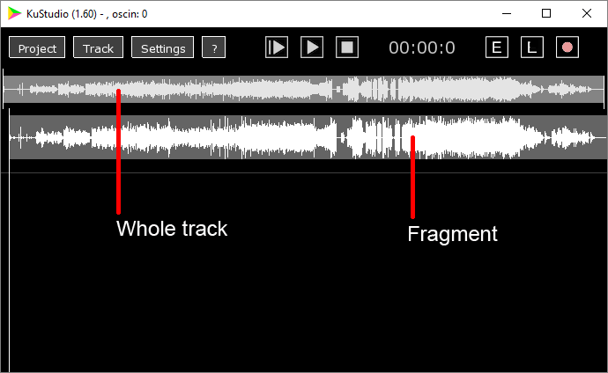

Using mouse, you can drag left and right segment boundaries on the whole track to select desired fragment.

To play the whole track press **Enter**. To stop it, click "Stop" button. You can't stop whole track playing using keyboard to prevent accidental stopping during real performance.

To play and stop the fragment press **Space**.

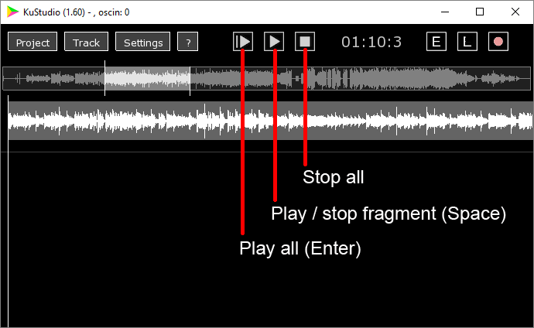

Now, we can add OSC tracks.

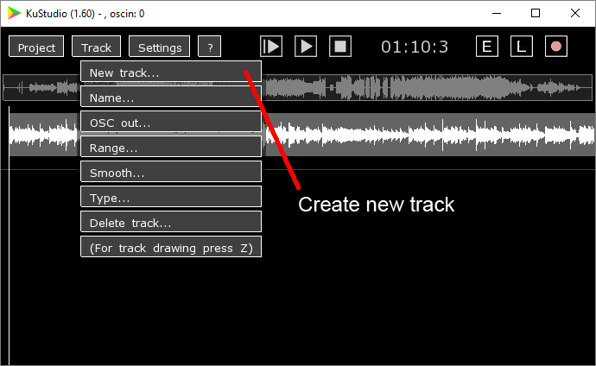

The track name corresponds the OSC address on which will be sent the tracks's values. For example, track named **valueX** will send data to **/valueX** address.

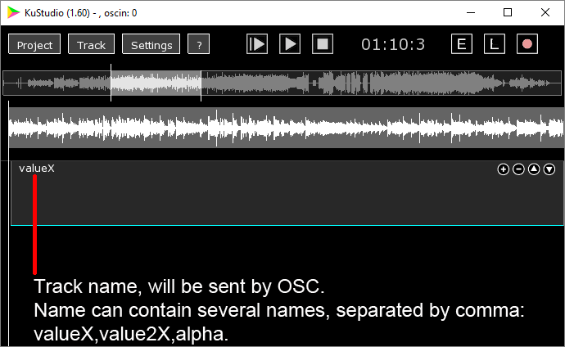

You can draw track's values using mouse. At first, you need to select track by clicking it.

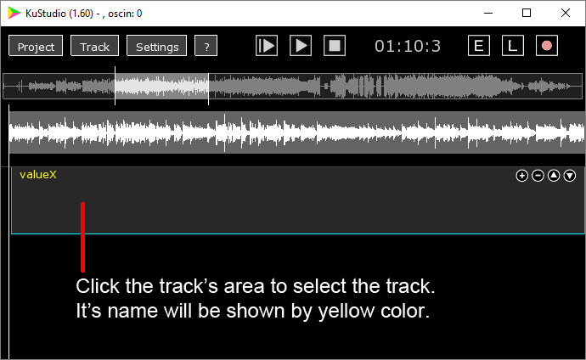

Then press "E" button to enable drawing mode. Or, equivalently, press and hold the key **z** in English keyboard layout (we propose to use this method to prevent accidental track's editing).

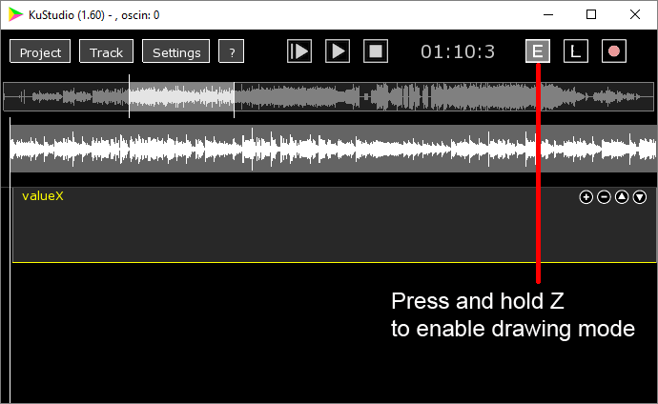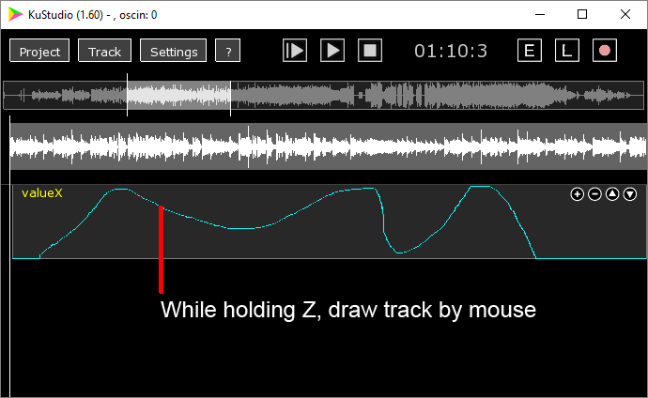

By default, track's range is from 0 to 1. To change it, use "Range" dialog.

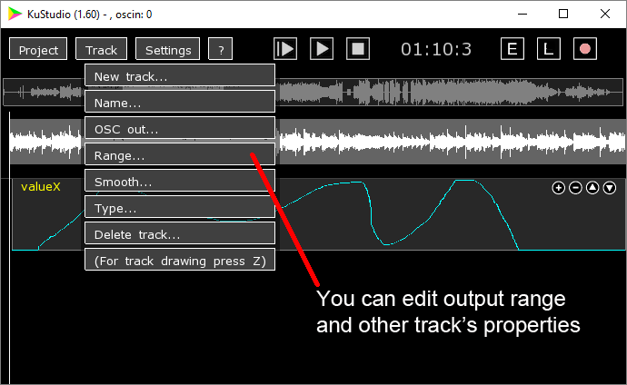

You can adjust vertical size and order of the tracks by clicking buttons in the top-right corner of each track.

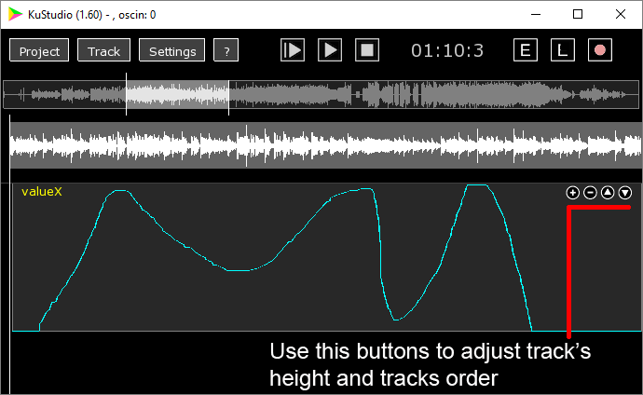

To setup OSC receivers you should specify host address and port, by using "OSC out 1,2,3,4" dialogs.

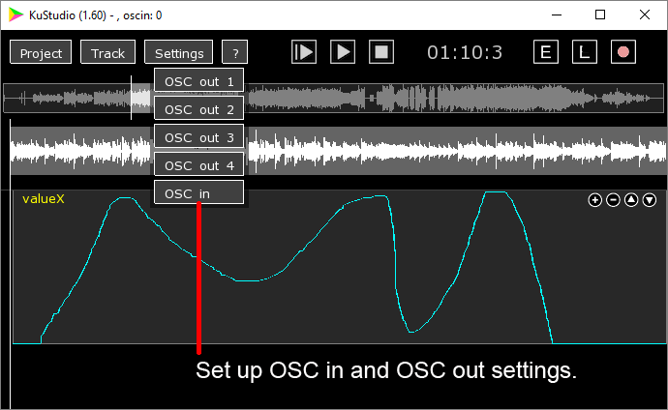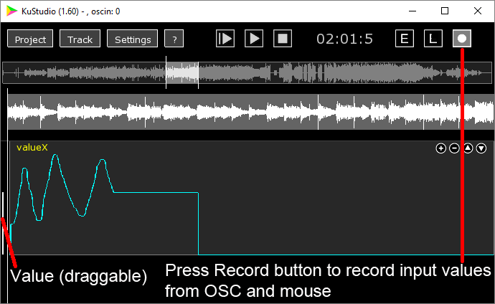

Save your KuStudio project by clicking "Save" or "Save as...".

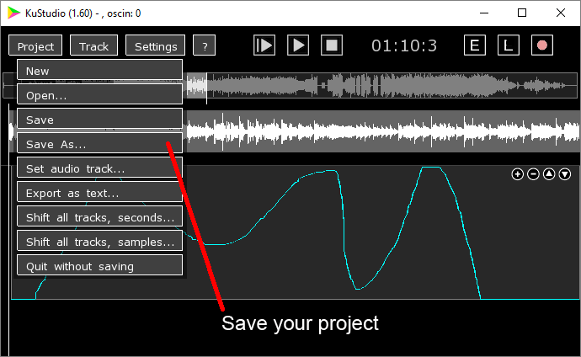

**Additional tricks**

**Drawing a line segment on a track**

Press and hold **z** key, then click and hold mouse at the start point of the line, then press and hold **x** key (you will see that "L" button will enable), then drag mouse to the end point of the line, and release mouse button. You will see an line of the track.

**Sending track's values to several addresses**

You can include to the track's name several OSC addresses, using comma (without spaces), such as **param1,param2,param3**

Then the track will send it's values to addresses **/param1**, **/param2**, **/param3**.

**Recording OSC values from external programs**

You can record the tracks data from external sources such as Max/MSP, VDMX, TouchOSC. To enable this feature, you need to set its OSC input port to non-zero value using "**Settings - OSC in dialog**".

Also, you need to enable "Recording" button and start playing (by pressing **Space** or **Enter**).

To record data to track named, for example, **valueX**, you need to send to KuStudio OSC messages with address /**valueX** and one float argument.

Another way to write data to some track is to use address

/kusN, where N is track's number.

For example, for sending data to the first track, use address **/kus1**.

**Controlling KuStudio using OSC commands**

KuStudio can receive OSC commands to start playing, stop playing, and load another KuStudio project.

To enable this feature, you need to set its OSC input port to non-zero value using "**Settings - OSC in dialog**".

**List of commands**

(Command is a OSC message without arguments)

/playStopSegment - play/stop fragment

/stopSegment - stop playing fragment

/playAll - play whole track

/stopAll - stop playing whole track or fragment

/openProject FILE_NAME - open project. Here FILE_NAME should be a string argument in OSC message, which is an absolute path to KuStudio project file with **kus** extension.

During it's working, KuStudio sends each second to the first OSC receiver it's status, as an OSC message:

**kustudio:status PROJECT_NAME PLAY_TIME APP_TIME STATUS**

Here:

**PROJECT_NAME** - a name of current KuStudio project,

PLAY_TIME - current position of playing in seconds

**APP_TIME** - time in seconds from starting KuStudio (helpful to see KuStudio is ok)

**STATUS** - current playing status, can be **playAll**, **playSegm**, **stop**.