**2.1 Task 1: Exploit the Vulnerability**

For this task, we will be exploiting printf vulnerabilities. Our goals are to

* crash the program
* print out the value of secret[1]
* modify the value of secret[1]
* and modify the secret[1] value to a pre-determined value.

To start, we will crash the program by telling printf that we are sending it multiple arguments when in reality, we are not. This will cause it to take arguments off the stack and examine those locations in memory. Eventually, one of the locations it’s bound to examine will be off limits or an invalid location in memory, crashing the program. A screenshot of this happening is below:

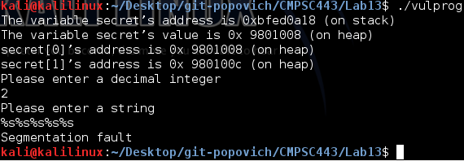

Next, we plan on printing out the value of secret[1]. Because the program prints out secret’s address for us (0xbfed0a18), we can use that as our format string.