Phishing Email Classifier
Course: Cybersecurity
Project type: Machine-learning based security detection tool
Team members: Member 1: Armen Mesropyan Member 2: Serzh Harutyunyan
Summary
This project implements a phishing email classifier that predicts whether an email is legitimate or phishing based on its subject and body text. The solution uses text preprocessing with a TF-IDF vectorizer and a Logistic Regression classifier, then exposes the model through a simple Streamlit web interface. The objective is to support users by quickly flagging suspicious messages before they click malicious links, open unsafe attachments, or share credentials.
The submitted implementation includes a trained model file, a saved TF-IDF vectorizer, a classifier module that performs prediction and confidence scoring, and a Streamlit application for interactive testing. The provided confusion matrix shows strong performance, with 31,524 correct predictions out of 32,483 evaluated emails, corresponding to approximately 97.05% accuracy.

1. Problem Statement
Phishing is a social engineering attack in which an attacker sends emails that appear trustworthy to steal credentials, deliver malware, or manipulate the victim into performing unsafe actions. Common phishing indicators include urgent language, suspicious offers, credential-verification requests, fake account warnings, and links to suspicious sites.
The security problem addressed in this project is the difficulty of manually reviewing every incoming email. Even trained users can miss signs of phishing when messages are well written or when they imitate familiar services. The project, therefore focuses on automatic email-content classification as a defensive support tool.

2. Research and Technical Background
Machine learning is suitable for phishing detection because phishing messages often contain recurring linguistic patterns. Instead of manually writing rules for every phrase, a trained classifier can learn statistical patterns from labeled legitimate and phishing email examples.
TF-IDF representation. Term Frequency-Inverse Document Frequency converts email text into numerical features. Words that are common in one email but less common across the dataset receive higher importance. This helps the model distinguish suspicious vocabulary from ordinary communication.
Logistic Regression classifier. Logistic Regression is a supervised learning algorithm that estimates the probability that a sample belongs to a class. It is appropriate for this project because it is efficient, interpretable, and performs well on sparse text features such as TF-IDF vectors.
Why is this approach useful in cybersecurity? The model can be integrated into an email-analysis workflow to provide a first-level warning. It is not a replacement for secure email gateways or user awareness, but it can improve detection and education by demonstrating how suspicious text patterns are identified.

4. System Design and Implementation
The application is divided into two main Python components:
File | Purpose
classifier.py | Loads the saved Logistic Regression model and TF-IDF vectorizer, combines subject and email body, transforms the text, predicts the class, calculates confidence, and returns a readable result.
app.py | Provides a Streamlit web interface where the user enters an optional subject and email body, clicks Analyze Email, and receives a Legitimate or Phishing result with confidence.
phishing_model.pkl | Serialized trained Logistic Regression model.
tfidf_vectorizer.pkl | Serialized TF-IDF vectorizer used to transform email text consistently during inference.
confusion_matrix.png | Evaluation figure showing prediction performance for legitimate and phishing classes.

5. Evaluation Results
Metric | Value | Meaning
Total evaluated emails | 32,483 | All samples in the evaluation confusion matrix.
Correct predictions | 31,524 | Legitimate and phishing emails correctly classified.
Accuracy | 97.05% | Overall percentage of correct predictions.
Phishing precision | 96.55% | When the model predicts phishing, how often it is correct.
Phishing recall | 97.12% | How many real phishing emails the model catches.
Phishing F1-score | 96.83% | Balanced score combining precision and recall.
False positives | 524 | Legitimate emails incorrectly classified as phishing.
False negatives | 435 | Phishing emails incorrectly classified as legitimate.

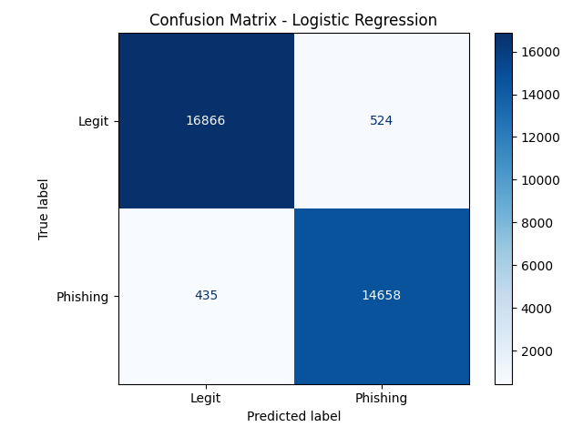
The model performs well on both classes. It correctly identifies 16,866 legitimate emails and 14,658 phishing emails. The false-negative count is especially important from a security perspective because a false negative means a phishing email is missed. In this evaluation, 435 phishing emails were missed, so future improvements should focus on reducing false negatives further.

Conclusion
The phishing email classifier successfully demonstrates how machine learning can support cybersecurity defense. By combining TF-IDF feature extraction, Logistic Regression classification, and a simple Streamlit interface, the project provides an accessible tool for detecting suspicious email content. The evaluation results show high accuracy and strong phishing recall, making the solution effective as a first-level warning system. The main takeaway is that ML-based detection is useful, but it should be combined with additional security checks and user awareness for stronger real-world protection.

