House Prices
Predict the sales price for each house.

Data Programming


Profesor: Student(s): Armend Shala Brahim Mustafa
Asst. Prof. Dr. Gëzim Sejdiu Oriola Arifi Eos Musliu Viona Paqarizi

Prishtinë, January 2026

DECLARATION OF AUTHORITY

By this statement, we as a team, declare that this work is the result of our original work. No part of this work has been obtained from anyone without reference to the accepted standards. This material is conceived and designed based on the sources cited using them and based on the sources cited in the references and in the cited literature.

It also makes it clear that, to the best of our knowledge, the work does not infringe the rights of any author, in any case. On the contrary, we accept our responsibilities which will be assigned to us by any committee or body that will eventually review any case of complaint or disagreement regarding the content of the paper, and at the same time we agree to be evaluated according to the regulation and the University statute and copyright law.

TABLE OF CONTENTS

INTRODUCTION 1
APPROACH 2
RESULTS 4
PROJECT TIMELINE 6
CONCLUSIONS AND RECOMMENDATIONS 7
REFERENCES 8

INTRODUCTION
This project focuses on predicting residential house sale prices using the Ames Housing dataset (the well-known Kaggle “House Prices – Advanced Regression Techniques” problem). The goal is to learn a regression function that maps a rich set of property attributes—location, lot size, quality/condition, living area, basement and garage information, and sale timing—to the final sale price.
Accurate price prediction is a practical data science task because it requires handling mixed data types (numeric + categorical), substantial missingness in “optional” property attributes (e.g., fireplaces, alleys, pools), and careful evaluation with appropriate metrics. The project emphasizes end-to-end data preparation, feature engineering, and model selection to obtain a strong generalization performance.
The following sections describe the dataset, preprocessing steps, modeling approach and evaluation results.

APPROACH
Dataset
Ames Housing training set (1,460 rows) with a separate test set (1,459 rows) used to generate a Kaggle-style submission. The target variable is SalePrice, which is highly right-skewed; therefore, we model log1p(SalePrice) and convert predictions back with expm1.
Data cleaning & feature engineering:
- Treated “missing means none” categories explicitly (e.g., FireplaceQu, basement quality/finish fields, and garage-related fields).
- Filled numeric basement area and related fields with 0 when the basement is absent, and applied median or most-frequent-value imputation for remaining numeric and categorical features.
Categorical encoding: selected categorical columns were one-hot encoded using pandas.get_dummies(drop_first=True).
Modeling: a GradientBoostingRegressor was trained within a preprocessing/estimation pipeline and tuned using GridSearchCV (5-fold CV). The final model was fit on the full training set and used to generate a submission file.
Model performance was evaluated using Root Mean Squared Error (RMSE) and R² score on a validation split.
Exploratory Data Analysis (EDA)
Exploratory Data Analysis (EDA) was conducted to understand the structure of the dataset, examine feature distributions, and identify missing values and potential outliers. The analysis revealed that the target variable SalePrice is strongly right-skewed, while several features such as overall quality and living area show a clear positive relationship with house prices. Additionally, a significant portion of missing values was found to represent the absence of optional property features rather than missing information.
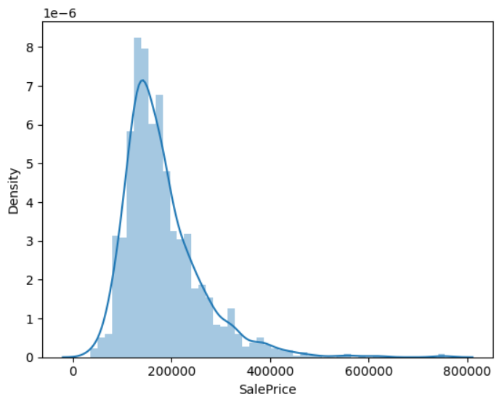
Fig.1. Distribution of SalePrice showing strong right skewness.

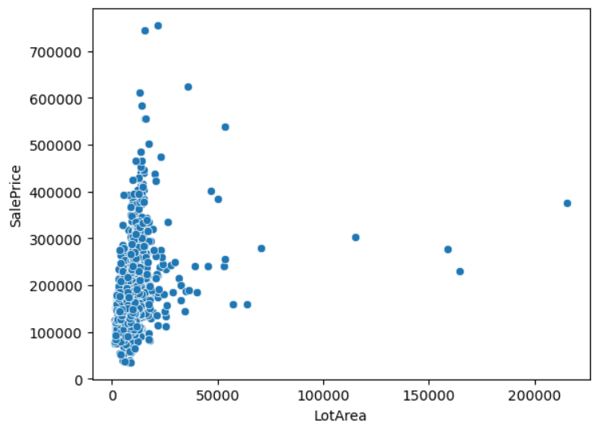
Fig.2. Relationship between lot area (LotArea) and SalePrice.

Insights obtained from EDA guided the data preprocessing, feature engineering, and modeling decisions described in the following sections

RESULTS
Cross-validation using GridSearchCV with 5-fold cross-validation identified Gradient Boosting as the best-performing model on the log-transformed target variable. The optimal model configuration was selected based on Root Mean Squared Error (RMSE) and demonstrated strong predictive performance.
Hold-out validation using an 80/20 train–validation split showed strong agreement between predicted and actual house prices, achieving a Validation R² of approximately 0.91 and an RMSE of approximately 26,700 on the original scale. Diagnostic plots indicate a stable and well-calibrated model.
Best Model Parameters
- learning_rate=0.05
- max_depth=3
- min_samples_leaf=5
- n_estimators=800
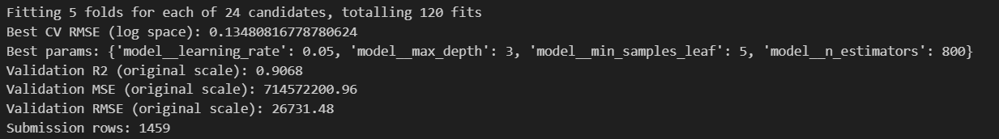
Fig.3. Model performance metrics obtained from cross-validation and hold-out validation.
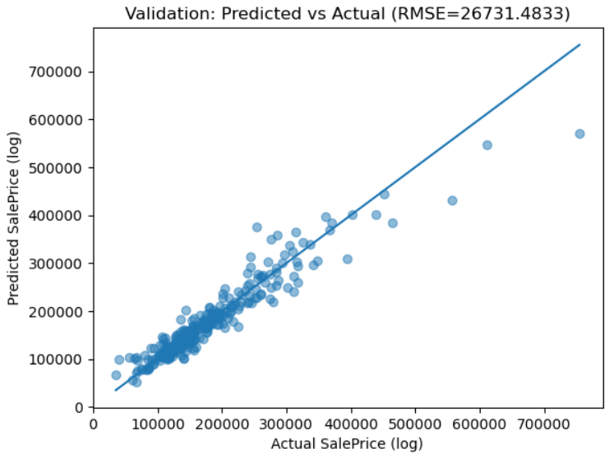
Fig.4. Predicted versus actual house prices on the validation set.
The strong alignment along the diagonal indicates high predictive accuracy.
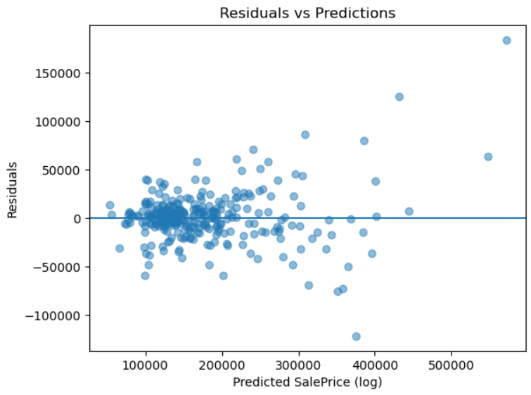
Fig.5. Residuals versus predicted house prices on the validation set.

The residual plot shows that errors are generally centered around zero, indicating that the model does not exhibit strong systematic bias. Larger residuals appear for higher predicted prices, which is expected due to increased variability in high-value properties.

PROJECT TIMELINE

Week | Task | Responsible Member
Week 1 | Initial project planning, definition of project structure, dataset familiarization, and exploratory data analysis (EDA), including identification of missing values and outliers, and documentation of key insights. | Oriola, Armend
Week 2 | Continued exploratory analysis, discussion of data quality issues, and preparation of EDA findings and suggestions for further preprocessing. | Oriola, Eos
Week 3 | Data cleaning, feature engineering (handling missing values, transformations, categorical encoding), model development using Gradient Boosting Regressor, cross-validation, hyperparameter tuning, and Kaggle submission. | Armend, Viona
Week 4 | Integration of results, preparation of figures and visualizations, report writing, and preparation of presentation slides. | Brahim, , All Members

CONCLUSIONS AND RECOMMENDATIONS

The final Gradient Boosting model, trained on a cleaned and properly encoded Ames Housing dataset with a log-transformed target variable (SalePrice), achieved strong predictive performance based on cross-validation and hold-out validation results. The modeling approach successfully captured non-linear relationships between property characteristics and house prices, resulting in a stable model and a complete submission generated for the test dataset.

Future work and recommendations:
- Exploring more advanced gradient boosting frameworks such as XGBoost, LightGBM, or CatBoost.
- Applying more systematic feature selection techniques and modeling feature interactions.
- Handling outliers using more robust statistical methods.
- Expanding hyperparameter optimization strategies, potentially using nested cross-validation for more reliable model assessment.

REFERENCES

[1] Kaggle. “House Prices – Advanced Regression Techniques (Ames Housing).”
[2] Pedregosa et al. Scikit-learn: Machine Learning in Python. JMLR, 2011 + scikit-learn docs (GradientBoostingRegressor, GridSearchCV).
[3] Andreas Müller, Sarah Guido: “Introduction to Machine Learning with Python” 2016
[4] Jake VanderPlas “Python Data Science Handbook: Essential Tools for Working with Data” 2017
[5] GitHub repository: house-price-prediction (code & notebooks). https://github.com/arifioriola/house-price-prediction/
[6] GitHub repository: house-pricing-prediction-kaggle (workflow, environment, model selection).
https://github.com/armenddsh/house-pricing-prediction-kaggle

