All these are found on p. 308

Show table to alvar p.306

Extract delivery variables for each demand unit

The equation is: DN+GP+RU=AW+RP

This indicates that the total net water delivered (DN) plus the groundwater extracted (GP) plus reused water (RU) is equal to the total water applied (AW) plus any water used or consumed by riparian areas (RP).

1. Extract all variables for each demand unit (stored in dic)

1. From step 1 dic, look for the variables that start with DN_
   1. The format of the variable should be: ‘DN_’+ ‘DU’ (ie: DN_90_PA1)
   2. Most have 1 variable starting DN_
   3. Significant number of variables have multiple nodes that look as follows.
      1. These nodes (DN_CAA…) are diversion node deliveries, but what do they mean?

Snippet of table 14-5 that shows this diversion nodes

1. From step 1 dic, look for the variables that start with GP_
   1. Most have 1 variable starting GP _
   2. Around 10 variables have multiple nodes that look as follows.

1. From step 1 dic, look for the variables that start with RU_
   1. All that have RU_ have only 1 variable
2. From step 1 dic, look for the variables that start with AW_
   1. Only 3 variables don’t have AW:
      1. 50_PA2
      2. 71_PA7
      3. NIDDC_NA3

* 50_PA2
  + Although it has gw pumping, it’s always zero

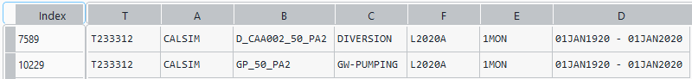

* 71_PA7
  + Although it has return flow, it’s always zero

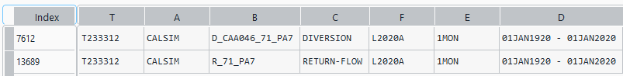

* NIDDC_NA3
  + Delivery variable is DN_
  + I don’t know why this variable doesn’t have AW, even though it has DN_

To do:

Compare with james dataset

Add 3 other variables

Demand Units

As discussed in Chapter 3, names of demand units within the WBA domain comprise a two or three-character WBA prefix, followed by a two-character ‘contract and water use type’ suffix. When this naming convention does not result in a unique name, a number has been added to theend of the acronym. For example, 08N_SA2 represents a CVP settlement contractor (denoted by ‘S’) using water for agricultural purposes (denoted by ‘A’). The number 2 is used to distinguish this settlement contractor from other agricultural settlement contractors in WBA 08N.In the schematic, the color and border of the demand unit symbol are used to distinguish between water purposes (agricultural, urban, wetland) and sources of water (surface water, groundwater). These conventions are illustrated in Figure 4-4. A complete list and description of demand unit scan be found in Chapter 3 (Demand Units). Demand units located in rim watersheds or in export areas outside the WBA domain are named using a five-letter acronym for the water purveyor/user.

The demand unit names are structured with a prefix and a suffix: the prefix indicates the water budget area, and the suffix is as follows:

* First letter represents group of CVP/SWP contractors or “non-project” water users
  + S is settlement, X is exchange, P is project contract (SWP/CVP) and N is non-project.
* Second letter is the type of water user.
  + A is agriculture, U is urban, R is managed wetlands
* Third letter is in cases when two demand units would share the same name, a number is appended to the suffix to distinguish between them.

Assume we have demand unit: “08N_SA1”.

Prefix: “08-N” is the WBA 08-North.

Suffix: S is settlement – A is agriculture – 1 just means there’s multiple that share the same name