**[What will it take to stabilize the Colorado River?](https://www.science.org/doi/full/10.1126/science.abo4452" \l "supplementary-materials)**

[A continuation of the current 23-year-long drought will require difficult decisions to prevent further decline](https://www.science.org/doi/full/10.1126/science.abo4452" \l "supplementary-materials)

<https://www.everycrsreport.com/files/20190321_R45546_bbcb0e946b7f42c8c312e2070e766cbecff0c0ee.pdf>

These are good papers to learn about the management of the Colorado river system.

<https://www.usbr.gov/lc/region/g4000/NaturalFlow/Final-MethodsCmptgNatFlow.pdf>

This document is about natural flows

<https://www.sciencedirect.com/science/article/pii/S0022169421007733#f0005>

we can get info on upper Colorado region

[Managing the Colorado River for an Uncertain Future](https://d1wqtxts1xzle7.cloudfront.net/94034779/478906149-libre.pdf?1668129127=&response-content-disposition=inline%3B+filename%3DWhite_Paper_3_Managing_the_Colorado_Rive.pdf&Expires=1723083228&Signature=dKT--Z4zuDlgqdLxy55KqOi-pb9l4jxAWOMHFpmBnG2KWcaXKZWhXXpY-6F45~Lc7XxlnViIXdLbhZp63orzg6mnDWzUnXSGmmG-qJAxcCCNpzEIGA-nZO89etlQqFgWR7WXwqfT6zgevoV6W3VYIIkVthsq1qcopziVZwYDpLmvcX4ZVbij9XBB08I96KxCYoT8fs~9cMeEOgLqObCKJKPNILb~U13oF2ucjHonzZx02y3adC-4HS0eRxnvN62vv5663KmAnBKkOJMvfxs0ja-CBDcQvYC-v-SYBy47WI4ur4lD-6ZadsHFEr-7W7YKsRIHx29J3clImUc2T5PWyw__&Key-Pair-Id=APKAJLOHF5GGSLRBV4ZA)

I would benefit from this. They use multiple decision making under uncertainty rules.

<https://agupubs.onlinelibrary.wiley.com/doi/full/10.1029/2021WR029753>

This to get dams and natural flow gages

<https://apps.usgs.gov/colorado-river-basin/drought-2023-water-year.html>

<https://waterdata.usgs.gov/nwis/current?search_criteria=huc2_cd&submitted_form=introduction>

to get streamflow data

[Water Resource Modeling of the Colorado River: Present and Future Strategies](https://www.researchgate.net/profile/Kevin-Wheeler-5/publication/336058345_Water_Resource_Modeling_of_the_Colorado_River_Present_and_Future_Strategies/links/5d8c79e6299bf10cff0e9112/Water-Resource-Modeling-of-the-Colorado-River-Present-and-Future-Strategies.pdf)

<https://engaging-data.com/colorado-river-reservoir-levels/>

This will help us to know the status of reservoirs (also very cool infographics)

<https://www.pnas.org/doi/epdf/10.1073/pnas.0812762106>

Info regarding the deliveries

[**The Colorado River water crisis: Its origin and the future**](https://wires.onlinelibrary.wiley.com/doi/full/10.1002/wat2.1672)

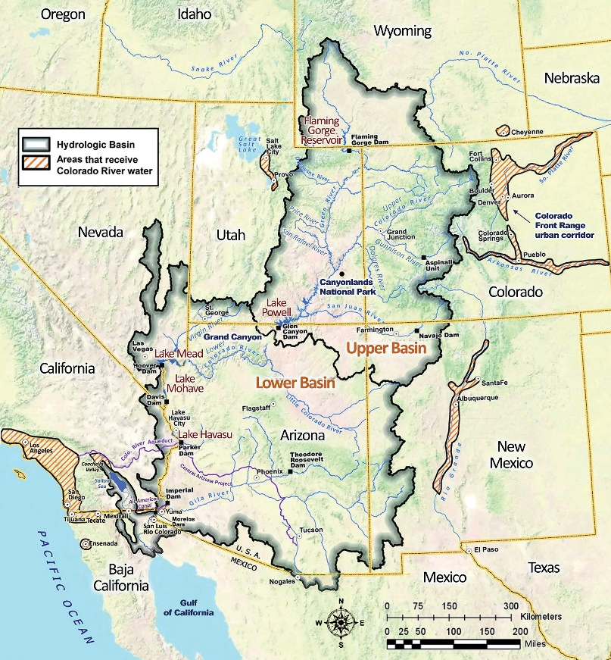

Colorado river is governed by two treaties: 1922 Colorado River Compact (Law of the river) and the 1944 Treaty between the United States and Mexico.

The compact divided Colorado river into two: Lower and Upper basin.

Lower basin: Arizona, Nevada, and California

Upper basin: Colorado, New Mexico, Utah, Wyoming, Arizona

Each basin gets 7.5 maf/yr of consumptive use. Mexico gets 1.5 maf/yr plus an additional 200,000 af when a surplus is declared

Total: 16.5 maf/yr is allocated for consumptive use.

The Compact also required the Upper Basin not to deplete the river’s flow to less than 75 MAF during any 10 consecutive years.

The 2 largest reservoirs are:

* Lake Powell: For Upper Basin users (to avoid violation of the non-depletion obligation)
* Lake Mead/Hoover Dam: For Lower Basin users

Lower Basin users and Mexico use all their 9 maf/yr apportionment of the Colorado river whereas Upper Basin consumptive uses averaged 3.7 MAF/year.

In the Lower Basin, Hoover Dam, completed in 1936, provides the majority of the Lower Basin’s storage and generates about 4.2 billion KWh of electricity per year for customers in California, Arizona, and Nevada.34 Also important for Lower Basin Operations are Davis Dam/Lake Mohave, which regulates flows to Mexico under the 1944 Treaty, and Parker Dam/Lake Havasu, which impounds water for diversion into the Colorado River Aqueduct (thereby allowing for deliveries to urban areas in southern California) and CAP (allowing for diversion to users in Arizona). Further downstream on the Arizona/California border, Imperial Dam (a diversion dam) diverts Colorado River water to the All American Canal for use in California’s Imperial and Coachella Valleys (Stern et al., n.d.).

In 2003 Quantification settlement agreement was signed. This agreement defined the rights to a portion of Colorado River water for:

* San Diego County Water Authority
* Coachella Valley Water District
* Imperial Irrigation District
* Metropolitan Water District of Southern California

The Quantification Settlement Agreement confirmed:

* the Imperial Irrigation District’s Colorado River annual allotment at 3.1 million acre-feet
* the Coachella Valley Water District’s Colorado River annual allotment at 330,000 acre-feet

The Quantification Settlement Agreement also established:

* the IID-San Diego County Water Authority water transfer
* A transfer of 105,000 acre-feet annually between IID and Metropolitan
* A transfer of as much as 103,000 acre-feet annually between Imperial and the Coachella Valley district (*Quantification Settlement Agreement*, 2020; San Diego County Water Authority, n.d.)

The two largest reservoirs in the Colorado River system, Lake Mead and Lake Powell, have been steadily declining the past 20 years as shown in the figure below. Keep in mind Lake Havasu and Lake Mohave which have much lower storage because Lake Havasu is used for diversions to MWD and Lake Mohave for diversions to Mexico.

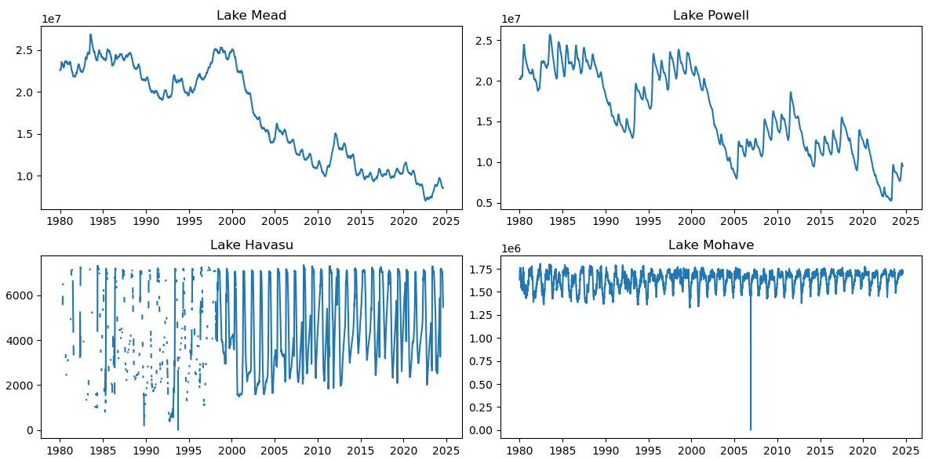

The sequence of lower Colorado basin reservoirs/dams is the following:

Hoover Dam/Lake Mead, Davis Dam/Lake Mohave, Parker Dam/Lake Havasu, Palo Verde Diversion Dam, Imperial Dam. (Other minor dams have been omitted, more can be found on excel)

Lake Havasu: Colorado River Aqueduct

Palo Verde Diversion Dam:

Imperial Dam: All American Canal

MWD

Diversions in some years seem to be higher than what MWD claims to have received. This is weird. If we look at 2010, 2011, 2012 reports for consumptive use its almost the same as diversions. It could be SDCWA is getting some of the waters that is diverted to MWD. In 2010 and 2011 exchange between MWD and SDCWA happened where MWD received 150 taf /yr