AOS Assignment 4
Linux Kernel Module
Name: Abhiram G P
Roll No: 2022201024

Step 1
Necessary libraries are installed using the following commands in the terminal.
sudo apt update
sudo apt upgrade
sudo apt install make binutils gcc

Step 2
A directory named a3 is made. Inside a3 hello_module.tar.gz is downloaded and unzipped
mkdir a3
cd a3
wget http://faculty.washington.edu/wlloyd/courses/tcss422/assignments/hello_module.tar.gz
tar xzf hello_module.tar.gz

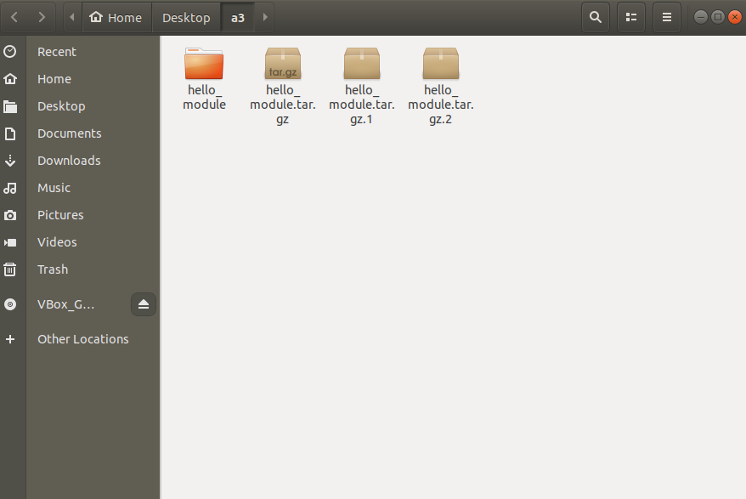

Navigate into hello_module
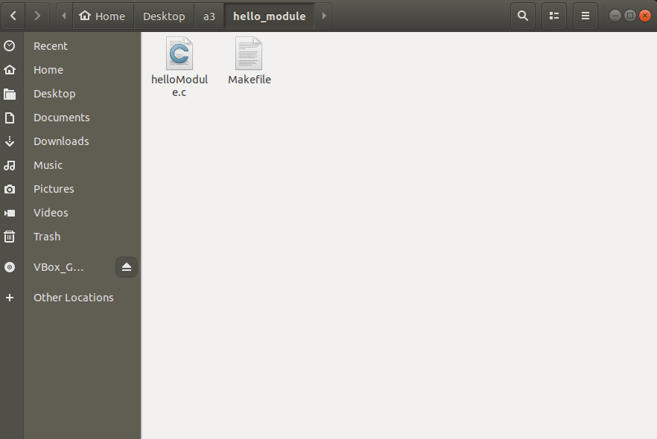

Step 3
helloModule.c code is changed as shown below, by adding the function count_running_processes()
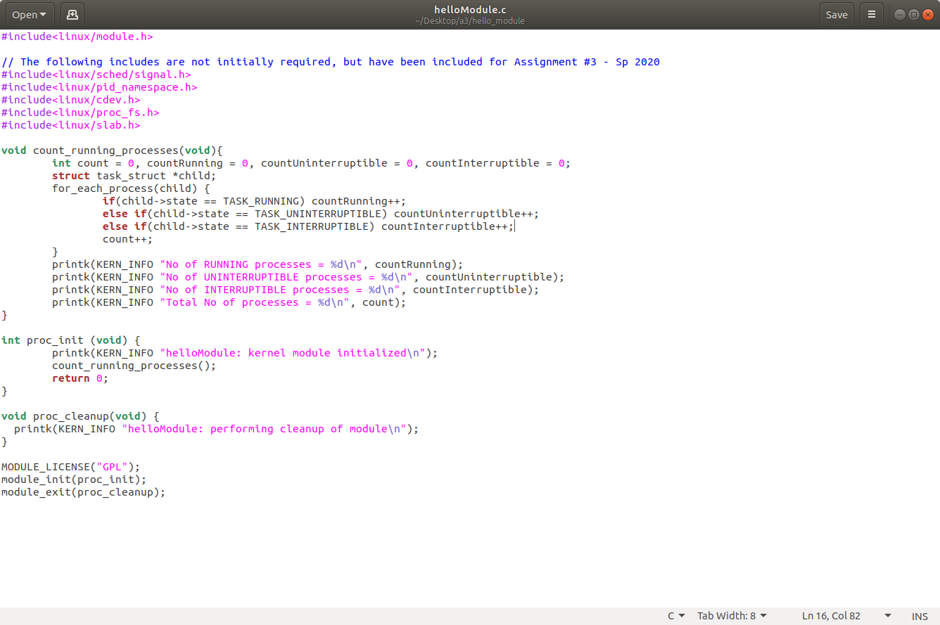

Step 4
Module is compiled using the make command. Makefile is shown below.
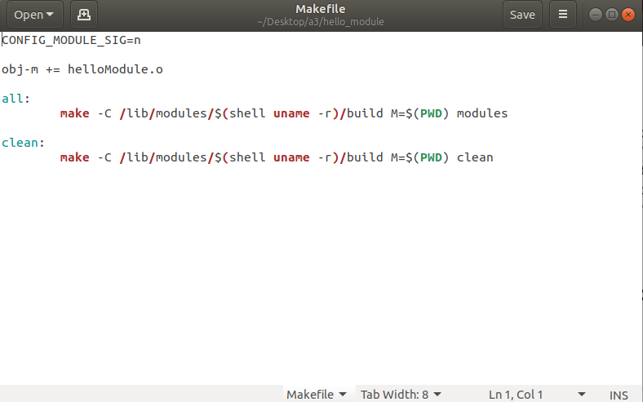
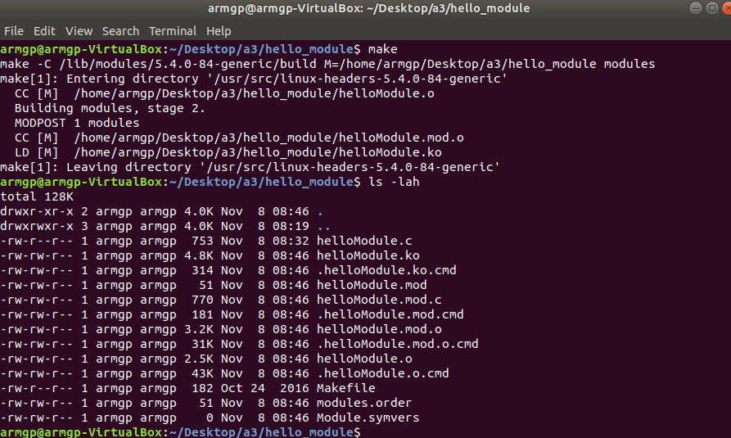

Step 5

Kernel object file is loaded.
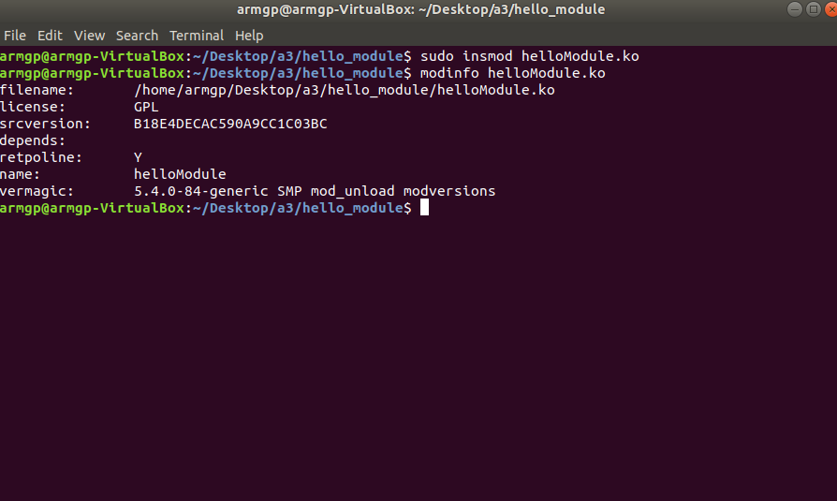
Last 10 lines of Kernel logs is checked using the tail command.
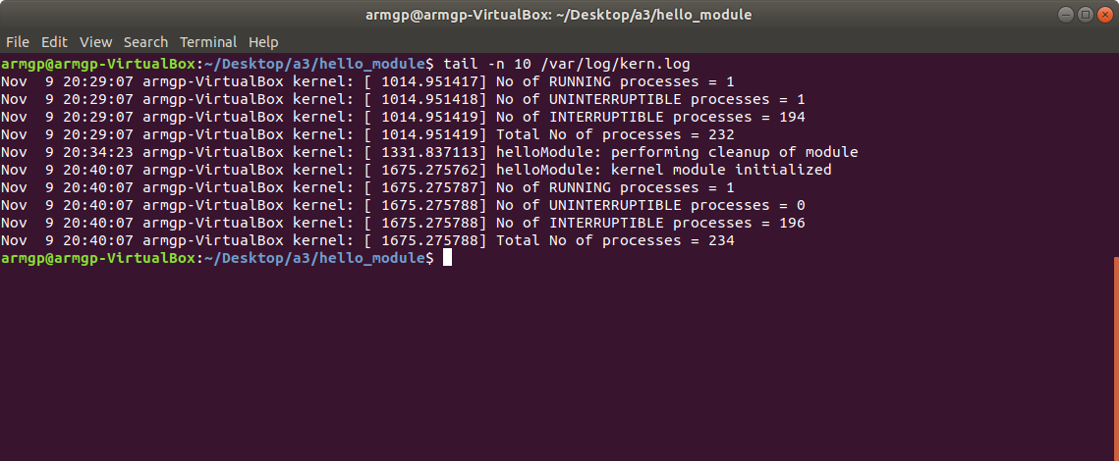

Step 6
Kernel module is unloaded and kernel logs ans syslog is checked.
