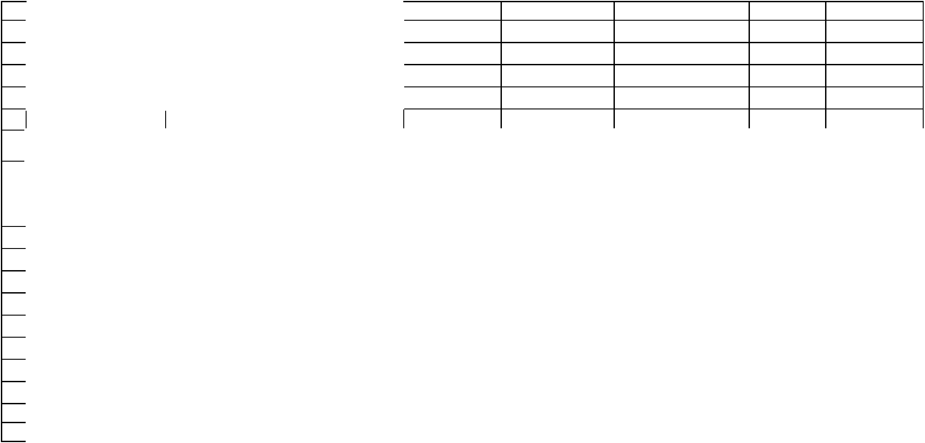  Team Name | TEAM DRUTHA
University/College | COLLEGE OF ENGINEERING, ADOOR
Competition Code | FFS - 2018
Year | 2018
Car # | HASTEN
 |  | Cost Summary Basics
Area Totals |  |  |  | Materials |  | Processes |  | Fasteners | Tooling |  |  | Total
 | Brake System |  | ₹ | 17,731.14 | ₹ | 4,609.32 | ₹ | 192.93 | ₹ | - | ₹ | 22,162.71
 | Engine & Drivetrain |  | ₹ 117,570.37 |  | ₹ | 7,055.26 | ₹ | 1,823.96 | ₹ | 21.67 | ₹ | 85,722.42
 | Frame & Body |  | ₹ | 60,418.41 | ₹ | 21,914.54 | ₹ | 496.83 | ₹ | 606.66 | ₹ | 83,436.44
 | Instruments & Wiring |  | ₹ | 5,035.55 | ₹ | 1,670.40 | ₹ | - | ₹ | - | ₹ | 6,705.95
 | Miscellaneous, Fit & Finish |  | ₹ | 27,804.79 | ₹ | 4,461.28 | ₹ | 551.64 | ₹ | - | ₹ | 32,817.71
 | Steering System |  | ₹ | 606.92 | ₹ | 2,581.58 | ₹ | 24.09 | ₹ | 433.33 | ₹ | 3,645.92
 | Suspension & Shocks |  | ₹ | 16,322.94 | ₹ | 13,393.58 | ₹ | 745.90 | ₹ | 370.08 | ₹ | 30,832.50
 | Wheels & Tires |  | ₹ | 62,187.40 | ₹ | 8,896.28 | ₹ | 1,304.00 | ₹ | - | ₹ | 72,387.68
 | Total Vehicle |  | ₹307,677.52 |  | ₹ | 64,582.24 | ₹ | 5,139.35 | ₹ 1,431.74 |  | ₹337,711.33

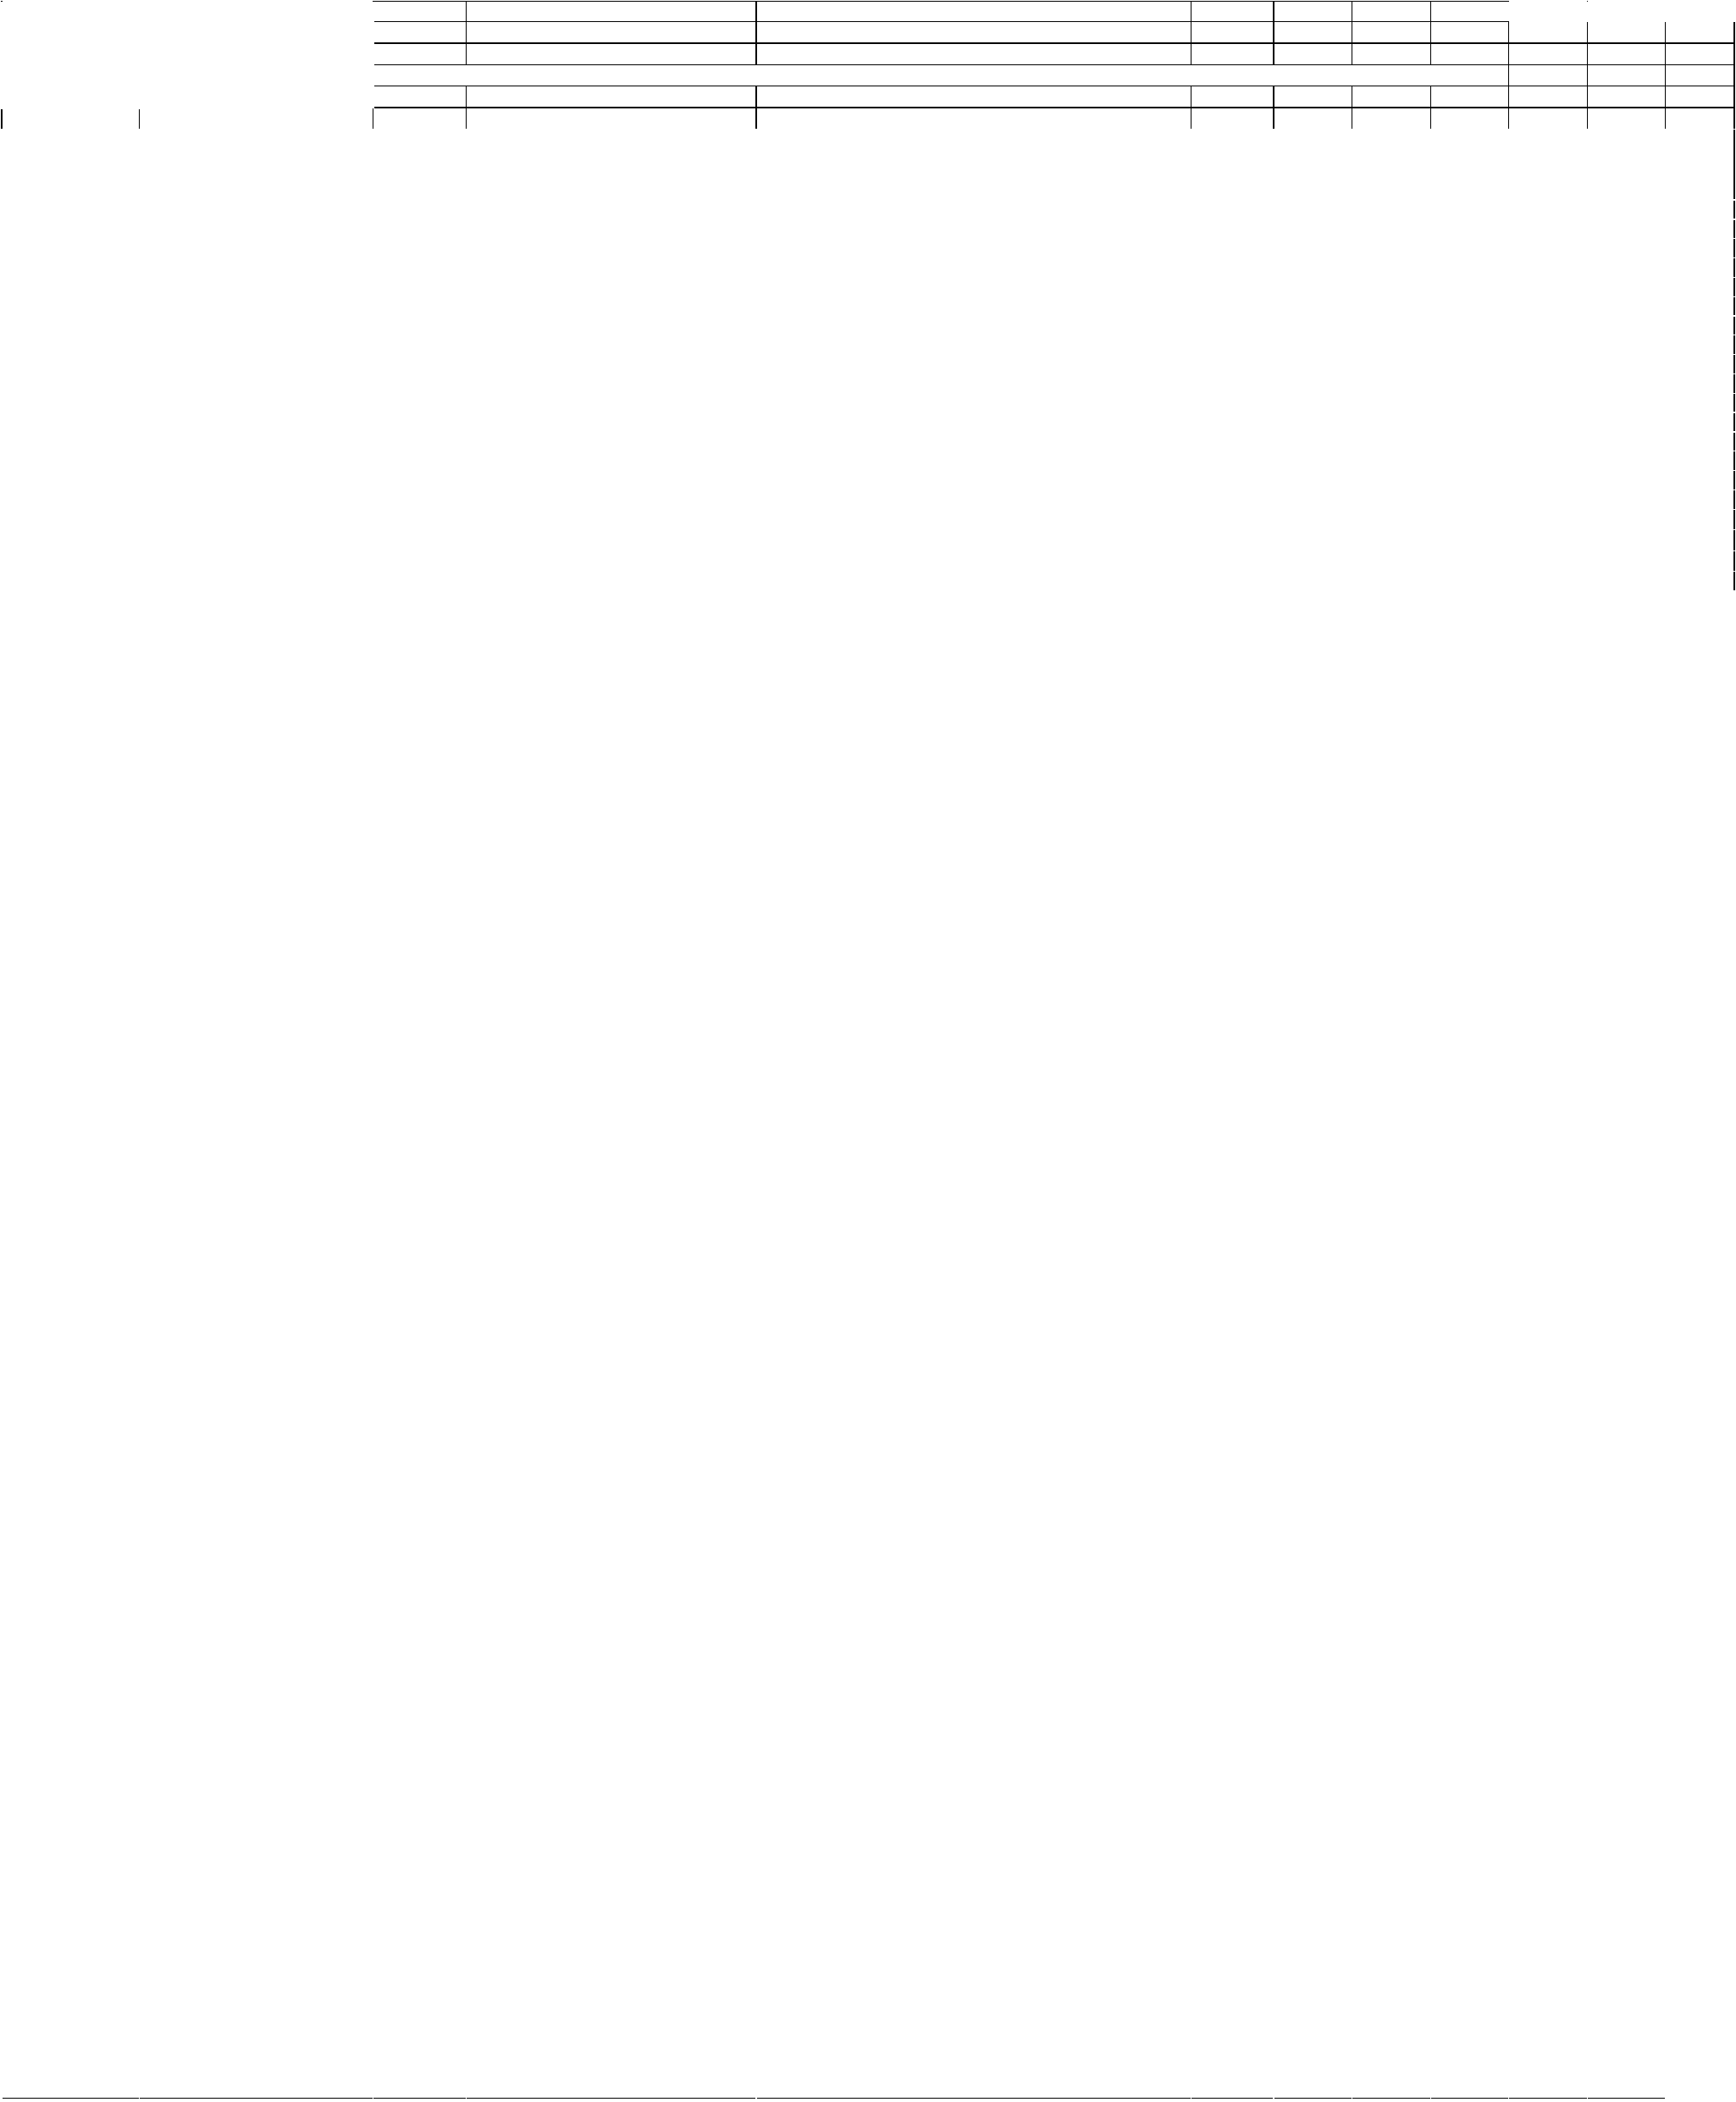  Team Name | TEAM DRUTHA |  |  |  |  |  |  |  |  | Total Vehicle Cost |  | 337711.33
University/College | COLLEGE OF ENGINEERING, ADOOR
Competition Code | FFS - 2018 |  |  | for engine on
Year | 2018 | The cost of assemblies on this chart should not include the cost of the parts in the assembly but only the materials, processes, fasteners and tooling in the assembly level.
Car # | HASTEN
Line Num. | Area of Commodity | Asm | Component | Description |  | Unit Cost | Quantity | Material | Process | Fastener | Tooling | Total
 |  |  |  |  |  | Unit Cost | Quantity | Cost | Cost | Cost | Cost | Cost
1 | Brake System |  | Brake Discs | Yamaha Ray Disc Rotor | (1,205.07) |  | 3 | 215 | 990.07 |  |  | 3615.21
2 | Brake System | Brake Discs | Disks |  |  | (0.00) |  |  |  |  |  | 0.00
3 | Brake System | Brake Discs | Keys |  |  | (0.00) |  |  |  |  |  | 0.00
4 | Brake System |  | Brake Fluid | Liquimoly, 500ml |  | (666.00) | 2 | 666 |  |  |  | 1332.00
5 | Brake System | Brake Fluid | Brake Fluid |  |  | (0.00) |  |  |  |  |  | 0.00
6 | Brake System |  | Brake Line |  |  | (0.00) |  |  |  |  |  | 0.00
7 | Brake System | Brake Line | Brake Line - Flexible | Flexible Brake Line | (1,425.35) |  | 2 | 1035 | 351.35 | 39 |  | 2850.70
8 | Brake System | Brake Line | Brake Line - Rigid | Hard Brake line |  | (433.49) | 1 | 43.14 | 351.35 | 39 |  | 433.49
9 | Brake System |  | Brake Master Cylinder | Bybre master cylinder | (1,115.51) |  | 3 | 1030 | 73.13 | 12.38 |  | 3346.53
10 | Brake System | Brake Master | Brake Master Cylinder |  |  | (0.00) |  |  |  |  |  | 0.00
11 | Brake System |  | Proportioning Valve |  |  | (0.00) |  |  |  |  |  | 0.00
12 | Brake System | Proportioning | Proportioning Valve |  |  | (0.00) |  |  |  |  |  | 0.00
13 | Brake System |  | Balance Bar |  |  | (0.00) |  |  |  |  |  | 0.00
14 | Brake System | Balance Bar | Balance Bar |  |  | (0.00) |  |  |  |  |  | 0.00
15 | Brake System |  | Brake Pads | Iron/Steel rotor |  | (269.13) | 6 | 261 | 8.13 |  |  | 1614.78
16 | Brake System | Brake Pads | Brake Pads |  |  | (0.00) |  |  |  |  |  | 0.00
17 | Brake System |  | Calipers | Wilwood PS -1 | (2,990.00) |  | 3 | 2995 | 105.63 | 12.93 |  | 8970.00
 | Brake System |  | Area Total |  |  |  |  | 17731.14 | 4609.32 | 192.93 | 0.00 | 22162.71
1 | Engine & Drivetrain |  | Engine | KTM Duke 390CC, 44BHP | ( 50,700.00 |  | 1 | 50700 | 268.13 | 190.62 |  | 50700.00
2 | Engine & Drivetrain |  | Exhaust Manifold | Exhaust flange and exhaust header | ( | 566.97) | 1 | 204.75 | 334.75 | 5.8 | 21.67 | 566.97
3 | Engine & Drivetrain |  | Muffler | Stainless steel, Exhaust inner and outer | ( | 511.97) | 1 | 143.65 | 244.4 | 123.92 |  | 511.97
4 | Engine & Drivetrain |  | Intake Manifold |  | ( | - ) |  |  |  |  |  | 0.00
5 | Engine & Drivetrain |  | Restrictor | Air restrictor | ( | 465.56) | 1 | 109.5 | 356.06 |  |  | 456.56
6 | Engine & Drivetrain |  | Air Filter | Air filter restricts debris entry | ( 3,291.93) |  | 1 | 3120 | 73.13 | 98.8 |  | 3291.93
7 | 0 |  | Turbo/Supercharger |  | ( | - ) |  |  |  |  |  | 0.00
8 | Engine & Drivetrain |  | Carburetor / Throttle Body |  | ( | - ) |  |  |  |  |  | 0.00
9 | Engine & Drivetrain |  | Engine Mounts |  | ( | - ) |  |  |  |  |  | 0.00
10 | Engine & Drivetrain |  | Fuel Injectors | Fuel injector, KTM Duke 390 | ( 5,364.58) |  | 1 | 5200.45 | 73.13 | 91 |  | 5364.58
11 | Engine & Drivetrain |  | Fuel Tank | 3 litre fuel tank | ( 2,573.78) |  | 1 | 458.25 | 2096.25 | 19.28 |  | 2573.78
12 | Engine & Drivetrain |  | Fuel Pump |  | ( | - ) |  |  |  |  |  | 0.00
13 | Engine & Drivetrain |  | Fuel Pressure Regulator |  | ( | - ) |  |  |  |  |  | 0.00
14 | Engine & Drivetrain |  | Fuel Filter | Fuel filter and lines restricting debris entry | ( | 795.60) | 1 | 520 | 130 | 145.6 |  | 795.60
15 | Engine & Drivetrain | Fuel Filter | Filter |  | ( | - ) |  |  |  |  |  | 0.00
16 | Engine & Drivetrain | Fuel Filter | Filter Mount |  | ( | - ) |  |  |  |  |  | 0.00
17 | Engine & Drivetrain | Fuel Filter | Fittings |  | ( | - ) |  |  |  |  |  | 0.00
18 | Engine & Drivetrain |  | Fuel Lines / Rails |  | ( | 306.10) | 1 | 30.5 | 130 | 145.6 |  | 306.10
19 | Engine & Drivetrain |  | Fuel Vent / Check Valve |  | ( | - ) |  |  |  |  |  | 0.00
20 | Engine & Drivetrain |  | Radiator | Heat exchanger, Air to liquid | ( | 175.71) | 1 | 84.53 |  | 91.18 |  | 175.71
21 | Engine & Drivetrain |  | Coolant |  | ( | 30.15) | 1 | 30.15 |  |  |  | 30.15
22 | Engine & Drivetrain |  | Overflow Bottles |  | ( | - ) |  |  |  |  |  | 0.00
23 | Engine & Drivetrain |  | Coolant Lines | Flexible coolant lines | ( | 30.15) | 1 | 30.15 |  |  |  | 30.15
24 | Engine & Drivetrain |  | Radiator Fans |  | ( | - ) |  |  |  |  |  | 0.00
25 | Engine & Drivetrain |  | Hose Clamps |  | ( | 49.40) | 2 |  |  |  |  | 98.80
26 | Engine & Drivetrain |  | Oil Cooler |  | ( | 84.53) | 1 |  |  |  |  | 84.53
27 | Engine & Drivetrain |  | Chain / Belt |  | ( 3,054.35) |  | 1 | 3054.35 |  |  |  | 3054.35
28 | Engine & Drivetrain |  | Ignition Coil / Wires |  | ( | - ) |  |  |  |  |  | 0.00
29 | Engine & Drivetrain |  | Axles |  | ( | 905.34) | 1 | 214.91 | 690.43 |  |  | 905.34
30 | Engine & Drivetrain |  | Differential Mounts |  | ( | - ) |  |  |  |  |  | 0.00
31 | Engine & Drivetrain |  | Sprocket / Pulleys |  | ( 1,185.63) |  | 2 | 376.34 | 712.01 | 97.28 |  | 2371.26
32 | Engine & Drivetrain |  | Differential |  | ( | - ) |  |  |  |  |  | 0.00
33 | Engine & Drivetrain | Differential | Differential Bearings | 6906-2RS bearing | ( | 916.50) | 1 | 916.5 |  |  |  | 916.50
34 | Engine & Drivetrain | Differential | Differential Internals |  | ( | - ) |  |  |  |  |  | 0.00
35 | Engine & Drivetrain | Differential | Differential End Cap -LH |  | ( | - ) |  |  |  |  |  | 0.00
36 | Engine & Drivetrain | Differential | Differential End Cap - RH |  | ( | - ) |  |  |  |  |  | 0.00
37 | Engine & Drivetrain | Differential | Differential Housing |  | ( | - ) |  |  |  |  |  | 0.00
38 | Engine & Drivetrain |  | CV Joints / U Joints | Cover joint | ( 13,488.14 |  | 4 | 13000 | 308.74 | 179.4 |  | 13488.14
39 | Engine & Drivetrain |  | Shields |  | ( | - ) |  |  |  |  |  | 0.00
40 | Engine & Drivetrain |  | Engine and Diff Oil |  | ( | - ) |  |  |  |  |  | 0.00
41 | Engine & Drivetrain | Power Train | Spool |  | ( 5,170.67) |  | 1 | 1539.12 | 3631.55 |  |  | 5170.67
 | Engine & Drivetrain |  | Area Total |  |  |  |  | 117570.37 | 7055.26 | 1823.96 | 21.67 | 85722.42
1 | Frame & Body |  | Pedals | Brake pedals for braking and accelration pedal for acceleration | ( | 320.86) | 4 | 43.88 | 212.55 | 31.93 | 32.5 | 1283.44
2 | Frame & Body |  | Shifter | Gear shifter | ( 2,203.74) |  | 1 | 2015.81 | 156 | 31.93 |  | 2203.74
3 | Frame & Body |  | Thottle Controls |  | ( | - ) |  |  |  |  |  | 0.00
4 | Frame & Body |  | Frame | Complete frame including roll hoops and engine mounts | ( 19,410.28 |  | 1 | 3451.19 | 15504.09 |  | 455 | 19410.28
5 | Frame & Body |  | Body | Stainless steel and glass fibre | ( 59,005.60 |  | 1 | 53950 | 4998 | 57.6 |  | 59005.60
6 | Frame & Body |  | Floor Pan | Floor covering | ( 1,186.64) |  | 1 | 731.64 | 195 | 260 |  | 1186.64
7 | Frame & Body |  | Clutch | Clutch pedal for gear shifting | ( | 346.74) | 1 | 94.25 | 211.25 | 19.58 | 21.66 | 346.74
8 | Frame & Body |  | Aerodynamic Wing (if used) |  | ( | - ) |  |  |  |  |  | 0.00
9 | Frame & Body |  | Shifter Cable / Linkage | a linkage is provided for gear shifting | ( | 770.00) |  | 720 | 50 |  |  | 0.00
10 | Frame & Body |  | Mounts | For connecting all components to the frame | ( | 36.25) | 86 | 1234.26 | 459.12 |  |  | 3117.50
 | Frame & Body |  | Area Total |  |  |  |  | 60418.41 | 21914.54 | 496.83 | 606.66 | 83436.44
1 | Electrical |  | Tachometer |  | ( | - ) |  |  |  |  |  | 0.00
2 | Electrical |  | ECM / Engine Electronics |  | ( | - ) |  |  |  |  |  | 0.00
3 | Electrical |  | Wire Harness / Connectors |  | ( | - ) |  |  |  |  |  | 0.00
4 | Electrical |  | Oil Pressure Gage / Light |  | ( | - ) |  |  |  |  |  | 0.00
5 | Electrical |  | Dash Panel |  | ( | - ) |  |  |  |  |  | 0.00
6 | Electrical |  | Kill Switch | Engine ON/OFF | ( 1,711.72) |  | 3 | 1430 | 281.72 |  |  | 5135.16
7 | Electrical |  | Fuses |  | ( | - ) |  |  |  |  |  | 0.00
8 | Electrical |  | Water Temperature Gage |  | ( | - ) |  |  |  |  |  | 0.00
9 | Electrical |  | Brake Light Bulb | Indicator light during braking | ( | 979.78) |  | 910 | 69.78 |  |  | 0.00
10 | Electrical |  | Solenoids |  | ( | - ) |  |  |  |  |  | 0.00
11 | Electrical |  | Indicator Lights |  | ( | - ) |  |  |  |  |  | 0.00
12 | Electrical |  | Battery | Power supply to the engine | ( 1,473.55) |  | 1 | 680.55 | 793 |  |  | 1473.55
13 | Electrical |  | Relays |  | ( | - ) |  |  |  |  |  | 0.00
14 | Electrical |  | Starter Button | Engine start | ( | 97.24) | 1 | 65 | 32.24 |  |  | 97.24
 | Instruments & Wiring |  | Area Total |  |  |  |  | 5035.55 | 1670.40 | 0.00 | 0.00 | 6705.95
1 | Miscellaneous, Fit & Finish |  | Seats | Driver seat | ( 19,331.66 |  | 1 | 16900 | 2418 | 13.66 |  | 19331.66
2 | Miscellaneous, Fit & Finish |  | On-Board Fire Suppression Sys. |  | ( | - ) |  |  |  |  |  | 0.00
3 | Miscellaneous, Fit & Finish |  | Safety Harness | Driver harness and safety precautions | ( 3,763.61) |  | 1 | 2925 | 300.63 | 537.98 |  | 3763.61
4 | Miscellaneous, Fit & Finish |  | Paint - Frame | Metallic black, spray paint | ( 2,756.00) |  | 1 | 2756 |  |  |  | 2756.00
5 | Miscellaneous, Fit & Finish |  | Paint - Body | Black and red, spray paint | ( 3,178.50) |  | 1 | 3178.5 |  |  |  | 3178.50
6 | Miscellaneous, Fit & Finish |  | Brake Light Housing |  | ( | - ) |  |  |  |  |  | 0.00
7 | Miscellaneous, Fit & Finish |  | Fire Wall | 60x110sqcm area, driver's protection | ( 1,637.58) |  | 1 | 613.83 | 1023.75 |  |  | 1637.58
8 | Miscellaneous, Fit & Finish |  | Mirrors (See 3.4.3.2) |  | ( | - ) |  |  |  |  |  | 0.00
9 | Miscellaneous, Fit & Finish |  | Safety Shields |  | ( | - ) |  |  |  |  |  | 0.00
10 | Miscellaneous, Fit & Finish |  | Headrest / Restraints | Driver's comfort | ( 2,150.36) |  | 1 | 1431.46 | 718.9 |  |  | 2150.36
11 | Miscellaneous, Fit & Finish |  | Impact attenuator | Protection and safety | ( 3,779.75) |  | 1 | 3779.75 |  |  |  | 3779.75
12 | Miscellaneous, Fit & Finish |  | Fasteners | Bolts and Nuts | ( | 66.10) | 97 | 3412 |  |  |  | 6412.97
 | Miscellaneous, Fit & Finish |  | Area Total |  |  |  |  | 27804.79 | 4461.28 | 551.64 | 0.00 | 32817.71
1 | Steering System |  | Steering Rack & Pinion | Wheel control | ( 2,069.10) |  | 1 | 270.55 | 1798.55 |  |  | 2069.10
2 | Steering System |  | Tie Rods |  | ( | - ) |  |  |  |  |  | 0.00
3 | Steering System |  | Steering Column & Shaft |  | ( | 372.83) | 1 | 58.5 | 311.03 | 3.3 |  | 372.83
4 | Steering System |  | Steering Wheel |  | ( | 634.18) | 1 | 122.85 | 78 |  | 433.33 | 634.18
5 | Steering System |  | Steering Wheel Quick Release | Quick release mechanism | ( | 569.81) | 1 | 155.02 | 394 | 20.79 |  | 569.81
6 | Steering System |  | Steering Rod Ends & Clevis |  | ( | 91.33) |  | 66.24 | 12.19 | 12.9 |  | 0.00
 | Steering System |  | Area Total |  |  |  |  | 606.92 | 2581.58 | 24.09 | 433.33 | 3645.92
1 | Suspension |  | Dampers |  | ( | 714.08) | 1 | 650 |  | 64.08 |  | 714.08

Team NameTEAM DRUTHATotal Vehicle Cost337711.33University/CollegeCOLLEGE OF ENGINEERING, ADOORCompetition CodeFFS - 2018for engine on2SuspensionSpringsBicycle spring, shock absorber( 1,629.06)416254.066516.243SuspensionSuspension Mechanism(- )0.004SuspensionPushrods / Pullrods(- )0.005SuspensionFront A-Arms or EquivalentFor connecting wheels and frame( 1,789.08)4750911.2773.6554.167156.326SuspensionRear A-Arms or EquivalentFor connecting wheels and frame( 1,741.97)2674.29939.8773.6554.163483.947SuspensionRea H-Arms or EquivalentFor connecting wheels and frame( 1,201.27)2692.45452.1434.1222.562402.548SuspensionBell Cranks(- )0.009SuspensionFront UprightsFor connecting A-Arms to the wheel( 2,270.55)2621.891648.664541.1010SuspensionRear UprightsFor connecting A-Arms to the wheel( 1,843.34)2510.841332.53686.6811SuspensionRod EndsFor connecting A-Arms to the frame(291.45)8146.75123.2421.462331.60Suspension & ShocksArea Total16322.9413393.58745.90370.0830832.501Wheels & TiresWheels( 7,725.00)4747525030900.002Wheels & TiresLug NutsNylon lock nuts(40.00)1640640.003Wheels & TiresTiresHoosier, wet tyres( 2,600.00)4260010400.004Wheels & TiresValve Stems(65.00)16565.005Wheels & TiresWheel Weights(- )0.006Wheels & TiresWheel BearingsFor faster movement of wheels( 4,570.82)44522.0648.7618283.287Wheels & TiresWheel Studs(- )0.008Wheels & TiresRear HubsFor connecting the tyre to the disc and upright( 2,990.39)2773.541925.31291.545980.789Wheels & TiresFront HubsFor connecting the tyre to the disc and upright( 3,059.31)2773.541925.31360.466118.62Wheels & TiresArea Total62187.408896.281304.000.0072387.68Vehicle TotalTotal( 64,582.24(5,139.35)(1,431.74)( 337,711

