Machine Management

Computer Networks – Term Project

December 10th, 2022

Juan A. ([armijosj@myumanitoba.ca](mailto:armijosj@myumanitoba.ca))

Contents

The Idea 2

Problem 2

Background 2

Relevance 2

Objective 2

Development: 3

Technologies employed: 3

Solidity 3

Truffle 3

Ganache 3

MetaMask 3

NodeJS 3

Ethers.js 3

Putting it together 3

How to run it: 4

1. Deploy the blockchain 4

2. Run the application 4

# The Idea

## Problem

Machine maintenance software allows workers to not do work or managers to oversee or ignore certan tasks.

## Background

Machine maintenance software is a system used in industries to track which machines need maintenance, fixing or routine checkin in a systematic way. Operators enter a request fir a maintenance and mainteners fulfill those requests by doing the work and loggin the information in the software and closing the request. The employees that have acces to the software can edit the requests without and simulate as they worked ona machine. From times to times machines get broken for lack of maintenance andbecause it turns out that in reality the machine never received the corresponding maintenance.

## Relevance

On a higly important industry a machine stop even for a couple of hours results in a loss of thousands of dollars and a delay in production cusing a significant monetary loss. There is even a more serious case, if a . A machine breaking is a otential harm for employess to the safety of employees resulting in suing the company or even death of one employee.

## Objective

The purpose of this project is to propose a top-of the technology, using the most recent technology to solve this problem by lett

Is to take advatange of the most recent technological advance Blockchain, to solve this problematic. The propose smart contract will let employees oversee every action and held accountable to whoever causes or tries to corrupt the workspace.

# Development:

## Technologies employed:

### Solidity

Link: <https://docs.soliditylang.org/>

Object-oriented, high-level language for implementing smart contracts.

### Truffle

Link: <https://trufflesuite.com/>

Framework for managing smart contract development.

### Ganache

Link: <https://trufflesuite.com/ganache/>

Free to use Ethereum blockchain deployer. Owned by Truffle.

### MetaMask

Link: <https://metamask.io/>

A crypto wallet & gateway to blockchain apps.

### NodeJS

Link: <https://nodejs.org/en/>

Used for web application development.

### Ethers.js

Link: <https://docs.ethers.org/v5/>

JavaScript library that aims to be a complete and compact library for interacting with the Ethereum Blockchain and its ecosystem.

## Putting it together

The smart contract is written in Solidity language. Truffle then deployed the smart contract into a personal Ethereum blockchain that is running in Ganache. MetaMask is the communication channel between the smart contract in the blockchain and the web application. The web application runs with NodeJS framework and uses the Ether.js library to make use of the smart contract.

## Prerequisites to run:

* Download Ganache
* Download Truffle Suite
* Download NPM
* Download NodeJS
* Create a MetaMask Account.

## How to run it:

Please be sure to have all prerequisite before starting the following steps. These are the steps that are followed in the demo video.

### Deploy the blockchain

Open Ganache and run a personal Blockchain.

Open a command line and type the following command: truffle migrate.

### Run the application

Run npm run dev

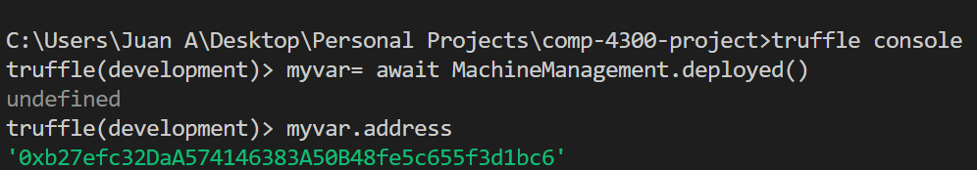

To exit type ctrl+ ‘C’ two times.

Log in into MetaMask

