**Web Technologies Basics**

**Concepts**

HTML Basics

Telerik Software Academy

<https://telerikacademy.com>

**Table of Contents**

* [Web Sites and Web Applications](https://github.com/TelerikAcademy/HTML/tree/master/Topics/01.%20Web-Basics#/web)
* [Web Browsers](https://github.com/TelerikAcademy/HTML/tree/master/Topics/01.%20Web-Basics#/browsers)
* [Hardware Servers](https://github.com/TelerikAcademy/HTML/tree/master/Topics/01.%20Web-Basics#/hardwareserver)
* [Web Servers](https://github.com/TelerikAcademy/HTML/tree/master/Topics/01.%20Web-Basics#/webserver)
* [Client-Server Architecture](https://github.com/TelerikAcademy/HTML/tree/master/Topics/01.%20Web-Basics#/clientserver)
* [Cloud](https://github.com/TelerikAcademy/HTML/tree/master/Topics/01.%20Web-Basics#/cloud)

**Web Page**

* Web Pages
  + Are **documents** or **information resources** that are suitable for the World Wide Web
  + Can be accessed through a **web browser** and displayed on a monitor or a mobile device
  + This information is usually in HTML or XHTML format, and may provide navigation to other web pages via **hypertext links**
  + Web pages frequently refer to other resources such as **style sheets** (CSS), **scripts** (JavaScript) and **images** into their final presentation

**Web Site**

* Web Sites
  + Are **collections** of related web pages containing web resources (web pages, images, videos, CSS files, JS files or other digital assets)
  + Have **common navigation** between web pages
  + Are **hosted** on at least one **web server**
  + Are accessible via a network (such as the Internet)
* **All publicly accessible websites** collectively constitute the **World Wide Web**

**Web Application**

* Web Application
  + Next level web sites
  + High interactivity
  + High accessibility (Cloud)
  + AJAX, Silverlight, Flash, Flex, etc.
  + Applications are usually broken into logical chunks called "tiers", where every tier is assigned a role
  + Desktop-like application in the web browser

**Web Browsers**

* A Web browser is a program designed to enable users to **access**, **retrieve** and **view** documents and other resources from the Web
* Main responsibilities:
  + **Bring** information resources to the user (issuing requests to the web server and handling any results generated by the request)
  + **Present** web content (render HTML, CSS, JS)
  + **Capable of executing** applications within the same context as the document on view (Flash)

**Layout Engines**

* Layout Engines are software components that **displays the formatted content** on the screen combining:
  + Marked up content (such as HTML, XML, image files, etc.)
  + Formatting information (such as CSS, XSL, etc.)
* It "paints" on the content area of a window, which is displayed on a monitor or a printer
* Typically embedded in web browsers, e-mail clients, on-line help systems or other applications that require the displaying (and editing) of web content
* The layout engine is the "heart of a browser"

**Layout Engines and Web Browsers**

* **Trident**-based
  + Internet Explorer, Netscape, Maxthon, etc.
* **Gecko**-based
  + Firefox, Netscape, SeaMonkey, etc.
* **Blink**-based
  + Chrome, Opera
* **WebKit**-based
  + Safari, iOS, Maxthon, Chrome (up to v27), etc.
* **EdgeHTML** (fork of Trident)
  + Microsoft Edge

**User Agent Strings**

* Identify web browsers and their version
  + History of (in)compatibility attempts
* Can have some additional information like layout engine, user's operating system, etc...

Mozilla/5.0 (Windows NT 6.3; WOW64) AppleWebKit/537.36 (KHTML, like Gecko) Chrome/41.0.2272.118 Safari/537.36

* **Mozilla/5.0** – a generic term which most modern browsers use (originally indicated Netscape)
* **Windows NT 6.3** – Windows 8.1
* **WOW64** – Windows-On-Windows 64-bit
* **AppleWebKit/537.36** – Blink is a fork of WebKit
  + KHTML is the previous name of WebKit
* **Chrome/41.0.2272.118** – real browser version
* **Safari/537.36** – artifact against scripts sniffing

**Hardware Servers**

* A hardware server is a **physical computer** dedicated to running one or more such services
* Servers are placed in colocation centers
  + Colocation facilities provide space, power, cooling, and physical security for the server
* The server may be:
  + Database server
  + File server
  + Mail server
  + Print server
  + VPS servers

**What Do the Web Servers Do?**

* All physical servers have hardware
* The hardware is controlled by the operating system
* **Web servers** are software products that use the operating system to **handle web requests**
  + Web servers **serve Web content**
* These requests are redirected to other software products (ASP.NET, PHP, etc.), depending on the web server settings

**Web Servers Market Share October 2015**

* Market share of the top million busiest sites
  + **Apache**
    - 47.18% (469,050)
  + **nginx**
    - 23.36% (236,650)
  + **IIS** (by Microsoft)
    - 11.64% (116,321)
  + **GWS** (by Google)
    - 2.25% (22,304)
* [Source](http://news.netcraft.com/archives/2015/10/16/october-2015-web-server-survey.html)

**Client-Server Architecture**

* The client-server model consists of:
  + A **server**
    - A single machine or cluster of machines that provides web applications (or services) to multiple clients
    - *Examples*:
      * Web server running PHP scripts or ASP.NET pages
      * IIS-based Web server
      * WCF-based service
      * Services in the cloud

**Client-Server Architecture**

* The client-server model consists of:
  + **Clients**
    - Software applications that provide UI (front-end) to access the services at the server
    - *Examples*:
      * Web browsers
      * Desktop applications
      * HTML5 applications
      * Silverlight applications
      * ASP.NET consuming services

**The Client-Server Model**

[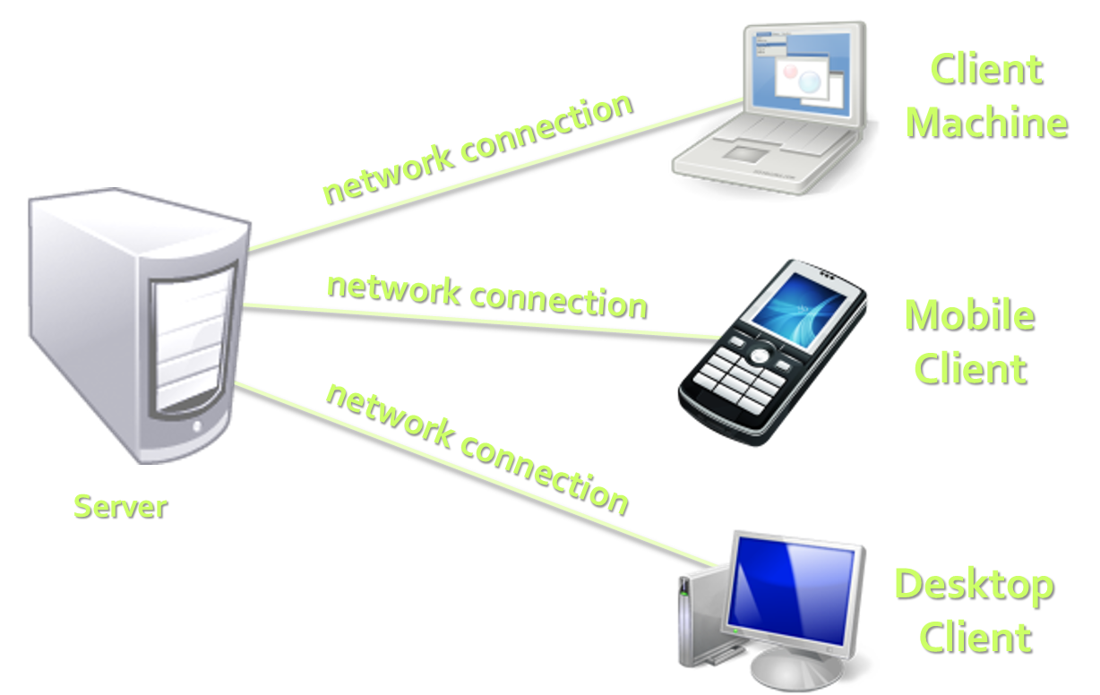](https://github.com/TelerikAcademy/HTML/blob/master/Topics/01.%20Web-Basics/imgs/client-server.png)

**Client-Server Model: *Examples***

* Web server (Apache, IIS) – Web browser
* FTP server (ftpd) – FTP client (FileZilla)
* EMail server (qmail) – email client (Outlook)
* SQL Server – SQL Server Management Studio
* BitTorrent Tracker – Torrent client (μTorrent)
* DNS server (bind) – DNS client (resolver)
* DHCP server (wireless router firmware) – DHCP client (mobile phone /Android DHCP client/)
* SMB server (Windows) – SMB client (Windows)

**What is Cloud?**

* **Cloud** ≈ multiple hardware machines combine their computing power and resources
  + Share them between multiple applications
  + To save costs and use resources more efficiently
* **Public clouds**
  + Provide computing resources on demand
    - Publicly in Internet
    - Paid or free of charge (to some limit)
  + Amazon AWS, Google App Engine, Microsoft Azure, Rackspace, PHPFog, Heroku, AppHarbor

**Cloud Computing Models**

* **Infrastructure as a Service (IaaS)**
  + Virtual machines in the cloud on demand
  + Users install the OS and software they need
* **Platform as a Service (PaaS)**
  + Platform, services and APIs for developers
  + E.g. Java + JBoss + JSF + JPA + MongoDB or JavaScript + Node.js + MongoDB + RabbitMQ
* **Software as a Service (SaaS)**
  + Hosted application on demand (e.g. WordPress)