Minesweeper Control System
Control System Overview
The Minesweeper Robot employs a closed-loop motion control system designed to provide accurate speed regulation, stable trajectory tracking, and reliable localization during operation on rough and uneven terrain. The control architecture combines a Raspberry Pi 4 running ROS 2, a Cytron motor driver, two incremental rotary optical encoders, and an MPU6050 inertial measurement unit (IMU).
Motion commands generated by ROS 2 are translated into PWM and direction signals that drive the robot's DC motors through the Cytron motor driver. Feedback from the wheel encoders and IMU is continuously processed to regulate motor speed, estimate robot position, and compensate for wheel slip.
The robot operates in environments such as sand, gravel, and grass, where wheel slippage can significantly degrade odometry accuracy. To address this challenge, encoder-based feedback is combined with IMU measurements to detect slipping conditions and improve localization performance.
Control Objectives
The motion control system was designed to achieve the following objectives:
- Maintain the desired wheel speed accurately.
- Ensure stable straight-line motion.
- Minimize localization errors caused by wheel slip.
- Improve autonomous navigation performance.
- Enhance odometry accuracy through sensor fusion.
Hardware Components
Component | Function
Raspberry Pi 4 | Executes ROS 2 control algorithms
Cytron Motor Driver | Drives the DC motors using PWM signals
MPU6050 IMU | Measures angular velocity, acceleration, and robot orientation
Encoder 1 (ENC1) | Left wheel speed and position feedback
Encoder 2 (ENC2) | Right wheel speed and position feedback
Incremental Rotary Encoder (600 PPR) | Provides wheel motion feedback for closed-loop control

PID Speed Control
Each drive motor is regulated using a Proportional–Integral–Derivative (PID) controller. The controller continuously compares the desired wheel velocity with the actual velocity measured by the optical encoder.
The speed error is calculated as:
$$e\left(t\right)=v_{ref}-v_{measured}$$
where:
- $\left(v_{ref}\right)$is the desired wheel velocity.
- $\left(v_{measured}\right)$ is the velocity measured by the encoder.
The PID controller computes the motor control signal according to:
$$u\left(t\right)=K_{p}e\left(t\right)+K_{i}\int{e}\left(t\right)dt+K_{d}\frac{de\left(t\right)}{dt}$$
where:
- $\left(K_{p}\right)$is the proportional gain.
- $\left(K_{i}\right)$is the integral gain.
- $\left(K_{d}\right)$is the derivative gain.
The resulting control signal is converted into a PWM command and transmitted to the Cytron motor driver through the motor control interface.
Advantages of PID Control
- Accurate speed regulation.
- Smooth acceleration and deceleration.
- Compensation for varying terrain resistance.
- Improved path-following performance.
- Increased stability during autonomous navigation.
Optical Encoder Feedback
The robot utilizes two incremental rotary encoders connected through:
- ENC1 (J30)
- ENC2 (J31)
Each encoder provides quadrature A and B phase outputs that allow measurement of:
- Wheel rotational speed.
- Rotation direction.
- Travel distance.
The installed encoders have a resolution of 600 pulses per revolution (PPR).
Wheel velocity is calculated using:
$$v=\frac{2πr×ΔCount}{600×Δt}$$
where:
- (r) is the wheel radius.
- 600 is the encoder resolution in pulses per revolution.
- $\left(ΔCount\right)$is the number of pulses detected during the sampling period.
- $\left(Δt\right)$is the sampling interval.
Encoder measurements provide the primary feedback signal for the PID speed controller and odometry estimation.

Wheel Slip Detection Using the MPU6050
Problem Statement
The robot is designed to operate on loose and irregular terrain. Under such conditions, wheel slip may occur, causing discrepancies between wheel rotation and actual vehicle movement.
During wheel slip:
- Encoders indicate wheel movement.
- Actual robot displacement is smaller than predicted.
- Odometry accuracy deteriorates.
- Localization and mine-mapping errors increase.
MPU6050-Based Slip Detection
The MPU6050 provides:
- Three-axis angular velocity measurements.
- Three-axis acceleration measurements.
- Robot heading estimation (yaw).
The controller continuously compares:
- Motion estimated from wheel encoders.
- Motion inferred from IMU measurements.
Slip is detected whenever:
$$\left|v_{encoder}-v_{imu}\right|>Threshold$$
or when the heading estimated from encoder odometry deviates significantly from the heading measured by the IMU.
This comparison enables real-time identification of slipping conditions.
Slip Compensation Strategy
When wheel slip is detected, the controller performs the following corrective actions:
- Reduces the motor PWM command.
- Dynamically adjusts PID control outputs.
- Increases reliance on IMU-based heading correction.
- Updates odometry using fused sensor data.
To maintain straight-line motion, the heading error is calculated as:
$$e_{yaw}=Yaw_{target}-Yaw_{imu}$$
A secondary PID controller generates a yaw correction signal:
$$u_{yaw}=K_{py}e_{yaw}+K_{iy}\int{e_{yaw}}dt+K_{dy}\frac{de_{yaw}}{dt}$$
The correction is applied differentially to the wheel motors:
$$PWM_{left}=PWM_{base}+u_{yaw} \\ PWM_{right}=PWM_{base}-u_{yaw}$$
This strategy enables the robot to maintain its intended heading even when one side experiences reduced traction.
Encoder–IMU Sensor Fusion
To improve localization accuracy, encoder odometry is combined with MPU6050 measurements through a sensor fusion process.
Fusion Inputs
- Encoder position estimates.
- Encoder velocity measurements.
- IMU acceleration data.
- IMU angular velocity data.
Fusion Outputs
- Robot position ((x,y))
- Linear velocity
- Robot orientation $\left(\left(θ\right)\right)$
Benefits of Sensor Fusion
- Reduced encoder drift.
- Detection and mitigation of wheel-slip effects.
- Improved heading estimation.
- Enhanced localization accuracy.
- More reliable autonomous navigation and mine mapping.
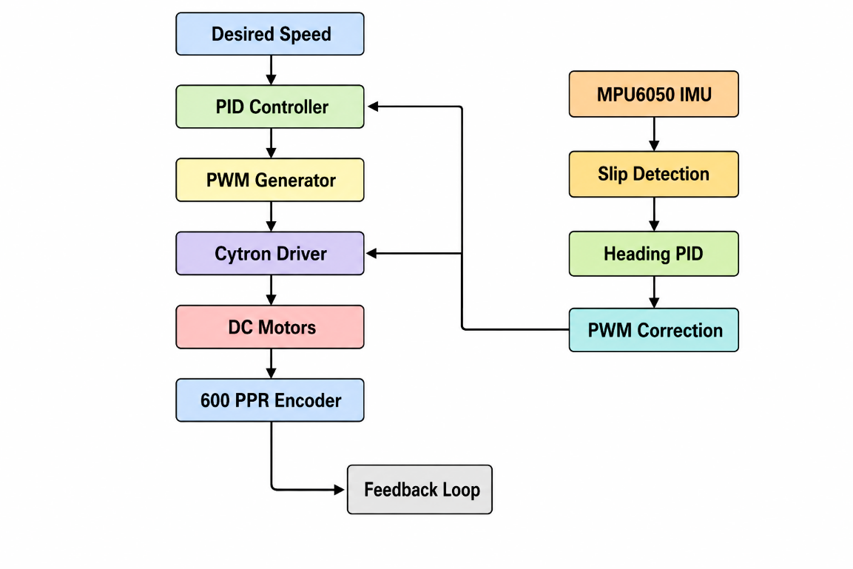
Control System Block Diagram

Expected Performance
By integrating PID speed control with encoder feedback and MPU6050-based slip detection, the Minesweeper Robot achieves accurate wheel speed regulation, stable heading control, and improved localization accuracy. The combination of encoder odometry and IMU measurements significantly reduces navigation errors caused by wheel slip, resulting in more reliable autonomous operation and more accurate minefield mapping.

