Computer vision assignment 3: intermediary images

Rectangles

Arnold
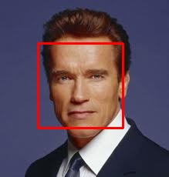
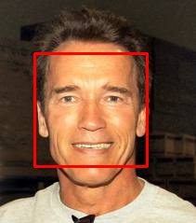
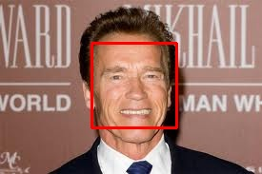
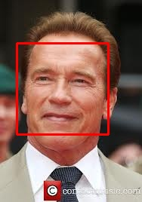
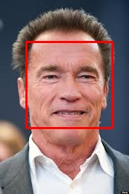
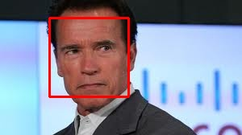
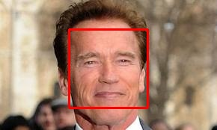
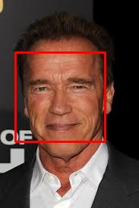

Barack
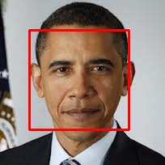
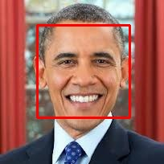
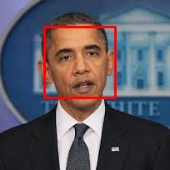
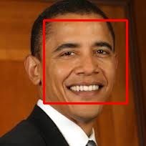
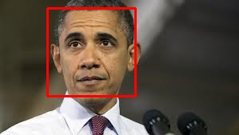
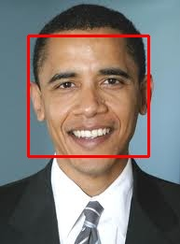
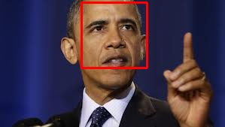
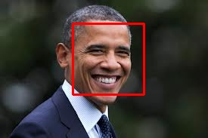
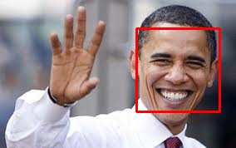

Models

Arnold
Mean

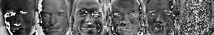
Eigenvectors

Barack
Mean

Eigenvectors
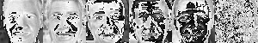

Reconstructions

Arnold
model_arnold

Reconstruction MSE for arnold images using model_arnold: [ 495.6 909.1]
model_barack

Reconstruction MSE for arnold images using model_barack: [ 1324.9 1103.2]
Classification: [('arnold', 495.6), ('arnold', 909.1)]

Barack
model_arnold

Reconstruction MSE for barack images using model_arnold: [ 1318.8 2282.6 1824.5 1721.5]
model_barack

Reconstruction MSE for barack images using model_barack: [ 877.6 1940.4 1584.6 706.6]
Classification: [('barack', 877.6), ('barack', 1940.4), ('barack', 1584.6), ('barack', 706.6)]

