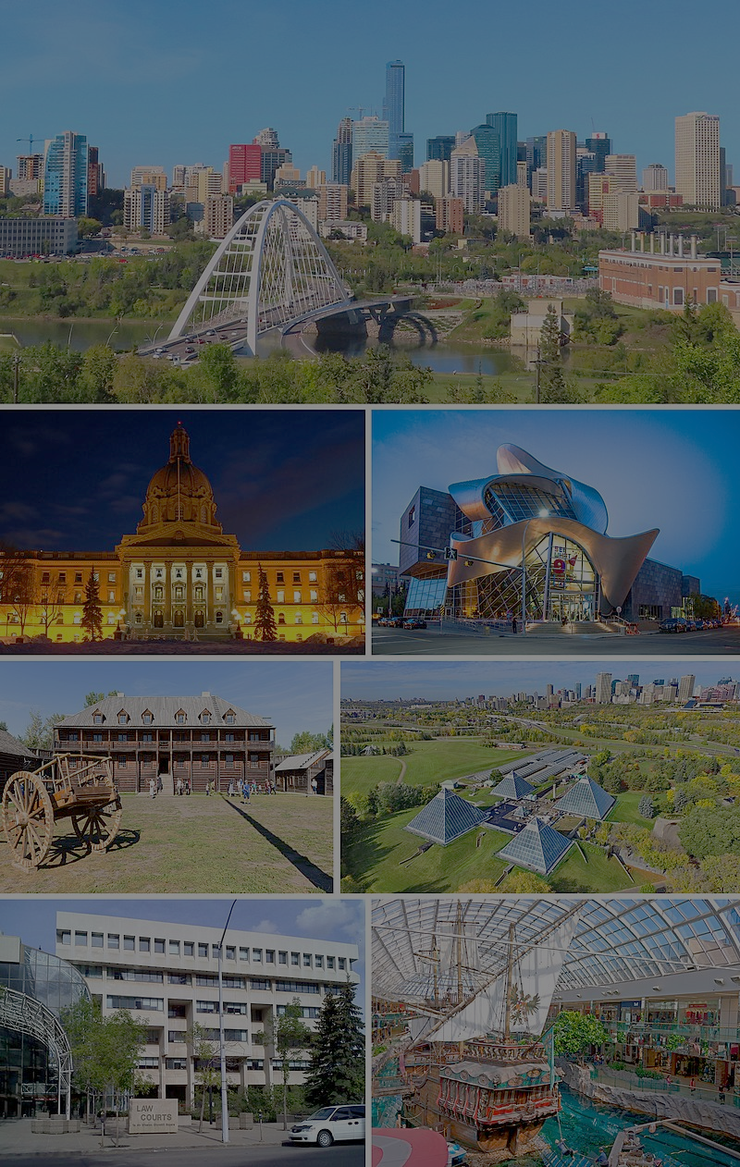**The Battle of Neighborhoods: Edmonton's Best Neighborhood**

**By Armin Norouzi**

**Abstract:**

In this project, first, the investigation on Alberta Capital city has been done to determine which neighborhood has the best neighborhood to live in. To analyze this, Data from Wikipedia has been used to generate Edmonton Neibhouds location information. Then, Foursquare API is employed to create a venue nearby each location. In the end, three more desirable neighborhoods based on the number of venue prospects have been identified.

1. **Introduction:**

Edmonton is the capital city of the Canadian province of Alberta. Edmonton is on the North Saskatchewan River and is the center of the Edmonton Metropolitan Region, surrounded by Alberta's central region. The city anchors the north end of what Statistics Canada defines as the "Calgary–Edmonton Corridor."

Edmonton's metro area had a population of 1,491,000 at the beginning of 2021, making it Alberta's second-largest city (after Calgary) and Canada's fifth-largest municipality. Edmonton's 2019 municipal census subsequently recorded a population of 972,223. In 2016, Edmonton had a metropolitan population of 1,321,426, making it the sixth-largest census metropolitan area (CMA) in Canada. Edmonton is North America's northernmost metro area with a population of over one million. A resident of Edmonton is known as an Edmontonian.

Edmonton's historic growth has been facilitated through the absorption of five adjacent urban municipalities (Strathcona, North Edmonton, West Edmonton, Beverly, and Jasper Place) in addition to a series of annexations through 1982 and the annexation of 8,260 ha (82.6 km2) of land from Leduc County and the City of Beaumont on January 1, 2019. Known as the "Gateway to the North," [18] the city is a staging point for large-scale oil sand projects in northern Alberta and large-scale diamond mining operations in the Northwest Territories.

Edmonton is a cultural, governmental, and educational center. It hosts a year-round slate of festivals, reflected in the nickname "Canada's Festival City." It is home to North America's largest mall, West Edmonton Mall (the world's largest mall from 1981 until 2004), and Fort Edmonton Park, Canada's largest living history museum.

The primary purpose of this project is to help people in exploring better facilities around their neighborhood. It will help people making wise and efficient decisions on selecting significant areas out of numbers of other neighborhoods in Edmonton, Alberta.

This project aims to analyze features for people migrating to Edmonton to search the best neighborhood as a comparative analysis between neighborhoods. The features include median housing price and better school according to ratings, crime rates of that particular area, road connectivity, weather conditions, good management for an emergency, water resources both fresh and wastewater, and excrement conveyed in sewers and recreational facilities.

It will help people to get the awareness of the area and neighborhood before moving to a new city, state, country, or place for their work or to start a new fresh life.