**Testing muncipaly_v2 mobile app (1.0.13 version)**

**OS version:Android 9**

* Application is successfully installed from apk. File/ PASS
* Application is successfully started(default started tab Vijesti) / PASS
* Testing tab Vijesti
  + Click on some notification opens the same one/PASS
  + Click on return button successfully returns from notifications to tab Vijesti/ PASS
  + Tab scroll allows you to load new news and display the **Učitaj više** button/ PASS
  + Click on the **Učitaj više** button loads older published notifications / PASS
  + Click on the **Pozive za hitne slučajeve** button opens list of emergency numbers/PASS
  + Click on the **Pozivi za hitne slučajeve** button while list of emergency numbers is opened closes list of emergency numbers/ PASS
  + Loading of emergency numbers icons/ **FAIL**

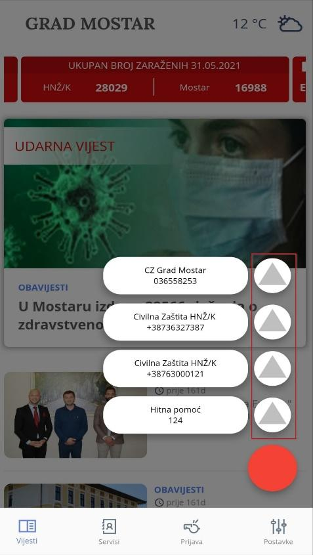

Icons should look like on the picture below

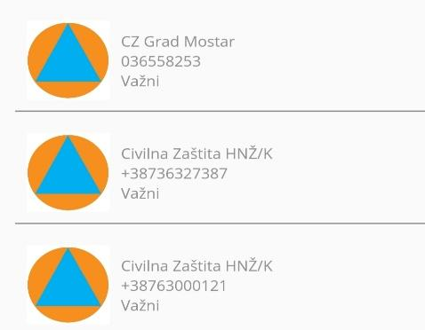

* Testing tab **Servisi**
  + Testing tab **Sve**
    - Click on tab Servisi opens list of all services of the city of Mostar/ PASS
    - Scroll of the page **Sve** allows showing other services that are not loaded/ PASS
    - Click on a service opens the given service/ PASS
    - Click on a service opens the given service and loads all elements of the page/ **FAIL**

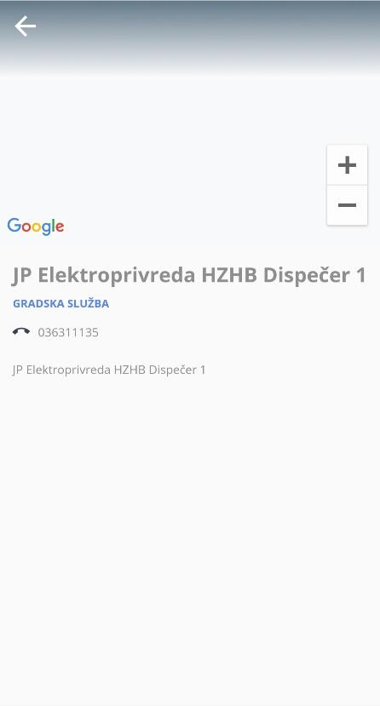

* + - Google maps location not loaded
    - Click on return button closes the given service and returns to the **Sve** tab/ PASS
  + Testing tab **Gradska služba**
    - Click on the **Gradska služba** tab opens a list of **Gradska služba** services/ PASS
    - Click on any service opens that service/ PASS
    - Click on service opens the given service and loads all elements of the page/ **FAIL**
    - Google maps location not loaded (note: some services have a map added and some haven’t)
  + Testing tab **Važni**
    - Click on tab **Važni** opens the list of important contacts of the city of Mostar/ PASS
    - Click on any service opens that service/ PASS
    - Click on a service opens the given service and loads all elements of the page/ **FAIL**
    - Google maps location not loaded (note: some services have a map added and some haven’t)
  + Testing tab **Zdravstveni djelatnici**
    - Click on tab **Zdravstveni djelatnici** opens the list of Health Professionals of the City of Mostar/ PASS
    - Scroll the page **Zdravstveni radnici** allows you to display other services that are not loaded/ PASS
    - Click on any service opens that service/ PASS
    - Click on a service opens the given service and loads all elements of the page/ **FAIL**
    - Google maps location not loaded (note: some services have a map added and some haven’t)
* Search Bar testing
  + Click on Search bar icon opens Search bar/ PASS
  + Entering search data in the Search bar displays a list of required data/ PASS
  + Click on the requested data opens the given service/ **FAIL**  
    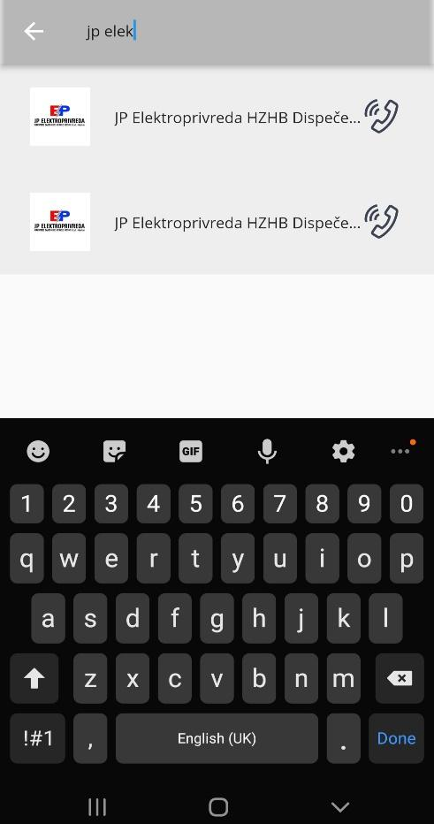
  + Click the return button returns you to the list of all services/ **FAIL**
    - The page is blank

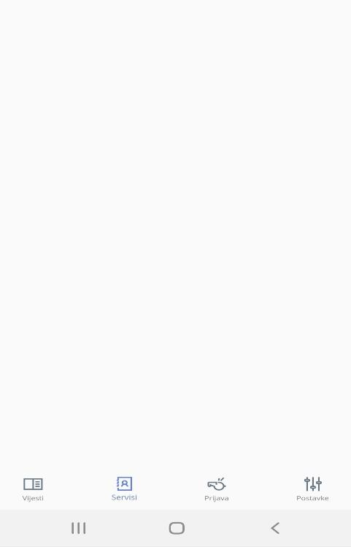

* Testing tab **Prijava**
  + Click on tab **Prijava** opens Google map with the displayed location/ PASS
  + Click on button **Prijava** opens page for reporting/ PASS
    - Click on the Galerija button allows you to upload pictures from your mobile phone/ PASS
    - Click on Pošalji button displays an error message box(Polje obavezno) for entering text/ PASS
    - Click on Pošalji button after the text has been entered in the report field, and after the image has been successfully uploaded/ PASS
    - Click on the button to delete the uploaded image after successfully submitting the report throws out the msg box on successful login/ **FAIL**

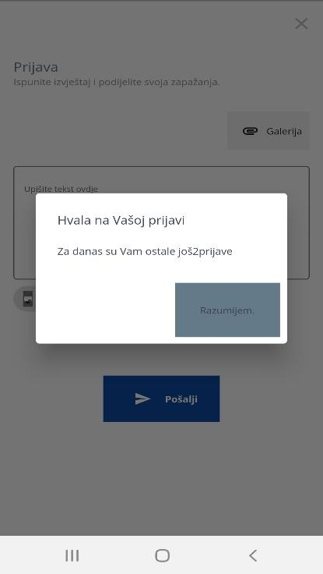

* + - Click on Povijest prijave button opens a page with a list of login history/ PASS

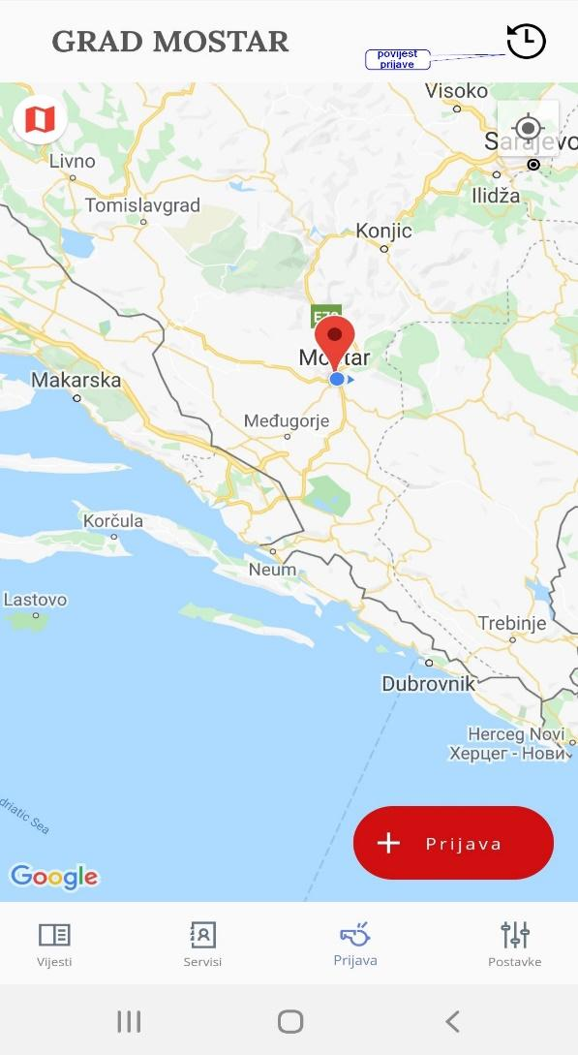

* + - Click on an application opens the application and displays information about that application/ PASS
    - Content error> Date should be capitalized

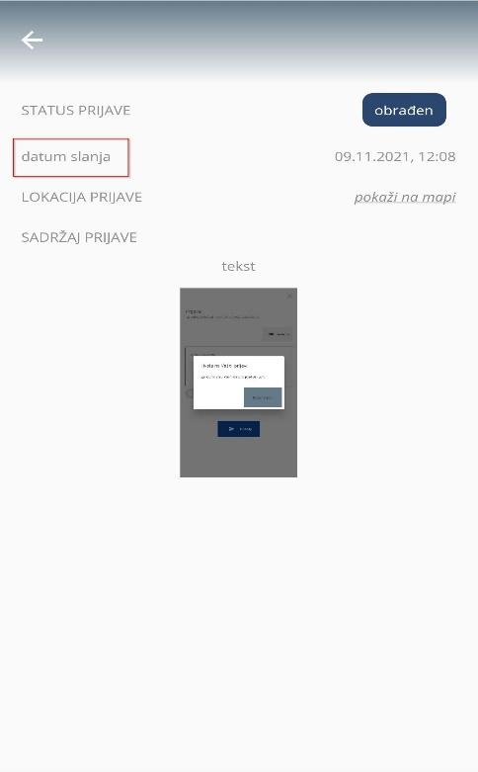

* + - Click to close the open application/ PASS
    - Click to close Login History/ PASS
* Testing tab **Postavke**
  + Click on tab **Postavke** opens application settings/ PASS
  + Click on Login via Facebook button opens a popup to continue logging in via Facebook/ PASS
  + Click on Continue as User/ **FAIL**
    - The login dialog just closes, no response message
  + Click on button Tamni način switches the app to dark mode/ PASS
  + Click on button Dozvoli obavijesti/PASS
  + Click on Pristup lokaciji button is disabled even though access is allowed when the application is started/ **FAIL**
  + Exiting from the app and restart leaves the buttons for Tamni način, Pristup lokaciji , Dozvoli obavještenja enabled / **FAIL**
    - The app turns off the buttons above
  + Click on button Jezik opens a menu of offered languages/ PASS
    - Click on one of the offered languages translates the application into selected language/ PASS