**Testing the site eduplate.at**

* Open page (page opened successfully) /PASS
* Clicking on the edu plate logo leads to the homepage / PASS
* Clicking on Home leads to the homepage / PASS
* Page scroll successfully loads every part of the page / PASS
* Clicking on the select button in the "Anstehende Kurse" section opens the list of offered courses/ PASS
* Click on a course from the list of offered courses filters the courses / PASS
  + Click on the "Filter loschen" button deletes the selected filters/ PASS
* Click on any course opens a page to purchase that course/PASS
  + The page scroll bar displays the modal to purchase the selected course / PASS
  + Click on "Buchen" adds the course to the shopping cart
* Click on "Bewertungen" to display the review form / PASS
  + Clicking on "Senden" without entering data in the form displays the alert "Bitte wähle eine Bewertung"/PASS
  + Click on "Senden" with a marked rating displays a message box for mandatory review / PASS (example as in the picture below) / PASS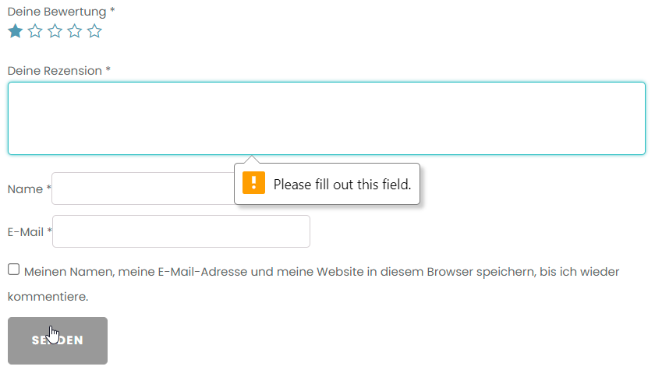
  + Click on "Senden" with the marked mark and the entered review shows the message box for the mandatory entry of names / PASS (example as in the picture below) /PASS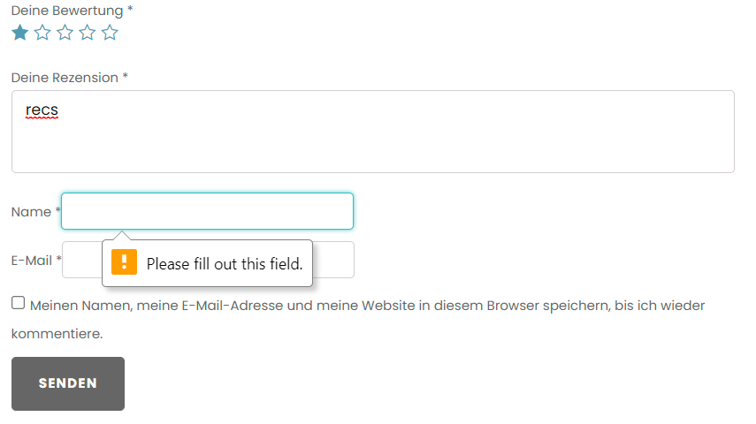
  + Click on "Senden" with marked rating and entered review and entered name and email successfully saves the entered review/ PASS
* Click on a link in the "Zukunftige Termine" list opens the course in a new page/PASS
  + Hover changes "E200 to Buchen" on a course (note: slow transition)/PASS
  + Click the "Senden sie uns ihre anfrage" button opens the request page/PASS
    - Click on the "Senden" button on a blank form displays a message box for mandatory entry of certain fields (example as in the picture below)/PASS 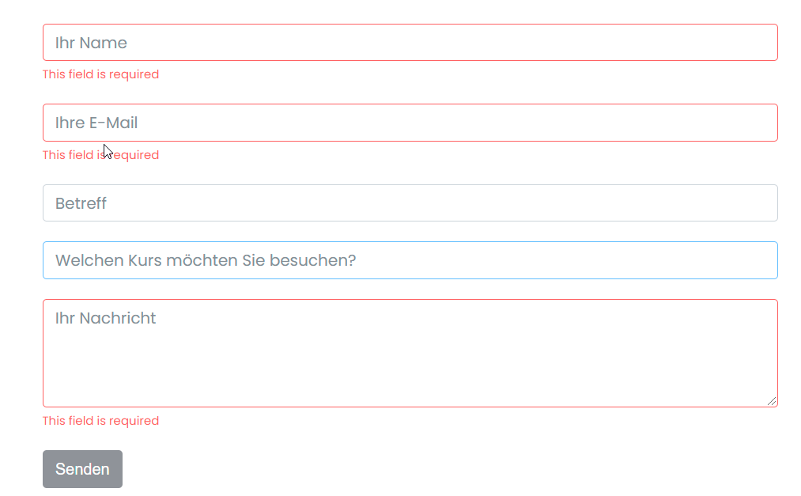

**Note**:Messages should be translated into German

* + - Click on "Senden" with all the entered data successfully sends the request/PASS
    - Resize textarea in application form/FAIL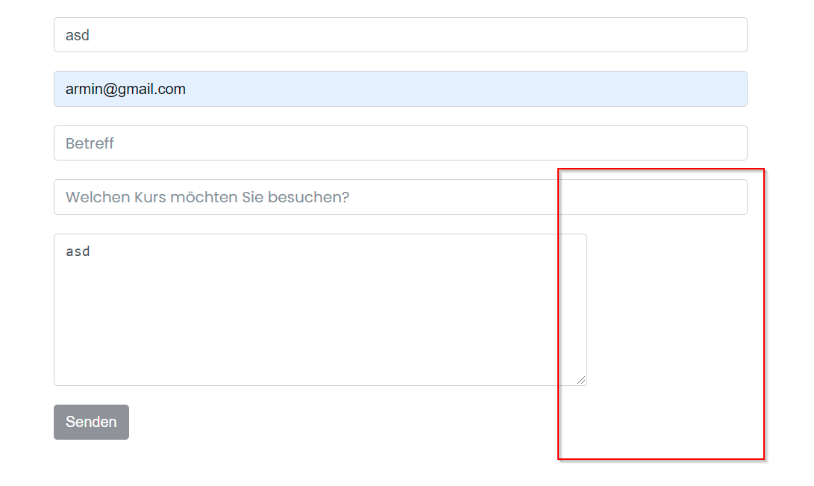
      * The textarea field should be a fixed size
* **Testing the footer section on Homepage**
  + Click on the facebook icon opens the facebook eduplate page (the link actually leads to the homepage)/FAIL
  + Click on the instagram icon opens the instagram eduplate page (the link actually leads to the homepage)/FAIL
  + Click on the twitter icon opens the twitter page eduplate (the link actually leads to the homepage)/FAIL
  + Click on the yoututbe icon opens the edutbe yoututbe page (the link actually leads to the homepage)/FAIL
  + Click on "Home" opens the Homepage/FAIL
    - Click leads to <https://officelernen.ito.dev/login_up.php?success_redirect_url=%2F>
  + Click on Kursangebot opens the Kursangebot / PASS page
  + Click on "Kursorte" opens the "Kursorte" / PASS page
  + Click "Uber uns" opens the "Uber uns" / PASS page
  + Click on "Contact" opens the "Contact" / PASS page
  + Click on "Shopping Cart" opens a module with a list of products in the shopping cart/ PASS
  + Click the "Scroll back to top" button returns the page to the top / PASS
  + Click on the "Chat" button opens the form for sending a message / PASS
    - Click on "Senden" sends a message / PASS
    - Click on the "Neue nachricht senden" button returns to entering a new message to send / PASS
    - Click the backward arrow returns to entering a new send message / PASS
    - Click on "Chat by twak.to" opens the page twak.to/PASS
    - Click the form close button closes the date / PASS
  + Click on "AGB" opens the general conditions page / PASS
  + Click on "Datenschutzerklarung" opens the data protection page / PASS
  + Click "Imprint" opens the Imprint / PASS page
* **Testing the navigation menu**
  + Hover on "Kursangebot" displays the course offer menu / PASS
  + Click on the "Powerpoint" course opens the page / PASS
    - Calendar "Zukünftige termine" content fail/FAIL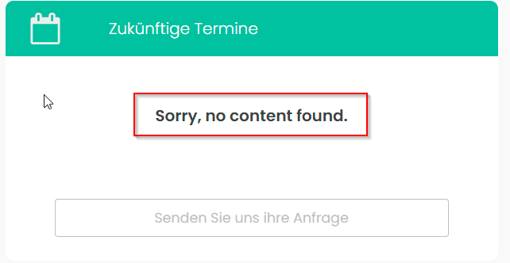
    - The message that there are currently no appointments needs to be translated into German
    - Power point specific content fail/FAIL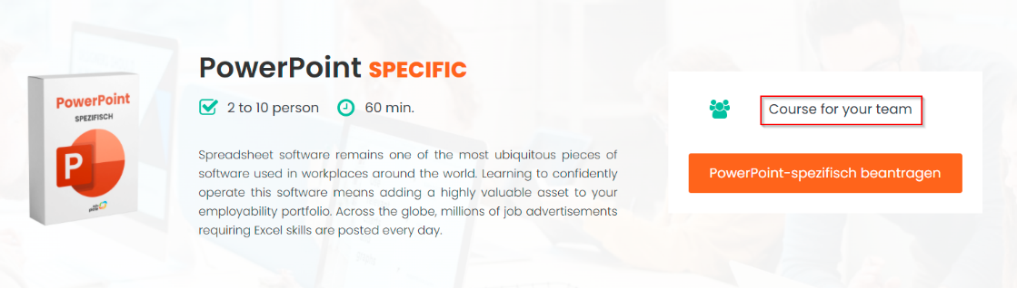
      * The message that the course offer for the team should be translated into German
    - Click on the button "PowerPoint-specific beantragen" opens the page with the form for entering the request for Powerpoint specific/PASS
  + Click on the "Excel" course opens the page/PASS
    - Excel specific content fail/FAIL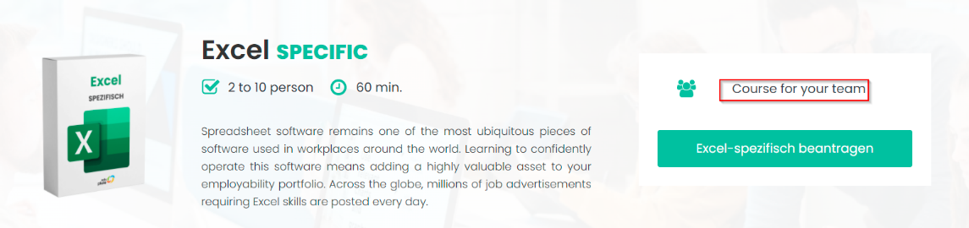
      * The message that the course offer for the team should be translated into German
      * Click on the "Excel-specific beantragen" button opens a page with a Powerpoint specific request form/PASS
  + Click on the "Word" course opens the page/PASS
    - Calendar „Zukünftige termine“ content fail/FAIL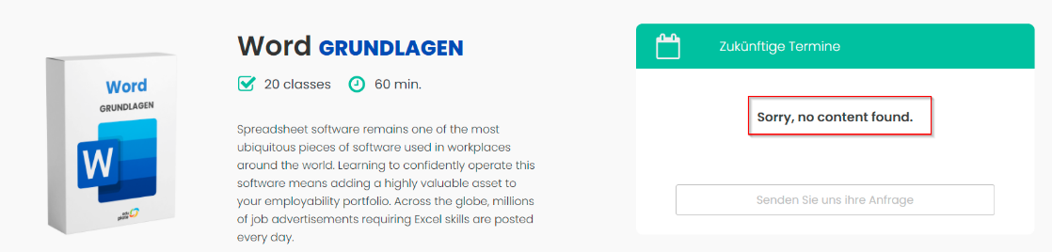
    - The message that there are currently no appointments needs to be translated into German
    - Word specific content fail/FAIL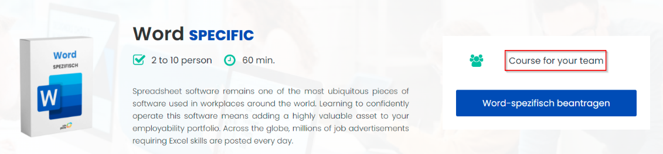
      * The message that the course offer for the team should be translated into German
    - Click on the "Word-spetifich beantragen" button opens a page with a Powerpoint specific request form/PASS
  + Click on the "Outlook" course opens the page/PASS
    - Calendar „Zukunftige termine“ content fail/FAIL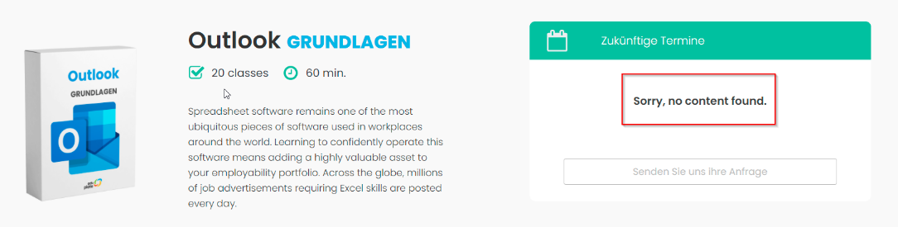
    - The message that the course offer for the team should be translated into German
    - Outlook specific content fail/FAIL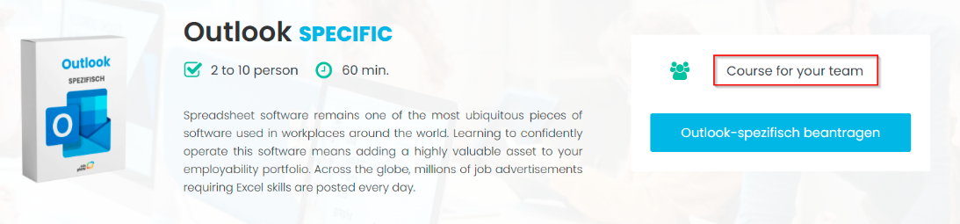
    - Click on the "Word-spetifich beantragen" button opens a page with a Powerpoint specific request form/PASS
  + Clikc on „Kursorte“ opens page Kursorte/PASS
    - Click on the addresses of the locations where the courses will be held/FAIL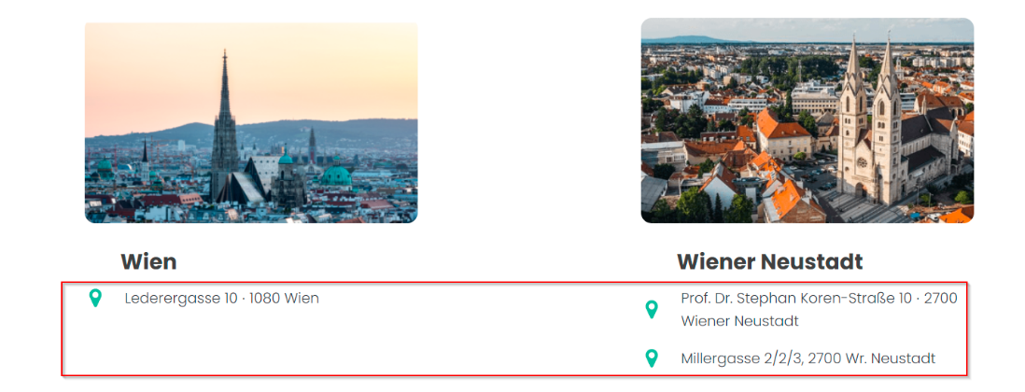
    - Click opens a blank page as in the images below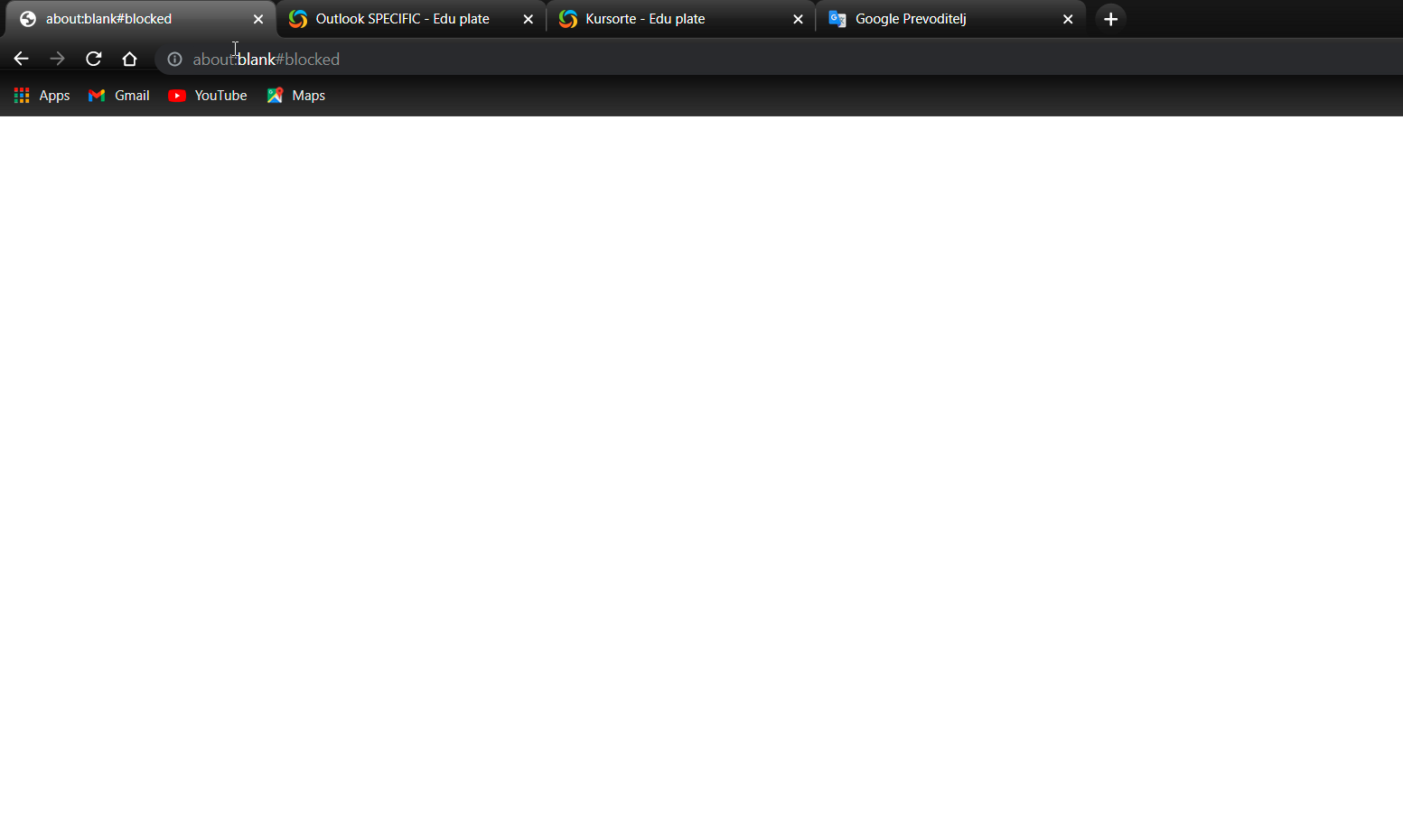
    - Google map loaded and functional/PASS
  + Click "Uber uns" opens the Uber uns page/PASS
  + Click on "Kontakt" opens the Kontakt page/PASS
    - Click on contact information/FAIL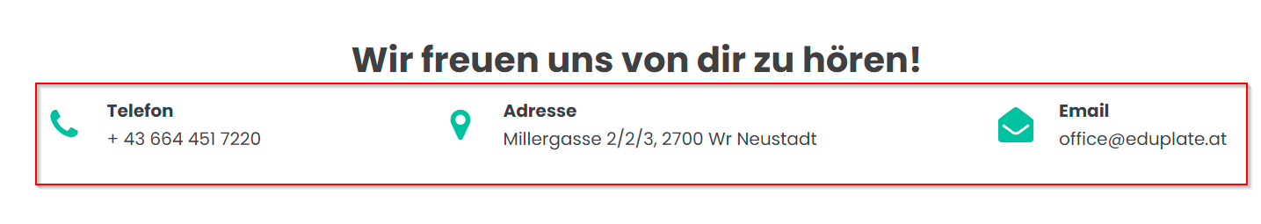
    - Click opens a blank page as in the images below
    - Contact form/FAIL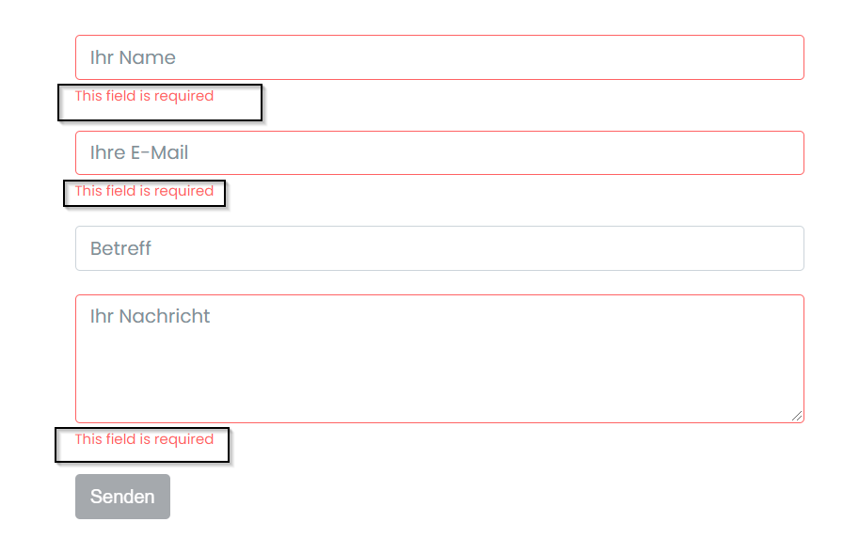
    - Required field messages need to be translated into German
    - Contact form with numbers entered in the field "Ihr name" /FAIL
      * **The name entry field needs to be validated**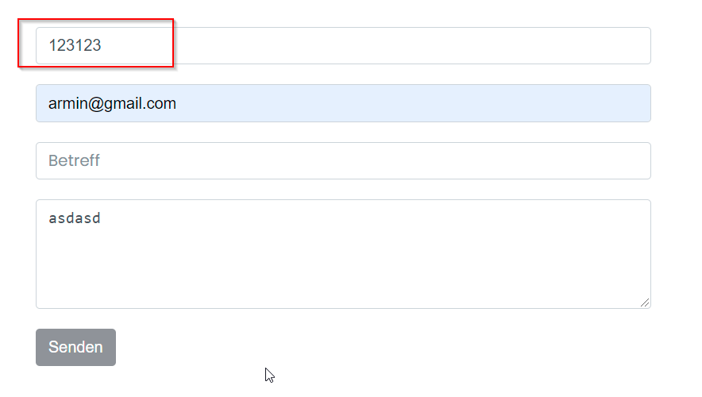
    - Successfully sent message with all required fields entered correctly/PASS
    - Resize the field "Ihr Nachricht"/FAIL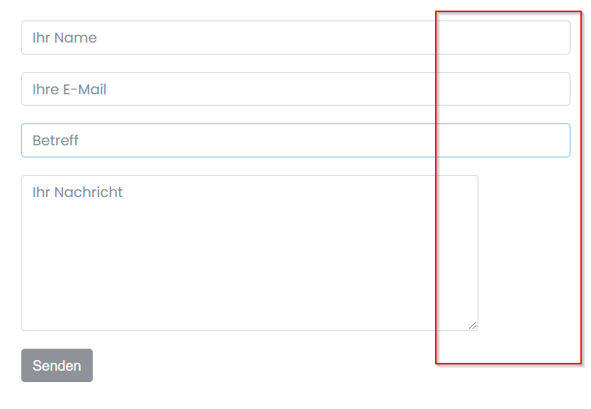
    - **Fix the message entry field**
  + Clicking on the "Login" button opens the page for entering the data needed to log in or create a new account/PASS
    - Registration form check button/FAIL
      * 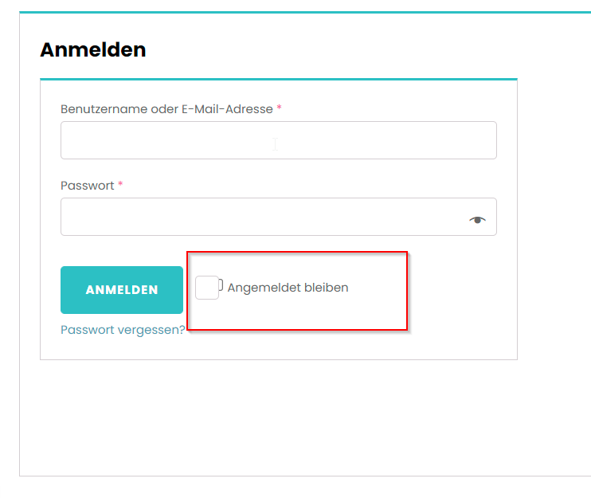
      * There should be one check button
    - Message box error for incorrectly entered username and password/FAIL
    - 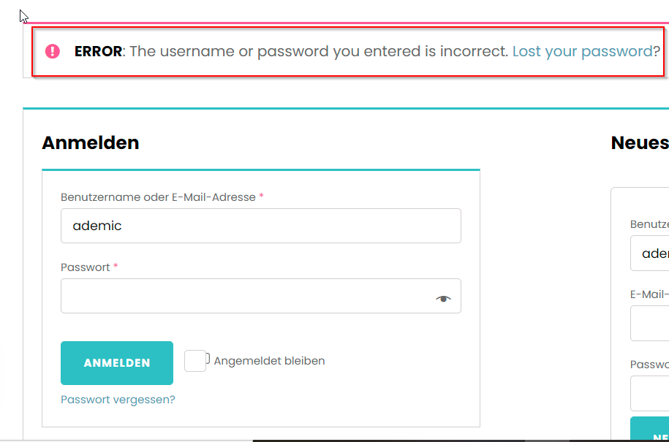
    - It should be translated into German