**Testing webpage euroll.ba**

* Open webpage / pass
  + Webpage successfully opened
  + All sections of the page are loaded
  + All links are working
  + Background video on the homepage is autostarted in background as expected, it is clickable, on the click on the “play button“ the youtube video is successfully opened
  + Checked with all language versions
* Check HR version / pass
  + Text on the webpage is localized on Croatian language
* HR version of the contact form “Kontaktirajte nas” / **fail**
  + 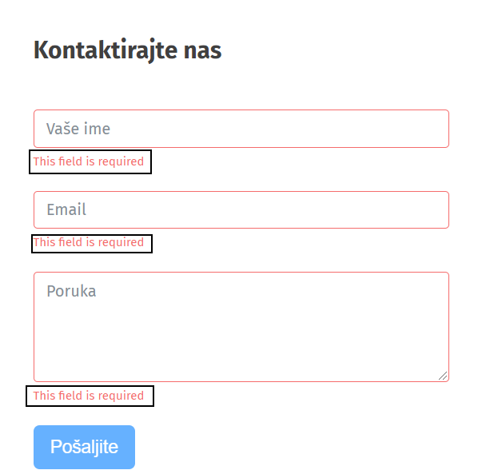
  + Message info “This field is required” should be translated to Croatian language
  + 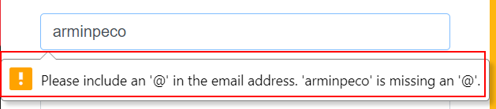
  + Message info about email form should also be translated to Croatian language
  + 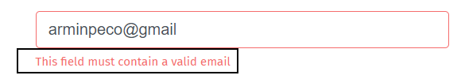
  + Also missing Croatian translate
  + 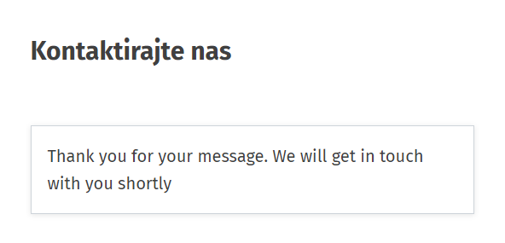
  + After successfully sent message, text is on English > it should be on Croatian
  + 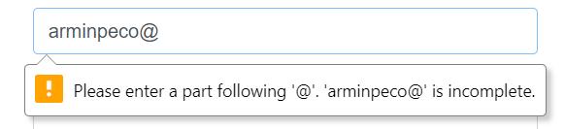
  + Missing Croatian translation
* Check EN version / pass
  + Text on the webpage is localized on English language
  + Contact form “Contact us” is translated correctly
* Check DE version / pass
  + Text on the webpage is localized on German language
* DE version of the contact form “Kontaktiere uns” / **fail**
  + 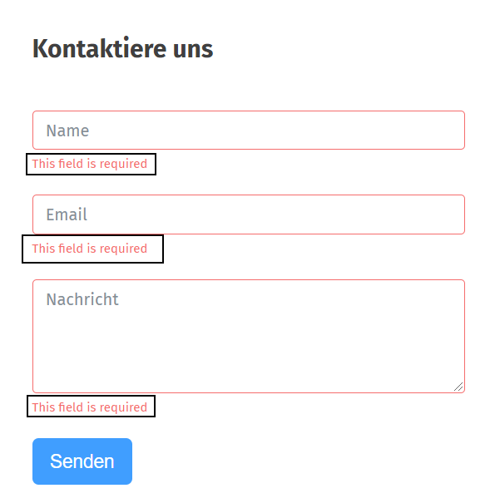
  + Message info “This field is required” should be translated to German language
  + 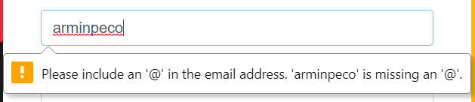
  + Message info about email form should also be translated to German language
  + 
  + Also missing German translation
* Check hovers / **fail**
  + 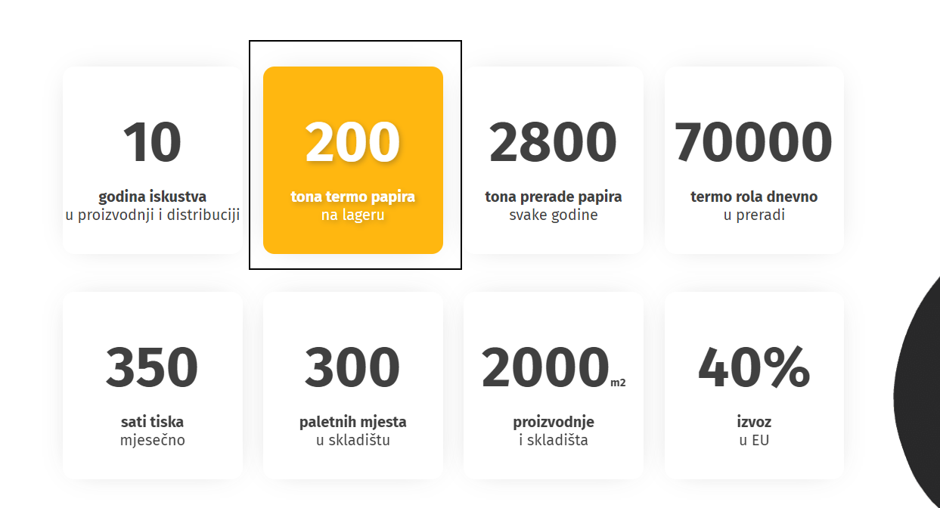
  + Move mouse cursor on the “200 tona termo papira na lager” > text “tona termo papira ” has delayed change of the color to the white
  + All other hovers have instant change of the color to the white
  + Issue is present in all language versions
* Send message via contact form / **fail**
  + Send message via contact form on German version is not working
  + Message can not be sent, nothing happens and there is not any warning or error display message
  + On HR and EN version everything works as expected, message is sent successfully
* Icons on info section / **fail**
  + There is missing icon for address, icons are present for phone and email
  + 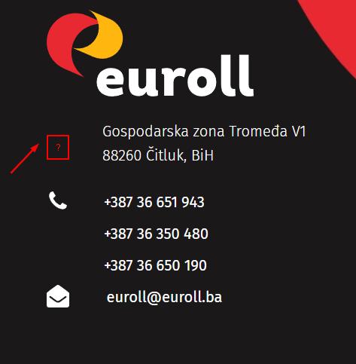
* Expand text field in “Contact us” form / **fail**
  + Expanding text field cause username and password field as well to expand out of the borders of “Contact us” form
  + 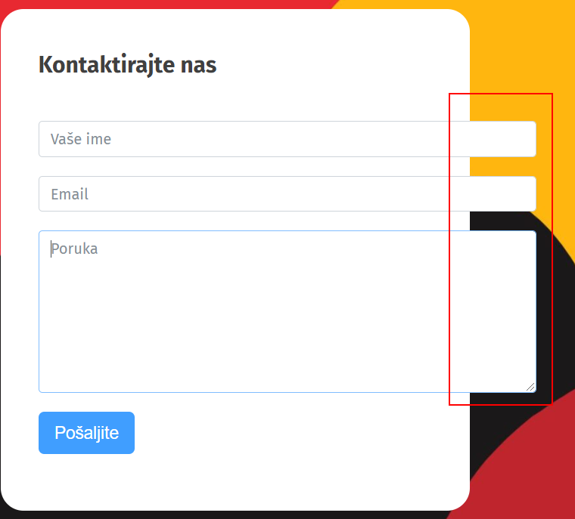
  + Also during expand, background picture is increasing as well
  + Fields should be fixed and unable to expand
  + Issue is present in German and English version as well
* Note:
  + 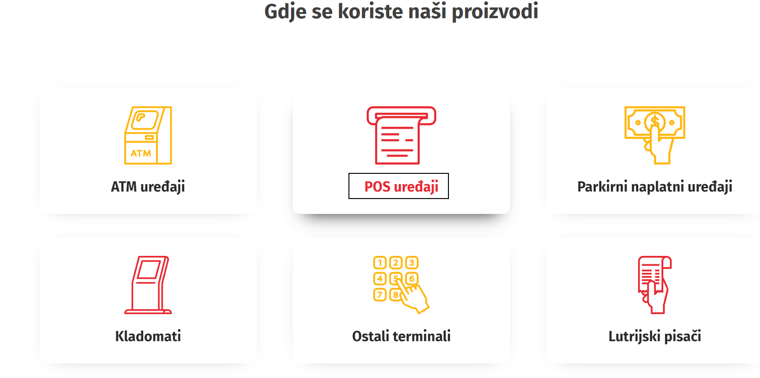
  + In this section, when mouse cursor is moved on the hover, text is in red color same as the photo
  + Consider to change text color to yellow in hovers who have red photo
  + Hovers with yellow photo have red text which is okay
  + It would looks nicer if the text is yellow with red photos