**Testing fort_net(tourist application) mobile app (1.1.10 version)**

**OS version:Android 9**

* Application is successfully installed from Google play store / PASS
* Application is successfully opened / PASS
* Click on „search bar“ opens list of all places with tourist offer/ PASS
* Click on „search“ allows to enter data for search / PASS
  + Data entry in search bar filters search / PASS
    - Click on tourist offer opens data about it / PASS
      * Click on picture opens it in full screen / PASS
      * Click on link to website opens wepage / PASS
      * Click on field „phone“ enables to call phone number / PASS
      * Click on „facebook“ field opens facebook page / PASS
      * Click on „instagram“ field opens instagram page / PASS
* Click on location enables selecting desired location / PASS
  + Click on „X“ closes „location“ page / PASS
* Click on button „Bastina“ opens page with offer for desired location / PASS
* Click on button „Bastina“ opens page with offer for desired location / PASS
* Photo gallery „Bastina“
  + Click on gallery item opens it successfully / PASS
  + Click on picture opens it in full screen / PASS
  + Click on website link opens that webpage / PASS
  + Click on „procitaj vise“ opens page with detailed information / PASS
* Testing of tab „Novosti“
  + „Novosti“ page is successfully opened / PASS
  + Click on news title opens complete news / PASS
* Testiranje taba Info
  + Info page is successfully opened / PASS
* Testing of tab „Multimedija“
  + Multimedia page is successfully opened
  + Click on „Foto galerija“ opens photo gallery / PASS
    - Scroll through gallery / FAIL
      * Scroll button appears on picture

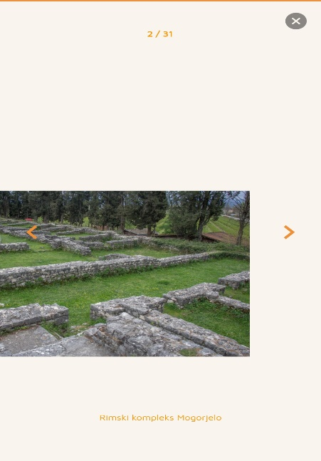

* + - Click on „X“ closes gallery / PASS

Note: Pictures are not in the same size in the gallery

* Testing of tab „Postavke“
  + Click on tab successfully opens „Postavke“ / PASS
  + Click on button „Jezik“ opens menu with languages / PASS
    - Click on language from menu translate application / PASS
  + Click on „X“ closes menu /PASS