KTH-MSE

Computational methods in materials science

Assignment: DFT

Armin Salmasi

1-Hartree potential, Blue line in the plot

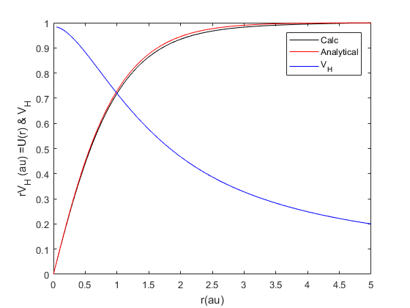

2- Comparison between simulation results with the analytical result for the ground state energy and wave function

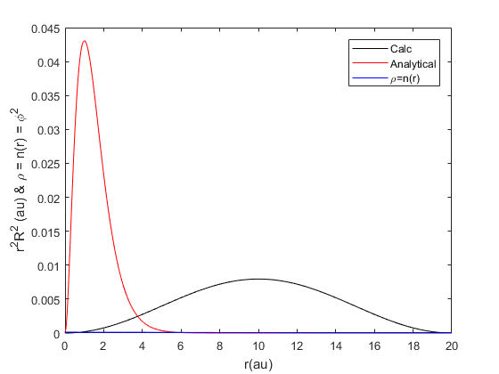

3- Initial guess was output of scrip2. Number of iterations = 22. The ground state energy and wave function are plotted. Removing the correlation and exchange terms simulation doesn’t converge (script3b)

