**Proceedings of the ASME 2019**

**Dynamic Systems and Control Conference  
DSCC2019  
October 8-11, 2019, Park City, UT, USA**

**DSCC2019-** **9153**



Input Shaping Control Of A Steer-by-Wire Vehicle For Yaw Stability

|  |  |
| --- | --- |
| Srivatsan Srinivasan, Venkat N. Krovi, Matthias J. Schmid[1]  Department of Automotive Engineering  Clemson University International Center for Automotive Research  Greenville, South Carolina 29607, USA  [srivats@g.clemson.edu](mailto:srivats@g.clemson.edu), [vkrovi@clemson.edu](mailto:vkrovi@clemson.edu), [schmidm@clemson.edu](mailto:schmidm@clemson.edu) |  |

Abstract

*There are several ways to incorporate electronic yaw stabilization into a vehicle design. Although the most popular ones are differential braking and torque distribution, a better alternative would be the inclusion of a controller into the steering process. However, this is not often pursued since in a steering system with a physical coupling between the steering wheel and the vehicle’s wheel, the controller could actually start working against the driver resulting in challenges to safety. This problem can be solved by the incorporation of a steer-by-wire system in the vehicle, which has started gaining traction due to the rapid development in autonomous and semi-autonomous vehicles. There are many steering assistance systems already in place, but most of them focus on either adaptive steering control (adaptive power steering and gear ratios) or on total steering control in autopilot functions (lane keeping control). Active safety systems can also be deployed using a steering controller, wherein based on the potential advantages of steer-by-wire (SbW), the vehicle can have an improved driving performance and maneuverability. In this paper, we introduce a new pure-feedforward (open loop) controller for the steer-by-wire system based on the concept of input shaping aimed at reducing the vibration/oscillation caused in vehicles during fast maneuvers.*

Keywords: steer-by-wire, steering control, yaw stability, input shaping, driver-assistance

1. INTRODUCTION

Vehicle yaw and rollover stability during safety-critical maneuvers while the driver is out of the loop has been a topic of interest for quite some time owing to recent advancements in advanced driver assistance systems (ADAS), semi-autonomous vehicles and autonomous vehicles [1],[2]. Traditionally, vehicle yaw stability has been achieved using either differential braking or torque distribution whereas steering control has been used only for assistive systems such as lane keep systems.



In modern vehicles, steering control is essential for several of the active safety systems such as Lane keep system, Emergency braking system, Active rollover safety system, Electronic stability control etc. In a mechanical steering system, variable time delays exist between the driver’s inputs and the responses of the vehicle dynamic states during a critical steering course. On the other hand, due to non-uniform delays in active brake actuators, a sideslip or a rollover may occur even to a vehicle with a traditional stability control system. This is one of the main reasons why drive-by-wire is a key enabling technology for autonomous vehicle development. Here, safety can be improved by providing computer-controlled intervention of vehicle controls since the steering wheel can be simply bypassed as an input device [3]. Additionally, the fast response time and increased accuracy contributes to improved maneuverability that requires small maneuvering angles.

Steer-by-wire has been the norm in aviation for decades and there has also been a growing trend in SbW vehicles in recent times. Infiniti became the first brand to bring it to market in 2014 with their Q50, which started incorporating SbW systems called as the Direct Adaptive Steering technology into their vehicles. This is a big step forward in ADAS systems as it opens a whole new market for potential development in the vehicle industry. Although it initially faced negative reviews, the revamped version released in 2017 has been widely appreciated [4]. A “Research and Markets” market survey that was published recently reported several top OEMs that are rapidly progressing towards deployment of preliminary forms of steer-by-wire vehicles [5]. This provides several new opportunities for steering controller development for vehicle safety systems. Although there are several open-ended research areas to be addressed in the SbW system’s development space [6], we have chosen to focus only on developing a new steering controller that is effective for ADAS, semi-autonomous and/or autonomous vehicles.

1. **STEERING CONTROL FOR YAW STABILITY**

The main objective of steering controller is to make up for the shortcomings in the reference inputs coming from a driver (human or a driver algorithm getting reference input from a planner). Typically, the driver has two main tasks while driving, namely- a) following the path and b) disturbance attenuation (yaw control). Since the driver usually does not have a good measure of the disturbances, the response gets delayed, causing stability issues. Yaw stability systems (ESC, VDC, etc.) gained popularity to help the drivers with the task of disturbance attenuation, so that their focus can just be on path following. Usually in manageable situations, the driver compensates for the instability caused by a disturbance by using the steering wheel. This is a form of steering control and is a better method for disturbance attenuation since it results in the least time and could result in a smoother maneuver (in comparison with traditional active safety systems for yaw-rate control). A SbW vehicle makes this easily possible because the steering wheel is merely an input device and a computer can intervene and tune the input easily.

There have been several related works in recent times that have focused on vehicle stability through the introduction of a steering controller for a steer-by-wire vehicle.

**2.1 Recent Literature**

A controller based on the $μ$ control strategy was proposed in [7] for a four-wheel steer-by-wire vehicle (FSV). An FSV vehicle is comprised of several highly complex cyber-physical systems that have a higher risk of failure than a normal SbW system. Recently, a few more complex closed-loop control algorithms were produced by researchers. A receding horizon yaw moment control was presented in [8] where both the sideslip angle and the yaw rate of the vehicle are optimally controlled and is guaranteed to achieve the control objective in a finite time. A bi-layer control strategy was proposed in [9] wherein, an adaptive sliding mode controller is on the upper layer that decides the compensation for the steering angle, and a terminal sliding mode compensator on the lower layer, where a neural network based basis function is used to learn the uncertainty bound in order to enforce the commanded angle in a finite time. This method is proven to have its merits but is complex for development as well as deployment. A simpler feedforward-feedback control scheme was proposed in [10] for articulated frame vehicles equipped with a type of electro- hydraulic actuated SbW technology. The feedforward gain to the driver’s steering wheel input was a tuned parameter, and the feedback term was a proportional gain to the error in the vehicle’s yaw which was also a tuned parameter. The tuning process of such a controller is often a tedious task and takes multiple levels of testing in order to calibrate it to perfection.

**2.2 Scope for Improvement**

As the responsibility of driving moves further and further away from the driver, the complexities of the algorithms increase multifold. These complexities need a high amount of computation to execute successfully in real-time, which is an important factor for consideration while developing control algorithms.

This paper presents a novel method to track the desired yaw rate in a vehicle during various maneuvers using a feedforward controller to deal with the steering control. The feedforward function is a finite impulse response filter (FIR) which modifies the reference commands in such a way that harmful components in them are reduced or removed. This control strategy is called the Input Shaper, a technique where the input to the closed-loop system is shaped for the control of residual vibration. The algorithm has been explored before in applications relating to crane systems [11][12] but has never been applied to vehicles. The vehicle yaw stability controlled by steering input is also often susceptible to residual oscillations during safety critical maneuvers (high speed lane change, evasive maneuvers, etc.) due to the inertia in the system.

Precise position control and rapid (low maneuver time) rest-to-rest motion is critical during such maneuvers. This requires reducing the inertia of the structure which then results in low frequency dynamics. If the vibration caused in a vehicle is considered in the control model, then timely commands that ideally result in zero residual vibration can be generated to filter out unwanted excitations, resulting from the human/planner-generated command signal. We attempt to do this through timely placed impulses that convolve with the driver input to control the vehicle.

In order to establish metrics for our controller’s performance, we refer to a well-established low computational steer-by-wire (SbW) feedback control algorithm described in Section 4 of this paper.

The mathematical equations of motion used for developing the controller model and the plant model are also presented in considerable detail. All simulations were performed using Matlab/Simulink [13].

1. Vehicle DYNAMICS MODELs

**3.1 Model Description**

The vehicle dynamics models used in this paper combine the chassis model and the tire-force (Pacejka) model [14]. We have used two chassis models in this paper:

*Four-Wheel vehicle model:* The planar 4-wheel vehicle model with yaw, roll and pitch dynamics along with longitudinal and lateral load transfer. This complex model is used as our plant for controller validation.

*Non-linear bicycle model:* This model combines the left and right wheel on each axle from the Four-wheel model together. Further, the roll and pitch dynamics are neglected resulting only in yaw dynamics. Thus, the model has two translational and one rotational degrees of freedom. This model is used as the model for control development.

*Wheel and Tire model:* The wheel is modeled bringing in an additional degree(s) of freedom in the form of wheel speeds. The inputs to each wheel are the respective driving/braking torques. Additionally, the slip angles and slip ratios of the respective wheels are also modeled. The tire forces are an important element in a vehicle dynamics model. We have used the Pacejka Magic Formula in order to model the front and rear tires’ forces.

The model equations used in this paper are presented in the Annex along with the nomenclature used. For further details on the models please refer the respective papers cited, where the equations are derived and presented in detail.

**3.2 Model Validation**

We have chosen the standard fishhook test as the maneuver to validate the models. This was chosen since the fishhook test is a rollover test, through which a clear distinction can be identified between the two models, because in the bicycle model the roll dynamics are neglected while in the four-wheel car they are modeled. The description for the Fishhook test is as follows:

The vehicle is driven in a straight line at 50 miles per hour. At time zero, handwheel position is linearly increased from zero to 270 degrees at a rate of 13.5 degrees per second. Hand wheel is is held at the 270 degrees for two seconds after which the maneuver is concluded [15]. Figure 1 is a plot of the hand-wheel angle profile given as the input to the models for this maneuver.

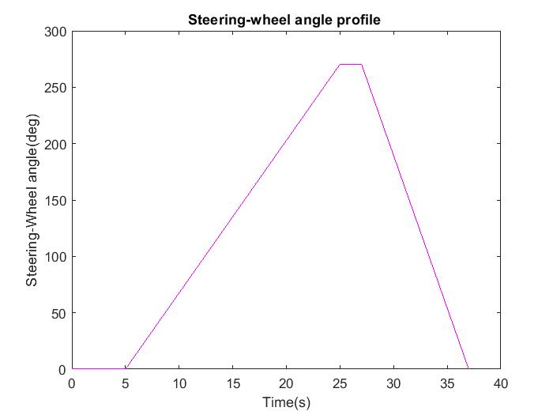

**Figure 1:** The profile of the input handwheel steer angle in degrees

In Figure 2, the bicycle model is able to complete the maneuver at 50 mph but the four-wheel model fails. This is because the four-wheel model considers the coupling between vehicle velocity and roll and this means that at 50 mph, the vehicle with these parameters will face a rollover. Since the bicycle model neglects roll, it can successfully complete the maneuver. In Figure 3, the four-wheel model can complete the maneuver when the speed is decreased to 25 mph.

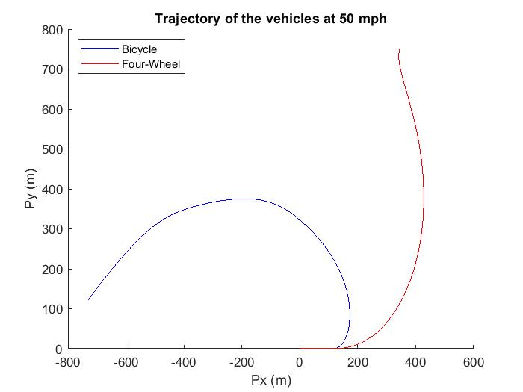

**Figure 2:** The two models' trajectory at 50 mph

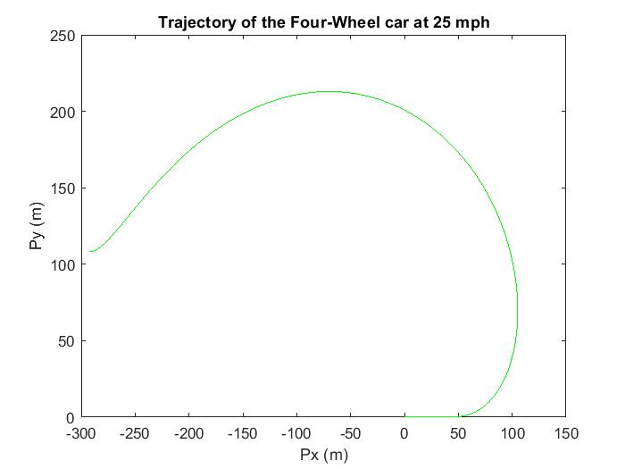

**Figure 3:** Four-wheel model completing the maneuver at 25 mph

1. Steer-by-wire Feedback controller

In this feedback based steering control for yaw stability, the assumption is of a front wheel drive vehicle. The effective road-wheel steering angle at the front wheels is a sum of driver input/planner input and the controller-decided compensation to enforce stability and safe maneuvering. It compensates for the driver’s understeer or oversteer to prevent skid. The feedback term should not interfere with the vehicle’s desired path and is for stability and safety only. The controller presented here was first proposed in [16] and can be referred to for further details. We used this controller as a comparison for our own controller. The design of the controller is presented below.

According to *Rajamani et al,* the SbW controller’s compensation steering angle rate is given by the control law:

$${\dot{δ}}_{sbw}=-\dot{ψ}+g\left(\dot{ψ}\right)+F(δ_{driver})$$

$\dot{ψ}$ is the vehicle’s actual yaw rate in the current time step.

$$g\left(\dot{ψ}\right)=\frac{\cos\left(θ_{vf}\right)}{V_{x}}\left[\left(l_{f}-l_{P}\right)\ddot{ψ}\cos\left(θ_{vf}\right)+\left(l_{f}{\dot{ψ}}^{2}-a_{x}\right)\sin\left(θ_{vf}\right)\right]$$

$θ_{vf}$ is the vehicle velocity angle at the front tires which is described by the state equation:

$${\dot{θ}}_{vf}=-\dot{ψ}+\left(\frac{\cos^{2}θ_{vf}}{V_{x}}\right)a_{yP}+g\left(\dot{ψ}\right)$$

Where $a_{yP}$ is the lateral acceleration at any point P in the vehicle and is given by:

$$a_{yP}=\frac{L}{ml_{r}}F_{yf}$$

Lastly, $F(δ_{driver})$ is a function chosen based on just the driver input and is considered as the desired yaw rate corresponding to the driver input. Essentially this means that the control law uses the error in the desired yaw rate ($F\left(δ_{driver}\right)-\dot{ψ}$) as the feedback term in order to calculate the compensation term ${\dot{δ}}_{sbw}$.

We decided to choose the tuning function- $F(δ_{driver})$ to be the desired yaw rate of the driver, assuming a neutral steer condition which is the type of maneuver usually achieved by an ADAS or Semi/Fully autonomous vehicle.

Hence the desired yaw rate is given by ${\dot{ψ}}_{des}=\frac{V_{x}}{R}$ where R is the road curvature.

Relating to δ, R is given by: $\frac{1}{R}=\frac{δ}{l_{f}+l_{r}}$

The $F\left(δ_{driver}\right)=\frac{K_{sbw}V_{x}δ}{l_{f}+l_{r}}$ where $K_{sbw}$ is a feedback gain to fine tune the controller performance (ideally it is of value 1).

The control structure/architecture of this SbW controller is presented in Figure 1.

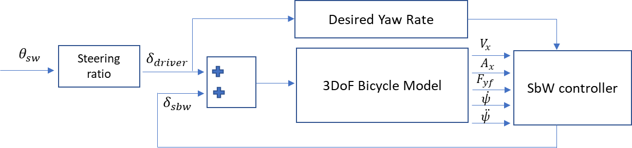

**Figure 4:** Control scheme for the feedback controller

1. Steer-by-wire FeedForward controller

The purpose of an input shaper is to control the self-induced vibrations (oscillations) in linear or quasi-linear dynamic systems. A vehicle exhibits oscillatory behavior due to its inertia during high speed maneuvers such as lane change, double lane change, fishhook, etc. These oscillations might be exacerbated by unnecessary inputs from the driver or planner.

This technique is advantageous in terms of computational capacity, design complexity and hardware necessities since it involves a simple convolution of the driver inputs with a series of designed impulses. It is also a feedforward/open-loop control technique where there is no necessity for measurements.

In this paper, we attempt to design this controller based on the parameters of a bicycle model that has been linearized around small steering angles and constant velocity. The equations presented here are an adaptation from [17] and have been redesigned specifically for the vehicle stability scenario.

In order to curb oscillations, the first step is to ensure zero vibration in the system while it is moving. This can be done by introducing a second impulse to counteract the first impulse caused by the input. Given a system’s approximate natural frequency ($ω_{n}$) and damping ratio (ζ), the vibration caused by a sequence of impulses can be calculated as:

$V\left(ω_{n},ζ\right)= e^{-ζω_{n}t_{n}}\sqrt{{C(ω_{n},ζ)}^{2}+{S(ω_{n},ζ)}^{2}}$ (1)

Where,

$C\left(ω_{n},ζ\right)=\sum_{i=1}^{n}{A_{i}e^{-ζω_{n}t_{i}}cos⁡(}ω_{d}t_{i})$ (2)

$S\left(ω_{n},ζ\right)=\sum_{i=1}^{n}{A_{i}e^{-ζω_{n}t_{i}}sin⁡(}ω_{d}t_{i})$ (3)

$A_{i}$ and $t_{i}$ are the amplitudes and time locations of the impulses and n is the total number of impulses. Additionally, $ω_{d}=ω\sqrt{1-ζ^{2}}$ is the damped natural frequency of the system.

Now by setting $V\left(ω_{n},ζ\right)=0$, we can solve for the amplitudes and placement time of those amplitudes. This when given in sequence, will cause zero vibration in the system. Now, since we do not want the solutions to converge to zero or infinity, we need to place certain constraints on the amplitudes of these impulses as follows:

$$\sum{A_{i}}=1$$

$$A_{i}>0$$

We have implemented a two-impulse controller (n=2) for the SbW controller. Assuming the first impulse’s time location to be at t=0, $t_{1}=0$ for $A_{1}$. Hence, we must now solve for $A_{1}$, $A_{2}$ and $t_{2}$.

For (1) to be 0, (2) and (3) each must equal to 0. Hence,

$$A_{1}+A_{2}e^{-ζω_{n}t_{2}}\cos\left(ω_{d}t_{2}\right)=0$$

$$A_{2}e^{-ζω_{n}t_{2}}\sin\left(ω_{d}t_{2}\right)=0$$

The final solution is given below, but its complete derivation can be found in [13].

$\left[\begin{matrix}A_{i} \\ t_{i}\end{matrix}\right]=\left[\begin{matrix}\frac{1}{1+K} & \frac{K}{1+K} \\ 0 & 0.5T_{d}\end{matrix}\right]$ where i=1,2 and $T_{d}$ is the damped period of vibration.

Now we calculate the required parameters based on a linearized bicycle model, where the A matrix is given by

$$A=\left[\begin{matrix}-\frac{C_{αf}+C_{αr}}{mV} & \frac{{l_{r}C}_{αr}-l_{f}C_{αf}}{mV^{2}}-1 \\ \frac{{l_{r}C}_{αr}-l_{f}C_{αf}}{I_{zz}} & -\frac{{l_{f}}^{2}C_{αf}+{l_{r}}^{2}C_{αr}}{I_{zz}V}\end{matrix}\right]$$

The natural frequency of the system ($ω_{n}$), damping ratio ($ζ$), damped natural frequency ($ω_{d}$) and the damped time period ($T_{d}$) are given by:

$$ω_{n}=\sqrt{A_{11}A_{22}-A_{12}A_{21}}$$

$ζ=-\frac{A_{11}+A_{22}}{2ω_{n}}$.

$ω_{d}=ω_{n}\sqrt{1-ζ^{2}}$

$$T_{d}=\frac{2π}{ω_{d}}$$

$V$ is the tangential velocity of the vehicle with respect to the road curvature and is given by $\sqrt{V_{x}^{2}+V_{y}^{2}}$. Lastly, $C_{αf}$ and $C_{αr}$ are the cornering stiffnesses at the front and rear tires. Here, it is approximated to be 16.5% of tire load per radian of slip angle [14]. This implies:

$$C_{αf}=0.165*57.29578*m*d_{f}$$

$$C_{αr}=0.165*57.29578*m*d_{r}$$

where $d_{f},d_{r}$ are front and rear load distribution ratios for the vehicle ($d_{f}+d_{r}=1$). Now we have all the parameters necessary to design a two impulse input shaper.

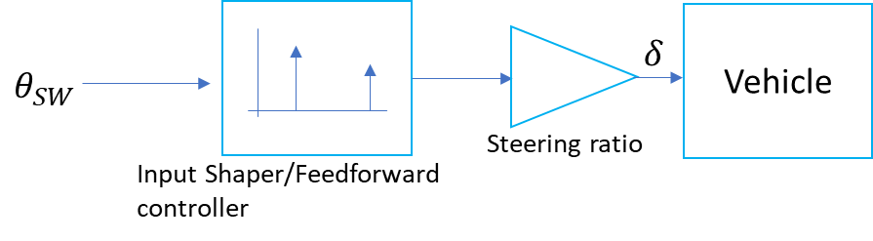

**Figure 5:** The proposed control scheme for the feedforward controller + feedback controller

1. RESULTS AND DISCUSSION

The controllers’ merits can only be tested in situations where the vehicle is challenged in its yaw limits. We chose the standard ‘Double lane change (DLC)’ maneuver since it is a standard test used to evaluate active safety systems like ESC. We have divided this section into various subsections presenting, describing and discussing the two controllers designed above in these test scenarios.

**6.1 The Maneuver**

Figure 6 shows the handwheel angle profile we chose for the DLC test. We have not made it a smooth sinusoidal curve towards the end of the maneuver in order to cause oscillations in the system, which happens almost happens always in high speed driving. The speeds we chose are 60 Kmph and 80 Kmph

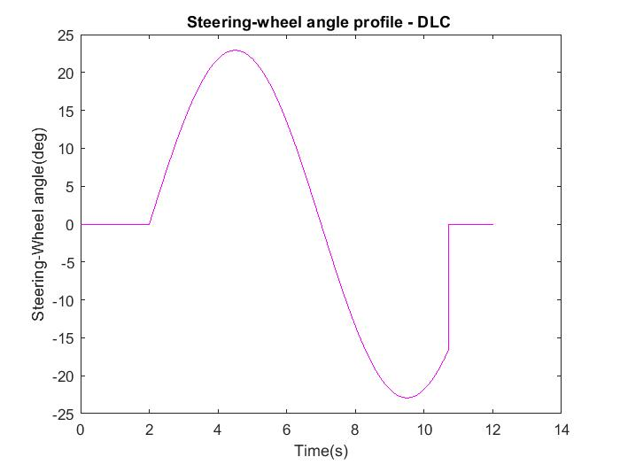

**Figure 6:** Handwheel angle profile for the DLC test

**6.2 Feedback SbW Controlled DLC (60 and 80 Kmph)**

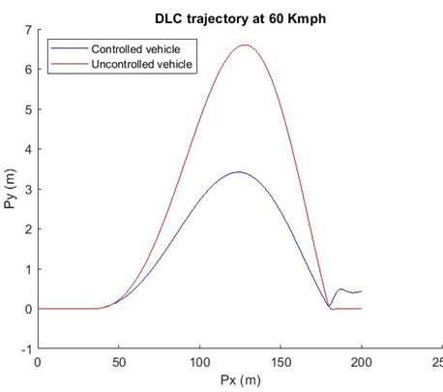

**Figure 7:** The feedback controller achieving a lateral displacement of less than 3.5m

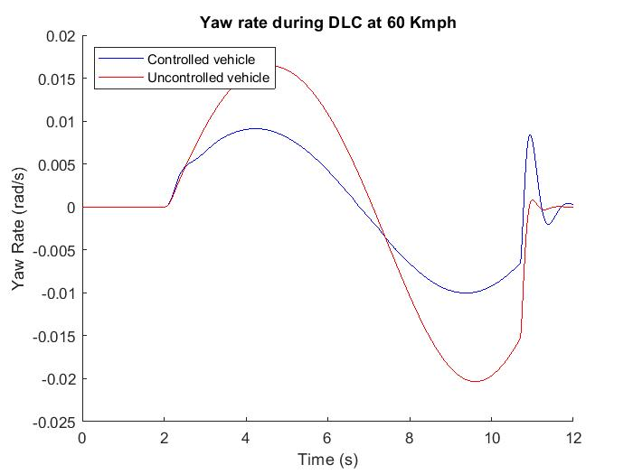

**Figure 8:** The yaw rate profile during the maneuver at 60 Kmph. Note the spike in the end caused by the controller for stability

**6.3 Feedback SbW Controller at 80 Kmph DLC**

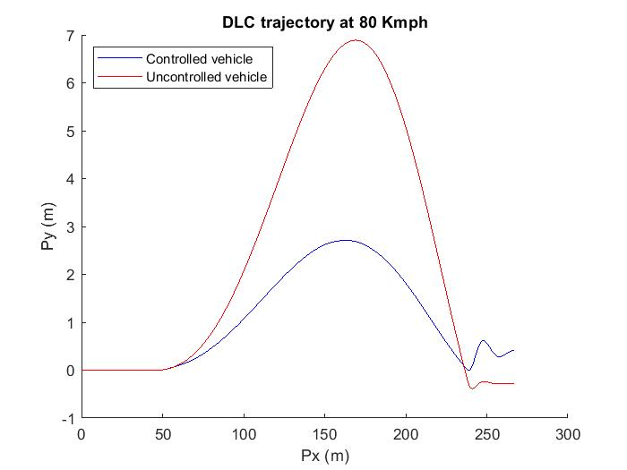

**Figure 9:** The same maneuver at 80 Kmph

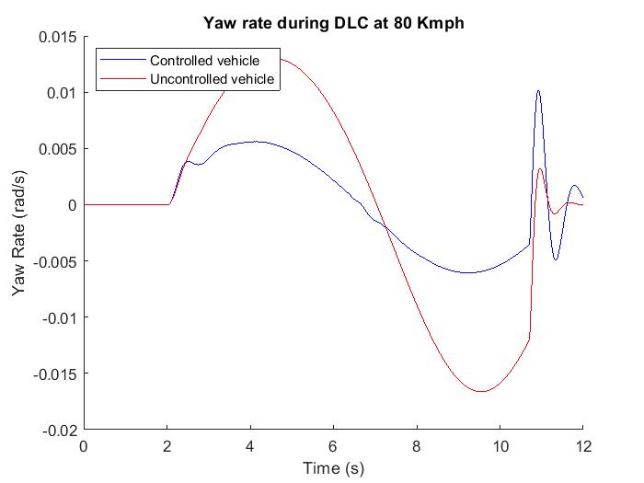

**Figure 10:** Yaw rate at 80 Kmph DLC

The feedback controller shown here can clearly control the vehicle from skidding and maintain an acceptable yaw rate limit. However, as noticed in the spikes in yaw rate during the end of the maneuver both at 60 Kmph and 80 Kmph (Figure 8 and 10), the controller is susceptible to bad input. This can be made smoother using the input shaper as mentioned in the previous sections as it can filter out bad inputs that causes the system to oscillate and perhaps go unstable. In the upcoming section, the results of the system behavior with the proposed control scheme shown in Figure 5 are presented. Since the feedback controller can handle the maneuver at 80 Kmph, we are sticking to testing only at that speed from now on, due to space constraints.

**6.4 Feedforward-Feedback Control at 80 Kmph**

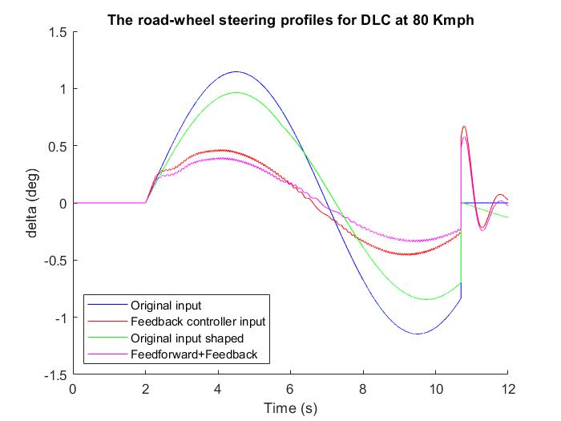

**Figure 11:** The delta profiles for the different schemes

It is clear in Figure 11 that the input has already made the change in steering input for the much smoother than the original input in order to make the vehicle oscillate lesser.

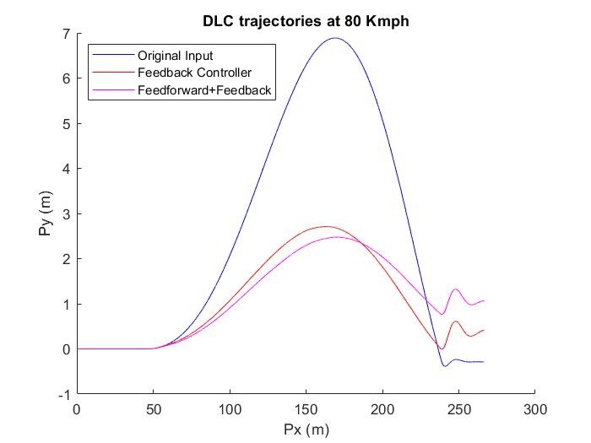

**Figure 12:** The vehicle trajectories at 80 Kmph DLC

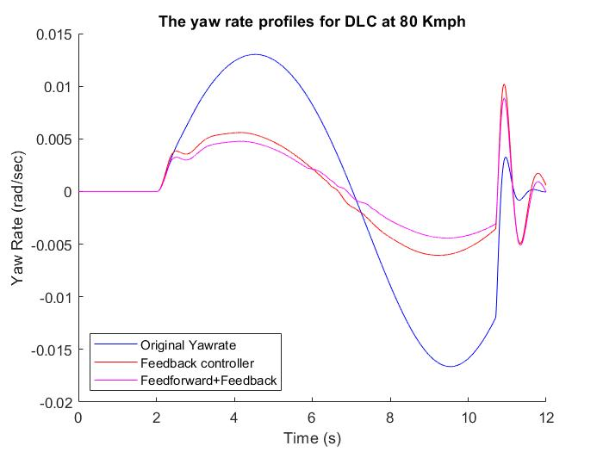

**Figure 13:** The various yaw rates profiles

**REFERENCES**

1. Wissing, C., Nattermann, T., Glander, K. H., & Bertram, T. (2018). Trajectory Prediction for Safety Critical Maneuvers in Automated Highway Driving. *IEEE Conference on Intelligent Transportation Systems, Proceedings, ITSC*, *2018*–*November*, 131–136. https://doi.org/10.1109/ITSC.2018.8569296
2. Phanomchoeng, G., Zemouche, A., & Rajamani, R. (2017). Real-time automotive slip angle estimation with extended H∞ circle criterion observer for nonlinear output system. *Proceedings of the American Control Conference*, 1636–1641. <https://doi.org/10.23919/ACC.2017.7963187>
3. Onoda, Y., Onuma, Y., Goto, T., & Sugitani, T. (2010). Design Concept and Advantages of Steer-by-Wire System. *SAE Technical Paper Series*, *1*(724). https://doi.org/10.4271/2008-01-0493
4. infinitis-drive-by-wire-system-gets-upgraded-in-2018-q50-red-sport-400 @ www.foxnews.com. (n.d.). Retrieved from <http://www.foxnews.com/auto/2017/11/20/infinitis-drive-by-wire-system-gets-upgraded-in-2018-q50-red-sport-400.html>
5. Research-Markets-Global-Automotive-Steering-System-Market @ www.businesswire.com. (n.d.). Retrieved from https://www.businesswire.com/news/home/20150922006166/en/Research-Markets-Global-Automotive-Steering-System-Market
6. Kelling, N. A., & Leteinturier, P. (2019). X-by-Wire : Opportunities , Challenges and Trends, (724).
7. Zhao, W., Qin, X., & Wang, C. (2018). Yaw and Lateral Stability Control for Four-Wheel Steer-by-Wire System. *IEEE/ASME Transactions on Mechatronics*, *23*(6), 2628–2637. https://doi.org/10.1109/TMECH.2018.2812220
8. Han, S., & Baek, J. (2015). A receding horizon yaw moment control law for steer-by-wire and independent drive vehicles. *2015 IEEE Conference on Control and Applications, CCA 2015 - Proceedings*, 1697–1701. https://doi.org/10.1109/CCA.2015.7320854
9. Wang, H., He, P., Yu, M., Liu, L., Do, M. T., Kong, H., & Man, Z. (2016). Adaptive neural network sliding mode control for steer-by-wire-based vehicle stability control. *Journal of Intelligent and Fuzzy Systems*, *31*(2), 885–902. https://doi.org/10.3233/JIFS-169019
10. Danielle Muoio. (2017). Tesla Gigafactory is massive. Retrieved March 15, 2018, from http://www.businessinsider.com/tesla-gigafactory-massive-photos-2017-7
11. Daher, N., & Ivantysynova, M. (2015). Yaw stability control of articulated frame off-highway vehicles via displacement controlled steer-by-wire. *Control Engineering Practice*, *45*, 46–53. https://doi.org/10.1016/j.conengprac.2015.08.011
12. Gürleyük, S. S., Bahadir, Ö., Türkkan, Y., & Üşenti, H. (2008). Improved three-step input shaping control of crane system. *WSEAS Transactions on Systems*, *7*(6), 652–661.
13. Singhose, W., Kim, D., & Kenison, M. (2008). Input Shaping Control of Double-Pendulum Bridge Crane Oscillations. *Journal of Dynamic Systems, Measurement, and Control*, *130*(3), 034504. https://doi.org/10.1115/1.2907363
14. MATLAB Release 2018b, The MathWorks, Inc., Natick, Massachusetts, United States.
15. Bakker, E., Pacejka, H. B., & Lidner, L. (1989). Vehicle Dynamics Studies. *SAE International*, 890087.
16. NHTSA. (2013). Laboratory Test Procedure for Dynamic Rollover The Fishhook Maneuver Test Procedure. *U.S. Department of Transportation*, (March), 1–43.
17. Rajamani, Rajesh. *Vehicle Dynamics and Control*. Springer, 2012.
18. Singh, T., & Singhose, W. (2002). Input shaping/time delay control of maneuvering flexible structures. *Proceedings of the 2002 American Control Conference (IEEE Cat. No.CH37301)*, 1717–1731 vol.3. https://doi.org/10.1109/ACC.2002.1023813
19. Berntorp K. Derivation of a six degrees-of-freedom ground-vehicle model for automotive applications. Technical Report ISRN LUTFD2/TFRT–7627–SE, Department of Automatic Control, Sweden: Lund University; 2013.
20. Schindler E. Fahrdynamik: Grundlagen Des Lenkverhaltens Und Ihre Anwendung Für Fahrzeugregelsysteme. Renningen: Expert-Verlag; 2007.

**NOMENCLATURE**





Non-Linear bicycle model

The non-linear bicycle model has 2 translational and 1 rotational degrees of freedom. The derivation and free body diagram (FBD) can be found detailed in [19].

*Equations of Motion for the Chassis*



, and



The normal forces at front and rear are given by and , where



*Equations of Motion for the Wheels and Tires*

The slip angles, slip ratios and wheel speeds are given by



Where and



The nominal tire forces according to the Magic formula [7] are given by:



The lateral combined forces are given by the friction ellipse described by the ellipse equation

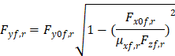

The longitudinal combined forces are given by and



The rotated lateral combined forces are given by and



FOUR-Wheel VEHICLE model

The Four-wheel vehicle model equations of motion are presented here. For derivations. FBD and details refer [20].

*Equations of Motion for the Chassis*

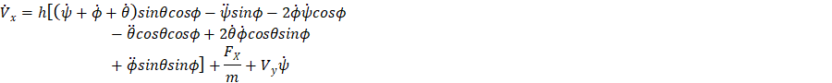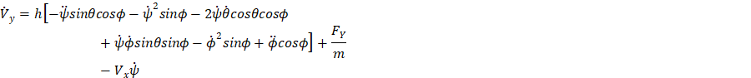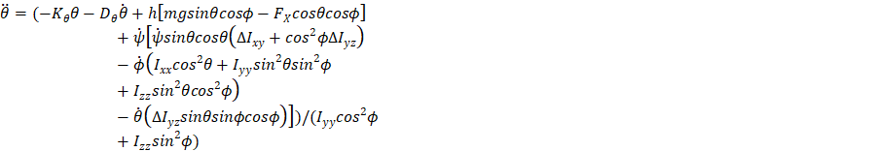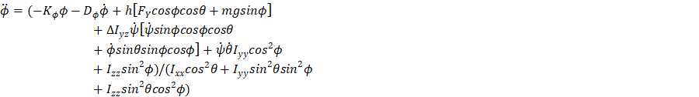

, and



The normal forces at the wheels are given by solving the set of following 4 equations



*Equations of Motion for the Wheels and Tires*

The slip angles, slip ratios and wheel speeds are given by (i=1,2,3,4):



Where , ,



and



The nominal tire forces according to the Magic formula are given by:



The lateral combined forces are given by the friction ellipse described by the ellipse equation

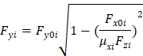

The rotated combined forces are given by

and



1. *Adress all correspondence to this author