Versa MCBB Remediation SOP / Tier 3 Runbook (Full Detail)
Change / Incident Reference: CHG002741129 – AWS Versa US0ETJ1SDRMCB01B Troubleshooting and Rebuild
This document preserves full technical context, commands, required values, validation gates, and governance controls (Templates vs CLI).

Contents
- 1. Purpose and Scope
- 2. Critical Governance Control: Templates vs CLI (Non-Negotiable)
- 3. Problem #1 – Disk Exhaustion from Runaway Logging (Bug 131770 / SPACK 2273–2279)
- 4. Problem #2 – RX/TX Ring Descriptor Misconfiguration (Interfaces Missing After Restart)
- 5. Combined Failure Chain ("Fuse" + "Bomb") and Safety Order of Operations
- 6. Step-by-Step Procedure (Template-First, Incident-Exception)
- 7. Pre-Change Validation Checklist (Template Updates)
- 8. Post-Change Validation Checklist (Template Updates)
- 9. Failure Conditions and Escalation Triggers
- 10. References

1. Purpose and Scope
Purpose: Provide a Tier 3, execution-ready SOP/runbook for remediating multiple Versa issues impacting MCBB. The SOP is designed for engineering execution and operational governance, and explicitly prevents regression due to template overwrite behavior.
- Applies to: Versa VOS devices in AWS/MCBB environments (and any environments sharing the same Versa Director templates).
- Out of scope: Non-Versa devices; unrelated MCBB components.

2. Critical Governance Control: Templates vs CLI (Non-Negotiable)
Policy Statement (MANDATORY):
- All persistent configuration changes MUST be performed through Versa Director template updates and pushed centrally.
- Direct CLI configuration is PROHIBITED except during an ACTIVE INCIDENT requiring immediate service restoration.
- Reason: the next template push will overwrite local (CLI) settings, causing silent regression and drift.
Incident Exception (ONLY during active incident):
- CLI actions may be used to restore service immediately (e.g., to stop disk growth or recover interfaces).
- After stabilization, the same changes MUST be applied to Versa Director templates and re-pushed to affected device groups.
- Post-incident reconciliation is REQUIRED to eliminate drift and prevent regression.

3. Problem #1 – Disk Exhaustion from Runaway Logging ("Fuse")

3.1 Symptoms / How It Appears
- Disk utilization increases abnormally due to uncontrolled log growth.
- When disk becomes full, the host reboots, triggering downstream failure modes.

3.2 Root Cause / Defect Details
- Bug ID: 131770 – SPACK download.log not compressed and cleaned up properly.
- Affected versions: SPACK 2273 to 2279.

3.3 Verification – Determine Current SPACK Version
Run on device CLI:
show security security-package information
Expected fields include Version, API Version, Flavor, Release Date, Update Type. Record the SPACK Version for compliance determination.
Or, using Versa Director:
Add the Spack Version field to the Filter Column options to list the SPACK versions
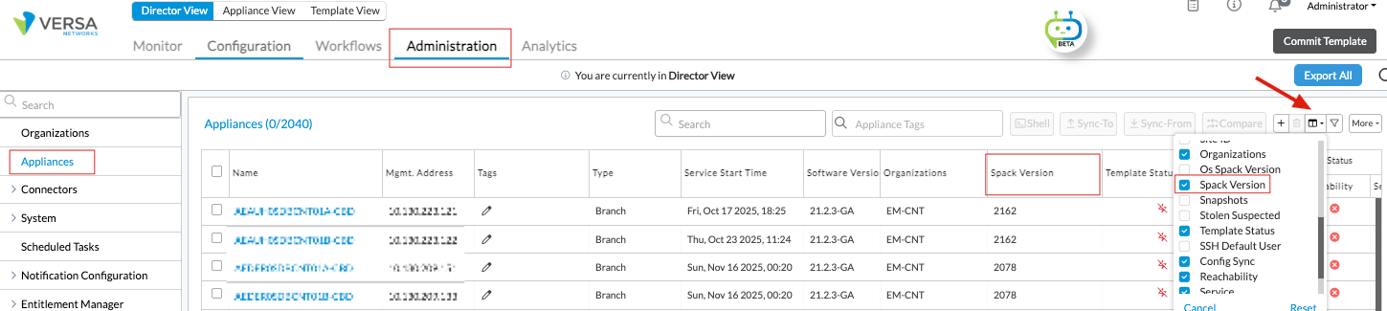
The Export All button can also be used, and the records can then be filtered in a CSV file.

3.4 Immediate Risk Mitigation – Safe Log Cleanup (Pre-Upgrade)
Run via shell on systems not yet upgraded (non-intrusive; no service reload required):
sudo rm -rf /download.log
sudo ln -fs /dev/null /download.log
- The symlink to /dev/null prevents the file from growing (stops disk consumption).
- This step SHOULD be performed before installing SPACK to ensure a clean log state.

3.5 Permanent Remediation – SPACK Upgrade
- Upgrade requirement: SPACK 2280 or later.
- Recommended baseline: latest available referenced in guidance (2337) and update regularly.
- Reboot requirement: No reboot required for SPACK remediation; SPACK update only.
Reference (Versa documentation):
Install an SPack on a VOS Device – Versa Director / SPacks documentation
https://docs.versa-networks.com/Management_and_Orchestration/Versa_Director/Configuration/Use_Security_Packages_(SPacks)

4. Problem #2 – RX/TX Ring Descriptor Misconfiguration ("Bomb")

4.1 Symptoms / How It Appears
- After restart/reload, hosts may come up WITHOUT interfaces (interfaces fail to initialize).
- This transforms a reboot event into a service-impacting outage condition.

4.2 Corrective Configuration (Required Values)
- First check VM Model (Azure/AWS/VMWare) using the following CLI command:
- show system details

- Then use the recommended values listed below.

- AWS:
- RX descriptors count MUST be 512.
- TX descriptors count MUST be 1024.
- AZURE:
- RX descriptors count MUST be 1024.
- TX descriptors count MUST be 1024.
- ON-PREM (VMWARE):
- RX descriptors count MUST be 2048.
- TX descriptors count MUST be 2048.

4.3 Mandatory Execution Method – Templates (Versa Director)
- These values MUST be enforced via Versa Director templates to prevent regression/drift.
- Do not rely on device-local CLI as a permanent fix (template push will override local settings).

4.4 CLI Procedure (Incident Exception Only)
Use ONLY during active incident when immediate recovery is required:
configure
set system service-options rx-descriptors-count <recommended value for VM type – check item 4.2>
set system service-options tx-descriptors-count <recommended value for VM type – check item 4.2>
commit and-quit

4.5 Applying Descriptor Changes – Service Restart Required
- Changes to ring descriptor values require a service restart to take effect.
- Impact: Restart will restart all Versa services.
Command:
request system restart
Prompt and response:
Will restart all Versa Services. Are you sure? [no, yes]
yes

4.6 Operationalization Notes from Facilitator
- Template enforcement was captured as a decision item (update templates across environments).
- Return-to-service should occur only after confirming interfaces and configuration are correct.

5. Combined Failure Chain ("Fuse" + "Bomb") and Safe Order of Operations
Failure Chain:
- Logging defect causes disk fill (fuse).
- Disk full triggers host reboot.
- If ring descriptors are misconfigured, device returns without interfaces (bomb).
- Outcome: complete service outage rather than recoverable reboot.
Safe Order of Operations (recommended sequence):
- Disk issue: (1) perform safe log cleanup; (2) upgrade SPACK to ≥ 2280 (prefer 2337).
- Ring issue: (3) update Versa Director templates to enforce descriptors; (4) push templates; (5) restart services in controlled window to apply descriptor values.

6. Step-by-Step Procedure (Template-First, Incident-Exception)

6.1 Preparation
- Identify affected device groups and templates in Versa Director (MCBB scope).
- Identify devices on defective SPACK (2273–2279) and devices with disk pressure.
- Identify devices currently exhibiting interface issues post-restart.

6.2 Phase A – Stabilize Disk Risk (as needed)
- If disk pressure is present and device is at risk: perform safe log cleanup via shell (see Section 3.4).
- Validate that the /download.log mitigation is in place (see Post-Change validation Section 8.5).

6.3 Phase B – Remove Defect Permanently (SPACK Upgrade)
- Upgrade SPACK to 2280 or later (preferred 2337).
- After upgrade, confirm SPACK version via show security security-package information.

6.4 Phase C – Prevent Interface-Outage Condition (Template Update)
In Versa Director, update templates to include the required descriptor values:
- AWS:
  - RX(512) / TX(1024)
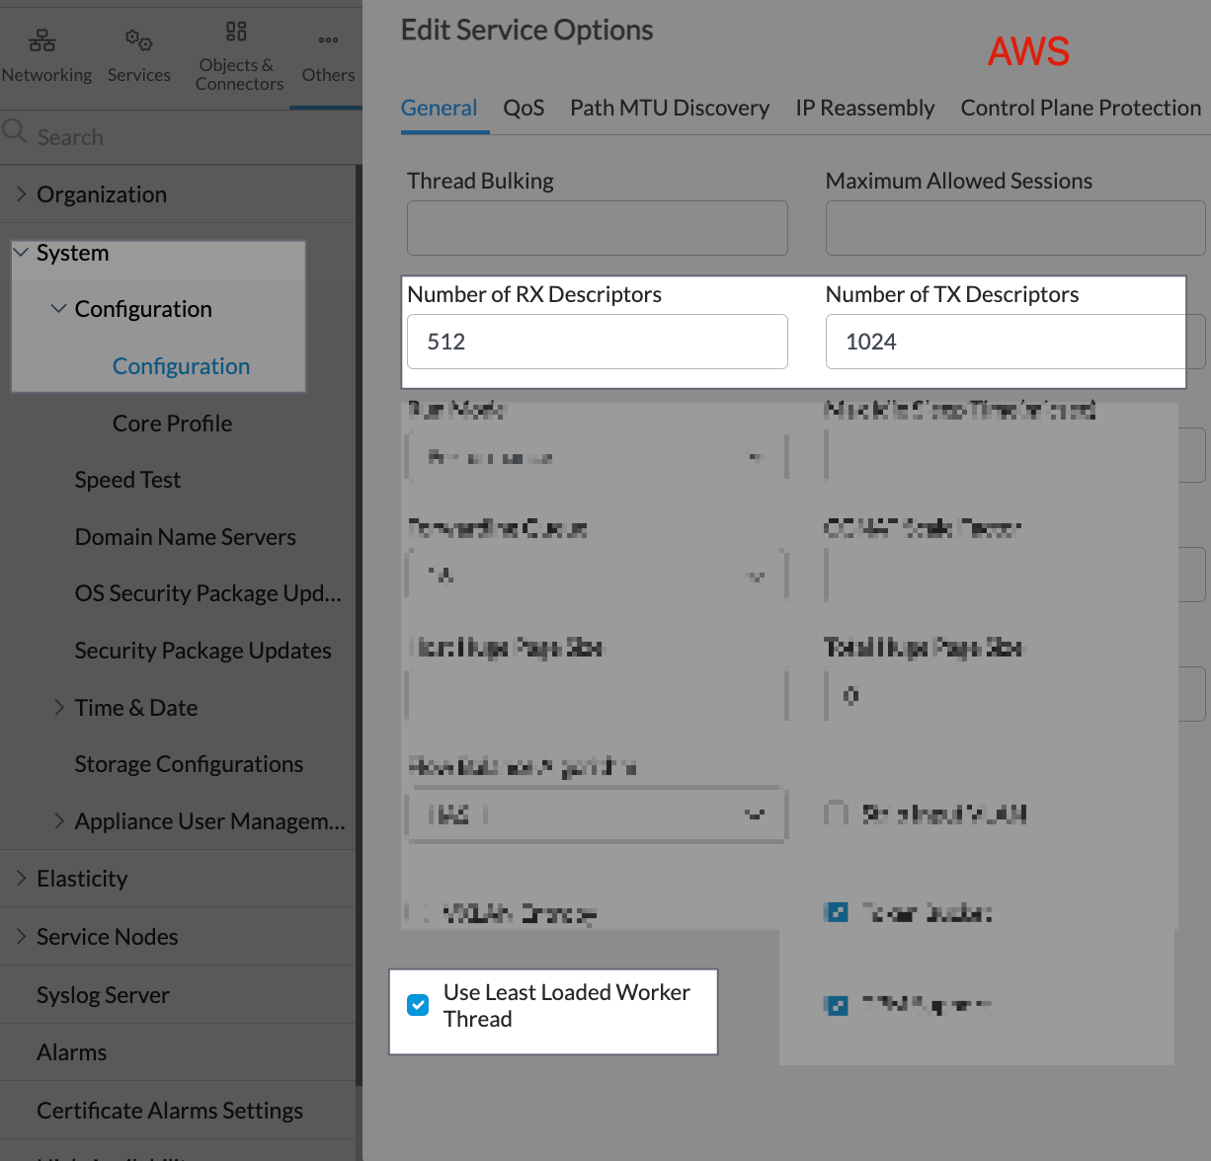

- Azure:
  - RX(1024) / TX(1024)

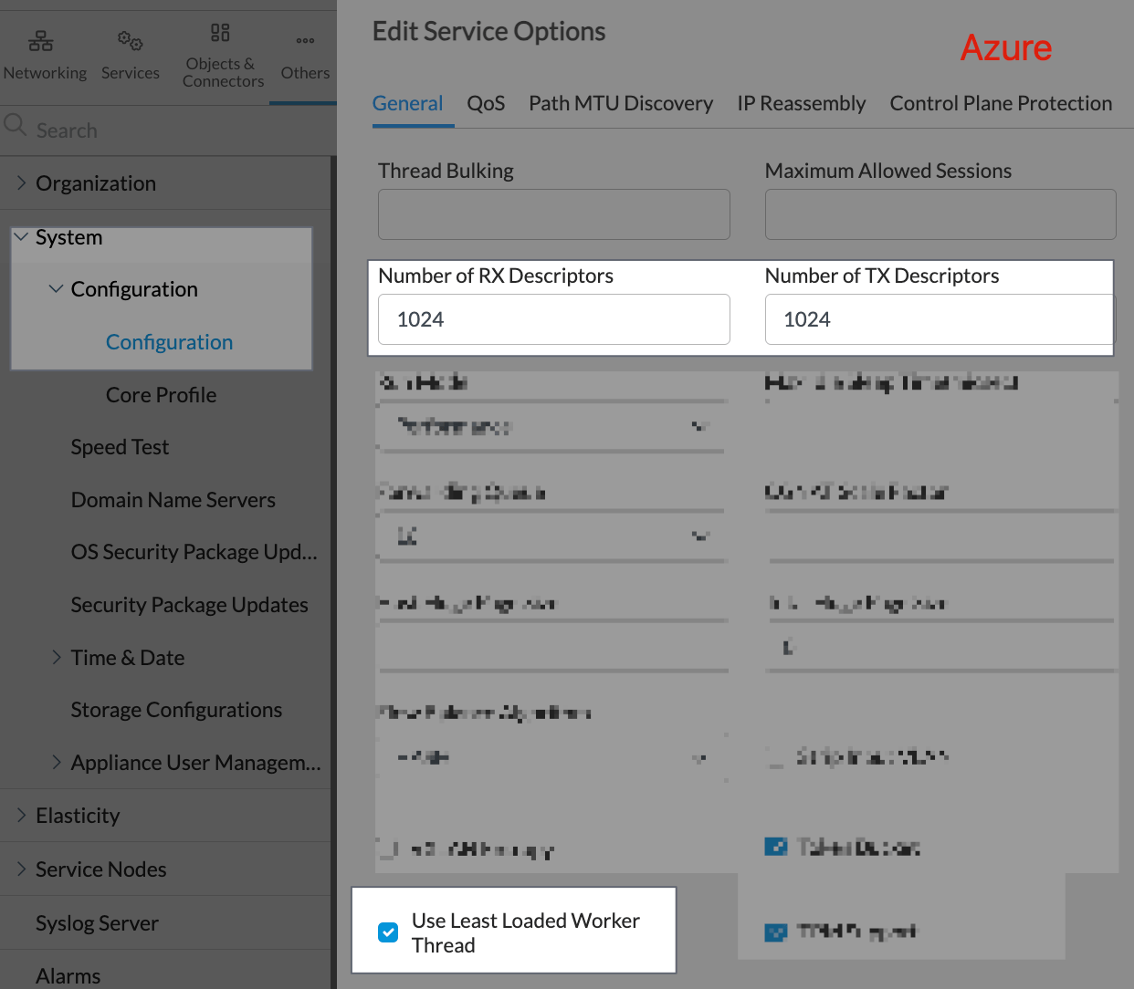

- On-Premises (VMware):
  - RX(2048) / TX(2048)

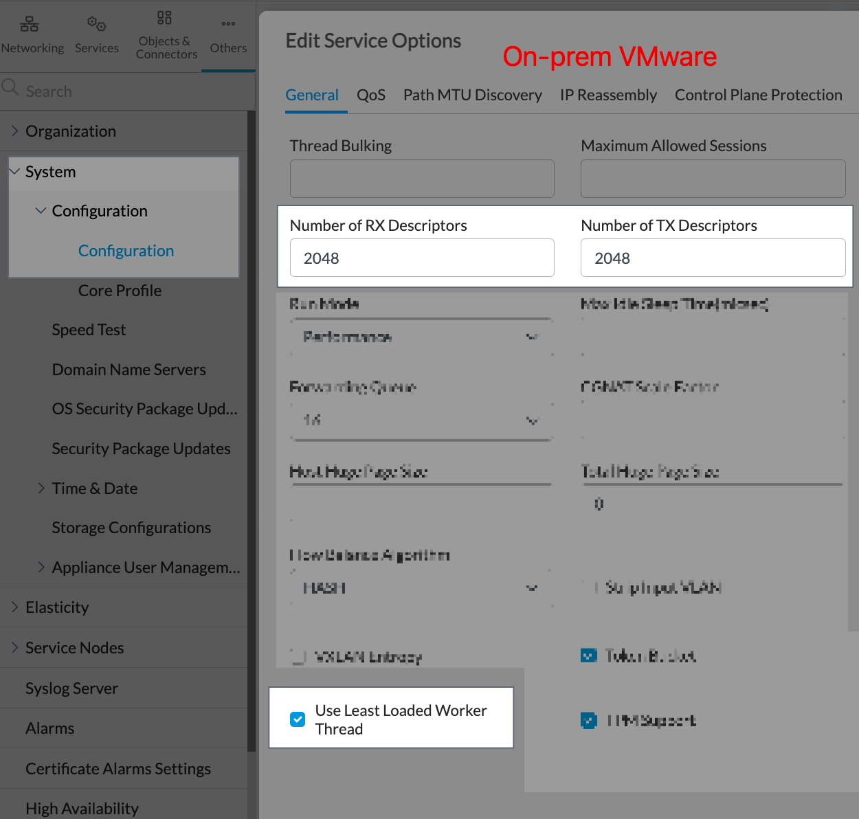

set system service-options rx-descriptors-count <recommended value for VM type – check item 4.2>
set system service-options tx-descriptors-count <recommended value for VM type – check item 4.2>
Push template updates to all applicable device groups/environments.
- Ensure no conflicting values in lower-level templates or overrides.

6.5 Phase D – Apply Descriptor Values (Service Restart Window)
- Schedule and execute a controlled restart window because descriptor changes require a service restart.
- Execute: request system restart (see Section 4.5).

6.6 Return-to-Service Gate
- Do NOT return a Versa node to service until interfaces are confirmed present and operational and descriptor config is correct.
- Use Post-Change Validation Checklist (Section 8) as the gating criteria.

7. Pre-Change Validation Checklist (Template Updates)
- Scope: confirm target templates and device groups (MCBB environments) are correct.
- Baseline SPACK: capture output of show security security-package information per cohort (defective vs compliant).
- Baseline disk: identify devices with low free space; prioritize those at highest risk.
- Baseline descriptors: capture show configuration | display set | match descriptors to identify current values.
- Baseline interfaces: confirm expected interfaces are present and operational (UP).
- Template content: validate the template includes rx/ tx values (Section 4.2) and that no conflicting template layers exist.
- rx=512 and tx=1024 (AWS)
- rx=1024and tx=1024 (AZURE)
- rx=2048 and tx=2048 (ON-PREM VMWare)
- Change classification: identify whether any steps require disruptive restart (descriptor application does).

7.1 Pre-Change Command Set (Copy/Paste)
# SPACK version check
show security security-package information

# Descriptor config presence
show configuration | display set | match descriptors

8. Post-Change Validation Checklist (Template Updates)
- Template application: confirm template push succeeded for all targeted devices (no failures / no partial application).
- Descriptor compliance: verify rx/tx are present in running config.
- rx=512 and tx=1024 (AWS)
- rx=1024and tx=1024 (AZURE)
- rx=2048 and tx=2048 (ON-PREM VMWare)

- SPACK compliance: verify SPACK version is ≥ 2280 (prefer 2337).
- Interface health gate: confirm interfaces are present and operational after restart (PRIMARY success criterion).
- Disk stability: confirm disk usage stabilized and runaway log growth is no longer occurring.
- Template enforcement check: perform/confirm subsequent template sync does not revert remediation values (drift prevention).
- Return-to-service: only after all above checks pass.

8.1 Post-Change Command Set (Copy/Paste)
# Descriptor compliance
show configuration | display set | match descriptors

# SPACK compliance
show security security-package information

# If log mitigation was applied (shell)
ls -l /download.log
Expected /download.log result when mitigation is applied:
/download.log -> /dev/null

9. Failure Conditions and Escalation Triggers
- Interfaces missing after restart (post-change) – treat as immediate remediation failure and do not return node to service.
- Descriptor values not equal to rx/tx after template push – indicates template layering conflict or failure to apply.
- rx=512 and tx=1024 (AWS)
- rx=1024and tx=1024 (AZURE)
- rx=2048 and tx=2048 (ON-PREM VMWare)
- SPACK remains within 2273–2279 after upgrade attempt – remediation incomplete; device remains susceptible to disk-fill reboot trigger.
- Disk continues to grow abnormally after mitigation – requires immediate investigation; ensure /download.log handling and SPACK upgrade completion.
- Any evidence that template pushes revert settings – governance failure; enforce template-only policy and remove local overrides.

10. References
- Versa SPacks documentation (Install an SPack on a VOS Device): https://docs.versa-networks.com/Management_and_Orchestration/Versa_Director/Configuration/Use_Security_Packages_(SPacks)
- Internal meeting facilitator notes emphasized template updates across environments and return-to-service validation gates (see meeting notes source in Teams/Facilitator Loop).

