Salvage Team Rush
Art Assets Document

Monky Games L.L.C.
Tim Heuer
Michael Speth

Purpose
This document details the art requirements for the Salvage Team Rush game.

Concept
The look and feel of this game should be a cartoony scifi. It should also look similar to Awesomenauts.

Requirements
The art assets are broken into <x> categories. Each category can be considered a deliverable and scheduled according to batch of work.

Colors

Logo
The logo should be based off of the primary ship.

Font
The font should be scifish with a bit of play. I think we can just keep the font that we used before shown in Illustration 1.
Illustration 1: powerpuff font

Banner
We used the power puff font to create a stylized banner. I used gimp to create Illustration 2. We like the way Illustration 2 looks in terms of the title. However, we don't like the logo and the arrangement can be changed.
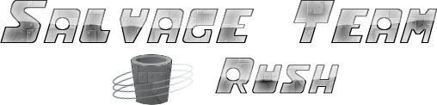Illustration 2: old banner

Desktop Shortcut Icon
This should be a scaled version of the logo. The size is 48x48 pixels.

HUD
Illustration 3 shows the redesigned HUD.
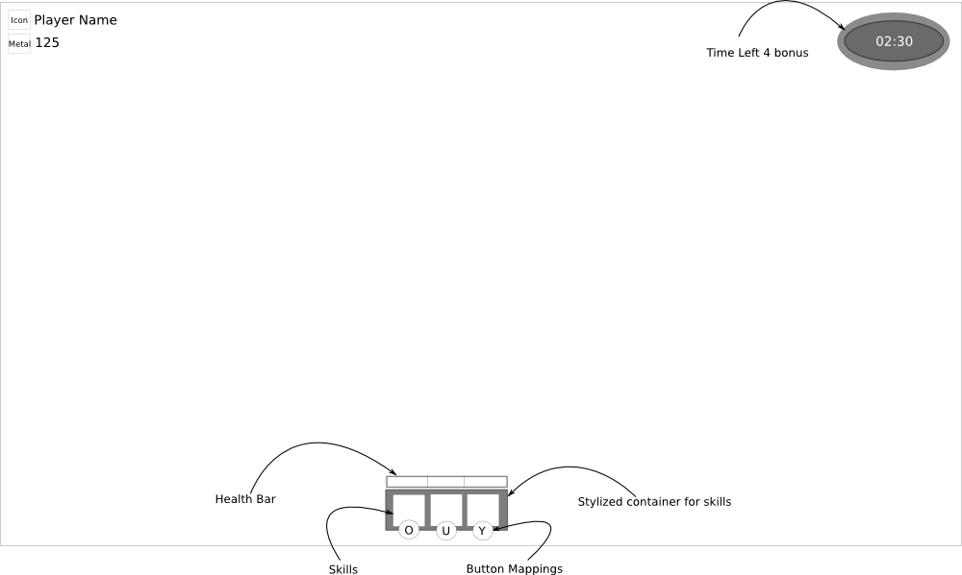Illustration 3: heads up display
The table below lists the icons needed for the hud.
Icon | Location | Description
Count down clock | Top Right | Displays the amount of time to complete the level in which a time bonus gives. Style and art is up to you.
Level Icon | Top Left | The icon next to the player name indicates the players current level category. We haven't yet determined the total number of level categories yet but I suspect it will be around 5 or 6 ish. For this document, design 1 level icon – should be a “private” like metal – maybe 1 copper bar.
Metal Icon | Top Left | Metal is the resource of the game to be collected. This icon is used to show the amount of metal a player has collected in their current match. This could very easily be a scaled down version of the metal in the game (described in a later section).
Health Bar | Bottom Center | The health bar should have alpha in between the health bar lines. There should be 2 versions of the health bar, one with 3 dividing lines and one with 4 dividing lines
Skill Container | Bottom Center | The skills should fit into the container (think diablo 3/awesomenauts/etc). The first skill slot will be used for the main thruster (it is not configurable). The second slot is for active skills, and the third is for passive skills.

Skill Icons
Skills allow the ship to operate with new abilities that enhances the gameplay. This section describes the skill and icon used for the skill. Note, each of the skills should have 2 icons as they will be used as buttons to. The first is normal and the second is when the button is pressed.
Skill | Type | Description
Thruster | Active | The default skill for making the ship go (always used and is always in the first skill slot)
Super Thruster | Active | A temporary boost in speed
Magnatizinator | Active | Stops the ship in place
Control Booster | Active | Gradually slows the ship when not boosting (makes the ship “sticky”)
Mega Shield | Active | Temporary invulnerability where the ship takes no damage
Reinforced Metal Plating | Passive | Permanent health increase (from 3 → 4)
Super Slick Hull | Passive | Permanent speed increase to the thruster (does not effect super thruster)
Extra Battery Pack | Passive | Increases the metal pick up range
Metal Detector | Passive | Pulls ship toward metal
Locked | N/A | Should be a pad lock that indicates the skill is unavailable for the player

Ship
This is the fun section. We need a ship model that will looks cool (great art direction). It should not be too complicated and should look more like a russian version of the solar jet man pod. The main body should have the primary color and the ship components should have a secondary color. There should be 4 different color schemes. This is an in-game graphic and should be 256x256 pixels (it will be scaled down in game). Illustration 4 shows a simple idea.
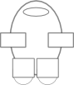Illustration 4: ship

Metal
Metal is the collectable resource of the game. There are 3 types of metal: silver, gold, and platinum. Silver is the most common, gold is less common, and platinum is rare. These are in game graphics so should be 256x256 pixels (but will be scaled down in game). The graphics for this shouldn't be complicated. Illustration 5 shows a concept.
Illustration 5: metal

Menu Background
The menu background should be simple. The graphic should contain metal or large chunks of metal on both sides of the menu buttons (symmetrical). Illustration 6 shows the general layout of the menu screen (disregard the background image).
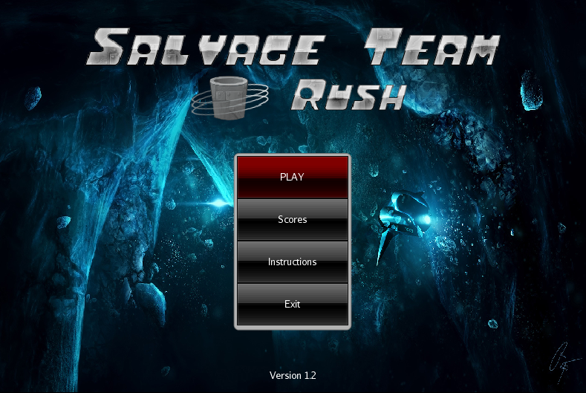Illustration 6: old menu

Maps
This will be the most challenging section for the art assets and game design. ST currently only has 1 map which is based off of the solar jet man bonus level. It was easy to make but for re-playability, we need more maps and maps that have more depth. I would like each map to have a theme which would be a separate planet. Think dagabogh, hoth, correlia, etc.
However, since this document has already a lot of work, lets focus on 1 map and that is the solar jetman bonus map. The map has the following components: walls, start point, metal, and a background image. The metal is already defined in another section. Illustration 7 shows the current map. Note, it looks very bland because I have repeated the same texture on all of the walls. I don't have any great ideas here so feel free to experiment. The background image should be something closer to the planet surface.

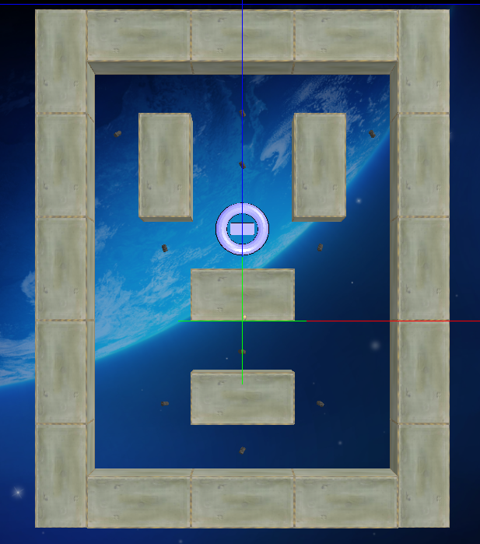Illustration 7: solar jetman bonus map

