**Armond Luthens**

**Bryan Prather-Huff**

Group #2

Homework #6

CS:4400 Database Systems

Hotel Management System

**1. ER Diagram:**

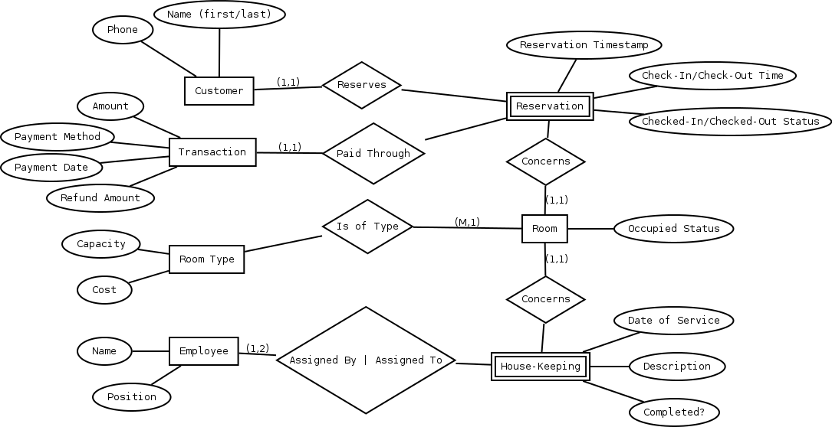

**2. Relational Model:**

|  |  |  |  |
| --- | --- | --- | --- |
| Customer | | | |
| customer_id | first_name | last_name | phone |

|  |  |  |  |  |
| --- | --- | --- | --- | --- |
| Transaction | | | | |
| transaction_id | amount | payment_method | payment_date | refund_amount |

|  |  |  |
| --- | --- | --- |
| Room | | |
| room_id | room_type | occupied_status |

|  |  |  |
| --- | --- | --- |
| Room_Type | | |
| room_type | no_people | cost |

|  |  |  |  |
| --- | --- | --- | --- |
| Employee | | | |
| employee_id | first_name | last_name | position |

|  |  |  |  |  |  |
| --- | --- | --- | --- | --- | --- |
| Housekeeping | | | | | |
| room_id | date_of_service | assigned_by_id | assigned_to_id | description | completion_status |

|  |  |  |  |  |  |  |  |
| --- | --- | --- | --- | --- | --- | --- | --- |
| Reservation | | | | | | | |
| customer_id | room_id | check_in_date | check_out_date | checked_in_status | checkout_out_status | transaction_id | reservation_date |

List all anomalies

An insert anomaly assumes that every customer has a phone number. Even if they don’t we require a number to be entered to contact.

An employee quits (is deleted from the employee table) after they have been assigned to service a room, leaving an anomaly in the Housekeeping table.

List all functional dependencies for each relation

customer_id 🡪 first_name, last_name, phone

room_id 🡪 room_type, no_people, cost

room_id, checked_in_date, checked_out_date 🡪 occupied_status

reservation_date, room_id 🡪 customer_id

**3. Test Plan**

Situations needed to cover:

- People checking out of a room the same day as people checking into the same room

- People checking out earlier than planned and generating a refund

-A person upgrading their room upon arrival

Errors that could occur

-Two people reserve the same room at the same time

-Someone reserves a room that another customer has just cancelled the reservation on before related tables get updated

-Two managers try to create a housekeeping assignment on the same room at the same time