PROJECT SYNOPSIS
BlindMatch 2.0
A Privacy-Preserving Decentralized Platform for Clinical Trial Recruitment Using Zero-Knowledge Proofs

Domain: Blockchain, Cryptography & Healthcare Informatics
Academic Year: SY ODD SEM 2026–27

Submitted By | ____________________________
Roll No. / PRN | ____________________________
Department | Computer Engineering / Information Technology
College | ____________________________
Project Guide | ____________________________
University | ____________________________

Submitted in partial fulfillment of the academic requirements for the project work.

1. Abstract
Clinical-trial recruitment is commonly slowed by fragmented hospital records, manual chart review, privacy concerns, and the need to exchange sensitive medical information across organizations. BlindMatch 2.0 is a privacy-first academic prototype that demonstrates how hospitals, patients and research organizations can collaborate without placing raw patient medical records on a central server or public blockchain. The system uses digitally signed clinical credentials, Zero-Knowledge Proofs (ZKPs), role-based access control, a persistent SQLite registry, and EVM-compatible smart contracts to prove that a patient satisfies trial eligibility criteria without revealing the underlying age, biomarker value or diagnosis to the researcher.
The final implementation contains four stakeholder portals: Admin, Hospital Issuer, Patient Privacy Wallet, and Researcher. An administrator approves participating hospitals and research organizations and manages staff accounts. An approved hospital verifies a patient's clinical values and issues a signed credential. The patient receives the credential through a one-time QR handoff, verifies the issuer and status, stores the credential locally, and generates a Groth16 proof in the browser using Circom-generated WebAssembly and SnarkJS. A smart-contract verifier validates the proof, while MatchRegistry.sol records only an anonymous match. The researcher sees the verified anonymous match and not the raw clinical record.
The final prototype also includes persistent SQLite storage for organization approvals, staff users, trial criteria, credential metadata/status, anonymous matches and audit events. The SQLite database can be stored outside the source-code directory using DATABASE_PATH so project upgrades do not overwrite application data. Raw signed patient credentials and one-time QR payloads are intentionally not retained as central EHR records. BlindMatch 2.0 is designed as an academic demonstration of privacy-preserving recruitment; production deployment would require formal security review, institutional governance, production key management, regulatory validation, and clinically validated data integrations.

2. Keywords
Zero-Knowledge Proofs (ZKP), Groth16, Circom, SnarkJS, Verifiable Credentials, Blockchain, Clinical Trials, Privacy-Preserving Computation, React, Node.js, SQLite, RBAC, EVM Smart Contracts.

3. Introduction
Clinical research depends on finding patients who satisfy precise inclusion and exclusion criteria. In traditional workflows, the researcher or an intermediary often needs access to identifiable medical records, or hospital staff must manually screen records for every study. These approaches create operational delays and increase the amount of sensitive health information that must be shared, copied or processed across institutional boundaries.
BlindMatch 2.0 changes the workflow from 'send the medical data to the researcher' to 'prove that the eligibility condition is true.' The hospital remains the trusted issuer of verified clinical facts. The patient becomes the holder of the signed credential and the party that generates the eligibility proof. The researcher becomes the requester who defines the trial criteria and receives only a cryptographically verified anonymous match. This model maps naturally to the issuer-holder-verifier pattern used by modern verifiable-credential systems.

4. Problem Statement
To design and implement a secure, decentralized and privacy-preserving clinical-trial recruitment platform that connects approved hospitals, patients and research organizations, verifies trial eligibility using zero-knowledge proofs, prevents unnecessary disclosure of raw patient medical data, maintains auditable organizational access, and records successful anonymous matches on an EVM-compatible blockchain.

5. Objectives
Provide a common platform connecting Administrators, Hospitals, Patients and Research Organizations.
Allow only approved hospitals to issue cryptographically signed clinical credentials.
Allow patients to receive credentials using a short-lived one-time QR handoff and store them locally.
Generate Groth16 zero-knowledge proofs from private clinical values without transmitting the raw values to the researcher.
Verify the proof through Solidity smart contracts and record only anonymous match information.
Allow approved research organizations to publish trial criteria and view verified anonymous matches.
Provide credential status checking and revocation without maintaining a central raw EHR database.
Provide persistent SQLite storage for non-PHI operational metadata, users, trials, matches and audit logs.
Implement staff login and role-based access control (RBAC) for Admin, Hospital and Researcher portals.
Support mobile Chrome/PWA use for the Patient Privacy Wallet.

6. Scope of the Project
The scope covers an end-to-end academic prototype running on a local Hardhat blockchain and browser-based portals. It demonstrates the complete privacy-preserving recruitment workflow from organization approval through hospital credential issuance, patient-side proof generation and researcher-side match viewing. The project intentionally uses synthetic/demo patient data for development and academic presentation.
The following are outside the production scope of this prototype:
Direct integration with hospital production EHR/HIS systems.
Clinical validation of eligibility rules or medical decision making.
Production HIPAA/GDPR certification or legal compliance attestation.
Production HSM/KMS management of hospital signing keys.
Mainnet cryptocurrency use or financial settlement.
National identity verification or real patient onboarding.

7. Existing System and Limitations
Existing Approach | Typical Limitation
Manual chart review | Slow, labor-intensive and difficult to scale across many trials.
Centralized recruitment databases | Create large repositories of sensitive data and attractive breach targets.
Direct EHR sharing | Requires broader disclosure of patient information than is necessary for eligibility testing.
Email/spreadsheet coordination | Weak auditability, inconsistent access control and high risk of process error.
Researcher-first screening | Patient has limited control before eligibility screening and contact.

8. Proposed System
BlindMatch 2.0 separates trust responsibilities. The hospital verifies the clinical facts and signs a credential; the patient retains the credential and proves eligibility locally; the blockchain verifies proof validity; and the research organization receives only an anonymous match. The Admin Portal operates as the trust registry for approved organizations and staff accounts.
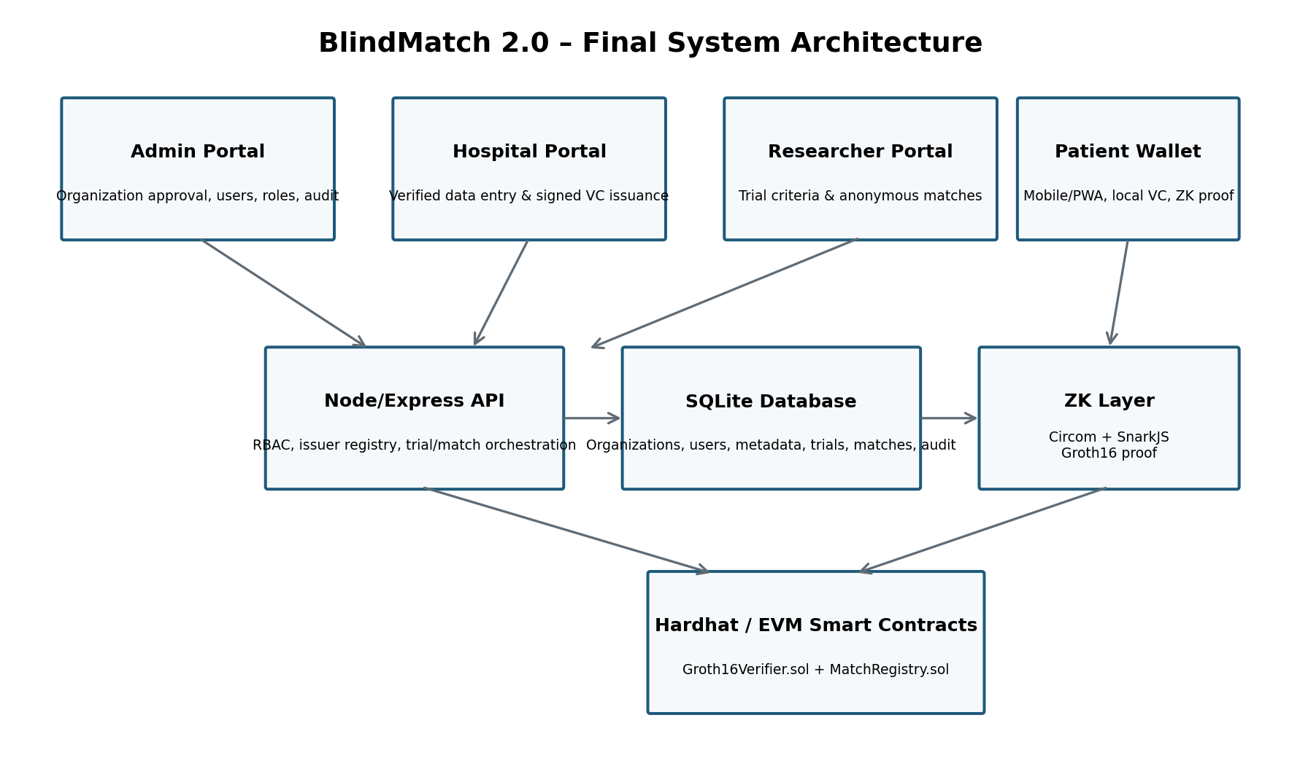
Figure 1. Final BlindMatch 2.0 system architecture

9. Stakeholders and Roles
Stakeholder | Role in BlindMatch 2.0
Admin | Approves/suspends organizations, creates staff users, maintains trust registry and reviews audit events.
Hospital | Verifies patient data, issues signed clinical credentials, checks issued credentials and can revoke them.
Patient | Receives signed credential, verifies issuer/status, stores it locally, generates ZK proof and controls consent.
Research Organization | Publishes trial criteria and views successful anonymous verified matches.
Blockchain / Verifier | Mathematically verifies Groth16 proofs and records match events without raw clinical data.

10. Functional Modules

10.1 Admin and Trust Registry Module
Admin authentication with role-based access control.
Register Hospital and Research Organization entities.
Approve, reject, suspend or re-activate organizations.
Create and enable/disable staff accounts.
Store organization identity/public-key metadata.
Review persistent audit events and platform summary data.

10.2 Hospital Issuer Module
Authenticated hospital staff login.
Verified patient reference, patient name and clinical values entry for the academic demo.
Credential generation with unique credential ID and expiry time.
Digital signature over the credential payload.
Poseidon commitment binding the hospital-issued values to the later ZK proof.
One-time QR transfer token for mobile handoff.
Credential status and revocation management.

10.3 Patient Privacy Wallet
Mobile-responsive React/PWA interface.
Scan one-time Hospital QR using mobile Chrome camera.
Fetch the signed credential once; the short-lived handoff token is invalidated after use.
Verify actual hospital issuer identity and current credential status.
Encrypt and retain credential data locally in the browser.
Download public trial criteria.
Generate Groth16 proof using SnarkJS and WebAssembly.
Submit the anonymous proof without sending private clinical witness values.

10.4 Researcher Module
Authenticated research-organization login.
Publish inclusion criteria such as age range, biomarker range and diagnosis code.
View trial list and anonymous verified matches.
Persist login session across page refresh.
Automatically refresh match results after successful patient proof submission.

10.5 ZK Circuit Module
The Circom circuit accepts private clinical witness values and public trial criteria. The circuit checks range constraints and diagnosis equality, and computes a Poseidon commitment from the credential values and secret salt. The commitment is exposed as a public signal and is compared with the hospital-registered commitment. This prevents a patient from using a valid credential identifier with fabricated witness values.

10.6 Smart Contract Module
Groth16Verifier.sol is generated from the final proving key and verification key.
MatchRegistry.sol receives proof calldata and public signals.
The contract verifies the proof, binds it to the expected trial ID, and rejects invalid or duplicate submissions.
Only anonymous identifiers/commitments and match events are stored on-chain in the prototype.

10.7 Persistent Database Module
BlindMatch uses SQLite for persistent operational data. The database path is configurable using DATABASE_PATH and can point to a dedicated location such as C:\BlindMatchData\blindmatch.sqlite. This separates application source code from persistent project data. SQLite is an embedded single-file database, so a separate database server is not required.
Stored in SQLite | Not Stored as Central Patient Record
Organizations and approval status | Raw hospital EHR / complete medical record
Staff users and RBAC data | Patient's locally encrypted wallet contents
Trial criteria | Groth16 private witness values
Credential ID, issuer, hash, commitment, status, expiry | One-time QR credential payload after handoff
Anonymous match metadata | Researcher-visible raw age/biomarker/diagnosis
Audit events | Private patient decryption keys

11. End-to-End Workflow
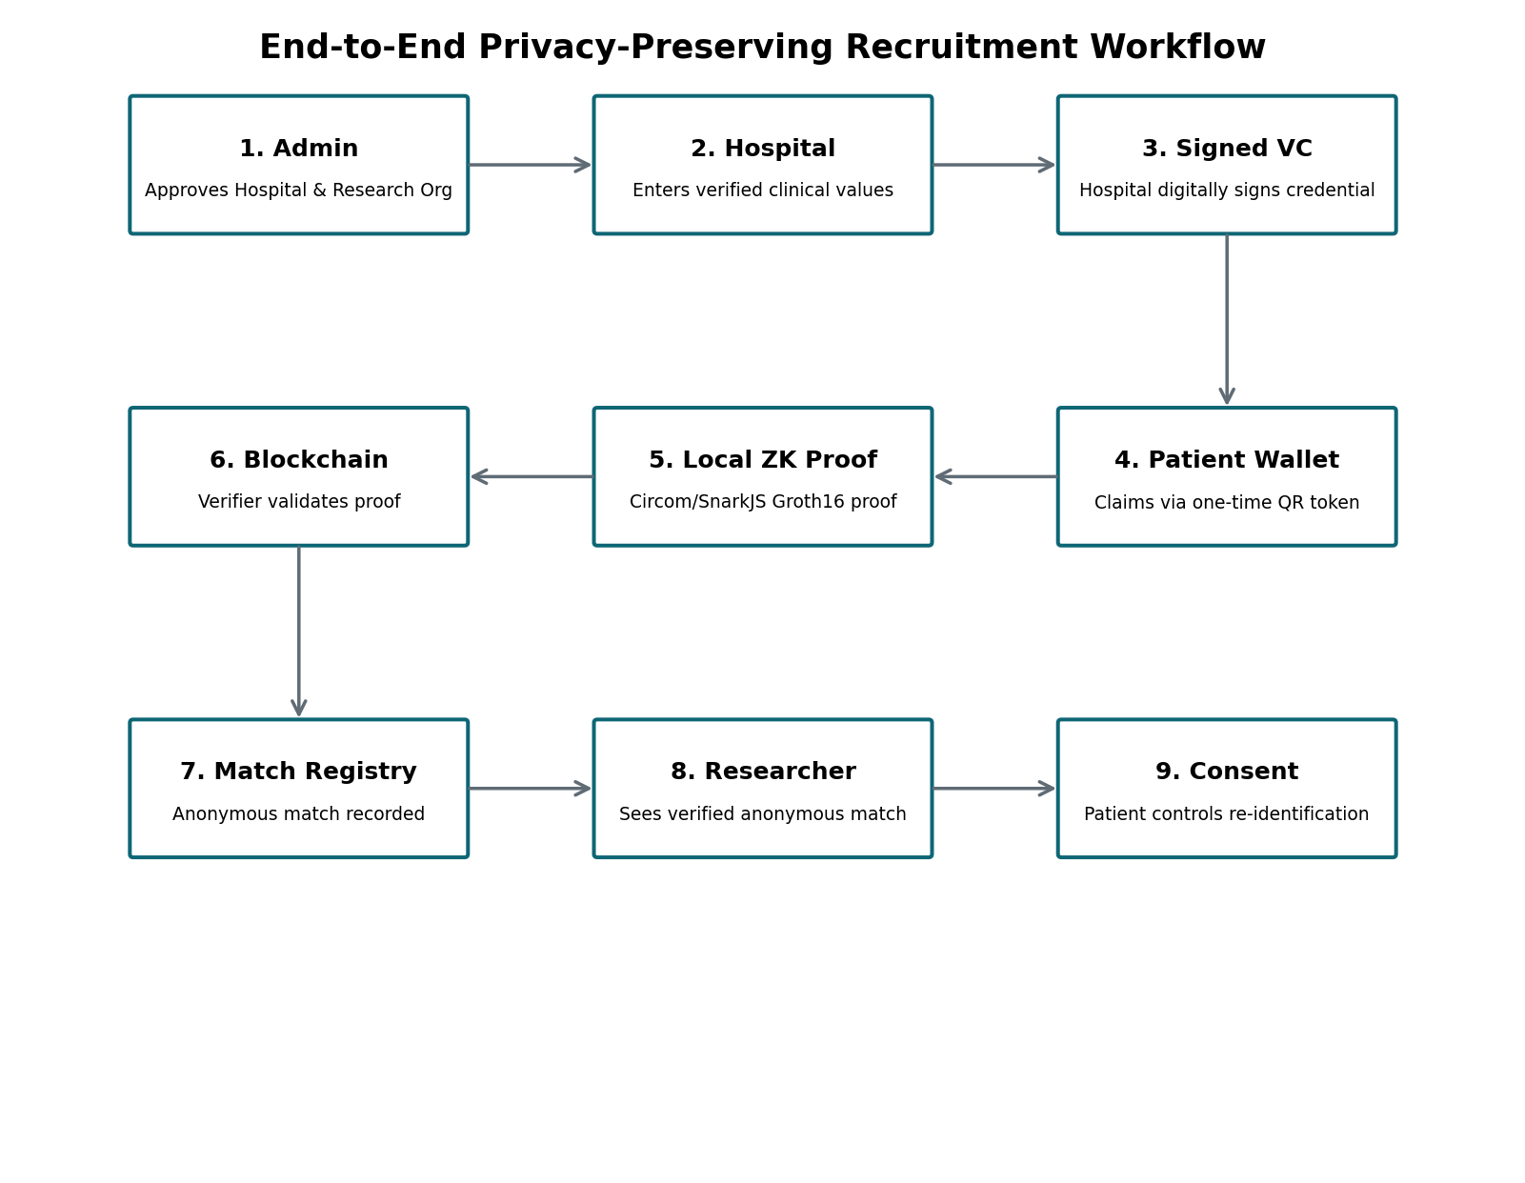
Figure 2. End-to-end BlindMatch 2.0 workflow
- Administrator registers and approves the participating hospital and research organization.
- Approved hospital staff logs in and enters verified clinical values for a demo patient.
- The backend creates a signed clinical credential containing issuer identity, credential ID, expiry, subject values and commitment.
- The Hospital Portal displays a short-lived one-time QR token instead of embedding the full credential in the QR.
- The Patient Wallet scans the QR, claims the credential once, verifies the digital signature, issuer identity and ACTIVE status, and stores it locally.
- An approved Research Organization publishes trial eligibility criteria.
- The Patient Wallet downloads public criteria and generates a Groth16 proof locally from the private clinical witness.
- The backend verifies credential metadata/status and commitment consistency, then relays the proof to the local blockchain.
- Groth16Verifier.sol validates the proof and MatchRegistry.sol records the anonymous successful match.
- The Researcher Portal displays the anonymous match without exposing the patient's raw clinical data.
- A later consent/re-identification workflow can be added so the patient decides whether to reveal contact information.

12. Zero-Knowledge Proof Design
In BlindMatch, zero-knowledge proving is used to separate verification from disclosure. The researcher needs to know whether the patient satisfies the criteria, but does not need the underlying private witness. The Groth16 prover therefore runs in the Patient Wallet using the compiled WebAssembly circuit and the final proving key.
Category | Examples in the Prototype
Private witness | Age, biomarker value, diagnosis code, credential salt.
Public trial inputs | Minimum/maximum age, minimum/maximum biomarker, required diagnosis, trial identifier.
Public binding value | Poseidon credential commitment derived from hospital-issued clinical values.
Proof output | Groth16 proof (A, B, C) and public signals suitable for Solidity verification.

13. Credential and Trust Model
The hospital is the issuer, the patient is the holder/prover, and the research organization acts as the verifier/requester. The final implementation records the actual issuing hospital identity in the signed credential and cross-checks it with the persistent credential registry. This prevents a credential issued by one hospital from being presented in the user interface as though it originated from another hospital.
Credential revocation is supported through the persistent registry. A revoked or expired credential is rejected before proof submission. The QR handoff token is deliberately temporary and memory-only: it is used to transfer the signed credential once without turning the backend into a permanent raw credential store.

14. Database Design
Logical Table | Purpose / Important Fields
organizations | Organization ID, type, name, status, public-key/DID metadata, approval dates.
users | Staff user ID, email, password hash/auth data, role, organization ID, enabled status.
trials | Trial ID, organization, title/sponsor, age range, biomarker range, diagnosis requirement, timestamps.
credentials | Credential ID, issuer organization/name, hash, Poseidon commitment, status, issue/expiry timestamps.
matches | Anonymous match ID, trial ID, ephemeral patient identifier, commitment, transaction hash/block metadata.
audit | Actor, action, details and timestamp for administrative/operational events.

Database separation is achieved through environment configuration. For example, DATABASE_PATH=C:/BlindMatchData/blindmatch.sqlite stores the SQLite file outside the source tree. Supporting commands include db:init, db:status and db:backup.

15. Authentication and Authorization
Admin, Hospital and Researcher portals use authenticated sessions/tokens. Protected routes verify both the user's role and the current approval state of the organization. Consequently, if an administrator suspends a hospital or research organization, a previously logged-in staff member is blocked on the next protected action. The Patient Wallet does not use a staff login because its main role is to hold and prove from the hospital-issued credential.

16. Technology Stack
Layer | Technology
Frontend | React.js, Vite, responsive CSS, PWA/mobile browser support.
Patient QR scanning | html5-qrcode with mobile camera; HTTPS required for browser camera access.
Backend | Node.js, Express.js, REST API, stateless/metadata-oriented orchestration.
Database | SQLite file via sql.js; external DATABASE_PATH supported.
ZK Circuits | Circom 2.x, circomlib comparators and Poseidon components.
Proof System | SnarkJS, Groth16, WebAssembly witness/proving artifacts.
Blockchain | Solidity, Hardhat local EVM, generated Groth16 verifier contract.
Web3 interaction | Ethers.js / JSON-RPC.
Mobile access | Chrome/PWA over HTTPS; Cloudflare Tunnel may be used for local demo exposure.

17. Hardware and Software Requirements

17.1 Software Requirements
Operating System: Windows 11 (tested development target); Linux/macOS can also be supported.
Node.js: Recent LTS version recommended for ZK/Web3 tooling.
npm for workspace dependency management.
VS Code or equivalent editor.
Google Chrome for desktop/mobile testing.
Optional SQLite CLI for manual database inspection; not required for application execution.
Optional cloudflared for HTTPS mobile demo access.

17.2 Hardware Requirements
Processor: Intel Core i5 / AMD Ryzen 5 or higher recommended.
RAM: Minimum 8 GB; 16 GB recommended for development and circuit compilation.
Storage: At least 5 GB free for source, dependencies, ZK artifacts and local development tools.
Mobile device with camera and modern Chrome browser for Patient Wallet QR demonstration.

18. System Security and Privacy Controls
Raw patient clinical data is not written to the blockchain.
Researchers receive anonymous verified matches rather than raw credential fields.
Hospital credentials are digitally signed and issuer identity is checked.
Credential commitments bind the proof witness to hospital-issued data.
One-time QR handoffs reduce exposure compared with placing the complete credential inside a visible QR code.
Credential expiry/revocation is checked before proof submission.
Staff actions are controlled through authentication, RBAC and organization approval status.
Persistent audit records improve traceability of administrative events.
External SQLite database path and backup commands reduce accidental data loss during code replacement.
Security note: these controls demonstrate privacy-preserving architecture but do not by themselves constitute production HIPAA, GDPR or other healthcare compliance certification.

19. Testing and Regression Strategy
The final project includes repeatable regression checks because integration defects occurred at several boundaries during development (organization identity propagation, QR scanning, issuer display, session persistence, trial creation and anonymous match refresh). The stabilized package therefore includes static regression checks and API smoke tests.
Test Area | Expected Result
Admin RBAC | Only authenticated Admin can approve/suspend organizations and manage staff users.
Hospital authorization | Only approved Hospital staff can issue/revoke credentials.
Issuer identity | Patient Wallet displays the actual issuing hospital, not a hard-coded demo issuer.
QR handoff | Short one-time token can be claimed once; camera scanning works on supported mobile HTTPS browsers.
Credential status | Expired/revoked credentials are blocked.
Researcher session | Refresh does not clear a valid login session.
Trial creation | Persistent trial is created without null/last-insert-row errors.
ZK build | Circom compiles and produces WASM, ZKEY and Solidity verifier artifacts.
Proof submission | Valid proof is accepted; invalid proof is rejected.
Anonymous matches | Researcher Portal auto-refreshes and displays the stored anonymous verified match.
Database persistence | Organizations, trials, metadata, matches and audit records survive API restart.

In the stabilized source tree, the static regression suite is designed to detect known regressions such as a hard-coded demo issuer, old JSON stores, legacy Bash-only build scripts, and incorrect Researcher refresh behavior. Runtime integration can be re-checked after installation using the provided API regression command while the local API is running.

20. Advantages of the Proposed System
Data minimization: trial eligibility can be verified without exposing the underlying clinical witness to the researcher.
Patient-centric control: the credential is held in the Patient Wallet and proof generation occurs locally.
Cross-organization trust: approved hospitals issue signed credentials while researchers rely on cryptographic verification.
Auditability: administrative and operational metadata can be retained without creating a centralized raw EHR database.
Revocation: hospitals can invalidate credentials that should no longer be used.
Scalability of screening logic: public trial criteria can be evaluated by many patient wallets independently.
Demonstrable mobile workflow: QR-based handoff makes the privacy model easy to present in a project demonstration.

21. Limitations
The current blockchain target is a local Hardhat EVM rather than a production network.
Hospital clinical data entry is manual/demo-oriented rather than integrated with a certified EHR interface.
The prototype uses a development credential signing/key model; production deployment requires secure institutional key management.
The ZK circuit demonstrates selected eligibility conditions and would require additional circuits/rule encoding for complex real studies.
SQLite is appropriate for this academic prototype; a high-scale multi-site production deployment may require a managed transactional database.
The consent/re-identification handshake is architecturally planned but can be expanded further for production-grade secure messaging.

22. Future Enhancements
Deploy the verifier and registry to a suitable production/test EVM or zkEVM environment.
Integrate FHIR-compatible hospital interfaces for standards-based credential issuance.
Use institution-managed HSM/KMS keys and decentralized identifiers for organization identity.
Implement richer trial-rule DSL/circuit templates for multiple biomarkers and exclusion criteria.
Add patient consent messaging, researcher invitation workflow and selective contact disclosure.
Add secure push notifications to the mobile Patient Wallet.
Add stronger database encryption/backup policy and production observability.
Implement multi-hospital federation and independent issuer key rotation/revocation.
Conduct performance benchmarking for proof-generation time on different mobile devices.
Conduct formal security review and regulatory/privacy impact assessment before any real clinical use.

23. Expected Outcomes
A working multi-stakeholder platform connecting Admin, Hospital, Patient and Research Organization roles.
Hospital-issued signed credentials that can be transferred to a patient without central permanent credential storage.
Local patient-side generation of Groth16 proof for trial eligibility.
On-chain proof verification and anonymous match recording.
Researcher visibility of successful anonymous matches without access to raw patient clinical values.
Persistent organizational, trial, credential-metadata, match and audit records in an external SQLite database.
A stable academic demonstration suitable for desktop and mobile presentation.

24. Conclusion
BlindMatch 2.0 demonstrates a practical privacy-by-design approach to clinical-trial recruitment. Instead of asking patients or hospitals to disclose raw medical information to every research organization, the platform separates the issuer, holder/prover and verifier roles and uses cryptographic proof to answer the narrower question: 'Does this patient satisfy the published eligibility criteria?' The final implementation extends the original concept into a complete stakeholder ecosystem with organization approval, staff RBAC, hospital credential issuance, mobile patient handoff, local Groth16 proof generation, Solidity verification, anonymous researcher matches, credential revocation, persistent SQLite metadata and auditability.
As an academic prototype, the system illustrates how modern verifiable credentials, zero-knowledge proofs and blockchain verification can be combined with familiar Web2 components such as React, Node.js and SQLite. The project therefore provides both a technically advanced cryptographic demonstration and a clear end-to-end workflow that can be evaluated, extended and presented in a college project setting.

25. References
[1] World Wide Web Consortium (W3C), Verifiable Credentials Data Model v2.0, W3C Recommendation, 15 May 2025. https://www.w3.org/TR/vc-data-model-2.0/
[2] W3C, 'The Verifiable Credentials 2.0 family of specifications is now a W3C Recommendation', 15 May 2025.
[3] iden3, snarkjs: JavaScript and WebAssembly implementation of zkSNARK schemes including Groth16. https://github.com/iden3/snarkjs
[4] Circom Documentation, Circom language and compiler documentation. https://docs.circom.io/
[5] SQLite Documentation, Database File Format / Single-file Database. https://sqlite.org/fileformat.html and https://sqlite.org/onefile.html
[6] Hardhat Documentation, Ethereum development environment for compiling, deploying and testing Solidity contracts. https://hardhat.org/
[7] OpenZeppelin / Solidity Documentation for smart-contract development concepts. https://docs.soliditylang.org/
[8] Polygon Documentation, zkEVM and EVM-compatible scaling concepts. https://docs.polygon.technology/
[9] ComputingOnline article referenced in the original project synopsis for zero-knowledge clinical/privacy context.
[10] PubMed reference included in the original synopsis: PMID 41623334.

Appendix A – Final Demonstration Sequence
1. Start local Hardhat blockchain.
2. Deploy Groth16Verifier.sol and MatchRegistry.sol.
3. Start Node/Express API and all four portals.
4. Login to Admin Portal and confirm Hospital and Research Organization are APPROVED.
5. Login to Hospital Portal and issue a credential for a synthetic patient.
6. Open Patient Wallet on mobile Chrome over HTTPS and scan the Hospital one-time QR.
7. Confirm the Patient Wallet shows the actual hospital issuer and ACTIVE credential status.
8. Login to Researcher Portal and publish matching trial criteria.
9. On Patient Wallet, generate the Groth16 proof locally and submit the anonymous proof.
10. Confirm Hardhat mines the verification transaction.
11. Confirm the Researcher Portal displays the new anonymous verified match.
12. Revoke the credential from Hospital Portal and demonstrate that reuse is rejected.

Appendix B – Suggested Project Folder/Runtime Ports
Component | Default Local Endpoint / Location
Researcher Portal | http://localhost:5173
Patient Wallet | http://localhost:5174
Hospital Portal | http://localhost:5175
Admin Portal | http://localhost:5176
Node/Express API | http://localhost:4000
Hardhat JSON-RPC | http://127.0.0.1:8545
External SQLite DB | C:/BlindMatchData/blindmatch.sqlite (configurable)

