**CPE301 – SPRING 2019**

Design Assignment 1B

Student Name: Armon Latifi

Student #: 2000698173

Student Email: latifa1@unlv.nevada.edu

Primary Github address: https://github.com/armonlatifi

Directory: https://github.com/armonlatifi/sub_da/tree/master/DA1B

Submit the following for all Labs:

1. In the document, for each task submit the modified or included code (only) with highlights and justifications of the modifications. Also, include the comments.
2. Use the previously create a Github repository with a random name (no CPE/301, Lastname, Firstname). Place all labs under the root folder ESD301/DA, sub-folder named LABXX, with one document and one video link file for each lab, place modified asm/c files named as LabXX-TYY.asm/c.
3. If multiple asm/c files or other libraries are used, create a folder LabXX-TYY and place these files inside the folder.
4. The folder should have a) Word document (see template), b) source code file(s) and other include files, c) text file with youtube video links (see template).

1. **COMPONENTS LIST AND CONNECTION BLOCK DIAGRAM w/ PINS**

List of Components used:

* + Assembler
  + Simulator
  + Debugger

1. **INITIAL/MODIFIED/DEVELOPED CODE OF TASK 1/A**

There was no initial code provided, only used a standard assembly file template on Atmel Studio 7.

1. **DEVELOPED MODIFIED CODE OF TASK 2/A from TASK 1/A**

;

; DA1.asm

; PART B

; Created: 2/21/2019 11:30:01 AM

; Author : Armon Latifi

;

.org 0x0000

LDI R0, O ;clear R0 by loading in zero

LDI XL, 0x00 ;the lower 8 bits of begin address, 0x0200

;are loaded into XL (x-low)

LDI XH, 0x02 ;the upper 8 bits of begin address, 0x0200

;are loaded into XH (x-high)

LDI YL, 0x00 ;the lower 8 bits of the next begin address, 0x0400

;are loaded into YL (y-low)

LDI YH, 0x04 ;the upper 8 bits of the next begin address, 0x0400

;are loaded into YH (y-high)

LDI ZL, 0x00 ;the lower 8 bits of the next begin address, 0x0600

;are loaded into ZL (z-low)

LDI ZH, 0x06 ;the upper 8 bits of the next begin address, 0x0600

;are loaded into ZH (z-high)

LDI R22, 3 ;set R22 as constant 3, for divisibility check

LDI R24, 0 ;set R24 as addc, initialize

LDI R21, 10 ;set R21 as 10, to ensure numerically greater than 10

LDI R20, 99 ;set R20 as constant 99, for the number of numbers

begin:

INC R21 ;increment R21 while values are being assigned to X

ST X+, R21 ;store value into X

MOV R23, R21

JMP divthree

cont:

DEC R20 ;99 values, decrement as each is processed

BRNE begin ;if 99 values have not been processed, loop back

JMP end ;if 99 values have been processed, end program

divthree:

SUBI R23, 3 ;begin divisibility check by subtracting three

BRLT divfalse ;if less then 0 then go to not divisible

CPI R23, 0 ;check and see if value in R23 is equal to zero

BRNE divthree ;if greater than 3, and nonzero, loop back up for more

;subtraction

JMP divtrue ;if equal to zero, value must be divisible by 3

divtrue:

ST Y+, R21 ;store divisible value into y

ADD R16, R21 ;add the index of the value

ADC R17, R24 ;add along with the carry

JMP cont

divfalse:

ST Z+, R21 ;store indivisible value into z

ADD R18, R21 ;add index of the value

ADC R19, R24 ;add along with the carry

JMP cont

end:

1. **SCHEMATICS**

N/A

1. **SCREENSHOTS OF EACH TASK OUTPUT (ATMEL STUDIO OUTPUT)**

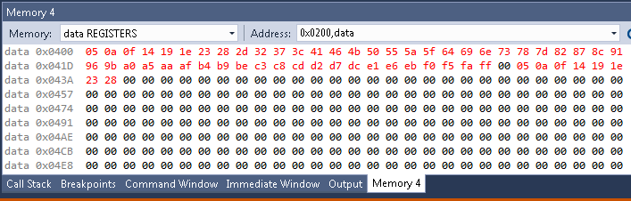

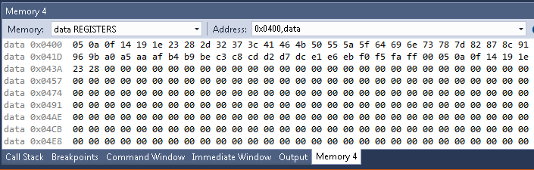

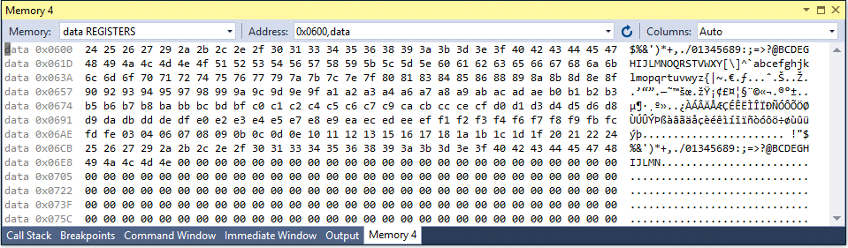

Here, the frequency was set at 16 MHz. We can also see that R16:R17 should have an expected result of 1980, the sum of the divisible numbers by 3. Likewise, R18:R19 should yield a result of 3960, which represents the sum of the numbers not divisible by 3. Below, the values of R16:R17 and R18:R19 are confirmed through the processor status window, displaying the values BC:07 and 78:0F respectively.

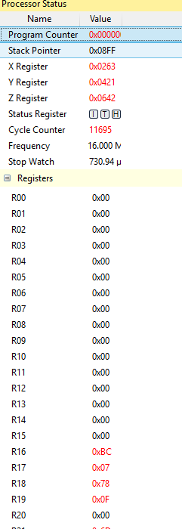

Below, this is verified with the compilation of my C++ program.

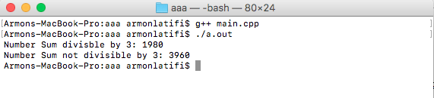

1. **SCREENSHOT OF EACH DEMO (BOARD SETUP)**

N/A

1. **VIDEO LINKS OF EACH DEMO**

N/A

1. **GITHUB LINK OF THIS DA**

https://github.com/armonlatifi/sub_da/tree/master/DA1B

**Student Academic Misconduct Policy**

<http://studentconduct.unlv.edu/misconduct/policy.html>

“*This assignment submission is my own, original work*”.

Armon Latifi