Craig ELlrod

senior cloud security architect

Checking ALL Armor Agent Statuses   
with N-Able

N-Central

Table of Contents

Introduction 2

Prerequisites 2

How it works 2

Import the ARMORall status check file 3

Step 1 – Navigate to the N-Able N-Central Web Browser Interface 3

Step 2 – Import the ARMORall.xml file, which also includes the ARMORall.amp file. 4

Step 3 – Set the Schedule 4

Step 4 – Check the Thresholds – for status checks 5

Step 5 – Check the Thresholds – for installation checks 5

Enable the status check policy on the devices 6

Step 6 – Enable the status check policy 6

Step 7 – Select Add 7

Step 8 – Select 1 instance of the ARMORall service. 7

Step 9 – Navigate to Views 🡪 Add Devices 🡪 <machine name> 🡪 Monitoring 8

Step 10 – Status should turn green, if it returns a red exclamation point, then one of the Armor Agents was either not installed or is not running. 8

Step 11 – Click on the ‘ARMORall’ policy 9

Step 12 – View which agent is failing. 9

# Introduction

This ARMOR Defense field guide will present a step-by-step method to deploy the Armor Agent automatically using the automation tools within N-Able’s N-Central platform.

## Prerequisites

An account with N-Able N-Central access.

<https://n-able.com>

An Armor Management Portal account – Managed Service Provider

<https://amp.armor.com>

The github for this tutorial.

<https://github.com/armorcloudsecurity/N-Able>

The scripts for this tutorial.

ARMORall.ps1

ARMORall.amp

ARMORall.xml

Note: The N-Able automation scripts and platform do not work with MAC OSX.

Additionally, there is a distinction with N-Able where they refer to the Managed Service Provider (MSP) account as the Service Organization (SO). Some illustrations in this document will refer to the “SO” or “MSP”, while other illustrations will refer to the MSP’s or SO’s customer, as “Customer”.

## How it works

Monitoring the Armor Agent Status for Windows through N-Able N-Central, involves these simple steps.

* Import the service template ARMORall.xml to check Armor status
* Enable the status check policy on the devices

# Import the ARMORall status check file

### Step 1 – Navigate to the N-Able N-Central Web Browser Interface

Navigate to Administration 🡪 Service Management 🡪 Custom Services.

Select Add 🡪 Service 🡪 Automation Manager Policy

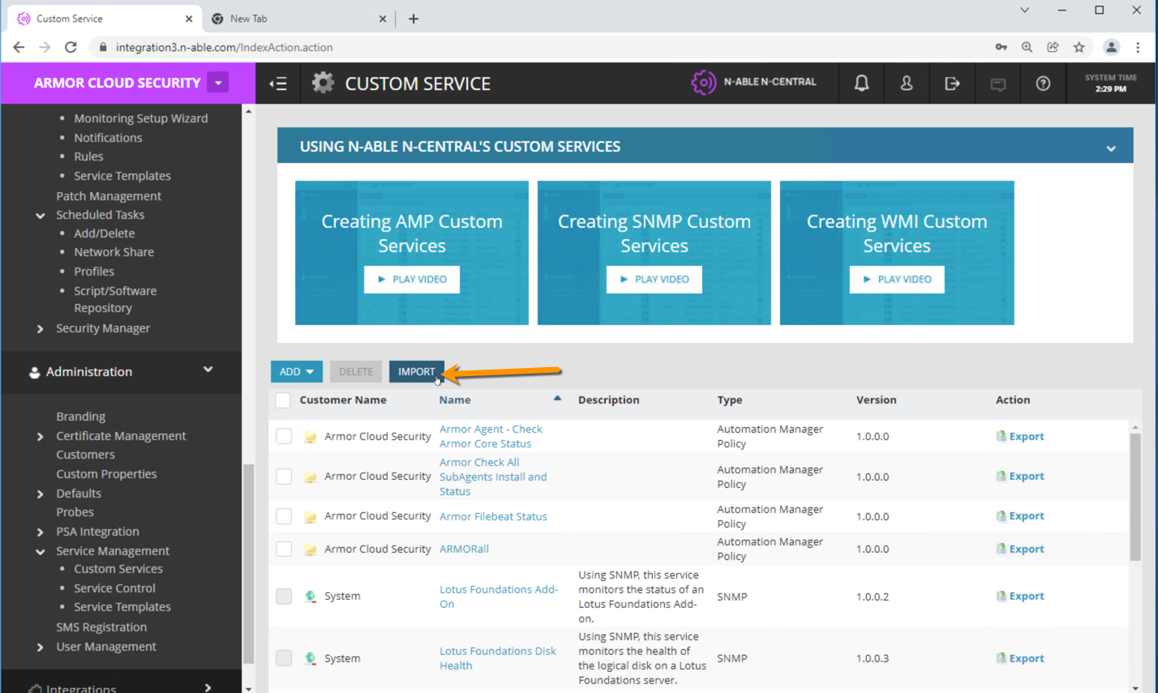

### Step 2 – Import the ARMORall.xml file, which also includes the ARMORall.amp file.

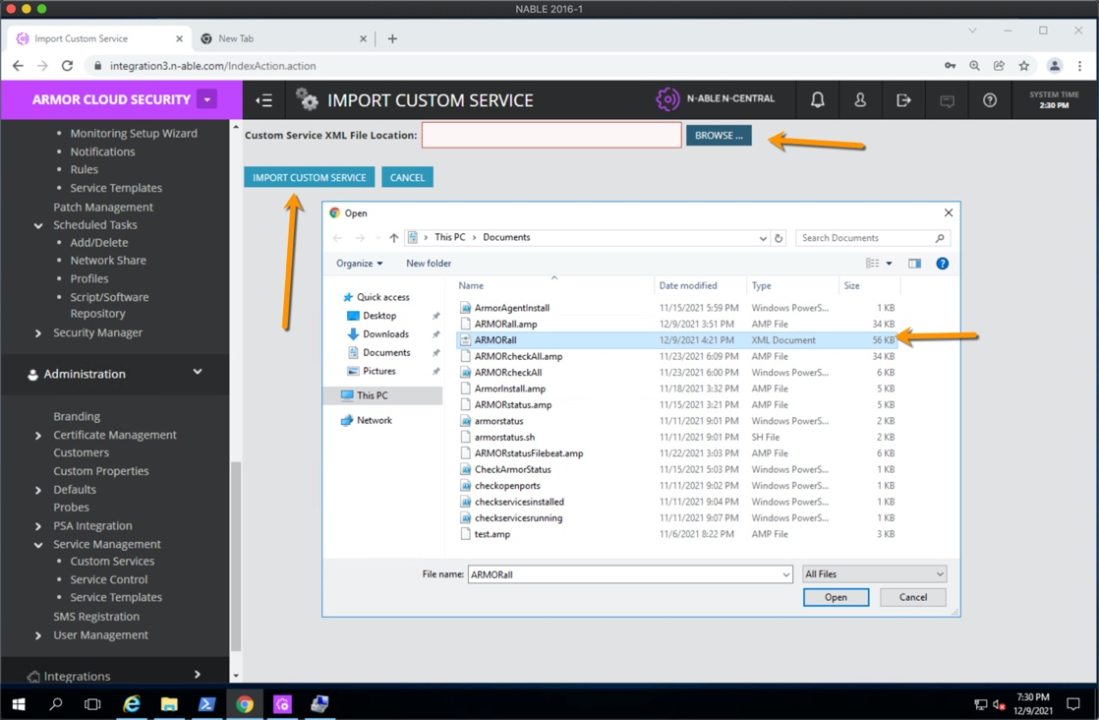

Name the service ‘ARMORall. The Automation Policy should be set to the policy we created in the Automation Manager earlier – ‘ARMORall.amp’.

### Step 3 – Set the Schedule

Configure the interval you want to check the agent status.

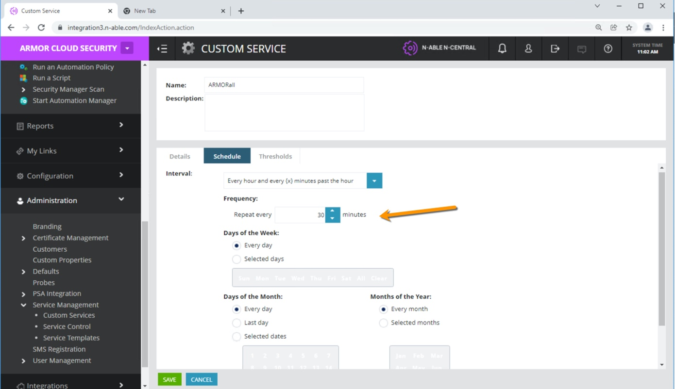

### Step 4 – Check the Thresholds – for status checks

Check the Threshold to trigger the automation policy. If the value of the string isn’t set to Running after the automation status run’s, the set the state to Failed. Double check this for all of the ‘Status’ check variables.

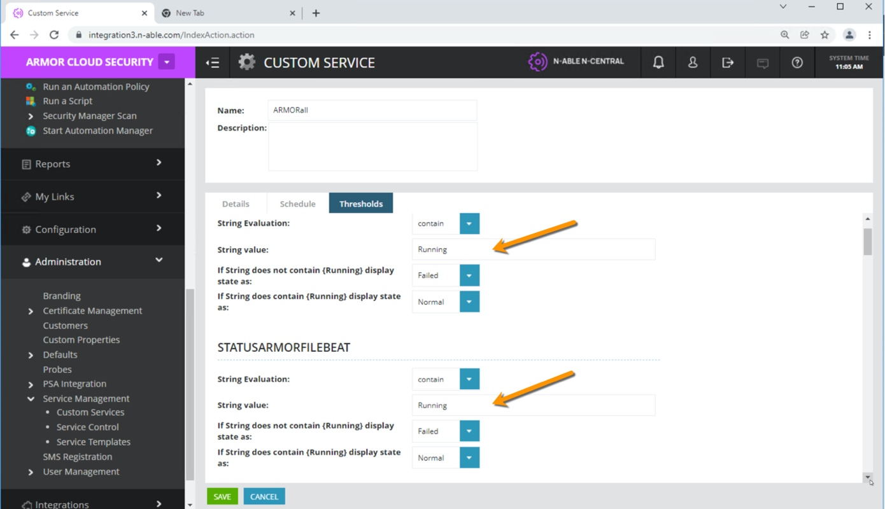

### Step 5 – Check the Thresholds – for installation checks

Check the Threshold to trigger the automation policy. If the value of the string isn’t set to Installed after the automation status run’s, the set the state to Failed. Check this for all of the ‘Installed’ check variables.

# Enable the status check policy on the devices

### Step 6 – Enable the status check policy

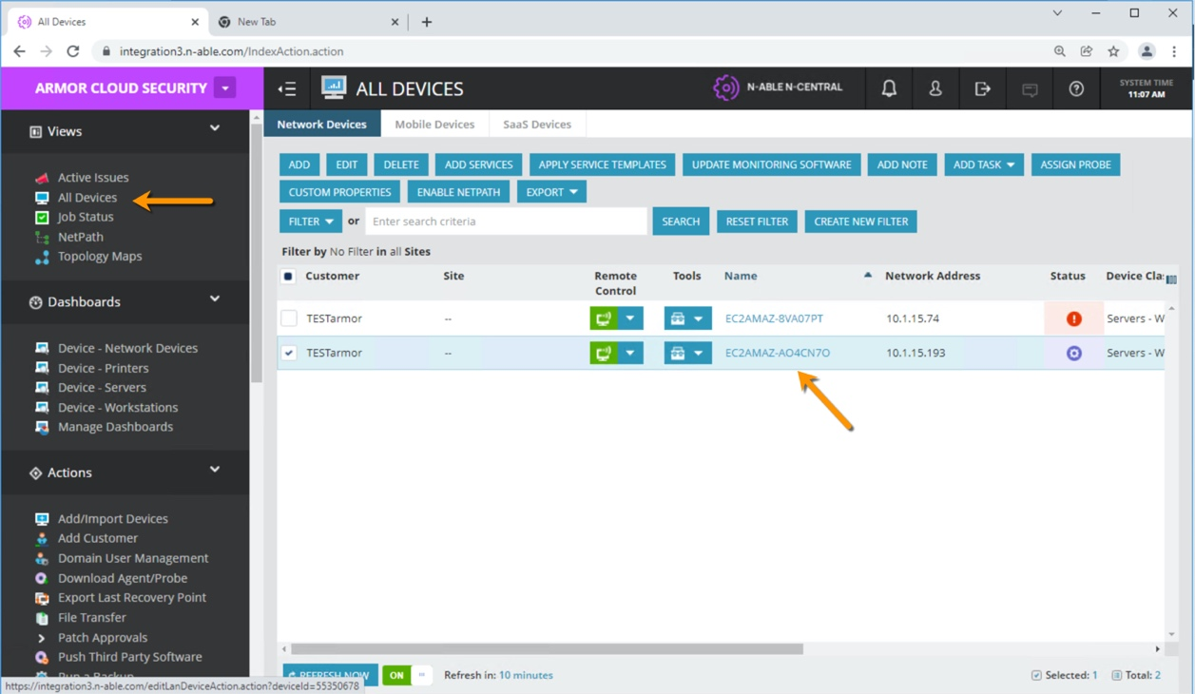

From the SO or MSP level, select Views 🡪 All Devices. Click on the machine name.

### Step 7 – Select Add

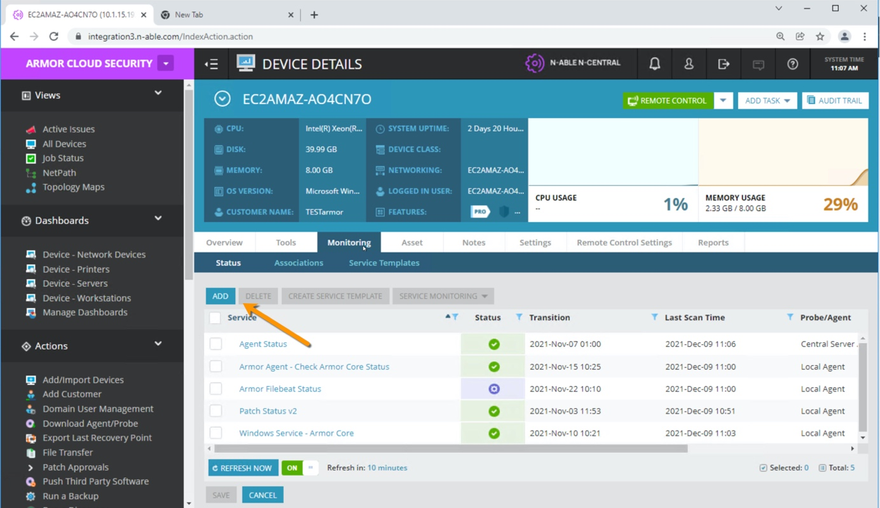

### Step 8 – Select 1 instance of the ARMORall service.

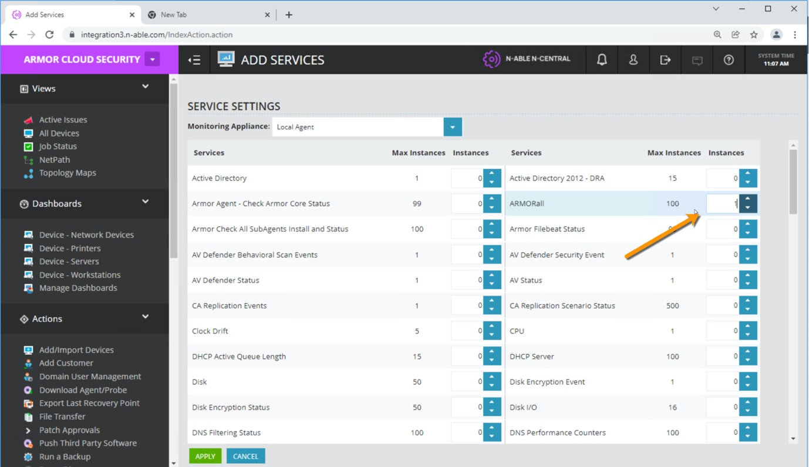

Click on ‘Apply’.

### Step 9 – Navigate to Views 🡪 Add Devices 🡪 <machine name> 🡪 Monitoring

Select the Service Monitoring drop down, and ‘Scan Now’.

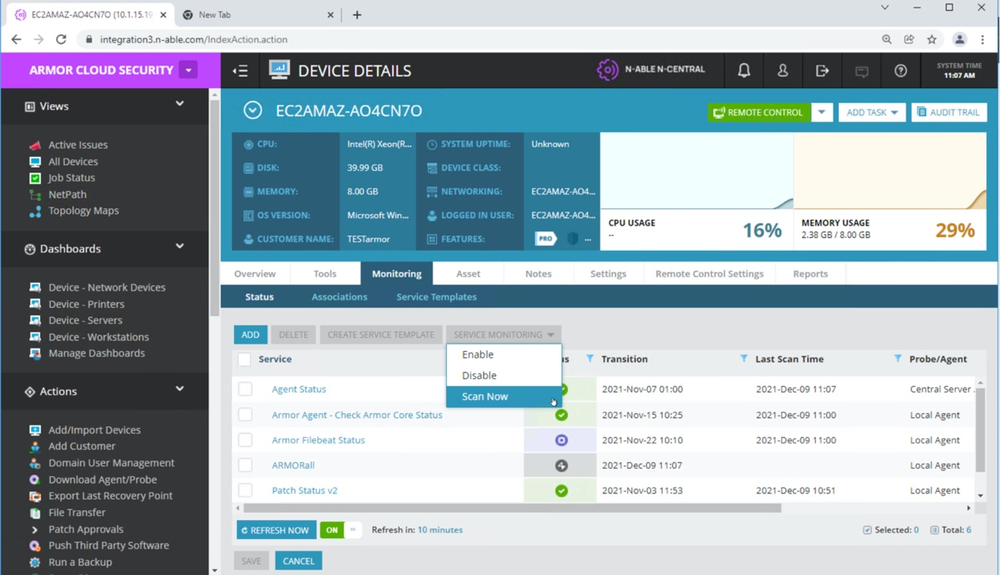

### Step 10 – Status should turn green, if it returns a red exclamation point, then one of the Armor Agents was either not installed or is not running.

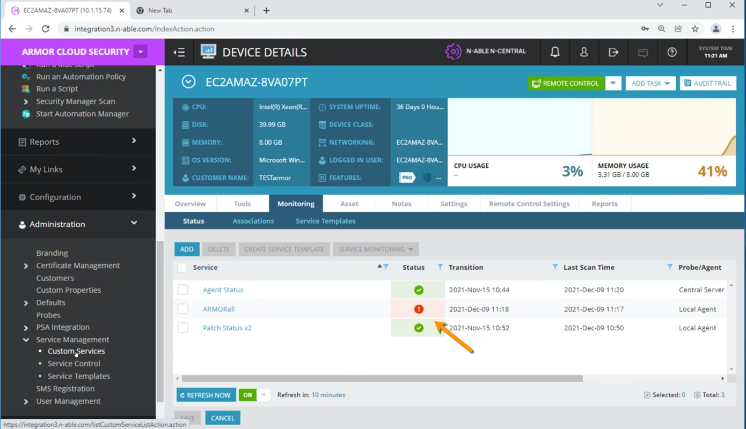

### Step 11 – Click on the ‘ARMORall’ policy

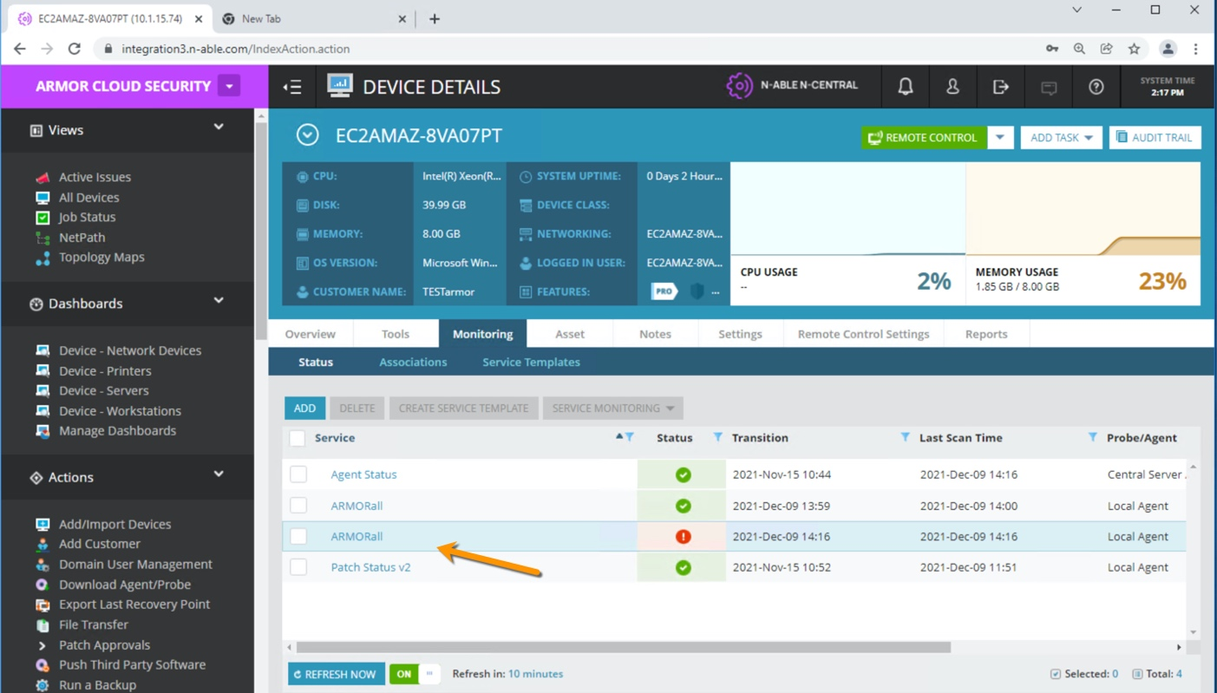

### Step 12 – View which agent is failing.

Here you can see which agent is failing or not installed. As an MSP you can restart the agent manually or install the missing agent manually. It is possible to create automated tasks for this, but would be more helpful if you were alerted, and then fix later – as advised by N-Able.

