Circuit documentation

Objective of the audio amplifier circuit is to power a 100W subwoofer (a speaker producing signals of low frequencies). Amplifier:

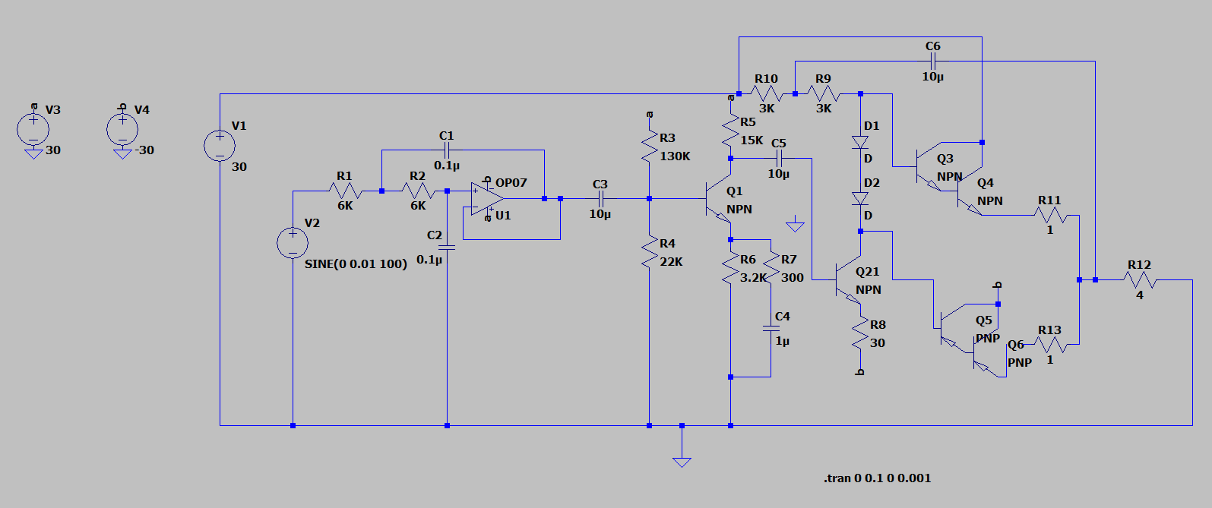

**Calculation of values:**

2 assumptions. First is that cutoff frequency = 200 Hz, and Q factor = 0.707. Take C1 to be 0.1 uC and C1 = C2. We can calculate R1, R2 where R1 = R2 = Q/(2pi * fc * C2), giving us 5.6 kilo-ohms. Practically speaking, I would not have a 5.6 kilo-ohm resistor component, so continue with a 6 kilo-ohm resistor. Also, this is a closed loop gain filter, so need for resistors at non-inverting terminal (shorted to output).

This circuit can be broken down into three distinct sub-circuits. The first is the low pass filter, which strips the input audio signal from noise and unwanted higher frequencies, allowing signals between 20 to 200 Hz to pass through. I implemented a Sallen-Key low pass filter. Here it is isolated:

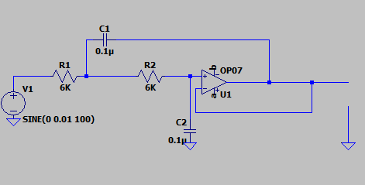

This is implemented on Tinkercad as such, before testing on real circuit.

Above, the signal on the left is input, signal above breadboard is output. Note that the signal is unchanged, since the frequency (100 Hz) is within the range allowed for the low pass filter (20 – 200 Hz).

In the following plot, the input signal is shown in green, and the output signal in blue (slight phase shift and damped amplitude):

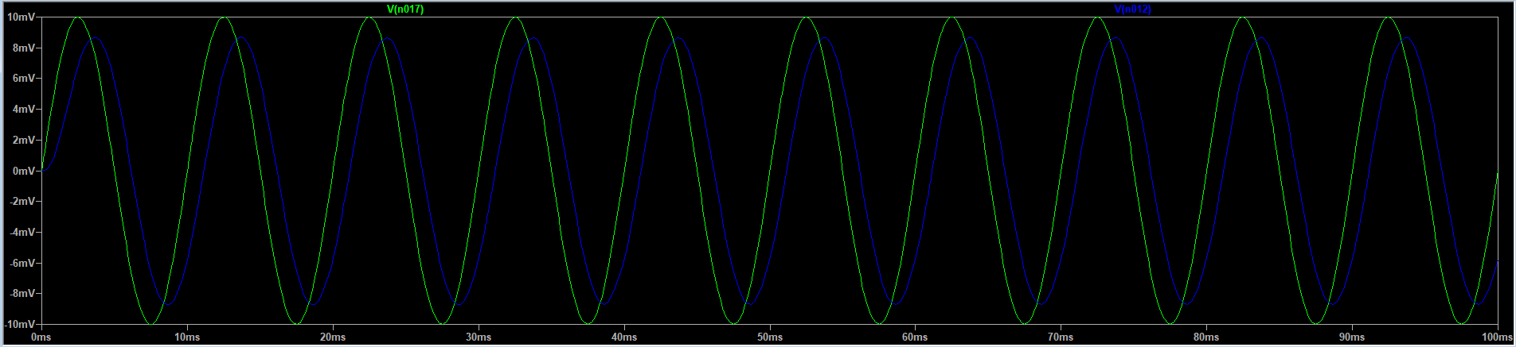

The second part of the circuit is the preamplifier, which is constructed as a class A amplifier. This is necessary because the voltage range we are working with at this stage (< 0.1 V, which is typical for analog sensors, for example microphones) is too low to be managed by a power amplifier, so we provide voltage gain to line level. Note that it does not provide current gain, which is left for the power amplifier to drive the subwoofer. Here is the isolated schematic:

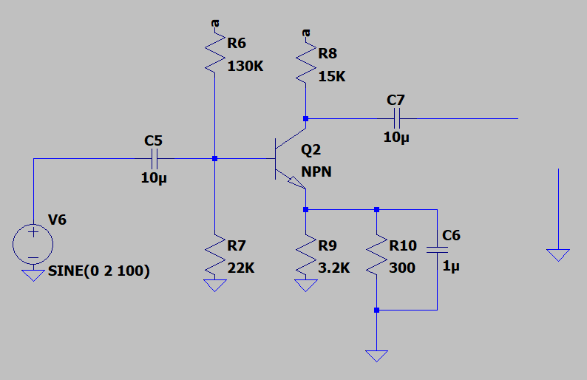

Since we require a power output = 100 W, and the load resistor is 4 ohms, we need a supply voltage of 30 V peak-to-peak. Assuming collector current = 1 mA and collector voltage = ½ supply voltage, then R5 = (Vsupply /2) / (collector current) = 15 / 0.001 = 15 kilo-ohms. Now, emitter voltage Vb = 12% of supply voltage = 3.6 V, and R3 = (Vsupply – Vb)/ (bias current) and R4 = Vb / (bias current). The bias current = collector current / hFE of transistor = 0.02 mA. Then according to the previous equations, R3 = 130K ohms and R4 = 22K ohms. R7 is a feedback resistor I inserted to reduce the decoupling effect of capacitor C4.

For some test input signal (shown in green), the signal is amplified (pink):

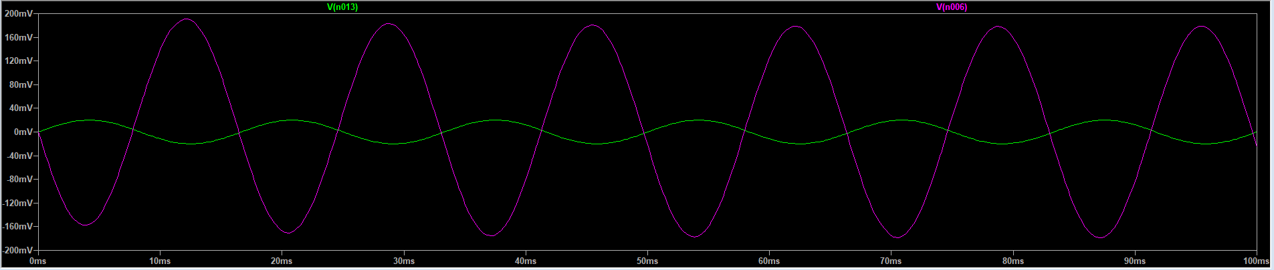

Finally, the third stage is the power amplifier, which is configured in class AB mode. The NPN transistor Q21 is there to act as a driver, taking in the (low power) input signal and converting into a high impedance signal. Also, Q3 and 4, as well as Q5 and 6, are cascaded together to increase current gain further (Darlington configuration). The resistor R10 is bootstrapped to provide these transistors with high impedance, so I chose a high value for it (3K ohms) and tinkered with the bounds. The coupled transistors Q3 and 4 deal with the positive half of the wave cycle, while Q5 and 6 conducts for the negative half cycle. To overcome the expected cross over distortion, the diodes D1 and D2 are used instead of resistors, as they bias the transistors. Resistors R11 and 13 are only there to minimize differences between the transistors. Since we need a low bias current, we need a high bias resistor, hence I choose a high value for R9 = 3000 ohms.

The output signal has a power of 100 W and can now be used to power a subwoofer of low impedance (in our case, 4 ohms).

The power amplifier sub-circuit is shown below on Tinkercad:

Combining the sub-circuits, we obtain the output signal with power between 101.342 to 101.362 W, i.e. hovers at 101 W:

