遊戲開始畫面
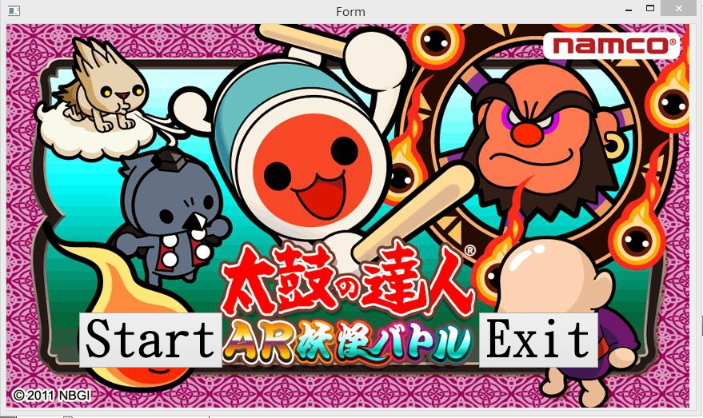

按下Start開始遊戲
按下Exit結束遊戲

遊戲進行畫面
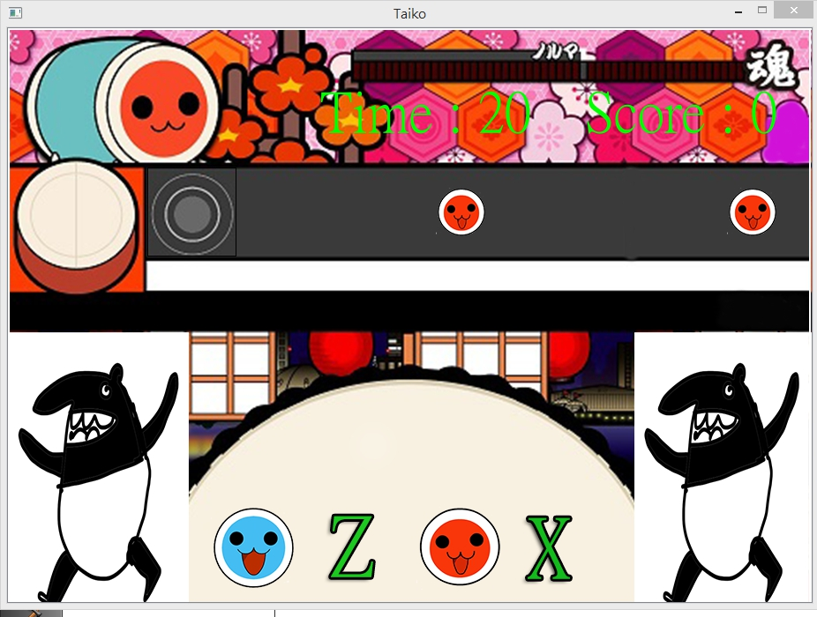

Time為遊戲時間限制30秒，到0時遊戲結束
Score為分數
當遇上紅色的鼓時，須按X消除，得1分
如果按Z，則會扣1分
當遇上藍色的鼓時，須按Z消除，得1分
如果按X，則會扣1分

遊戲結束畫面
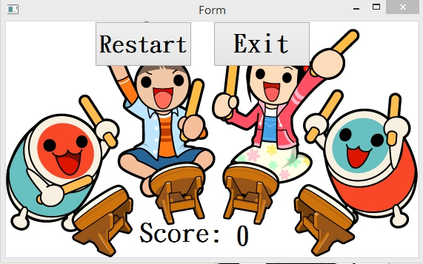
按下Restart重新開始遊戲
按下Exit結束遊戲

UML
Form
-on_pushButton_clicked():void
-on_pushButton_2_clicked():void

Game
*scene: QGraphicsScene
*score: Score
*player: MyRect
*time: Time
call():void

Drum
*correct:QMediaPlayer
*wrong:QMediaPlayer
+move():void
<<constructor>>+Drum()
+keyPressEvent(QKeyEvent * event):void

Drum_1
*correct:QMediaPlayer
*wrong:QMediaPlayer
+move():void
<<constructor>>+Drum_1()
+keyPressEvent(QKeyEvent * event):void

End
value:int
t:int
s:int
-on_pushButton_clicked():void
-on_pushButton_2_clicked():void

MyRect
+spawn():void

Score
score:int
+getScore():void
+increase():void
+decrease():void

Time
count:int
decrease():void
*end: End

