Guidelines to follow the Nagoya Protocol on Access and Benefit Sharing (ABS)

for

Marine Biodiversity Observation network for genetic monitoring of hard-bottom communities (ARMS-MBON)

Version

1.0

Date

2020-04-01

The Nagoya Protocol on Access and Benefit Sharing (ABS) is the main global mechanism to regulate the access and utilisation of genetic resources, including marine genetic resources. The agreement entered into force on October 12, 2014, as a supplement to the 1992 Convention on Biological Diversity. In March 2020, 122 countries and the EU are contracting parties to the Protocol. The protocol attends to the sovereign rights of the states on the benefits arising from the utilisation of the genetic resources within their national jurisdiction, including territorial waters. The volume of national implementing rules continues to proliferate, and this requires continuous screening of the national regulatory landscape globally. ARMS network participants need to be aware of the ABS Regulations in the country where the ARMS are deployed and from which genetic resources are going to be accessed and utilised. In Europe, and as of March 2020, the genetic resources providing states with approved National ABS regulations imposing obligations of previous informed consent on access (PIC) and mutual agreed terms (MAT) of utilisation of such resources are Belarus, Croatia, France, Malta and Spain. Most other countries have decided to grant free access to their genetic resources.

The European ARMS project requires providing proof that sampling has been done in accordance with due diligence protocols of the Protocol and that genetic resources can be utilised according to National ABS regulations in place. In countries with approved National ABS regulations, this is a matter of applying for the necessary permits and keeping note of the permit id/code. In countries where *no* actions have been taken to regulate access to national genetic resources, proof of such circumstance has to be provided, i.e. it is still necessary to prove that you were duly diligent in seeking to conform with the Protocols.

Note the following:

* Nagoya National Focal Points need to be contacted before doing any sampling.
* ARMS project participant in each country is always the user, while the institution doing the sequencing is only providing a service.

The steps to follow are:

**STEP 1**. Visit the ABS clearing house (<https://absch.cbd.int>) to search for information on the National ABS landscape (legislation, administration and policy issues, contact points.) for the country where the sampling will occur. Figure 1.

**STEP 2**. Find the ABS National Focal Point of interest. Figure 2.

**STEP 3**. Write to the National ABS Focal Point or the National ABS Mailbox. Figure 3.

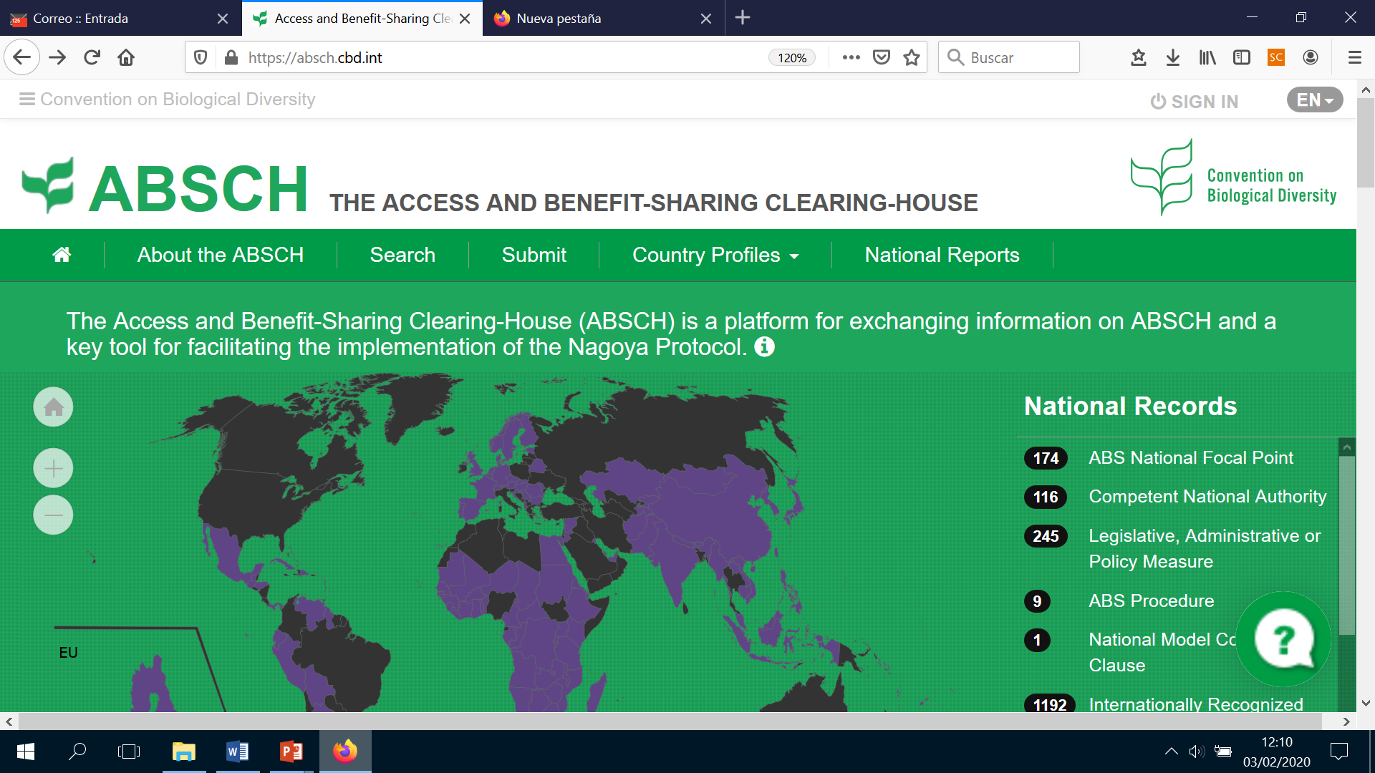

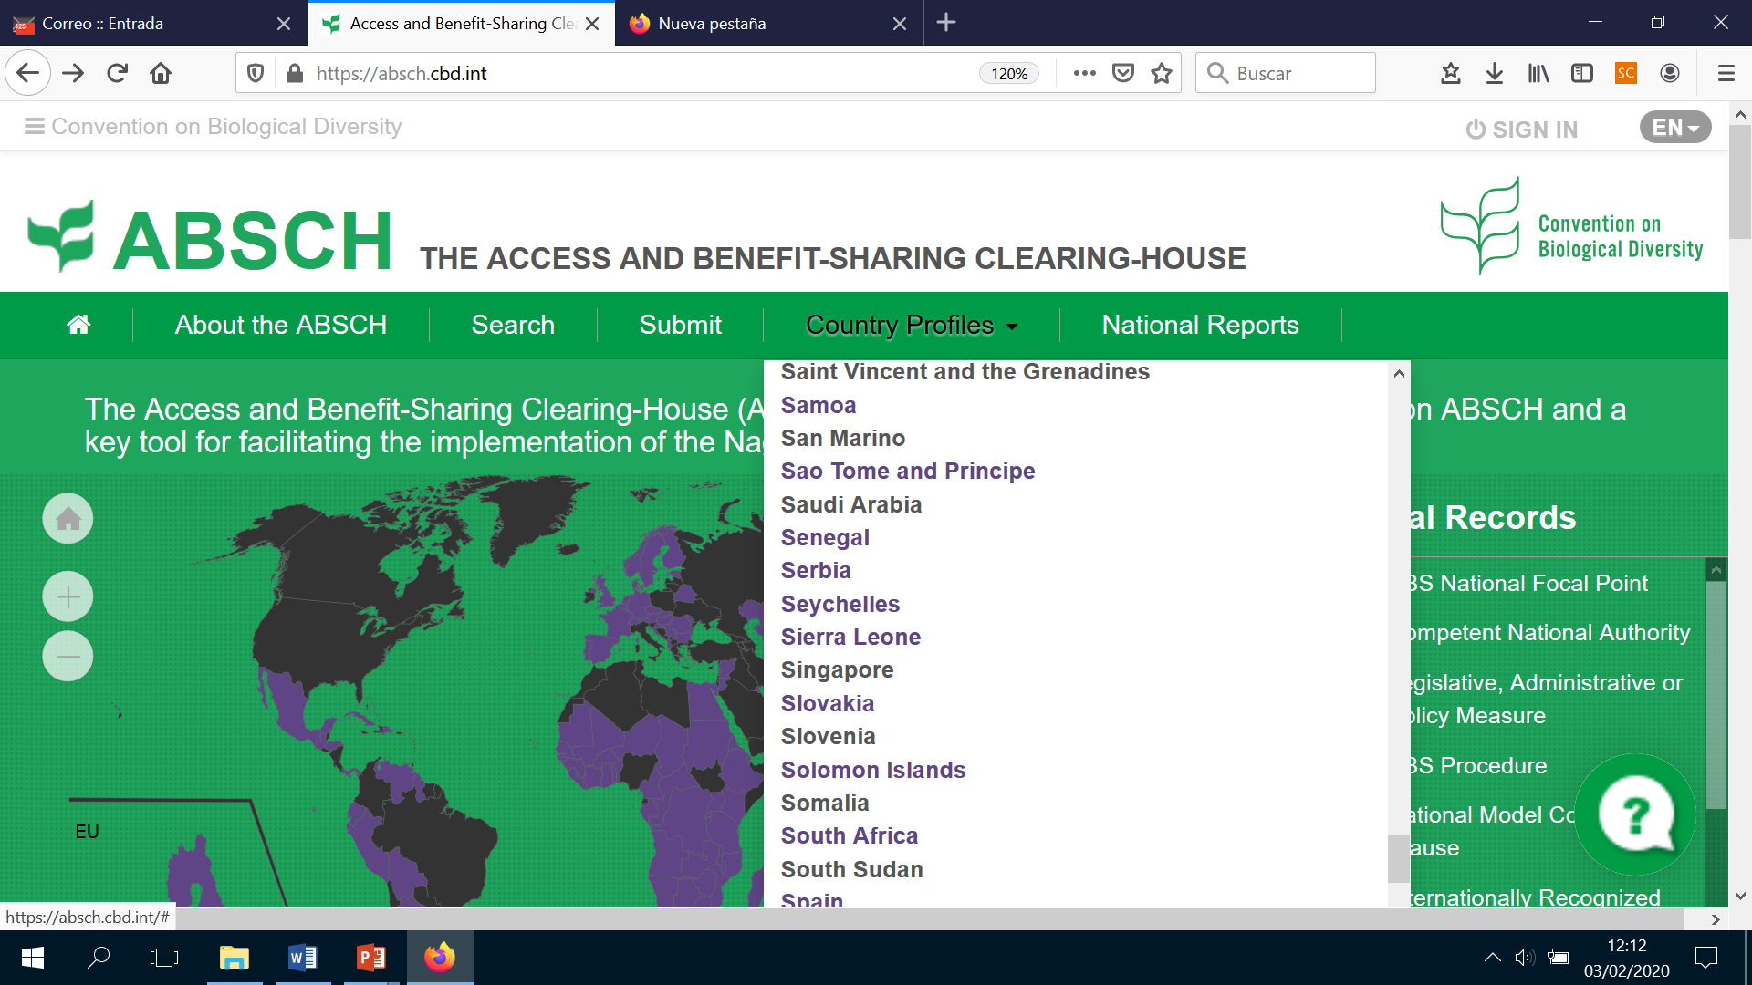

*Figure 1. ABS clearing house website: Step 1 National ABS landscape*

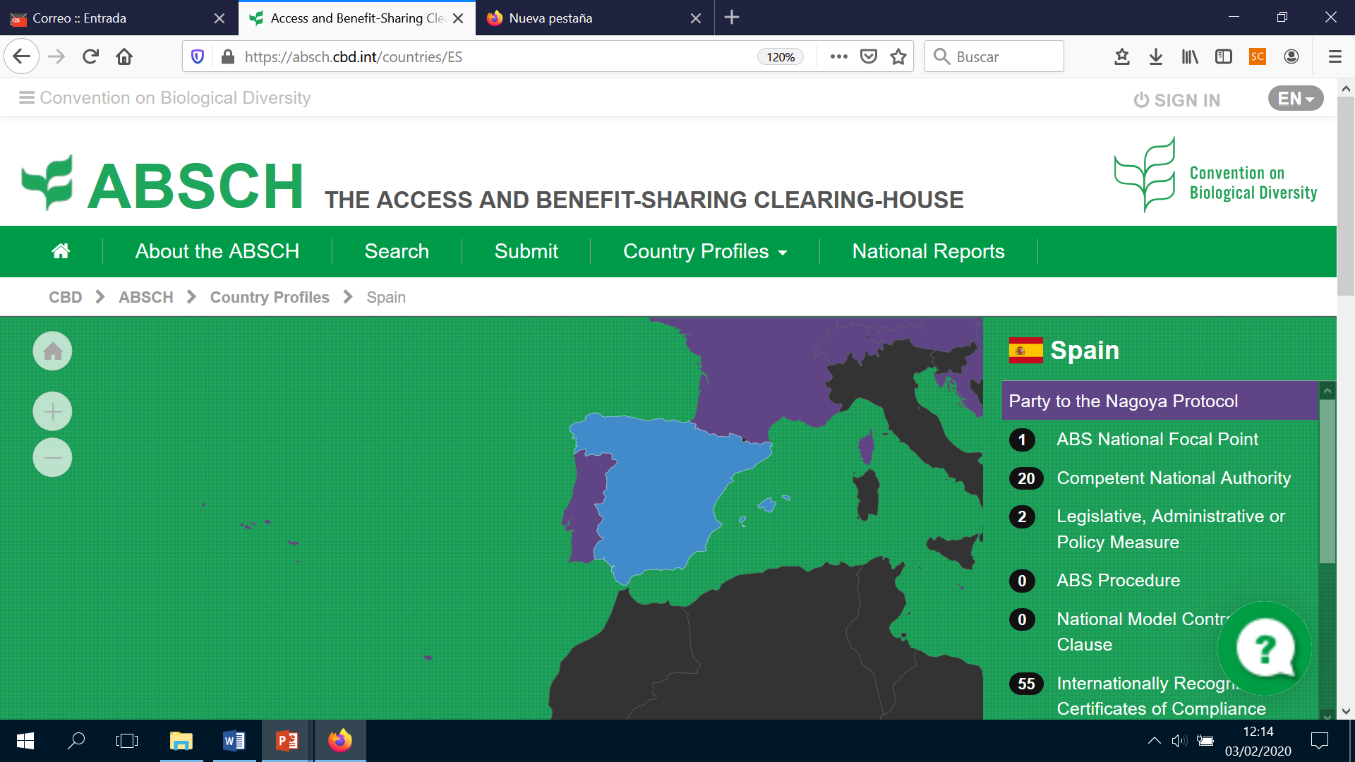

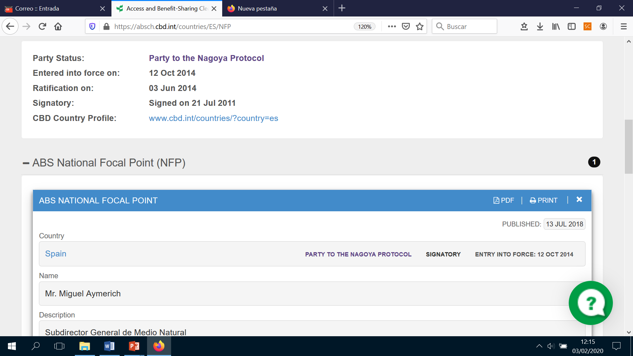

*Figure 2. ABS clearing house website: Step 2 National Focal Points*

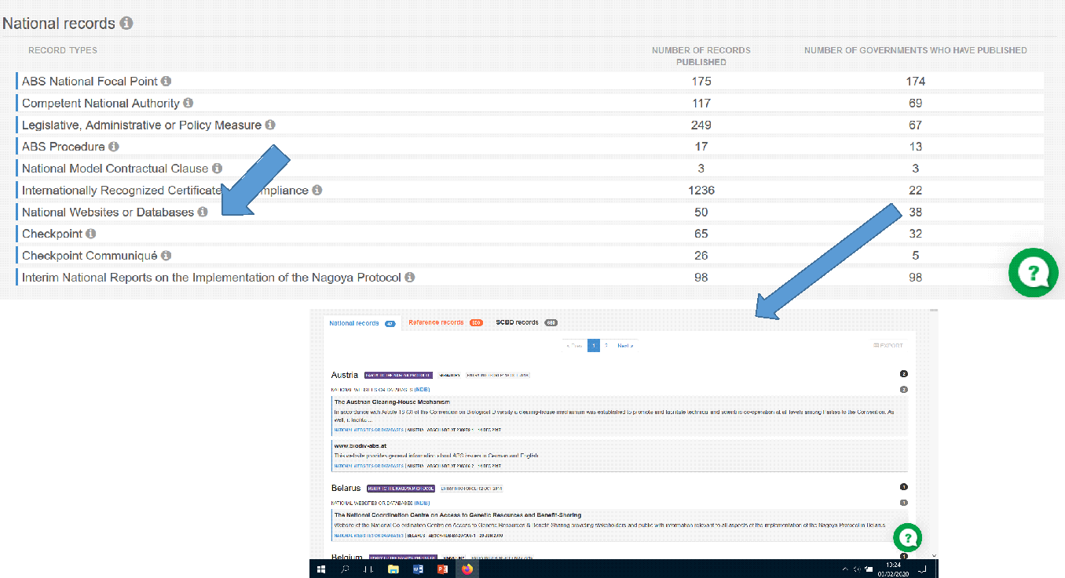

*Figure 3. Writing to the National Focal Points*

The ABS National Focal Point has to be contacted to ask about the ARMS deployment and sampling. Prove of contact may be necessary, so communication via email is preferable to a phone call. For a first contact there are countries with Nagoya Centres: as of March 2020, 38 countries have published national websites linked to Nagoya and ABS, with a Nagoya mailbox. Write an e-mail to the mailbox or to the Nagoya ABS Focal point. and ask whether it is necessary to obtain PIC and negotiate MAT for the ARMS project. If these permits are necessary, you will be pointed to the mechanism in place. Some countries have ABS portals for web-based PIC and MAT requests. If permits are not necessary, keep the email with that reply, as it provides your “due diligence”. If you get no reply, keep track of your emails as that can also be used as “due diligence” (although, strictly-speaking, no reply = no sampling allowed),

When making contact with the National Focal Point, include the following:

* A short explanation of the ARMS project. Explain what ARMS means: "Autonomous Reef Monitoring Structures" (http://www.oceanarms.org/) PVC cages, 23 cm X 23 cm, with plates that are deployed in the sea bottom where they are colonised by the benthic fauna and flora.
* The names of all research team members participating in the sampling and sample processing.
* The location of ARMS deployment site (longitude and latitude), method, and dates of deployment and retrieval.
* A brief explanation of methods applied (plate photographing, plate scraping and organism collection, sieving, homogenisation in DMSO, sending off for metabarcoding).
* State where the samples will be sent to, and that metabarcoding will be carried out analysing COI, 18S rRNA and ITS.
* State clearly that the purpose is “taxonomy and biodiversity monitoring with research purposes”.

**Mentioning the taxonomic purpose is importan**t. For example, in Spain taxonomic research is OUT of scope (no ABS signed permits necessary), but in France is IN scope (signed permits are necessary).

The answer received from the Nagoya focal point or the mailbox could be:

1. Access to national genetic resources is free under our national regulations (no Access regulations in force);
2. Access to national genetic resources for taxonomic purposes is out of scope (no signed ABS permits necessary for ARMS project),
3. Access to national genetic resources for taxonomic purposes is in scope (signed ABS permits are necessary).
4. You receive no reply

*If 1 or 2*: These emails are the permits for the user and the proof of “Due Diligence” that the international regulatory landscape and the ARMS project require. Digital copies must be deposited in the ARMS PlutoF page for your observatory (sampling event), and also need to be sent to the metabarcoding centre along with the samples themselves, logsheets and material transfer agreement.

*If 3*: Asking for PIC and MAT will be necessary. The information on how to apply should be provided by the National Contact Point, in case the information sent does not trigger the process already. When granted the documents will be signed by the user and the National ABS competent authority. These will be archived by the National competent authority with the ABS Clearing House (ABSCH) and the user will receive a signed Internationally Recognised Certificate of Compliance (IRCC). This IRCC will need to be included with the material that you send to the metabarcoding centre, and must also be deposited in the ARMS PlutoF page for your observatory (sampling event). (In fact, it is *only* the IRCC code that is required, but a copy of the document is also acceptable.)

*If 4*: When no answer is received, it is necessary to try more than once. We recommend that you try 3 times, each one month apart. The ARMS project needs to provide proof that the National focal point has been asked, so a digital copy of e-mails sent need to accompany samples and logsheets, and must be deposited in the ARMS PlutoF page for your observatory (sampling event). Note that the ABSCH stores all national legal information required, so if no ABS restrictions apply in the country of concern the user can provide the link to the National documentation that states that “access to national genetic resources is free in his/her country”.