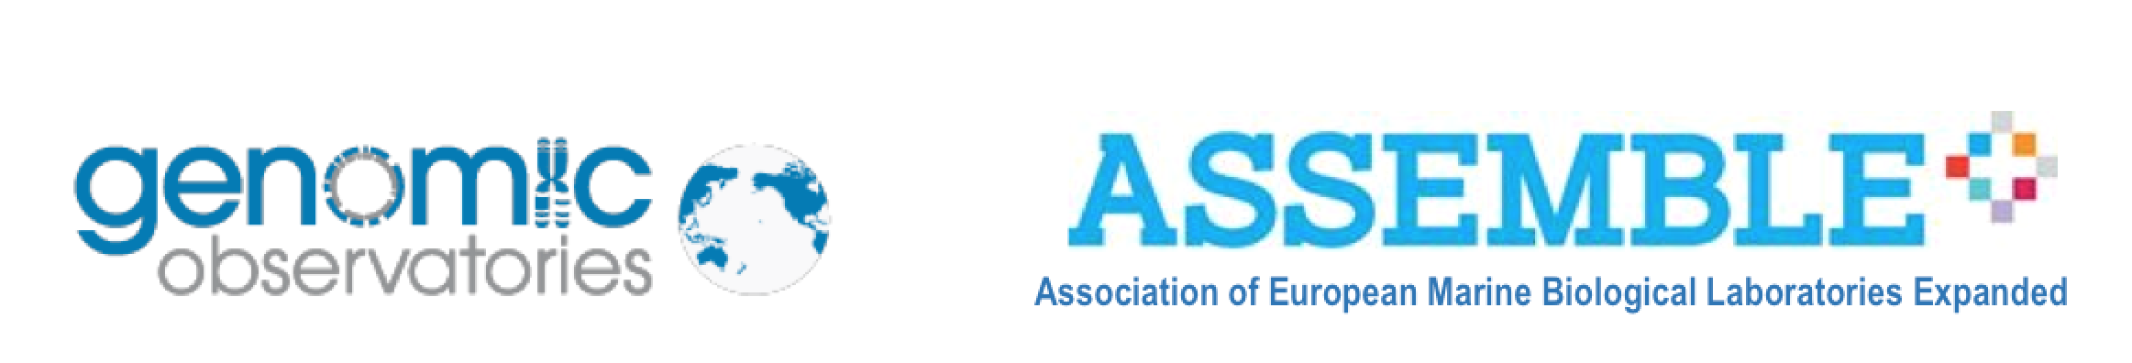

Material Transfer Agreement (MTA)

for

Marine Biodiversity Observation network for genetic monitoring of hard-bottom communities (ARMS-MBON)

Version

1.0

Date

2020-04-01

**Material Transfer Agreement**

**Between**

***<add you institutions name here>* and the *Hellenic Centre for Marine Research***

This agreement, effective as of the date of the last approving signature on this document, between the *<add you institutions name here>* and the *Hellenic Centre for Marine Research*, conveys to the Hellenic Centre for Marine Research temporary custodial responsibilities for biological samples listed in the below Appendix.

As a part of this agreement, *Hellenic Centre for Marine Research* will:

* Store and/or sequence the samples, with the provision that *Hellenic Centre for Marine Research* can not be held liable for loss or destruction of the samples in the event of catastrophic facility or equipment failure.
* abide by the conditions of the Access and Benefit–sharing Agreement as constituted in the Nagoya Protocol.

Appendix

|  |  |  |  |
| --- | --- | --- | --- |
| **Material sample identifier** | **Deployment Date / Retrieval Date** | **Collection site** | **Collectors name** |
| Fill one row for each material sample, e.g. ARMS_Koster_VH2_180418–180906_SF40_A | e.g. 2018-04-18 / 2018-09-06 | Koster, Sweden | Matthias Obst |
|  |  |  |  |

*<add you institutions name here>*

By <add signature and date>

Contact information:

*<add contact information of the signee>*

*Hellenic Centre for Marine Research*

By

Contact information:

*Christina Pavloudi*

*Institute of Marine Biology, Biotechnology and Aquaculture*

*Hellenic Centre for Marine Research*

*(former US Base) Gournes Pediados*

*71500 Heraklion Crete*

*Greece (Hellas)*

*Tel: +30 2810 33 77 41*

*Email:* [*cpavloud@hcmr.gr*](mailto:cpavloud@hcmr.gr)