 | Fast National University of Computer & Emerging Sciences
Human Computer Interaction
Deliverable-4
Prototype: Structure, Function and Accessibility
Instructor:
Dr. Javeria Imtiaz
Section: BSCS-7B
Member 1: Muneeba Zaheer (23i-0581)
Member 2: Armish Tauqir (23i-0786)
Member 3: Areej Fahim (23i-0504)
Member 4: Warisha Shaukat (23i-0809)
Team No. and Team Name: 05 Konnect
Date: Nov 4, 2026

Table of Contents
1. Purpose, inputs from D3 and scope
Part A. Low-fidelity interactive prototype and critique record
2. Information architecture (card sort and navigation pattern)
3. Grayscale wireframe flow
4. Accessibility audit log
5. Fixed versus deferred issues
6. Critique record
Part B. Functional prototype, design system and implementation
7. Functional task flow (vertical slice)
8. Minimal design system
9. Feedback, errors and component states
10. Implementation documentation
11. Accessibility re-check
12. D4 video
13. AI-use note
14. Reflection
15. Submission checklist

1. Purpose, inputs from D3 and scope
D4 turns the D3 storyboard into a prototype in two parts. Part A validates structure and accessibility at low fidelity, while changes are cheap. Part B makes the core task actually work so it can be checkpointed live and inspected in D5A. Every decision below traces back to D3 (selected concept M4-E), D2 (requirements R1 to R5, themes T1 to T5, HTA) and the D1B evidence notes (for example H-12, J-06).

1.1 What we carried forward from D3
D3 item | What it says | How D4 uses it
Selected concept M4-E (camera overlay, refined) | A phone view of the real machine that names parts in the machine's own words, rings the part the current step refers to, opens on a task, shows one step at a time with that step's cautions, tags normal responses and draws a “full to here” line. | This is the concept wireframed in Part A and built in Part B.
Storyboard | Persona A (Careful First-Timer) sets up and starts a heavy-load wash on the washing machine. | Core task of the vertical slice: “First wash: set up and start a heavy load” on the Panasonic NA-F135A1.
D2 HTA, Plan 0 (washing machine) | 1 Find instructions, 2 Identify parts, 3 Prepare (tray, then detergent), 4 Load, 5 Set controls (power on and read display, select Heavy/Bedding and water level Auto), 6 Start and interpret. | Step order of the prototype: tray → main-wash compartment → load → power/display → program → Start/lid lock.
D3 risk: live part recognition cannot be built at low fidelity | Test the flow and wording, not recognition accuracy. | Recognition is Wizard-of-Oz in Part B (Section 10.3). The camera feed itself is real.
D3 risk: hands may be full; printed markings stay small | Large buttons, one step per screen; enlarged symbols in the overlay. | 48 px minimum targets; 18 px minimum body text; symbols paired with words (Section 8).
D3 5.2: English first, optional Urdu | R5: critical markings understandable regardless of language. | English and Urdu are both built, with right-to-left layout for Urdu.

1.2 Requirements the prototype must serve (from D2)
Req. | Short form | Where the prototype addresses it
R1 | Identify each named part, control and symbol correctly first time | Steps 1, 2, 5: ring + label on the live view in the machine's words (W2, W3, W6)
R2 | Reach the instruction for the current step in 60 s or less | Home opens directly on the task; one step per screen (W1, step frame)
R3 | Correct order; no cautioned action | Fixed step order from the HTA; Next disabled until a step is done; wrong-compartment and overfill errors (E2, E3)
R4 | Understand normal responses when they happen | “32 = wash minutes. Normal.” (W5), “Click = lid locked. Normal.” (W7), global “Is this normal?” (N1, N2)
R5 | Critical markings perceivable and understandable | Symbols always paired with words; large type; 4.5:1 contrast; English and Urdu

1.3 Scope of D4
- One machine, one model: Panasonic NA-F135A1 top-load washing machine (the D1B machine). The air fryer is out of D4 scope.
- One task, fully working (vertical slice): “First wash: set up and start a heavy load”, including its alternate and error paths.
- Machine reference: the machine details used on screen (tray inside the lid on the left, two compartments with symbols only, push buttons and digital display showing a number before Start, Heavy/Bedding program, water level Auto, lid locks with a click, 13.5 kg capacity, manual detergent section p. 36) come from D1B Section 4.1. We could not download images of the machine into our build environment, so the prototype uses the live phone camera, and a labelled grayscale drawing of the machine as the fallback. No photo of the machine is shown as if it were real.

Part A. Low-fidelity interactive prototype and critique record

2. Information architecture

2.1 Method: AI-simulated card sort
The D4 brief allows AI-simulated participants to replace users for the card sort. To keep the sort grounded in our own fieldwork rather than in invented users, each simulated participant (SP) was built from one D1B participant's profile and behaviour, as recorded in the D2 participant and persona tables. The sort was run in two rounds:
- Open sort: each SP grouped all 24 cards into piles of its own and named the piles. No category names were given.
- Analysis: we counted, for every pair of cards, how many of the 5 SPs put them in the same pile (co-occurrence matrix), then clustered the cards (average-linkage hierarchical clustering on 1 − agreement, cut at 0.55).
- Closed check: the team named the final IA categories from the clusters. Each SP then placed all 24 cards into those fixed categories, and we counted how many cards landed where the IA puts them.
SP | Grounded in (D1B / D2) | How this shaped the simulated sort
SP-F | F (Persona B, Lookup User; machine first, then contents; twin-tub background) | Groups by where things are on the machine (detergent, loading, buttons); looks for the screen that answers a specific question.
SP-H | H (Persona A, Careful First-Timer; reads from page one; never used a washer) | Puts cautions with ‘before you begin’ (reads warnings first, H-03); groups ‘sounds and numbers’ together (H-08, H-14).
SP-G | G (Persona B, Lookup User; owns a front-loader; uses tables) | Most fine-grained piles; separates program settings from start, as on her own front-loader.
SP-I | I (Persona A, Careful First-Timer; afraid of skipping a safety part) | Makes a separate ‘Safety’ pile for load and cautions (I-01: afraid of skipping a safety part).
SP-J | J (Persona C, Try-First Fixer; tries the machine, then YouTube) | One big ‘do the wash’ pile and one ‘help’ pile; anything not about doing goes to help (J-09, J-12).

Cards (content and functions of the concept)
Card | Content / function | Card | Content / function
C01 | Choose a task (First wash) | C13 | Press Start
C02 | Confirm my machine model | C14 | Lid-lock click
C03 | Find the detergent tray | C15 | Countdown on the display
C04 | Main-wash compartment | C16 | Is this normal? (point at anything)
C05 | Softener compartment | C17 | Part names on the camera view
C06 | How much detergent | C18 | Enlarge a tiny symbol
C07 | Full-to-here line on the drum | C19 | Cautions for this step
C08 | Is my load too much? | C20 | Switch English / Urdu
C09 | Power on | C21 | Camera can't see the part
C10 | What does "32" mean? | C22 | Show a drawing instead of camera
C11 | Choose Heavy/Bedding program | C23 | Step progress (step 3 of 6)
C12 | Water level Auto | C24 | Go back a step

2.2 Open sort results
SP | Piles and pile names (as named by the SP)
SP-F | Getting started: C01, C02, C20  Detergent: C03, C04, C05, C06  Loading: C07, C08  Buttons and display: C09, C10, C11, C12, C13, C15  Is it working?: C14, C16  Seeing the parts: C17, C18, C21, C22  Moving around: C19, C23, C24
SP-H | Before you begin: C01, C02, C19, C20  Putting things in: C03, C04, C05, C06, C07, C08  Starting the machine: C09, C11, C12, C13  Sounds and numbers: C10, C14, C15, C16  Help me see: C17, C18, C21, C22  Where am I: C23, C24
SP-G | Setup: C01, C02  Detergent tray: C03, C04, C05, C06  Load: C07, C08  Program settings: C09, C11, C12  Start and running: C10, C13, C14, C15  Check a signal: C16  View tools: C17, C18, C20  When it fails: C21, C22  Navigation: C19, C23, C24
SP-I | Start here: C01, C02, C20  Safety: C07, C08, C19  Detergent: C03, C04, C05, C06  Controls: C09, C10, C11, C12, C13  Normal or broken?: C14, C15, C16  Seeing the machine: C17, C18  Problems: C21, C22  Steps: C23, C24
SP-J | Do the wash: C01, C03, C04, C05, C07, C09, C11, C12, C13  Settings: C02, C20  Did I break it?: C10, C14, C15, C16  Help: C06, C08, C18, C19, C21, C22  Camera: C17  Back / next: C23, C24

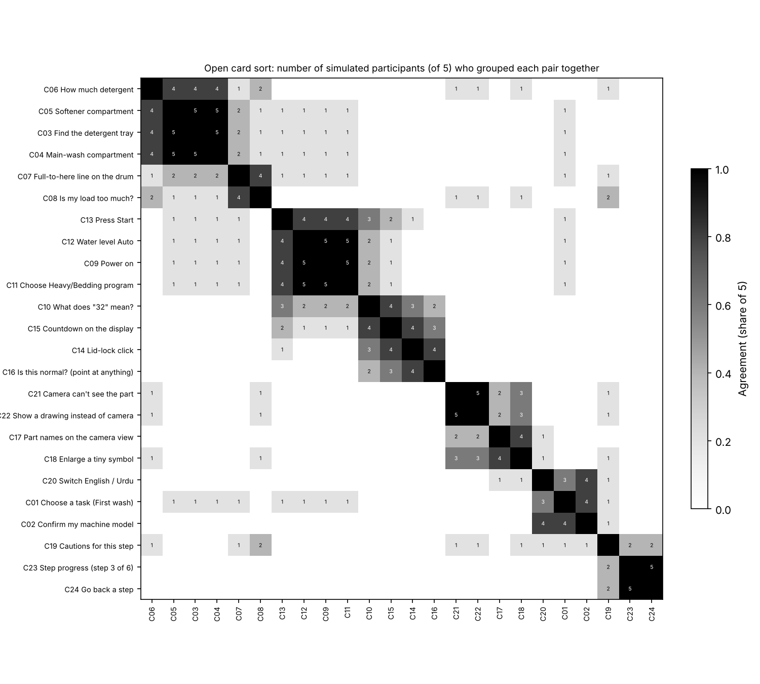
Figure 1. Co-occurrence matrix of the open sort, ordered by the cluster tree. Each number is how many of the 5 SPs grouped that pair together.
Clusters from the analysis (cut at 0.55, i.e. pairs grouped together by roughly half or more of the SPs):
Cluster | Cards
K1 | C03 Find the detergent tray  C04 Main-wash compartment  C05 Softener compartment  C06 How much detergent
K2 | C07 Full-to-here line on the drum  C08 Is my load too much?
K3 | C09 Power on  C11 Choose Heavy/Bedding program  C12 Water level Auto  C13 Press Start
K4 | C10 What does "32" mean?  C14 Lid-lock click  C15 Countdown on the display  C16 Is this normal? (point at anything)
K5 | C17 Part names on the camera view  C18 Enlarge a tiny symbol  C21 Camera can't see the part  C22 Show a drawing instead of camera
K6 | C01 Choose a task (First wash)  C02 Confirm my machine model  C20 Switch English / Urdu
K7 | C23 Step progress (step 3 of 6)  C24 Go back a step
K8 | C19 Cautions for this step

2.3 From clusters to the information architecture
IA category | Cards | Source cluster and reasoning
Home: choose a task | C01 Choose a task (First wash) | K1 put the task with model and language (all ‘getting started’). We made the task the hub screen itself, because R2 needs the user to reach the current step quickly.
Settings (in header) | C02 Confirm my machine model  C20 Switch English / Urdu | Same cluster K1. Language is a header button so it is reachable from every screen (R5).
Step 1: Detergent (tray and compartment) | C03 Find the detergent tray  C04 Main-wash compartment  C05 Softener compartment  C06 How much detergent | K2, 5 of 5 SPs agreed on all pairs. Becomes two screens (tray, then compartment) to follow HTA 3.1 then 3.2.
Step 2: Load | C07 Full-to-here line on the drum  C08 Is my load too much? | K3. Kept as one step with the ‘full to here’ check (T4).
Step 3: Set the controls | C09 Power on  C11 Choose Heavy/Bedding program  C12 Water level Auto | K4 also contained Start. We split Start into its own step because HTA step 6 is where hesitation was observed (F-07 hovered over Start, H-10) and because SP-G and SP-H kept them apart.
Step 4: Start | C13 Press Start | Split from K4 (see above).
Is this normal? (global) | C10 What does "32" mean?  C14 Lid-lock click  C15 Countdown on the display  C16 Is this normal? (point at anything) | K5, strong agreement. Because these signals happen at different moments (power on, Start, during the wash), this group is a global dialog reachable from every screen, not a step.
Camera view tools (on every step) | C17 Part names on the camera view  C18 Enlarge a tiny symbol | K6 mixed these with recovery cards. We separated them: naming parts is the normal behaviour of every step, recovery only appears when something fails.
Can't see it? (recovery) | C21 Camera can't see the part  C22 Show a drawing instead of camera | From K6; shown only inside error state (a).
Step frame (on every step) | C19 Cautions for this step  C23 Step progress (step 3 of 6)  C24 Go back a step | K7 + K8. Progress, Back and the step's caution belong to every step screen rather than to a menu.

2.4 Closed check
SP | Cards placed as in the IA | Cards placed elsewhere
SP-F | 92% | C10 What does "32" mean? → Step 3: Set the controls  C15 Countdown on the display → Step 4: Start
SP-H | 92% | C19 Cautions for this step → Home: choose a task  C08 Is my load too much? → Is this normal? (global)
SP-G | 96% | C10 What does "32" mean? → Step 3: Set the controls
SP-I | 96% | C19 Cautions for this step → Step 2: Load
SP-J | 88% | C06 How much detergent → Can't see it? (recovery)  C08 Is my load too much? → Can't see it? (recovery)  C18 Enlarge a tiny symbol → Can't see it? (recovery)
All | 93% average

What the closed check changed:
- “What does 32 mean?” (C10) was put under ‘Set the controls’ by two SPs. The number appears right after Power, so the answer is now shown in two places: inline on Step 4 (W5) and in the global ‘Is this normal?’ dialog.
- “Cautions for this step” (C19) was put with ‘Home’ or ‘Load’ by the two page-one SPs (H, I). We keep cautions on each step, but repeat the R3-critical caution (detergent in MAIN WASH) on the Start step, where a mistake can no longer be undone.
- SP-J put help-like cards (C06, C08, C18) under recovery. This matches Persona C looking for help only after something goes wrong (J-09). Recovery is therefore placed inside each error message (Try again / Choose again / Check again) rather than in a separate help screen.

2.5 IA tree and navigation pattern
Level | Structure
Header (every screen) | Konnect + machine model · Language (English / اردو) · Is this normal?
Hub | Home: choose a task → First wash (active) · Other tasks (not in prototype)
Sequence (First wash) | Step 1 Find tray → Step 2 MAIN WASH → Step 3 Load to line → Step 4 Power and display → Step 5 Heavy/Bedding → Step 6 Start and lid lock → Done
Step frame (every step) | Progress · Step n of 6 · Title · Instruction · Camera view with ring and labels · Caution · Status/feedback · Back / Next
Global utility | Is this normal? dialog: 32 on display · lid click · number going down · something else
Recovery (inside errors) | Try again · Show a drawing instead · Choose again · Check again

Stated navigation pattern: hub-and-spoke at the top, sequential (linear) inside the task, with one global utility. The card sort produced one small ‘getting started’ group and a set of groups that follow the order of the job (detergent, load, controls, start). A hub fits the first: the user picks a task, and future tasks become new spokes. A linear sequence fits the second, because the order itself is a requirement (R3) and D1B showed users skipping or reversing steps (J-05 preheat, H-12 compartment). The ‘normal or broken?’ group was the one group the SPs did not tie to a step, so it is a global dialog rather than a spoke.

3. Grayscale wireframe flow
Built in draw.io (file: Konnect_D4_PartA_Wireframes.drawio, submitted with this report). Grayscale only, with boxes and labels: the point is structure and flow, not appearance. Row 1 is the core task, row 2 the alternate and error paths and the global dialog.
Figure 2 is on the next (landscape) page.

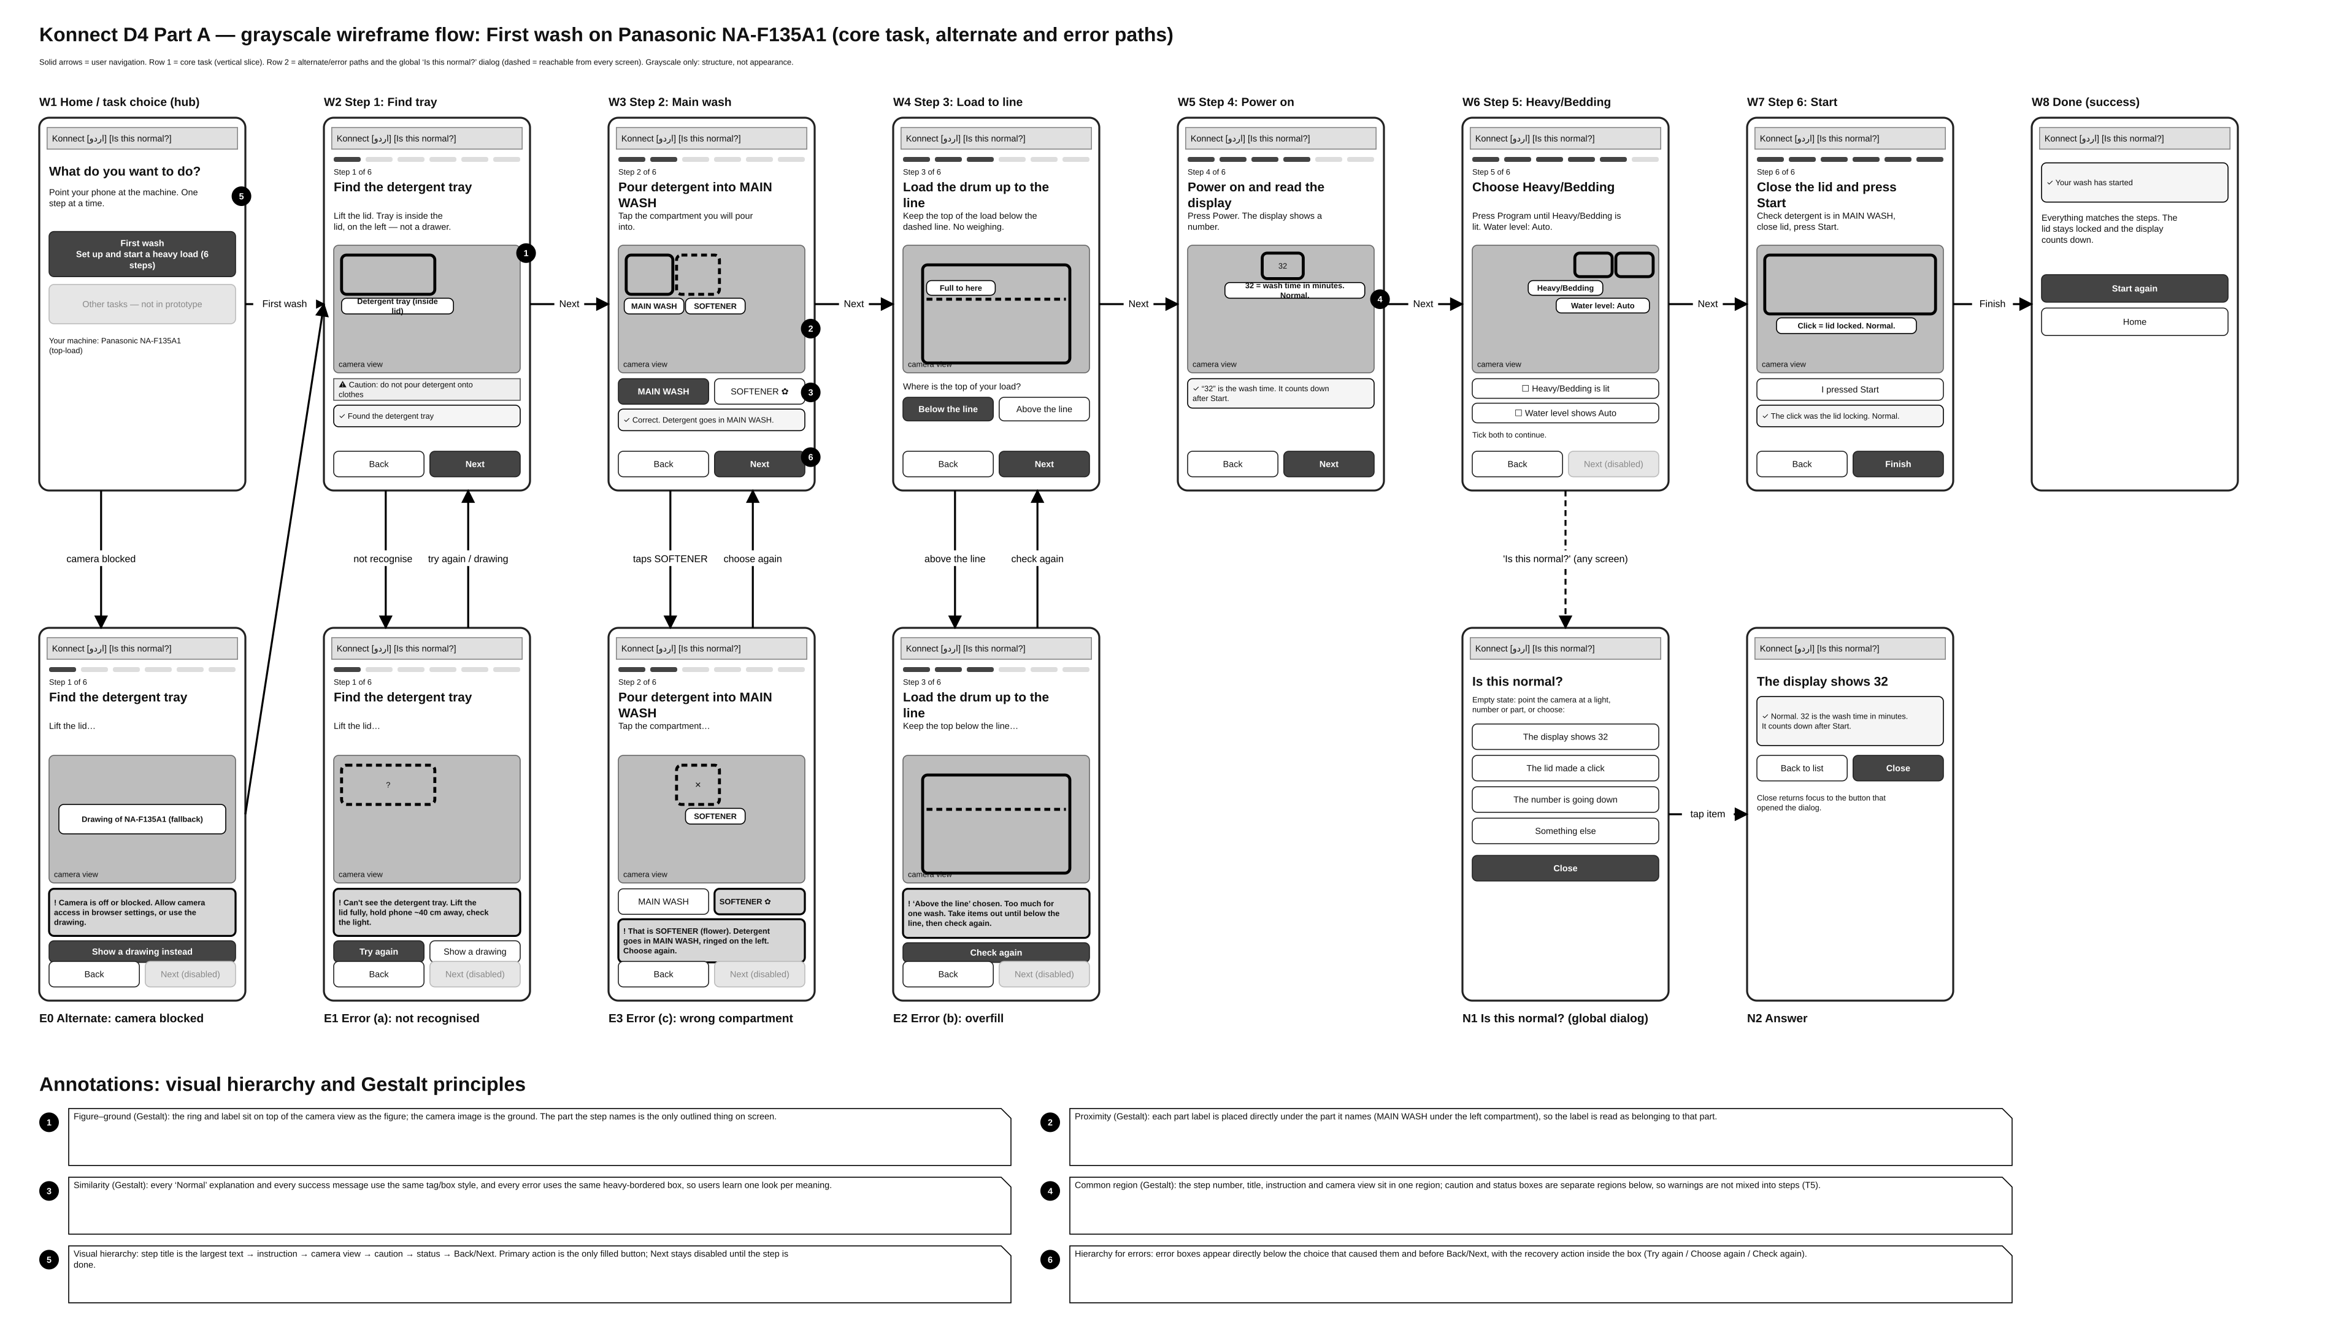
Figure 2. Wireframe flow W1–W8 (core task), E0–E3 (alternate and error paths), N1–N2 (global ‘Is this normal?’). The full-size version is in the .drawio file.

3.1 Screen inventory
ID | Screen | HTA step | Requirement | Evidence it answers
W1 | Home / task choice (hub) | 1 Find the instructions | R2 | H-15, F-12 (steps buried)
W2 | Step 1: Find the detergent tray (inside lid, left) | 3.1 | R1 | G-07, H-11, H-17
W3 | Step 2: Pour detergent into MAIN WASH | 3.2 | R1, R3, R5 | H-12, G-06, F-06, F-08
W4 | Step 3: Load the drum up to the line | 4.1, 4.2 | R3 | H-05, H-06, F-04, G-02
W5 | Step 4: Power on and read the display (“32”) | 5.1 | R4 | F-03, H-08, F-11
W6 | Step 5: Choose Heavy/Bedding, water level Auto | 5.2 | R1, R4 | H-10, G-10, G-03
W7 | Step 6: Close the lid and press Start (lid click) | 6.1, 6.2 | R3, R4 | F-07, H-14
W8 | Done (success) | 6.2 | R4 | —
E0 | Alternate: camera blocked → drawing | — | R1 | Technical path
E1 | Error (a): part not recognised | 2.1 | R1 | I-05 (viewing angle)
E3 | Error (c): wrong compartment (softener) | 3.2 | R3 | H-12
E2 | Error (b): load above the line | 4.2 | R3 | F-04
N1/N2 | Is this normal? list / answer (global) | 6.2 | R4 | H-14, J-06, I-11

3.2 Navigation, alternate and error paths
Path | Route | What the user sees
Core | W1 → W2 → W3 → W4 → W5 → W6 → W7 → W8 | One step per screen; Next is disabled until the step is done; Back is always available.
Alternate E0 | W1 → E0 → W2 (drawing mode) | If the browser blocks the camera: specific message and ‘Show a drawing instead’.
Error (a) E1 | W2 → E1 → W2 | ‘Can't see the detergent tray. Lift the lid fully, hold the phone about 40 cm away, and make sure the area is well lit.’ Try again / Show a drawing.
Error (c) E3 | W3 → E3 → W3 | ‘That is SOFTENER (flower symbol). Detergent goes in MAIN WASH, the compartment ringed on the left. Choose again.’
Error (b) E2 | W4 → E2 → W4 | ‘Too much for one wash. Take some items out until the top of the load is below the dashed line, then check again.’
Global | Any screen → N1 → N2 → back to the same screen | Dialog; closing returns focus to the button that opened it.

3.3 Visual hierarchy and Gestalt principles (noted on the wireframes as 1–6)
# | Principle | Where | How it is applied
1 | Figure–ground | W2 camera view | The ring and label are the figure; the camera image is the ground. Only the part the step names is outlined (T1).
2 | Proximity | W3 compartment labels | Each label sits directly under the part it names, so MAIN WASH is read as the left compartment, not the right.
3 | Similarity | W3 buttons / all status boxes | Every ‘Normal’ and success message shares one style; every error shares one heavy-bordered style. One look per meaning.
4 | Common region | W5 step frame | Step number, title, instruction and camera share one region; caution and status boxes are separate regions below, so warnings are not mixed into the steps (T5).
5 | Visual hierarchy | W1, all steps | Title (largest) → instruction → camera → caution → status → Back/Next. The primary action is the only filled button.
6 | Hierarchy for errors | W3 / E1–E3 | The error appears directly below the choice that caused it, above Back/Next, with the recovery action inside the error box.

3.4 AI decisions in the wireframes (disclosure)
The wireframe screens and draw.io file were generated with AI (Claude, Anthropic) from the D3 concept, the D2 HTA and the card-sort IA. AI decided the screen layout inside each frame, the wording of the three error messages, and where the Gestalt annotations are placed. The team decided the scope (one model, one task), which error paths to include (a, b and c) and the navigation tool (draw.io), and checks every screen against D2/D3 before submission.

4. Accessibility audit log
Status: the manual keyboard-only and screen-reader walkthroughs have not been run yet. The team will agree how and on which device to run them (to be discussed), then fill in Tables 4.1 and 4.2. The brief requires these walkthroughs to be done by a person, so no findings are reported for them here.

4.1 Keyboard-only walkthrough log (to be completed by the team)
Procedure: no mouse or touch. Use Tab / Shift+Tab, Enter / Space and Esc only, through W1 → W8, then E0–E3 and the dialog. Log every point where focus is lost, in an illogical order, invisible or unreachable.
# | Screen | Action | Expected focus | What happened | POUR | Fix / status
K1 | W1 | Tab from page start | Language → Is this normal? → First wash |  | Operable
K2 | W2 | Enter on First wash | Focus moves to step title |  | Operable
K3 | W3 | Choose SOFTENER | Focus moves to error message |  | Operable
K4 | W4 | Choose Above the line | Focus moves to error; Check again reachable |  | Operable
K5 | W6 | Space on both check boxes | Next becomes available |  | Operable
K6 | N1 | Open dialog, Esc | Focus returns to ‘Is this normal?’ |  | Operable
K7

4.2 Screen-reader-informed walkthrough log (to be completed by the team)
# | Screen | What was announced | Problem (meaningless / wrong order) | POUR | Fix / status
S1 | W2
S2 | W3
S3 | E1–E3
S4 | N1
S5 | Urdu mode

4.3 Automated pre-check (AI-run, not a substitute for 4.1 and 4.2)
While building, the prototype was driven in a headless Chromium browser with a script (Playwright). It recorded the Tab order on Home and the accessibility tree a screen reader receives on Step 1. This helped catch problems early, but it does not count as the manual walkthrough.
# | Screen | Finding | POUR | Status
P1 | W2–W7 (drawing mode) | The machine drawing's symbols (⏻ 32 ▤ ▦ ≋ A ▢ ✿) were read out after the image description: meaningless announcements. | Perceivable | Fixed: symbols hidden from assistive technology; the image keeps one text description.
P2 | All steps | The caution box started with a bare “⚠”, announced without meaning. | Perceivable | Fixed: icon hidden; the text now starts with “Caution:” (“احتیاط:” in Urdu).
P3 | W3 | The two tappable rings on the camera view duplicated the MAIN WASH / SOFTENER buttons, so they would be announced twice. | Robust | Fixed: rings hidden from assistive technology and removed from Tab order; the labelled buttons below remain.
P4 | W1 | Tab order: Language → Is this normal? → First wash → Facilitator controls. The disabled ‘Other tasks’ is skipped. | Operable | As intended. No change.
P5 | All | On a new step, focus moves to the step title; errors use role=alert and take focus; the dialog returns focus to its opener; switching language changes lang/dir (ur/rtl). | Operable / Understandable / Robust | Verified by the script.

5. Fixed versus deferred issues
Issue | Decision | Reason
P1, P2, P3 | Fixed before submission | Low cost; would create meaningless announcements.
D1: The live camera picture has no text equivalent of what is on screen | Deferred (mitigated) | Real scene description needs real recognition. Every step gives the instruction, part name and result as text, so the task can be done without seeing the overlay.
D2: Urdu wording not yet checked by a native reader on the team | Deferred, to fix before the checkpoint | AI-drafted translation; a team member must check it.
D3: Facilitator panel buttons are 40 px high (below the 48 px used elsewhere) | Deferred | Used only by the facilitator, not part of the user interface.
K1–K7, S1–S5 | Pending | Results of the manual walkthroughs in 4.1 and 4.2.
Any issue deferred here must be revisited before the instructor checkpoint (Section 11).

6. Critique record
How this critique was run: no studio rapid-critique notes were available to us at the time of writing. The wireframes were therefore critiqued by an AI reviewer (Claude, Anthropic) on 4 Nov 2026, reviewing each screen against R1–R5, the D3 open risks and the three personas. The team reviews and confirms each point. This is not a record of a studio session; if a studio critique takes place, its notes should be added as a new round.
# | Screen | Critique point | Response in the submitted version | Status
1 | W3 | If the compartments are told apart by symbol only (the flower), the screen repeats the machine's problem (F-08, G-06). | Both choices carry words: MAIN WASH and SOFTENER ✿; the error names the symbol and the word. | Done
2 | W4 | A self-check (‘below / above the line’) can simply be skipped. | Next stays disabled until the user answers; ‘Above’ leads to E2. | Done
3 | W6 | Two check boxes may feel like extra work for Persona C (try-first). | Kept, because H-10 and G-10 show hesitation at this exact step. To be measured in D5B. | Open: test in D5B
4 | W1 | A disabled ‘Other tasks’ may look broken. | Labelled ‘Not in this prototype’. | Done
5 | E1 | An error that only says ‘not found’ does not tell the user what to do. | Message says what to change (lift the lid fully, about 40 cm away, light) and offers Try again or a drawing. | Done
6 | W7 | The prototype cannot hear the lid click; the user confirms Start by tapping. | ‘I pressed Start’ + Wizard-of-Oz click; disclosed in Section 10.3 and in the video. | Disclosed
7 | All | T2 signals happen at several moments (power on, Start, during the wash), not on one step. | ‘Is this normal?’ is in the header on every screen. | Done
8 | All | D3 risk: Persona A may stay on paper (I used no phone). | A printed fallback card is outside D4 scope; carried to D5 as an open question. | Deferred
9 | W1→W2 | No path for a blocked camera. | Added E0 with the drawing fallback. | Done
Team confirmation: ☐ Reviewed and confirmed by the team (initials: ______ )

Part B. Functional prototype, design system and implementation

7. Functional task flow (vertical slice)
The core task works end to end: Home → six steps → Done, with all three error states, the camera-blocked path, the global ‘Is this normal?’ dialog, and English/Urdu switching.
Live link: https://claude.ai/artifact/6VSAaj2ZovVvHG6dFY3bjp
File: konnect-prototype.html (one self-contained file). Opened on a laptop or inside the claude.ai viewer, the browser blocks the camera, so the prototype shows the camera-blocked message and continues on the labelled drawing. For the live camera on a phone, the same file must be opened from an https address (for example GitHub Pages).
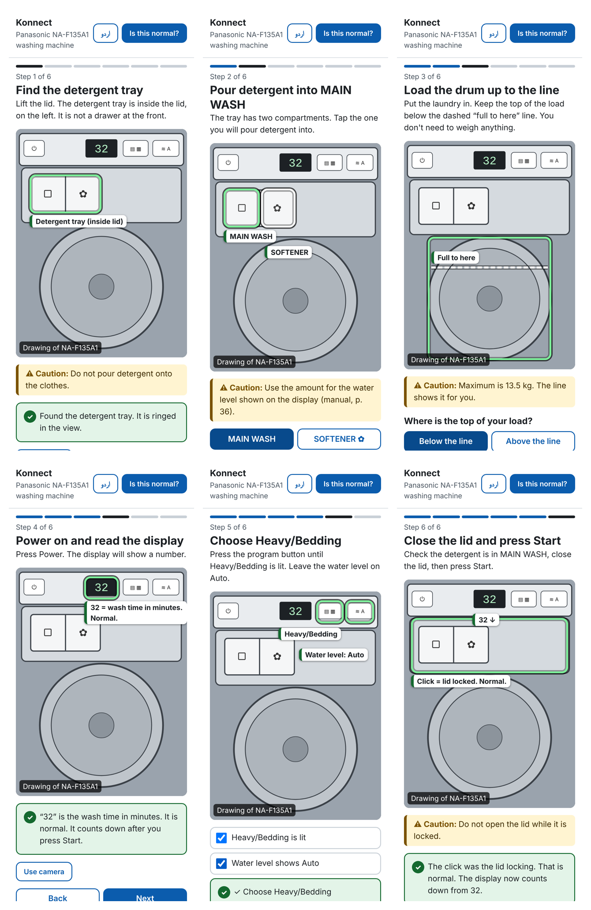
Figure 3. Core path in the built prototype (drawing mode): Steps 1–6 after each step is completed.

7.1 What is built and what is simulated
Part of the flow | Built or simulated | Detail
Live camera feed (rear camera) | Built | Real camera through the browser (getUserMedia). Falls back to the drawing if blocked.
Overlay rings, labels and ‘full to here’ line | Built (pre-placed) | Positions are fixed per step. The user lines the part up inside the ring, as in D3.
Recognising that the part is in the ring | Simulated (Wizard-of-Oz) | Auto-‘recognised’ after 2 s, or set by the facilitator (Recognised / Not recognised).
Hearing the lid click after Start | Simulated (Wizard-of-Oz) | User taps ‘I pressed Start’; the click is confirmed after 2 s or by the facilitator.
Compartment choice and error (c) | Built | Real logic: SOFTENER → error, MAIN WASH → success.
Load check and error (b) | Built | Real logic based on the user's answer (above / below the line).
Program check (Step 5) | Built | Next is enabled only when both boxes are ticked.
Is this normal? dialog | Built | Three known signals plus ‘Something else’ (honest limit message).
English / Urdu, right-to-left | Built | Every user-facing string in both languages.

8. Minimal design system

8.1 Colour palette (with semantic colours)
Token | Hex | Use | Contrast (measured)
ink | #1B1F23 | Body text | 16.6:1 on white
muted | #4A5560 | Secondary text | 7.6:1 on white
brand / focus | #0B5CAD | Primary button, links, focus ring | 6.7:1 (white text on brand)
success | #14692F on #E3F4E8 | Success, ‘Normal’ tags, found ring | 5.9:1
caution | #7A5200 / #3D2900 on #FFF4D1 | Step cautions | 6.3:1 / 12.6:1
error | #B42318 on #FDE8E6 | Error messages, wrong choice | 5.6:1
disabled | #5E6873 on #E3E7EB | Disabled Next | 4.6:1
surface / bg / line | #FFFFFF / #F2F4F6 / #C9D0D7 | Backgrounds and borders | —
Meaning is never carried by colour alone: every success has a ✓ icon and words, every error a ‘!’ icon and words, and wrong choices also change their border.

8.2 Type scale (3 levels) and spacing
Level | Size / weight | Used for
Heading (t1) | 26 px bold | Step title
Sub-heading / label (t2) | 20 px bold | App name, question headings, task names
Body (t3) | 18 px regular (16 px minimum for small labels) | Instructions, messages, buttons
Spacing scale: 4 / 8 / 16 / 24 / 32 px. Corner radius 12 px. Minimum touch target 48 px (44 px for small buttons).

8.3 Recurring components (one styled version each)
- Button: primary (filled), secondary (outlined), wrong-choice (error tint).
- Step frame: progress bar, ‘Step n of 6’, title, instruction.
- Camera stage: live video or drawing, mode badge, ring (searching / found / wrong), part tag, ‘full to here’ line.
- Caution box: yellow with left bar, starts with ‘Caution:’.
- Status message: info, loading (spinner), success (✓), error (!), with optional action buttons inside.
- Choice pair, check box row, dialog.

9. Feedback, errors and component states

9.1 Feedback for every user action
User action | Feedback (visible + announced) | Timing
Open First wash | Step title takes focus; ‘Starting camera…’ then ‘Looking for the detergent tray…’ | Immediate
Part in ring | Ring turns solid, label appears, ‘Found the … It is ringed in the view.’ | ≈2 s (Wizard-of-Oz)
Choose a compartment / load answer | Success or error message under the choice; button state changes | Immediate
Tick check boxes | Hint ‘Tick both to continue’ → success message; Next enabled | Immediate
Press Next while disabled | Focus moves to the message or hint explaining what is missing | Immediate
I pressed Start | ‘Waiting for the machine… You may hear a click.’ → ‘Click = lid locked. Normal.’ | ≈2 s
Switch language | Whole interface switches; direction becomes right-to-left | Immediate

9.2 Deliberately handled error states
Error | Trigger | Message (specific and actionable) | Recovery
(a) Part not recognised | Facilitator sets ‘Not recognised’ | Can't see the detergent tray. Lift the lid fully, hold the phone about 40 cm away, and make sure the area is well lit. | Try again · Show a drawing instead
(b) Overfill | User answers ‘Above the line’ | Too much for one wash. Take some items out until the top of the load is below the dashed line, then check again. | Check again
(c) Wrong compartment | User taps SOFTENER | That is SOFTENER (flower symbol). Detergent goes in MAIN WASH, the compartment ringed on the left. Choose again. | Choose MAIN WASH
Camera blocked | Browser denies the camera | Camera is off or blocked. Allow camera access in your browser settings, or use the drawing of your machine. | Show a drawing instead

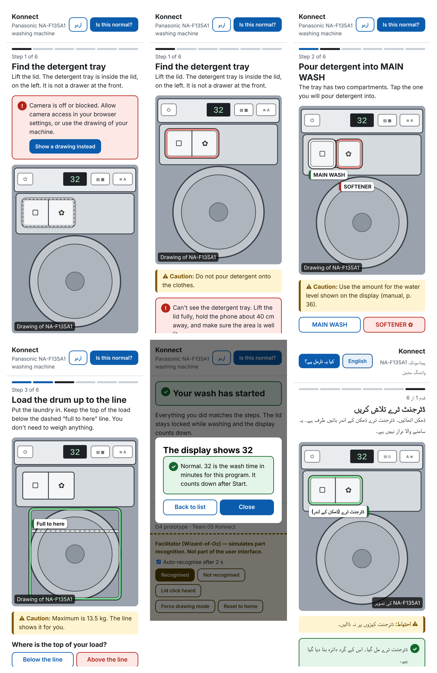
Figure 4. Camera blocked, error (a), error (c), error (b), the ‘Is this normal?’ answer, and Step 1 in Urdu.

9.3 Component states implemented
State | Where it appears
Default | All buttons, rings, check boxes
Focus / hover | 3 px blue focus ring on every control (keyboard); darker fill on hover
Active | Pressed buttons shift 1 px and darken; chosen answers use aria-pressed
Disabled | Next until the step is done; ‘Other tasks’ on Home
Loading | ‘Starting camera…’, ‘Looking for …’ (dashed pulsing ring), ‘Waiting for the machine…’
Empty | ‘Is this normal?’ before a signal is chosen: ‘Point the camera at a light, number or part, or choose from the list.’
Error | (a), (b), (c), camera blocked; red ring on the wrong compartment
Success | Found ring, ✓ messages, ‘Your wash has started’

10. Implementation documentation

10.1 Tool and technology
- Web app: one HTML file with plain HTML, CSS and JavaScript, with no framework and no server. It runs in any modern phone or laptop browser.
- Camera: browser MediaDevices.getUserMedia (rear camera). Dialog: native HTML <dialog>. Announcements: an aria-live region; errors use role=alert.
- Wireframes: draw.io. Testing: an automated run of every path in headless Chromium (Playwright), with screenshots (Figures 3 and 4).
- AI (Claude, Anthropic) wrote the code; see Section 13. Every part is explained in this section so the team can answer questions at the checkpoint.

10.2 Scope decision: vertical slice
We built one task fully (a vertical slice) instead of many shallow screens. The brief strongly prefers this, and D5A needs a prototype that actually behaves. The chosen task is the D3 storyboard scenario, and it covers both strong themes the concept is selected for: identifying parts (T1: steps 1, 2, 5) and reading normal signals (T2: steps 4, 6). It also includes all three error paths. The air fryer, other tasks and other models are out of scope.

10.3 Wizard-of-Oz components
Component | What it simulates | Why simulated | How it is operated
Part recognition | The app recognising the tray, drum, display and panel inside the ring | Per-model recognition cannot be built or trained at this stage (D3 risk, R1) | Auto-recognised after 2 s, or the facilitator presses Recognised / Not recognised in the clearly separated ‘Facilitator controls’ panel
Lid click detection | The app hearing the lid lock after Start | Sound detection is not built | Auto after 2 s, or facilitator presses ‘Lid click heard’
Force drawing mode | Switching to the drawing without a camera error | Lets the demo run on a laptop | Facilitator button

10.4 Test evidence (automated run, 4 Nov 2026)
Check | Result
Camera unavailable → error shown and drawing offered | Pass
Error (a): focus moves to the error message | Pass
Error (c): Next stays disabled until MAIN WASH is chosen | Pass
Error (b): Check again resets the choice | Pass
Step 5: Next blocked until both boxes ticked; focus goes to the explanation | Pass
Dialog closes with Esc; focus returns to ‘Is this normal?’ | Pass
Urdu: html lang/dir becomes ur/rtl | Pass
JavaScript errors during the full run | None
Live camera on a phone over https | Not tested by us; must be tried before the checkpoint

11. Accessibility re-check
Status: pending. After any final change and before the instructor checkpoint, the team re-runs the keyboard and screen-reader walkthroughs by hand on the final build and confirms each fix is still present. Generated code is not accepted as accessible without this check.
Fix | Still present? (manual check) | Checked by / date
P1 drawing symbols hidden | ☐
P2 ‘Caution:’ text | ☐
P3 duplicate rings hidden | ☐
Focus to step title on every step | ☐
Errors take focus and are announced | ☐
Dialog returns focus | ☐
K1–K7 / S1–S5 fixes (from Section 4) | ☐
Deferred D2 (Urdu checked) | ☐

12. D4 video
To be produced after the build is final. File name: 05-Konnect-D4-Prototype.mp4 (MP4, up to 5 minutes, AI narration with captions, six-segment structure, one focused feedback question).

13. AI-use note
Step | Tool | What AI did | What the team did / must do
IA: card sort | Claude (Anthropic) | Played the 5 simulated participants (built from D1B profiles), ran the open and closed sorts, computed the matrix and clusters | Chose the D1B grounding; reviews the IA names and the changes in 2.4
Wireframes | Claude + draw.io | Generated the screens, arrows and Gestalt annotations as a .drawio file | Chose scope, error paths and tool; checks every screen
Accessibility audit | Claude | Listed what to check; ran an automated pre-check (Section 4.3) and fixed P1–P3 | Runs the manual keyboard and screen-reader walkthroughs (pending)
Critique record | Claude | Acted as the reviewer for the rapid critique | Confirms or rejects each point
Functional build | Claude | Wrote the HTML/CSS/JS prototype and the Urdu text | Must be able to explain every part; a native reader checks the Urdu
Accessibility re-check | — | Not done by AI | Manual re-check before the checkpoint (Section 11)
Report | Claude | Drafted and formatted this document | Reviews and edits before submission

14. Reflection (graded for completion)
To be written by the team in its own words (one or two sentences each).
(1) What did you keep as your own thinking versus what came from AI?
______________________________________________________________
(2) How did it feel to flag your AI use here?
______________________________________________________________

15. Submission checklist
Item (from the D4 brief) | Status
Card-sort-derived IA and stated navigation pattern | Done (Section 2)
Connected low-/medium-fidelity wireframe flow with alternate/error paths | Done (Section 3, .drawio)
Keyboard-only and screen-reader audit logs under POUR | Pending: manual walkthrough (Section 4)
Note on fixed vs deferred | Done; to be updated after the walkthrough (Section 5)
Critique record | Done (AI reviewer); team to confirm (Section 6)
AI-use note | Done (Section 13)
Reflection answered | Pending: team
Vertical-slice functional task flow, working live | Done (Section 7); test the live camera on a phone
Minimal design system applied consistently | Done (Section 8)
Visible feedback and handled error states | Done (Section 9)
Component states | Done (Section 9.3)
Implementation documentation incl. Wizard-of-Oz | Done (Section 10)
Part A accessibility fixes reconfirmed | Pending: manual re-check (Section 11)
Video (MP4 ≤ 5 min, captions, six segments, feedback question) | Pending: after the build is final
All members ready to explain the work | Team

