Search Paths for AI Agents

Nephi Johnson
William Armstrong

Abstract

AI agents in the game bzflag must determine a route to their current goal. This is possible through the use of a graph-search through their environment. Penalties can be added to the heuristic(s) of the graph-search to enable the agents to avoid obstacles, walls, and enemy tanks. After experimenting with several search algorithms, it was found that the Greedy Best-first Search yielded the fastest sub-optimal results while still successfully avoiding penalized areas. The A* search-algorithm was somewhat slower, but yielded optimal paths. Other heuristic-less algorithms provided a path to the target, yet were inefficient and non-optimal.

Context

In most AI situations, agents must determine the best or least expensive path to take in a given situation. AI agents can be made to accomplish this by implementing algorithms that search the decision-space. This paper details the results of experimenting with various search algorithms for AI agents in the game bzflag, with and without penalties for encroaching on prohibited areas (enemy tanks, walls, and obstacles). These experiments were done in conjunction with another research group.

Setup

We have configured the game bzflag in such a way that we have an external program provide the AI for a team of tanks in a game. Each of the games in bzflag is played in a finite world or map. Each map can have obstacles and walls. Each game can have teams of enemy tanks. The goal of each game is to capture the enemy's flag and return to base. Our AI agents will be utilizing graph-searches on the map to determine the best path to the enemy's base. In order to do this, the map must be discretized. Our AI-program allows us to set the discretization level at run-time. We have generated graphs for each search-algorithm using the gnuplot program.

Algorithms

Breadth First Search

The breadth first search algorithm is on of the simplest ones to compute. The image below shows a BFS on a bzflag map descretized into pieces with a width of 80. For this search, the algorithm popped 95 nodes and had a resulting path length of nine. The green path is the final path taken.
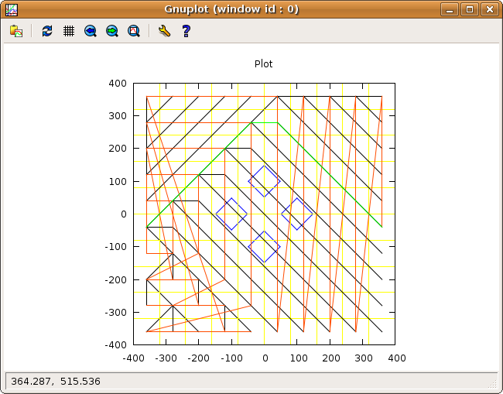

The image below is also a BFS of the same map as above, except with a more ganular descretization (pieces with widths of 200) so the actual BFS algorithm could be seen. 14 nodes were popped in this example for a final path length of three.

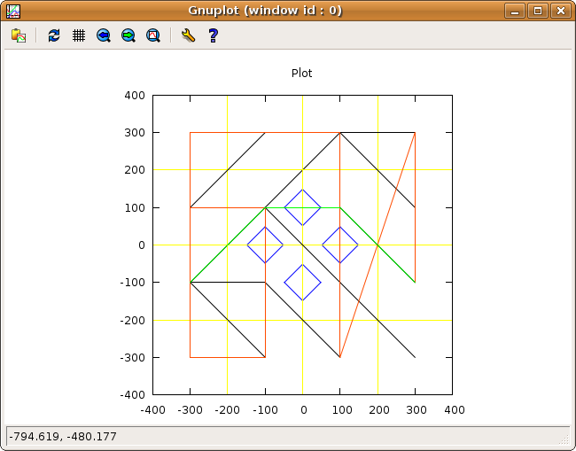

Depth First Search

Depth first search (DFS) is also one of the more simple algorithms to implement. The image below shows the results of a DFS. In the end, 17 nodes were popped and for a final path length of 15. Once again, the green line shows the final path chosen.

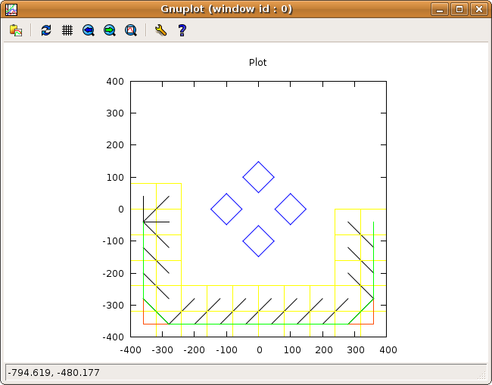
The image below is another DFS with coarser granularity (widths of 200). Five nodes were popped for a final path length of 3.

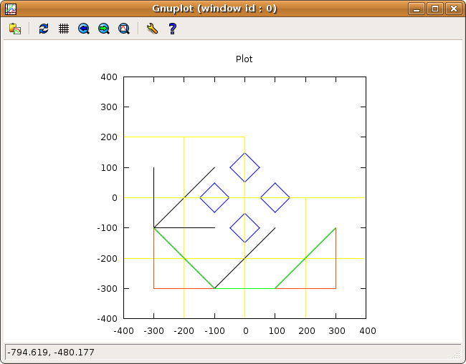

Iterative Deepening Search

This algorithm is very expensive computationally. The graph below shows the results of a IDFS on a bzflag map

Greedy Best First Search

asdfas dfasasdfzzzdfasd fasdfasdfa sdf asdf asdf asdf asdf asdfasd asfd asdfas dfasasdfzzzdfasd fasdfasdfa sdf asdf asdf asdf asdf asdfasd asfd asdfas dfasasdfzzzdfasd fasdfasdfa sdf asdf asdf asdf asdf asdfasd asfd asdfas dfasasdfzzzdfasd fasdfasdfa sdf asdf asdf asdf asdf asdfasd asfd asdfas dfasasdfzzzdfasd fasdfasdfa sdf asdf asdf asdf asdf asdfasd asfd asdfas dfasasdfzzzdfasd fasdfasdfa sdf asdf asdf asdf asdf asdfasd asfd asdfas dfasasdfzzzdfasd fasdfasdfa sdf asdf asdf asdf asdf asdfasd asfd asdfas dfasasdfzzzdfasd fasdfasdfa sdf asdf asdf asdf asdf asdfasd asfd asdfas dfasasdfzzzdfasd fasdfasdfa sdf asdf asdf asdf asdf asdfasd asfd

A*

asdfas dfasasdfzzzdfasd fasdfasdfa sdf asdf asdf asdf asdf asdfasd asfd asdfas dfasasdfzzzdfasd fasdfasdfa sdf asdf asdf asdf asdf asdfasd asfd asdfas dfasasdfzzzdfasd fasdfasdfa sdf asdf asdf asdf asdf asdfasd asfd asdfas dfasasdfzzzdfasd fasdfasdfa sdf asdf asdf asdf asdf asdfasd asfd asdfas dfasasdfzzzdfasd fasdfasdfa sdf asdf asdf asdf asdf asdfasd asfd asdfas dfasasdfzzzdfasd fasdfasdfa sdf asdf asdf asdf asdf asdfasd asfd asdfas dfasasdfzzzdfasd fasdfasdfa sdf asdf asdf asdf asdf asdfasd asfd asdfas dfasasdfzzzdfasd fasdfasdfa sdf asdf asdf asdf asdf asdfasd asfd asdfas dfasasdfzzzdfasd fasdfasdfa sdf asdf asdf asdf asdf asdfasd asfd

