IT Support KPIs - September 2026
Period: 01 Sep 2026 to 30 Sep 2026. Generated on 13 Nov 2026.

Overview
70 tickets were opened in September 2026 across 6 clients, an average of 3.3 per working day (21 working days). 70 were resolved, taking 26.7 hours on average, and 82.9% of them met their SLA. Compared with August 2026, tickets are up 1.4% and the SLA rate is up 4.6 percentage points.
- Busiest category: Email (19 tickets).
- Tickets still open: 0.
- Public holidays in VIC: Friday before AFL Grand Final (2026-09-25).

Tickets by priority
Priority | Tickets | SLA target (h) | Avg hours | SLA met
P1 | 3 | 4 | 2.8 | 100.0%
P2 | 11 | 8 | 6.6 | 81.8%
P3 | 35 | 24 | 19.9 | 77.1%
P4 | 21 | 72 | 52.0 | 90.5%
P1 is the most urgent. Hours are from opened to resolved.

Tickets by client
Client | Tickets | Open | Avg hours | SLA met
Northside Legal | 18 | 0 | 33.3 | 72.2%
Yarra Valley Wines | 15 | 0 | 26.9 | 86.7%
Bluegum Accounting | 12 | 0 | 15.1 | 91.7%
Harbourview Dental | 10 | 0 | 33.2 | 90.0%
Riverbend Logistics | 10 | 0 | 26.2 | 70.0%
Southgate Medical | 5 | 0 | 18.4 | 100.0%
Clients with the most tickets first

Tickets by category
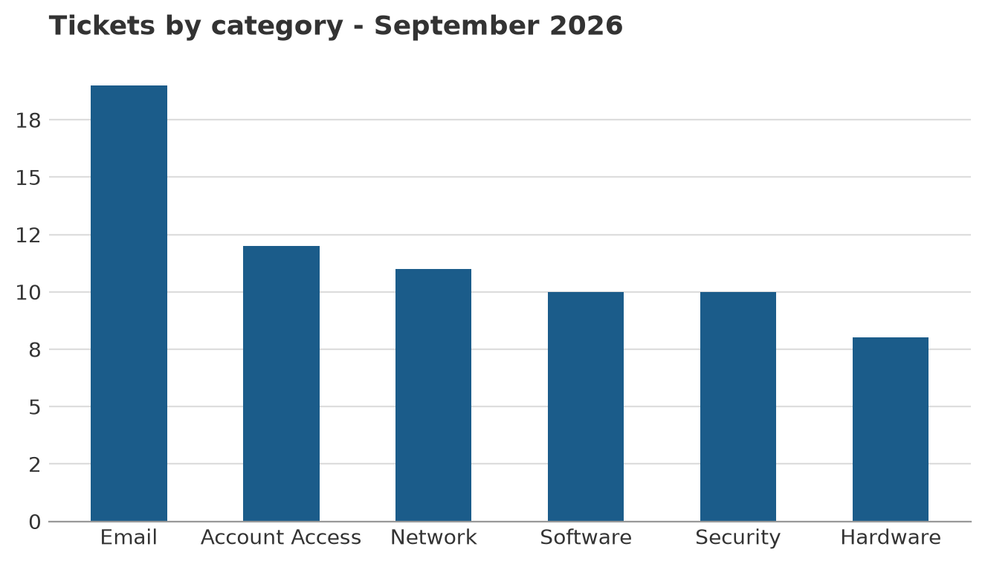
Number of tickets opened in each category

Backups
300 backup jobs ran for 6 clients, with an overall success rate of 97.0%.
Client | Jobs | Successful | Failed | Success rate
Northside Legal | 30 | 27 | 3 | 90.0%
Yarra Valley Wines | 30 | 27 | 3 | 90.0%
Riverbend Logistics | 60 | 57 | 3 | 95.0%
Harbourview Dental | 90 | 90 | 0 | 100.0%
Bluegum Accounting | 60 | 60 | 0 | 100.0%
Southgate Medical | 30 | 30 | 0 | 100.0%
Lowest success rate first

Data sources
- Support tickets (Excel): data/tickets.xlsx - 70 tickets in this period.
- Backup results (PDF table): data/backup_status.pdf - used.
- Public holidays (REST API): https://date.nager.at/api/v3/PublicHolidays/2026/AU - used.

