Sales Summary - October 2026
Period: 01 Oct 2026 to 31 Oct 2026. Generated on 13 Nov 2026.

Overview
Total sales for October 2026 were $269,570 from 88 orders, an average of $3,063 per order. This is down 6.7% on September 2026 ($288,822).
- Top region: VIC with $83,194 (30.9% of all sales).
- Best-selling product: Asus Zenbook Pro Dual Screen Laptop with $62,965.
- Regions on target: 3 of 5.

Sales by region
Region | Sales | Share | Target | Achieved | Status
VIC | $83,194 | 30.9% | $70,000 | 118.8% | On target
QLD | $73,864 | 27.4% | $86,000 | 85.9% | Below target
WA | $46,789 | 17.4% | $39,000 | 120.0% | On target
NSW | $35,987 | 13.3% | $40,000 | 90.0% | Below target
SA | $29,736 | 11.0% | $27,000 | 110.1% | On target
Sales by region, highest first
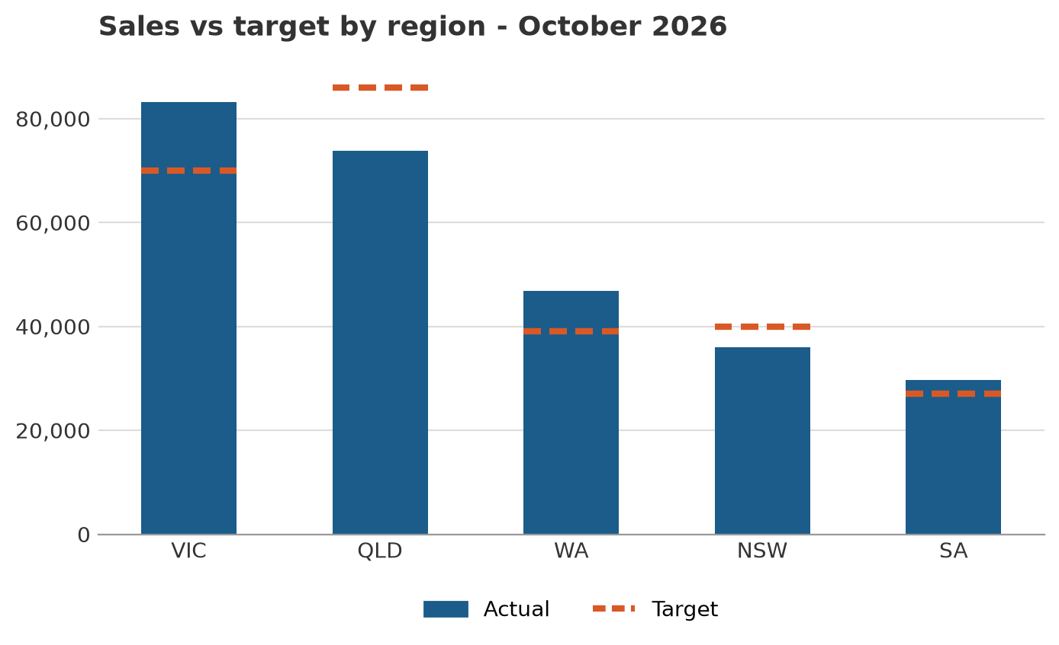
Bars show actual sales; dashed lines show the target

Sales by product
Product | Category | Units | Sales | Share
Asus Zenbook Pro Dual Screen Laptop | laptops | 35 | $62,965 | 23.4%
Samsung Galaxy Tab S8 Plus Grey | tablets | 68 | $40,732 | 15.1%
Apple MacBook Pro 14 Inch Space Grey | laptops | 17 | $33,983 | 12.6%
Huawei Matebook X Pro | laptops | 23 | $32,177 | 11.9%
iPad Mini 2021 Starlight | tablets | 60 | $29,940 | 11.1%
Apple AirPods Max Silver | mobile-accessories | 47 | $25,803 | 9.6%
Lenovo Yoga 920 | laptops | 19 | $20,881 | 7.7%
New DELL XPS 13 9300 Laptop | laptops | 7 | $10,493 | 3.9%
Samsung Galaxy Tab White | tablets | 25 | $8,725 | 3.2%
Apple Airpower Wireless Charger | mobile-accessories | 49 | $3,871 | 1.4%
Sales by product, highest first
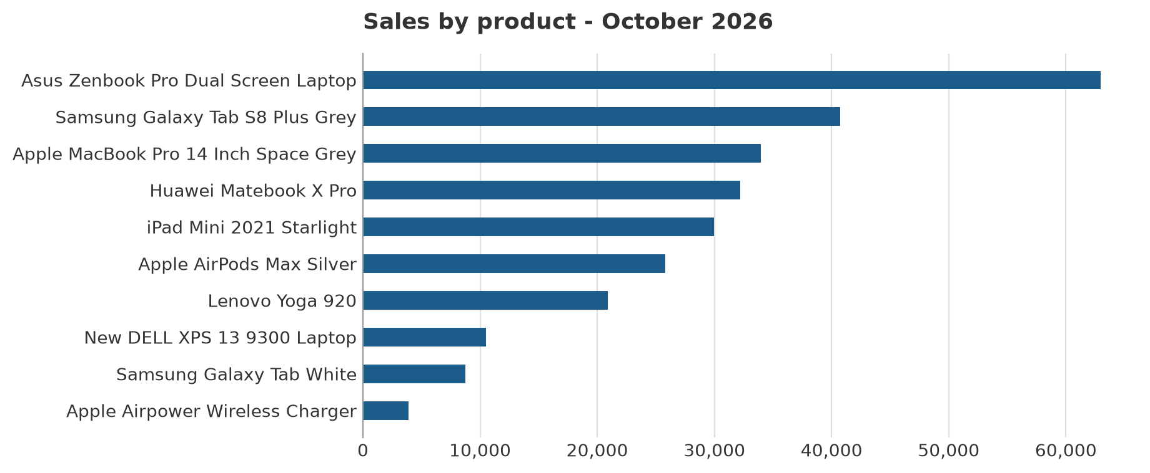
Sales by product

Data sources
- Sales orders (CSV): data/sales.csv - 88 orders in this period.
- Sales targets (PDF table): data/sales_targets.pdf - used.
- Product names (REST API): https://dummyjson.com/products - used.

