IT Support KPIs - October 2026
Period: 01 Oct 2026 to 31 Oct 2026. Generated on 14 Nov 2026.

Overview
68 tickets were opened in October 2026 across 6 clients, an average of 3.1 per working day (22 working days). 63 were resolved, taking 25.8 hours on average, and 84.1% of them met their SLA. Compared with September 2026, tickets are down 2.9% and the SLA rate is up 1.3 percentage points.
- Busiest category: Account Access (15 tickets).
- Tickets still open: 5.
- Public holidays in VIC: none in this period.

Tickets by priority
Priority | Tickets | SLA target (h) | Avg hours | SLA met
P1 | 2 | 4 | 3.0 | 100.0%
P2 | 18 | 8 | 6.0 | 82.4%
P3 | 30 | 24 | 17.4 | 89.3%
P4 | 18 | 72 | 64.5 | 75.0%
P1 is the most urgent. Hours are from opened to resolved.

Tickets by client
Client | Tickets | Open | Avg hours | SLA met
Northside Legal | 20 | 2 | 23.8 | 72.2%
Southgate Medical | 14 | 1 | 34.1 | 76.9%
Riverbend Logistics | 11 | 1 | 12.6 | 100.0%
Harbourview Dental | 9 | 0 | 17.4 | 88.9%
Bluegum Accounting | 8 | 1 | 38.7 | 100.0%
Yarra Valley Wines | 6 | 0 | 33.9 | 83.3%
Clients with the most tickets first

Tickets by category
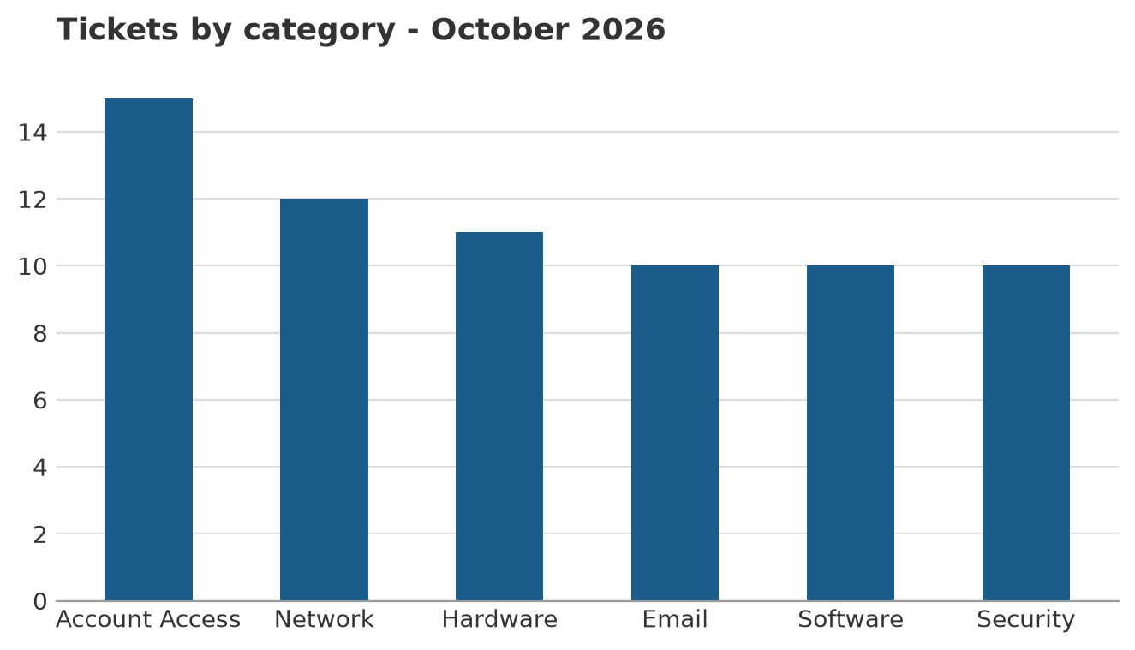
Number of tickets opened in each category

Backups
372 backup jobs ran for 6 clients, with an overall success rate of 96.5%.
Client | Jobs | Successful | Failed | Success rate
Harbourview Dental | 31 | 28 | 3 | 90.3%
Yarra Valley Wines | 62 | 59 | 3 | 95.2%
Northside Legal | 31 | 30 | 1 | 96.8%
Bluegum Accounting | 93 | 90 | 3 | 96.8%
Southgate Medical | 62 | 60 | 2 | 96.8%
Riverbend Logistics | 93 | 92 | 1 | 98.9%
Lowest success rate first

Data sources
- Support tickets (Excel): data/tickets.xlsx - 68 tickets in this period.
- Backup results (PDF table): data/backup_status.pdf - used.
- Public holidays (REST API): https://date.nager.at/api/v3/PublicHolidays/2026/AU - used.

