Mrunali Gupta
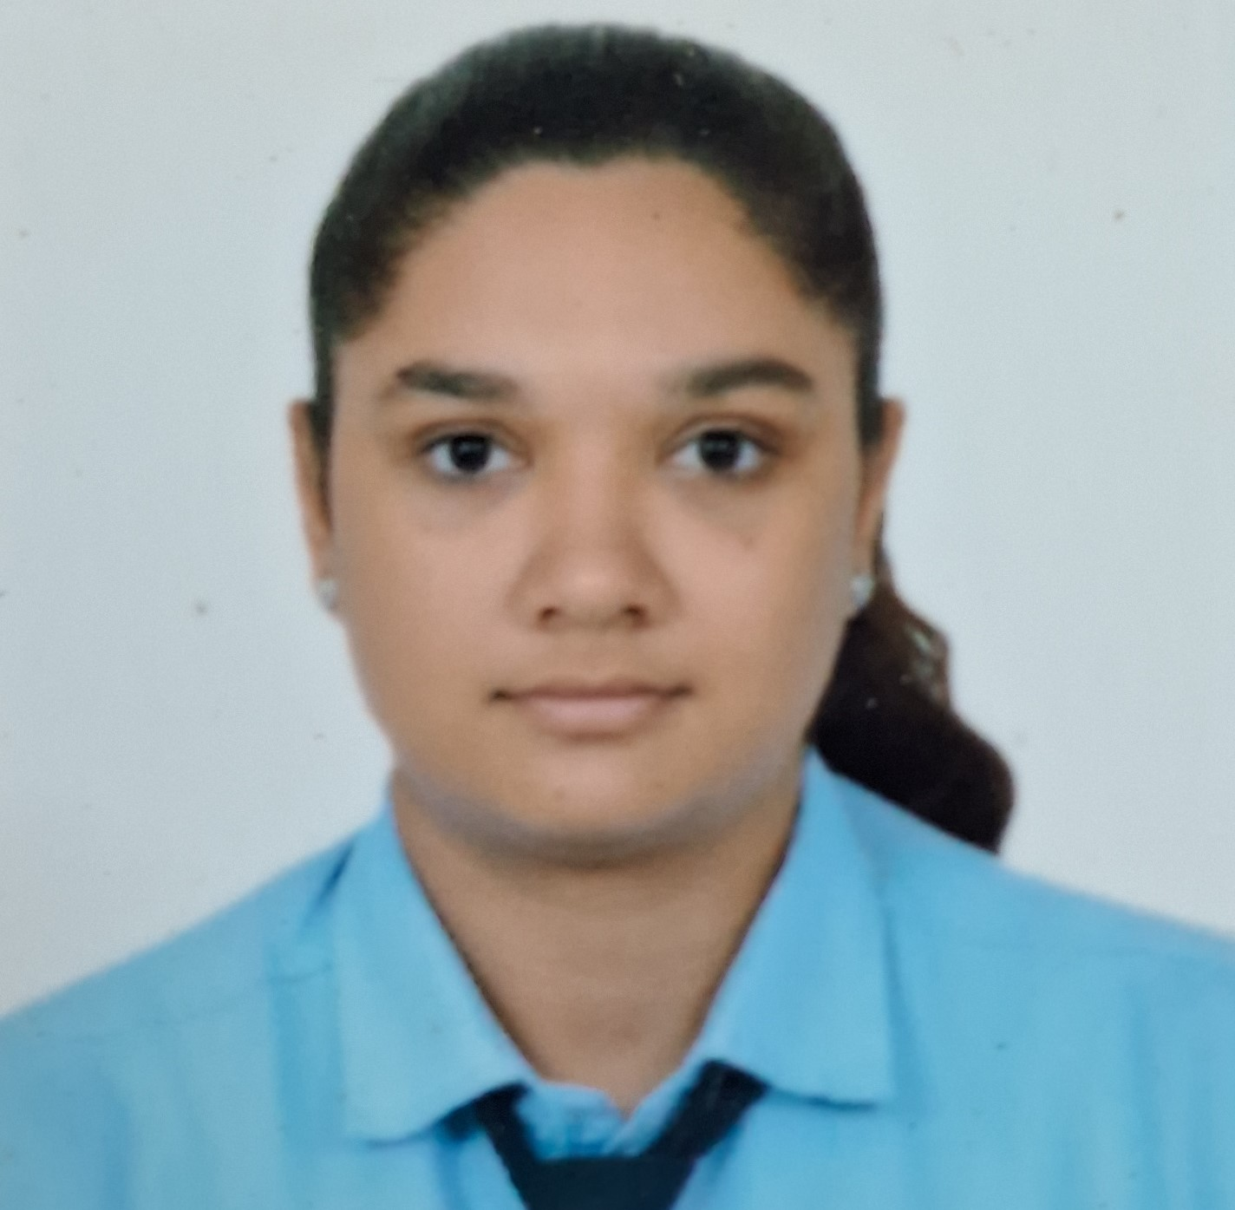
B. TECH CSE (Cloud Technology and Information Security)

Vadodara, Gujarat | 7359808797 | mrunaligupta1123@gmail.com

Objective
Enthusiastic and detail-oriented professional with an academic background in computer science and 2.5 years of experience, seeking a position in administrative work.

Education
- 12th CBSE
- Currently in B.tech 3rd Year

Skills
Technical Skills | Soft Skills
- ChatGPT Expertise  - Ms Word  - Ms powerpoint  - MS EXCEL | - Team Collaboration  - Adaptability  - Multi-Tasking  - Time Management  - Continuous Learning

Languages:
English, Hindi, Gujarati
Profiles: https://www.linkedin.com/public-profile/settings

Achievements:
Hackathon- IES MCRC Hackathon , Secured 3rd position in the Social Media Challenge organized by Avenir analytics Club.

Work Experience:
Adminstrator 2 years Experience

