WEEK1
Architecture

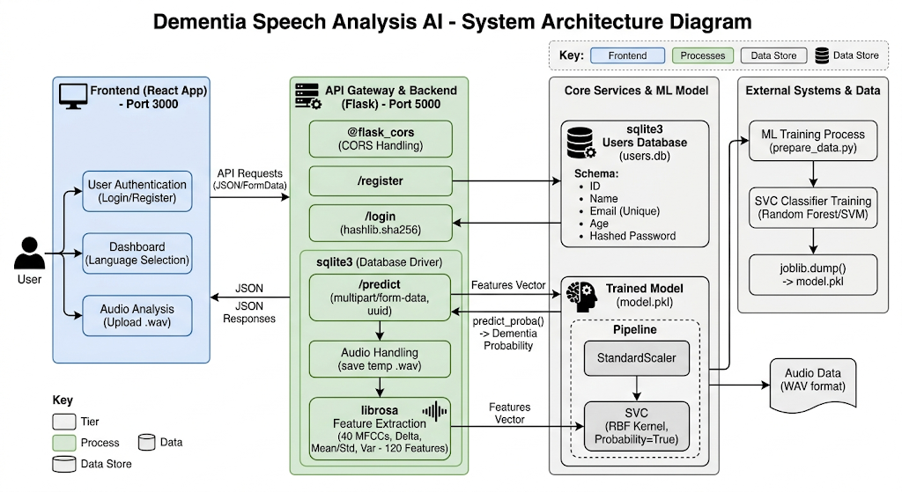

Software Requirements Specification (SRS)

Introduction
This project is a web-based application that predicts dementia risk using speech audio. The system allows users to register, log in, upload audio, and receive a prediction with a confidence score using a machine learning model.

The system consists of:
- Frontend: React (user interface)
- Backend: Flask (API + processing)
- Machine Learning Model: SVM with MFCC + PCA
- Database: SQLite (stores user data and predictions)
The workflow is:
User → Login/Register → Dashboard → Select Language → Upload Audio → Prediction → Result Display

Functional Requirements
1.User Registration
- User can create an account using:
  - Name
  - Email
  - Age
  - Password
- System stores user details securely in the database.

2. User Login
- User can log in using email and password.
- System validates credentials using hashed password.

3. Dashboard Access
- After login, user is redirected to dashboard.
- Dashboard shows:
  - Welcome message
  - Language selection
  - Action button for analysis

4. Language Selection
- User selects a language before analysis.
- Selected language is stored temporarily and sent to backend.
5. Audio Upload
- User can upload an audio file (.wav).
- File name is displayed before submission.

6. Prediction Process
Backend performs:
- Audio loading using Librosa
- Feature extraction (MFCC, delta, statistics)
- Dimensionality reduction using PCA
- Classification using SVM

7. Result Display
- System displays:
  - Prediction (Dementia / No Dementia)
  - Confidence score
  - Selected language

8. Data Storage
- User data is stored in SQLite database.
- Prediction results can also be stored with:
  - user_id
  - prediction
  - confidence
  - timestamp

9. Error Handling
System handles:
- Invalid login
- Duplicate registration
- Missing file upload
- Backend errors

Non-Functional Requirements
1. Performance
- System should respond within a few seconds.
- Prediction should be near real-time.

2. Usability
- Interface should be simple and easy to use.
- Clear navigation between pages.

3. Security
- Passwords must be stored in hashed format.
- Input validation should be performed.

4. Reliability
- System should handle valid requests consistently.
- Temporary files should be deleted after processing.

Conclusion
The system provides a simple and effective way to perform dementia risk prediction using speech signals. It integrates frontend, backend, machine learning, and database components into a single workflow, making it suitable as a preliminary screening tool.

