WEEK 2
AGILE PROCESS MODEL
23BCE1505
Arna Bhattacharya

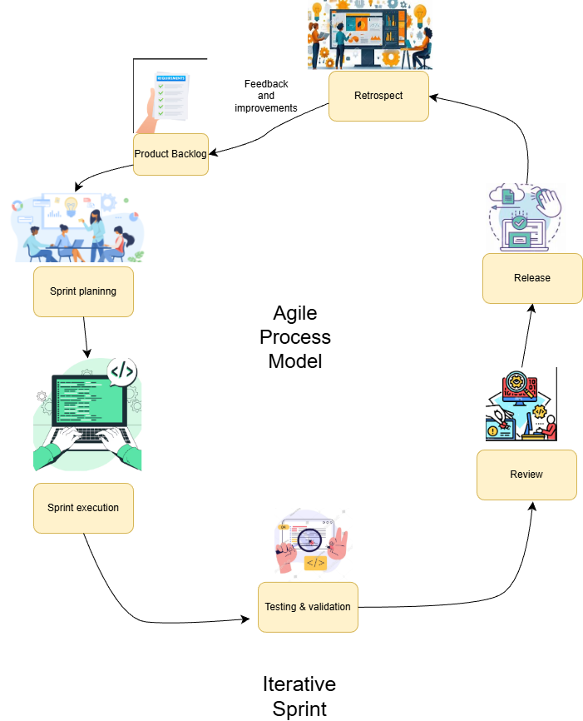
Agile Model Overview
The AI-Assisted Early Cognitive Screening and Dementia Risk Flagging System is developed using the Agile development model, specifically following a Scrum-based iterative approach. Agile is well suited for this project because it involves continuous refinement of user interfaces, AI-driven analytics, and clinical decision support features, all of which benefit from incremental development and frequent feedback.
Instead of developing the entire system in a single phase, Agile divides the project into small, manageable iterations called sprints. Each sprint delivers a working and testable increment of the system, allowing early validation of functionality, usability, and analytical accuracy.

Sprint Planning
At the beginning of each sprint, the Product Owner, along with the development team, selects high-priority features from the product backlog. These features are written as user stories.
Clear acceptance criteria are defined for each user story to ensure measurable outcomes at the end of the sprint.

Sprint Execution
During sprint execution, development tasks are distributed across different system components:
- User Interface Development
  - Patient dashboard
  - Speech recording interface
  - Language selection and visualization screens
- Application & Control Logic
  - User authentication
  - Test session management
  - Baseline data handling
  - Workflow orchestration
- AI & Analytics Development
  - Speech-to-text processing
  - Speech behaviour analysis
  - Rule-based dementia risk scoring
Each component is developed incrementally and integrated continuously, ensuring that the system remains functional throughout the sprint.

Testing and Validation
Testing is performed continuously within the sprint rather than at the end of the project. This includes:
- Input validation and workflow testing
- Verification of speech analysis outputs
- Validation of risk scoring logic
- Data storage and retrieval checks
This ensures that errors are detected early and that AI outputs align with expected clinical logic.

Sprint Review
At the end of each sprint, a working version of the system is demonstrated to stakeholders. This may include:
- Functional UI screens
- Sample speech analysis results
- Preliminary risk classification outputs
- Generated reports and charts
Feedback from stakeholders is documented and added to the product backlog for future sprints.

Sprint Retrospective
The sprint concludes with a retrospective meeting, where the team evaluates:
- What went well
- What challenges were faced
- What improvements can be made in the next sprint
This supports continuous improvement in both technical execution and team collaboration.

Benefits of Using the Agile Model for This Project
1. Incremental and Early Delivery
Agile enables early delivery of core features such as speech recording and risk visualization. This allows the system to be tested and evaluated even before full functionality is completed.

2. Flexibility for AI Model Refinement
AI-based systems require continuous tuning. Agile allows speech analysis rules, scoring thresholds, and baseline comparisons to be refined across multiple sprints without disrupting the entire system.

3. Continuous Stakeholder Feedback
Regular sprint reviews ensure that clinicians, domain experts, and evaluators can provide feedback early, improving the relevance and usability of the screening system.

4. Reduced Risk in Healthcare Applications
By validating outputs incrementally, Agile reduces the risk of incorrect risk flagging or flawed workflows, which is critical in healthcare-related applications.

5. Better Integration of Multidisciplinary Components
This project combines UI design, backend services, AI analytics, and reporting modules. Agile promotes continuous integration, ensuring all components work together smoothly.

6. Improved Quality and Reliability
Continuous testing within each sprint improves system stability, data integrity, and analytical accuracy, resulting in a more reliable cognitive screening platform.

7. Faster Adaptation to Requirements
If new screening rules, languages, or reporting formats are required, Agile allows these changes to be prioritized and implemented in upcoming sprints without reworking the entire system.

