WEEK 3
SOFTWARE ENGINEERING LAB
REG NO- 23BCE1505
NAME- Arna Bhattacharya
Use Case Diagram
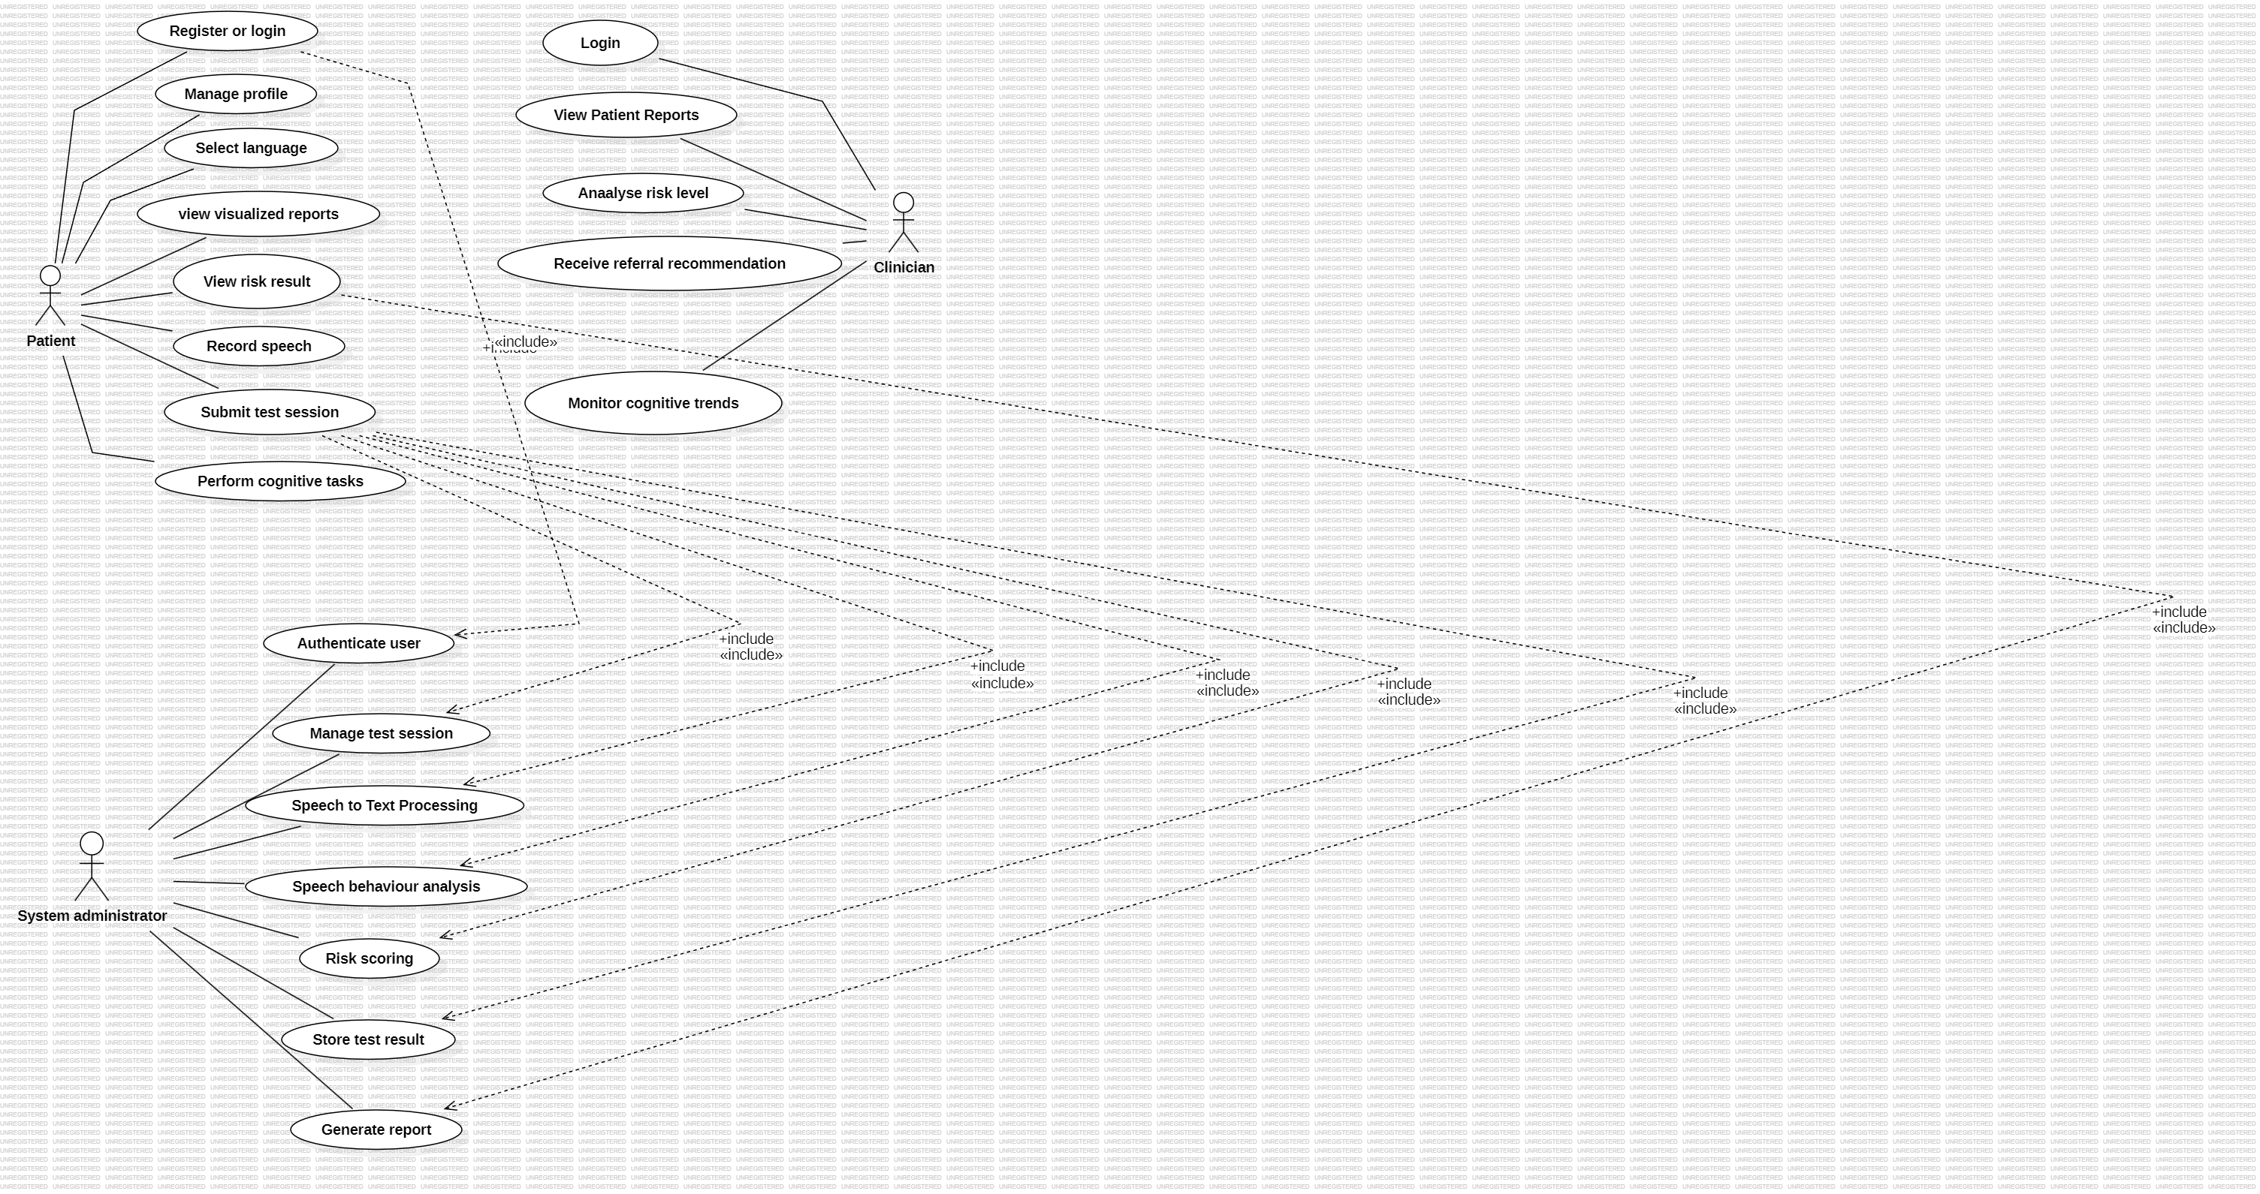

CLASS DIAGRAM
