**BCSE204T- Design and Analysis of Algorithms**

**PPS-6-Practice Sheet**

**(N Queen-Backtracking)**

**Date:18-2-25**

**Name: Arna Bhattacharya**

**Register no: 23BCE1505**

**(Submit any Three Questions)**  
**Answers:**

**Q1)** **A positive integer n can be partitioned into a sequence of distinct positive integers a1,a2,...,an such that n = a1+a2+...+ak. We call a1+a2+...+ak as k−size distinct partition of n. Here, none of the positive integers ai,i = 1, 2..., n are same. Distinct partitions of 3 are 2+1 and 3. We consider the partition 2 +1 and the partition 1+2, as the same partition. Maximum size distinct parttion of 3 is 2 + 1. Similarly, distinct partitions of 6 are 1+5,2+4,3+2+1,6. Maximum-size distinct partition of 6 is 3+2+1. Given a positive integer n, design a back-tracking algorithm to compute a maximum-size distinct partition of n.**

**CODE**

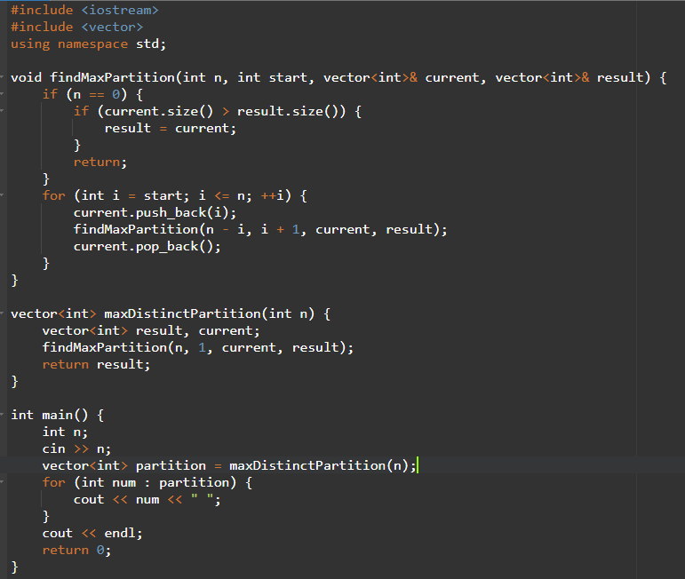

**OUTPUT**



**Q2)** **Consider the Sudoku Problem : You are given a partially filled 9 × 9 grid. The task is to fill the 9 Ö 9 grid with digits (from 1 to 9) so that each column, each row, and each of the nine 3 Ö 3 subgrids contain all of the digits from 1 to 9. Design a backtracking algorithm to solve the Sudoku problem. Analyse the algorithm with the running-time and the time-complexity. Analyse the algorithm with the running-time and the time-complexity.**

**CODE**

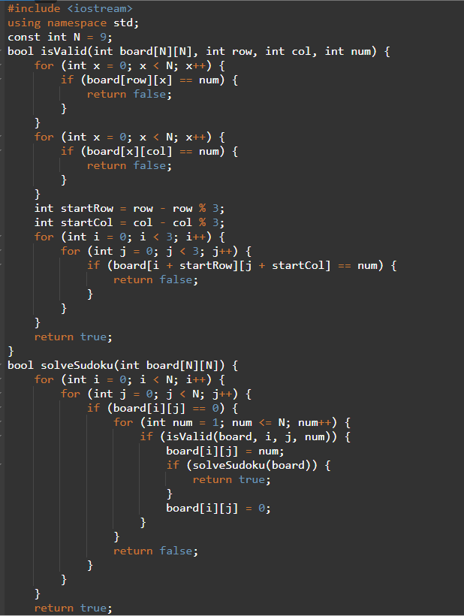

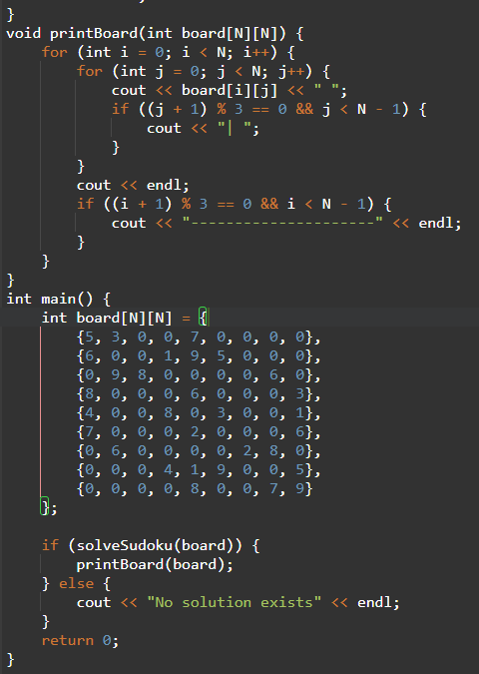

**OUTPUT**

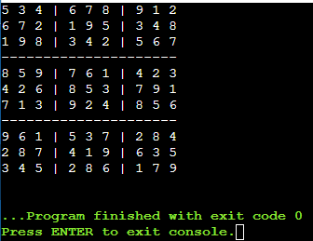

**Q3)** **Given a non-empty set S of non-negative integers and a positive integer k, problem is to find a subset S′ of S such that sum of the integers of S′ is equal to k. Design a back-tracking algorithm to solve the above Problem. Analyse the algorithm with the running-time and the time-complexity**

**CODE**

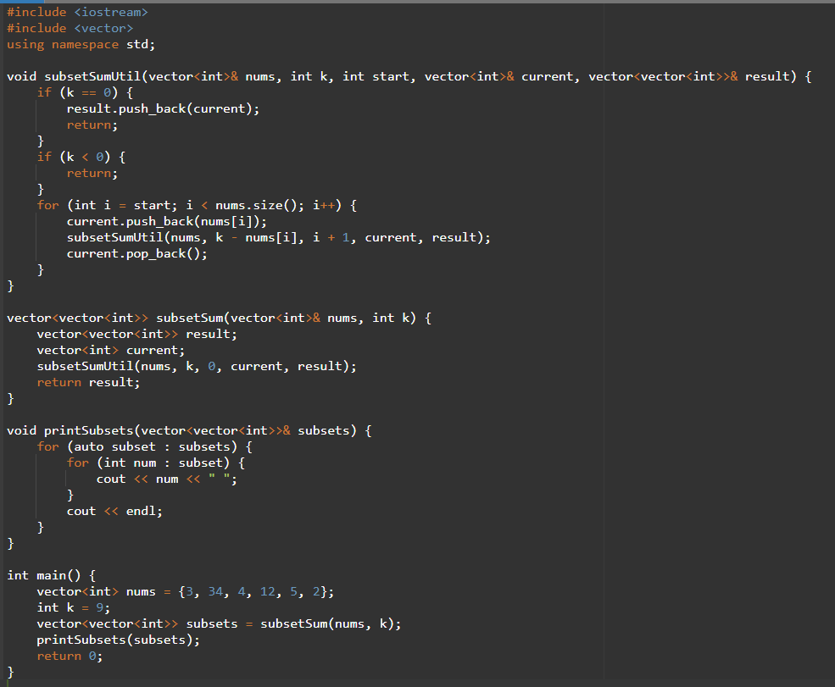

**OUTPUT**

