SEQUENCE DIAGRAM
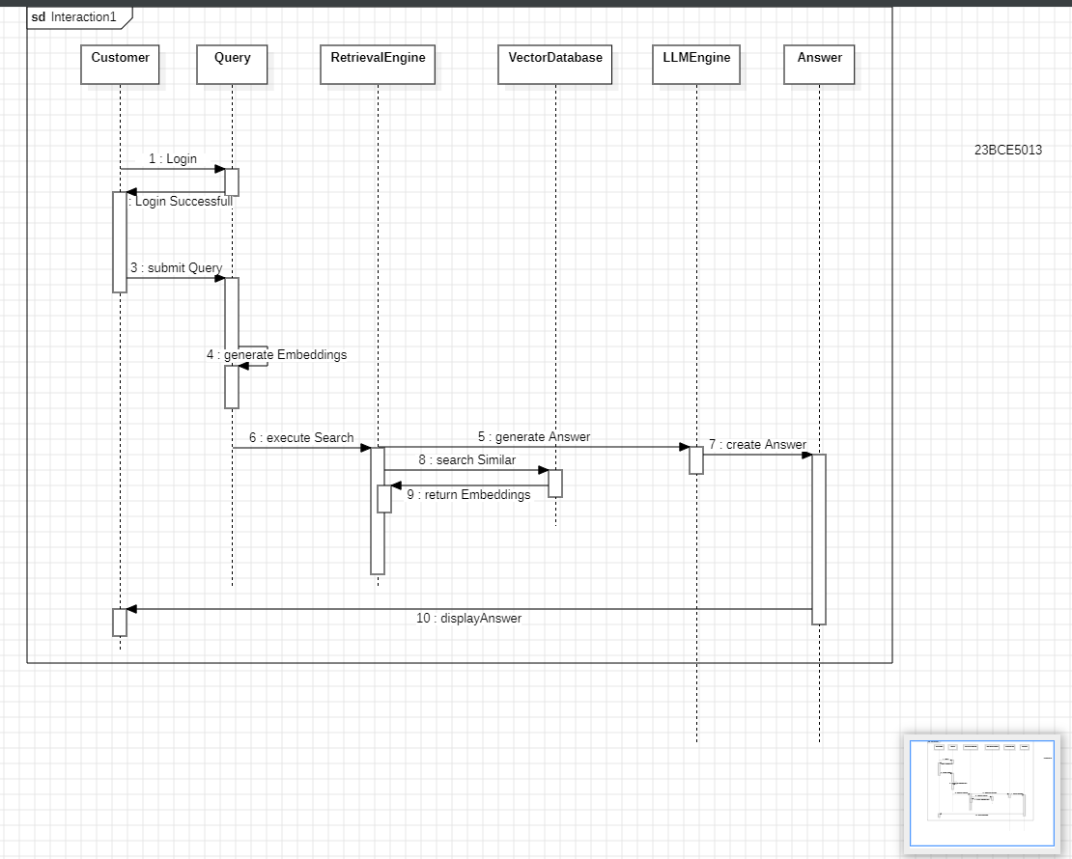

ACTIVITY DIAGRAM
