OmniSearch
An Offline, AI-Powered Multimodal RAG Intelligence Platform

Project Report
Software Engineering

Submitted by
Arnab Kundu
Registration No. 23BCE5013

Vellore Institute of Technology, Chennai
School of Computer Science and Engineering

GITHUB LINK : https://github.com/arnab-kundu5013/D2-23BCE5013-Arnab

1. Problem Statement
Modern organisations and research groups routinely generate and accumulate large volumes of heterogeneous digital content — textual documents (PDF, DOCX), images (photographs, scanned charts, diagrams), and audio recordings (meeting minutes, lectures, interviews). When an individual needs to locate a specific piece of information, the conventional approach involves opening each file manually, scanning through its content, and mentally correlating related material spread across different formats. This process is time-consuming, error-prone, and poorly scalable.
Existing search solutions — whether desktop-based file indexers or cloud-hosted search engines — suffer from one or more of the following shortcomings:
- They rely on simple keyword matching and fail to capture semantic meaning, so a query phrased differently from the stored text returns no results.
- They handle only a single data modality (typically text), leaving images and audio files unsearchable unless manually tagged with keywords.
- They depend on continuous internet connectivity and upload user data to remote servers, raising privacy and confidentiality concerns — especially in domains such as healthcare, legal, and defence.
- They do not provide source-level citations in answers, forcing the user to verify every claim by opening the original documents manually.
There is, therefore, a clear need for a search and question-answering platform that can (a) ingest documents in multiple modalities, (b) understand and retrieve information based on semantic similarity rather than exact keywords, (c) correlate related content across modalities automatically, (d) generate concise, cited answers using a large language model, and (e) operate entirely offline to preserve data privacy.

2. Objectives
The primary objectives of this project are outlined below:
1. Multimodal Ingestion: Design and implement an ingestion pipeline capable of processing PDF documents, DOCX files, images (JPEG, PNG), and audio recordings (MP3, WAV). Each modality requires a dedicated extraction strategy — text parsing for PDFs and DOCX, image captioning via a vision-language model for images, and automatic speech recognition for audio files.
2. Semantic Embedding and Indexing: Convert extracted content into high-dimensional vector embeddings using a locally hosted embedding model (nomic-embed-text via Ollama) and store them in a vector database (ChromaDB) organised into modality-specific collections (TEXT, IMAGE, AUDIO).
3. Cross-Modal Retrieval with Fusion Ranking: Implement a retrieval layer that fans out approximate nearest-neighbour (ANN) queries across all three collections simultaneously and merges the ranked result lists using Reciprocal Rank Fusion (RRF) to produce a single, unified ranking that is not dominated by any single modality.
4. Cross-Modal Link Detection: After ingestion, automatically detect semantic relationships between content of different modalities — for example, an audio transcript mentioning a concept that also appears in a PDF — and persist these as navigable cross-modal links in the metadata database.
5. Cited Answer Generation: Forward the retrieved and re-ranked context to a locally running large language model (Llama 3.1 8B via Ollama) to generate a natural-language answer grounded in the retrieved passages, with inline citations pointing to the source document, page number, or audio timestamp.
6. Offline and Privacy-Preserving Operation: Ensure that every component of the platform — the embedding model, the LLM, the vector database, and the application server — runs on the local machine without requiring any internet connectivity or data transmission to external services.
7. RESTful API Design: Expose the entire functionality through a well-structured, documented set of REST API endpoints so that the platform can be consumed by any frontend client, command-line tool, or integration script.

3. Methodology / Approach
The project follows a layered, service-oriented architecture built on Node.js with TypeScript. Each major concern — ingestion, embedding, vector storage, retrieval, answer generation — is encapsulated in a dedicated service module with well-defined interfaces. This section describes the methodology for each layer.

3.1 Technology Stack
Component | Technology
Runtime & Framework | Node.js 18+, Express 4, TypeScript 5
Metadata Database | SQLite (via Knex query-builder)
Vector Database | ChromaDB (HTTP API, cosine similarity, HNSW indexing)
Embedding Model | nomic-embed-text (served locally via Ollama)
LLM for Answer Generation | Llama 3.1 8B (served locally via Ollama)
Vision-Language Model | LLaVA 7B (served locally via Ollama)
Audio Transcription | Whisper.cpp (optional, local binary)
PDF Parsing | pdf-parse (Node.js library)
DOCX Parsing | Mammoth (Node.js library)
Image Processing | Sharp (Node.js library)

3.2 Ingestion Pipeline
When a user uploads a file through the /api/ingest endpoint, the system first identifies the file type by its MIME type and extension, then routes it to the appropriate extractor module. The extraction phase works as follows:
- PDF files: The pdf-parse library extracts raw text from each page. The text is then split into overlapping chunks of approximately 500 characters with a 100-character overlap to preserve contextual continuity across chunk boundaries.
- DOCX files: The Mammoth library converts the document into plain text, which is then chunked using the same overlapping strategy.
- Images: The Sharp library reads image metadata (dimensions, format). The image is then sent to the locally running LLaVA 7B vision-language model, which generates a natural-language caption describing the visual content.
- Audio files: If Whisper.cpp is available, the audio is passed to the local Whisper model for automatic speech recognition. The resulting transcript is segmented by speaker turn and timestamp.
After extraction, each chunk or caption is embedded using the nomic-embed-text model and upserted into the corresponding ChromaDB collection (TEXT, IMAGE, or AUDIO) along with rich metadata — file identifier, file name, chunk index, page number, character offsets, image dimensions, or audio timestamps.

3.3 Retrieval and Ranking
When the user submits a natural-language query via /api/query, the system performs the following steps:
- The query string is embedded into a vector using the same nomic-embed-text model.
- The query vector is used to run an approximate nearest-neighbour (ANN) search against each of the three ChromaDB collections — TEXT, IMAGE, and AUDIO — in parallel.
- Each collection returns its top-K results ranked by cosine distance.
- The three ranked lists are merged using Reciprocal Rank Fusion (RRF). For every document appearing at rank r in any list, RRF computes a score of 1 / (k + r), where k = 60 is a smoothing constant. Scores from multiple lists are summed, so a document that appears in multiple modalities receives a higher combined score.
- The fused list is sorted by descending RRF score and truncated to the final top-K results.
RRF was chosen over simple score averaging because different vector spaces and distance metrics make raw scores incomparable across collections. RRF is rank-based and therefore naturally normalised.

3.4 Cross-Modal Link Detection
After every file ingestion, a background service embeds a representative sample of the newly ingested content and queries the other modality collections. If the cosine similarity exceeds a threshold of 0.75, a cross-modal link record is persisted in the SQLite database. For instance, a PDF paragraph about quarterly revenue might link to an image caption describing a revenue bar chart, or an audio segment discussing the budget could link to a text chunk from a financial report.
These links are resolved during retrieval and included in the API response so that the consuming client can surface related content from other modalities alongside the primary results.

3.5 Answer Generation
The retrieved context passages — along with their source metadata — are assembled into a structured prompt and forwarded to the locally running Llama 3.1 8B model via the Ollama /api/generate endpoint. The system supports both streaming and non-streaming response modes:
- In streaming mode, the server opens a Server-Sent Events (SSE) connection and forwards each token from the LLM to the client as it is generated, providing a responsive, real-time feel.
- In non-streaming mode, the full response is accumulated server-side and returned as a single JSON payload.
The prompt instructs the LLM to ground its answer exclusively in the provided context and to cite the source document, page number, or timestamp for each claim. The citation builder utility extracts structured citation objects from the LLM output so that the client can render clickable references.

3.6 Architectural Overview
The system follows a layered architecture, summarised below:
Client Request → Express Routes → Controllers → Service Layer → External Backends
The service layer is decomposed into the following modules: (i) Ingest services (pdf.extractor, docx.extractor, image.extractor, audio.extractor, chunker), (ii) Embedding service, (iii) Vector service (ChromaDB client), (iv) Retrieval service (multi-collection search with RRF), (v) Cross-modal service (link detection), (vi) LLM service (Ollama client with streaming support), and (vii) Processor (orchestrator that coordinates the full ingest pipeline).
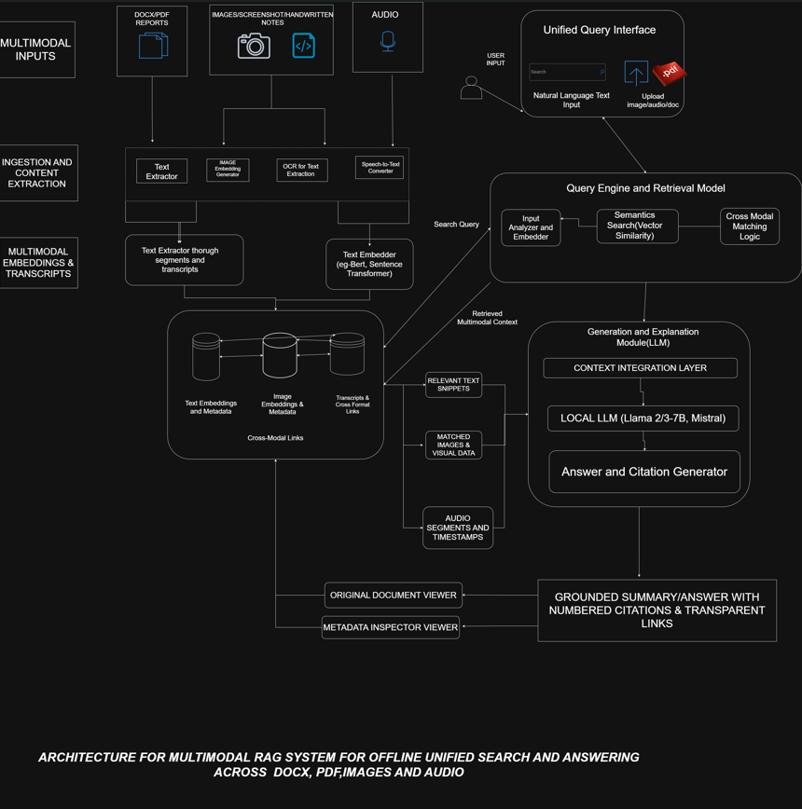

4. Work Completed So Far (50% Implementation)
As of the date of this report, approximately fifty per cent of the planned implementation has been completed. The following subsections detail the components that have been built, tested, and are in working condition.

4.1 Backend Server and API Layer
The Express application server has been fully set up with CORS support, JSON body parsing, request logging (via Morgan and Winston), and a global error handler. All four route groups have been defined and wired:
Endpoint | Description
GET /api/health | Server health check
POST /api/ingest | File upload (multipart/form-data; PDF, DOCX, PNG, JPG, MP3, WAV)
GET /api/ingest/:fileId/status | Check processing status of an uploaded file
POST /api/query | Submit a natural-language query and receive a cited answer
POST /api/query/image | Image-based search (upload an image as the query)
GET /api/files | List all ingested files
GET /api/files/stats | System-wide statistics (file counts, chunk counts)
GET /api/files/:id | Retrieve metadata for a specific file
DELETE /api/files/:id | Delete a file and its associated chunks
GET /api/files/:id/download | Download the original uploaded file
GET /api/files/:id/chunks | View the indexed chunks of a file
GET /api/files/links | List all cross-modal links

4.2 Ingestion Pipeline (All Four Extractors)
All four extractor modules have been implemented and are functional:
- pdf.extractor.ts — Extracts per-page text from PDF files using pdf-parse.
- docx.extractor.ts — Converts DOCX documents to plain text via Mammoth.
- image.extractor.ts — Reads image metadata with Sharp and generates captions using the locally hosted LLaVA 7B model through Ollama.
- audio.extractor.ts — Transcribes audio files using the local Whisper.cpp binary and segments the transcript by speaker and timestamp.
The text chunker module (chunker.ts) implements two chunking strategies: chunkText for flat text and chunkPages for page-structured documents. Both use a sliding window with configurable chunk size and overlap.

4.3 Embedding and Vector Storage
The embedding service wraps the Ollama /api/embeddings endpoint and provides both single-text and batch-embedding functions. Batch embedding is performed sequentially to avoid overloading the local Ollama instance, which runs single-threaded inference internally.
The vector service exposes a complete CRUD interface over ChromaDB collections using the v2 HTTP API: ensureCollection (create-or-get), upsertChunks, queryCollection, deleteByFileId, and countCollection. It maintains a local cache of collection UUIDs to minimise redundant API calls.

4.4 Retrieval Service with RRF
The retrieval service is fully implemented. It fans out parallel ANN queries across the TEXT, IMAGE, and AUDIO collections, merges the results using Reciprocal Rank Fusion, and resolves cross-modal links from SQLite for the top-ranked source files.

4.5 LLM Service (Streaming and Non-Streaming)
The LLM service supports both streaming and non-streaming modes. In streaming mode, it processes the newline-delimited JSON stream from Ollama token by token and invokes callbacks (onToken, onDone, onError) for the controller to forward events to the client. Robust error handling is included, with a five-minute timeout for slow models.

4.6 Cross-Modal Link Detection
The cross-modal link detection module runs as a post-ingest hook. It embeds a representative text sample from the newly ingested file, queries the other modality collections, and persists any matches above the 0.75 cosine similarity threshold as link records in the SQLite database. This allows the query response to surface related documents across different modalities.

4.7 Database Layer
The SQLite database — managed through the Knex query-builder — stores file metadata (file ID, original name, type, size, upload timestamp, processing status, chunk count, error messages) and cross-modal link records (source file, target file, source chunk, target chunk, link type, confidence score).

4.8 Remaining Work (Planned for the Second Phase)
The following components are planned for the remaining fifty per cent of the implementation and are not yet complete:
- Web-based frontend user interface for file upload, search, and result browsing.
- Citation rendering and document viewer with highlighted source passages.
- Comprehensive unit and integration test suite.
- Performance benchmarking and optimisation (cold-start latency, chunking strategy tuning).
- Deployment documentation and containerisation (Docker Compose setup).
- Support for additional file formats (e.g., Excel spreadsheets, PowerPoint slides)
VIDEO LINK & PROOF OF WORK: https://drive.google.com/drive/folders/1a4xBhADgJJok51453dyeIVCFld91wMiW?usp=drive_link

