**e-Commerce Website with React, Redux, TypeScript, NodeJS, MongoDB**

1. This is an e-commerce application with a user login feature.  
2. There will be several pages:  
  
**Home Page**: Where product list will be shown  
**Product Detail Page**: Where detail of a particular product will be shown.  
**Cart:** All the product user has added will be shown in this page.  
**Login:**A view to allow user to login, Signup  
**Dashboard:**An admin can login to this dashboard to

* see all the order list, change order status from pending to done or rejected.
* See all the user list. Edit user information , Add new User
* all pending cart along with user information

**Flow**  
  
**User:**  
  
When a user comes to this site, on the home page, there will be a showcase of all products with **pagination**. Users can see product details by clicking on the product where he will have the option to add to cart the product with a different quantity. But, no user without logging in can not add the product to the cart. So if a user clicks add to cart without login, will be redirected to login. During this time, the clicked product will be stored in Localstorage and when successfully logged in, the product will be added to cart.  
  
Each time the user add product to cart, an API request will be sent to add to cart and in return API will response with the cart details along with added product.  
  
In user's profile page, user can update profile information and also see the order status which is already made by the user. Will have the ability to cancel the Order. Then user can place order.  
  
  
The product page will have search and filtering option through which user can search a particular product and filter by category.

**Admin:**  
An admin will login in to the dashboard . There admin can check the all orders, pending orders, Successfull orders and Rejected orders. Orders can be filtered by Data and status. Admin will have the option to change order status, block a user. Admin can add, delete and update Category, product, User  
  
  
  
  
  
  
**N.B:**

* This project should have a finalized UI and UX just like a finished product. The API is already deployed to github and will be demonstrated to class.
* The requirements can be changed on the fly to cope up with real-time project environment.
* We will use API from our local. For API, I have setup a repository which link is : [**https://github.com/arnab-shuvo/fakecommerce**](https://github.com/arnab-shuvo/fakecommerce)
* If you want to develop your own API, feel free to do it.
* All the instructions regarding this repository and the API documentation is already mentioned in the repository's **Readme.md file.**Hence if anyone has any questions, feel free to reach out to me.
* This project will be solo submission. Therefore, you can definitely collaborate with everyone regarding any problem .

**Planning:**

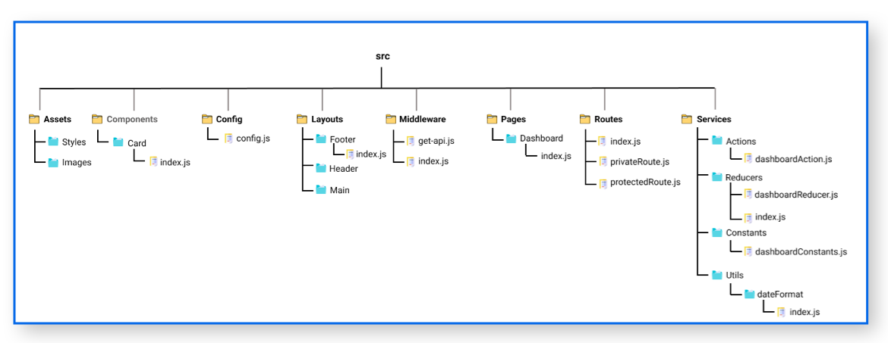

* + There are some changes needed to implementation of the final project from above structure image.
  + Changes are:
    - Assets
      * Frontend
        + Styles
        + images
      * backend
        + styles
        + images
    - Layouts
      * Frontend
        + Header
        + Main
        + footer
      * backend
        + Header
        + Main
        + Footer
    - Store
      * Index.js
      * Reducers
        + ProductReducer.js
        + CartReducer.js
        + LoginReducer.js
        + RegisterReducer.js
      * Action
        + Action.js
        + ActionType.js
* **Steps:**

1. Create react-app (npx create-react-app final_project)
2. npm Install redux, react-redux, --save-dev @redux-devtools/core
3. npm install react-router-dom@6