Your Friend has developed the Product and he wants to establish the product startup and he is searching for a perfect location where getting the investment has a high chance. But due to its financial restriction, he can choose only between three locations - Bangalore, Mumbai, and NCR. As a friend, you want to help your friend deciding the location. NCR include Gurgaon, Noida and New Delhi. Find the location where the most number of funding is done. That means, find the location where startups has received funding maximum number of times. Plot the bar graph between location and number of funding. Take city name "Delhi" as "New Delhi". Check the case-sensitiveness of cities also. That means, at some place instead of "Bangalore", "bangalore" is given. Take city name as "Bangalore". For few startups multiple locations are given, one Indian and one Foreign. Consider the startup if any one of the city lies in given locations.
In [2]:
import pandas as pd
import numpy as np
import matplotlib.pyplot as plt

def correct_city(s):
l = s.split('/')
city = l[0].strip()
if city=='Delhi':
return 'New Delhi'
if city=='bangalore':
return 'Bangalore'
return city

df = pd.read_csv('startup_funding.csv')
df.CityLocation.dropna(inplace=True) # drop rows having nan values in CityLocation column

# Make a new column of correct city names
df['city'] = df.CityLocation.apply(correct_city)
city_count = df.city.value_counts()
#print(city_count)

cities = ['Bangalore', 'New Delhi', 'Mumbai', 'Gurgaon', 'Noida']
num_fundings = [city_count.loc[city] for city in cities]
#print(num_fundings)

plt.bar(cities, num_fundings, width=0.6, edgecolor='black')
plt.xticks(rotation=60)
plt.show()
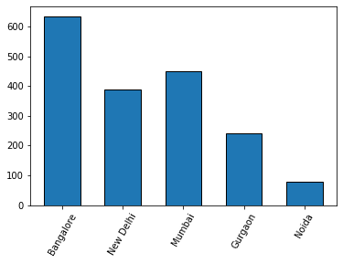

Even after trying for so many times, your friend’s startup could not find the investment. So you decided to take this matter in your hand and try to find the list of investors who probably can invest in your friend’s startup. Your list will increase the chance of your friend startup getting some initial investment by contacting these investors. Find the top 5 investors who have invested maximum number of times (consider repeat investments in one company also). In a startup, multiple investors might have invested. So consider each investor for that startup. Ignore undisclosed investors.
In [39]:
import numpy as np
import pandas as pd
import csv
import matplotlib.pyplot as plt

invest_count = {}
with open('startup_funding.csv', encoding='utf8') as obj:
file_data = csv.DictReader(obj, skipinitialspace=True)
for row in file_data:
investors = row['InvestorsName']
if not pd.isnull(investors) and investors!='':
inves_list = [investr.strip() for investr in investors.split(',')]
for i in inves_list:
invest_count[i] = invest_count.get(i,0)+1

invest_count_arr = list(invest_count.items())
invest_count_arr.sort(key=lambda x: x[1])
req_arr = invest_count_arr[::-1]
for i in range(5):
print(req_arr[i])

arr = [req_arr[i][1] for i in range(5)]
invstrs = [req_arr[i][0] for i in range(5)]
plt.bar(invstrs, arr, width=0.6)
plt.xticks(rotation=30)
plt.show()
plt
('Sequoia Capital', 64)
('Accel Partners', 53)
('Kalaari Capital', 44)
('SAIF Partners', 41)
('Indian Angel Network', 40)
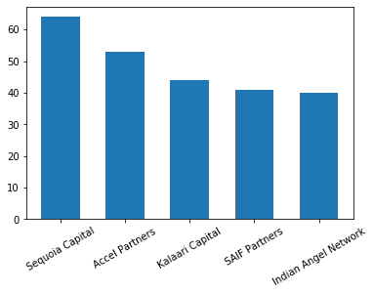
Out[39]:
<module 'matplotlib.pyplot' from 'c:\\users\\mehak\\appdata\\local\\programs\\python\\python37-32\\lib\\site-packages\\matplotlib\\pyplot.py'>

After re-analysing the dataset you found out that some investors have invested in the same startup at different number of funding rounds. So before finalising the previous list, you want to improvise it by finding the top 5 investors who have invested in different number of startups. This list will be more helpful than your previous list in finding the investment for your friend startup. Find the top 5 investors who have invested maximum number of times in different companies. That means, if one investor has invested multiple times in one startup, count one for that company. There are many errors in startup names. Ignore correcting all, just handle the important ones - Ola, Flipkart, Oyo and Paytm.
In [28]:
import numpy as np
import pandas as pd
import csv
import matplotlib.pyplot as plt

invest_count = {}
with open('startup_funding.csv', encoding='utf8') as obj:
file_data = csv.DictReader(obj, skipinitialspace=True)
for row in file_data:
investors = row['InvestorsName']
startup = row['StartupName']
if not pd.isnull(investors) and investors!='' and not pd.isnull(startup) and startup!='':
lwr_str = startup.lower()
l1 = lwr_str.split() # to chk against oyo rooms
l2 = lwr_str.split('.') # To chk against flipkart.com

#if 'ola' in s_name.lower(): # can't do like that bcz it will also include startups like kolabro which is not ola

if 'ola' in l1 or 'ola' in l2 or 'olacabs' in l1:
req_startup = 'Ola'
elif 'flipkart' in l1 or 'flipkart' in l2:
req_startup = 'Flipkart'
elif 'oyo' in l1 or 'oyo' in l2 or 'oyorooms' in l1:
req_startup = 'Oyo'
elif 'paytm' in l1 or 'paytm' in l2:
req_startup = 'Paytm'
else:
req_startup = startup

inves_list = [investr.strip() for investr in investors.split(',')]
for i in inves_list:
if i=='':
continue
if invest_count.get(i,-1) == -1:
invest_count[i] = set()
invest_count[i].add(req_startup)

invest_count_arr = list(invest_count.items())
#print(invest_count_arr)
invest_count_arr.sort(key=lambda x: len(x[1]))
req_arr = invest_count_arr[::-1]
for i in range(5):
print(req_arr[i][0], len(req_arr[i][1]))

arr = [len(req_arr[i][1]) for i in range(5)]
invstrs = [req_arr[i][0] for i in range(5)]
plt.pie(arr, labels=invstrs, autopct='%.2f')
plt.show()
Sequoia Capital 48
Accel Partners 47
Kalaari Capital 41
Indian Angel Network 40
Blume Ventures 36
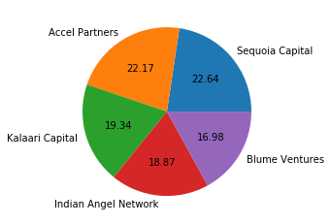

Even after putting so much effort in finding the probable investors, it didn't turn out to be helpful for your friend. So you went to your investor friend to understand the situation better and your investor friend explained to you about the different Investment Types and their features. This new information will be helpful in finding the right investor. Since your friend startup is at an early stage startup, the best-suited investment type would be - Seed Funding and Crowdfunding. Find the top 5 investors who have invested in a different number of startups and their investment type is Crowdfunding or Seed Funding. Correct spelling of investment types are - "Private Equity", "Seed Funding", "Debt Funding", and "Crowd Funding". Keep an eye for any spelling mistake. You can find this by printing unique values from this column. There are many errors in startup names. Ignore correcting all, just handle the important ones - Ola, Flipkart, Oyo and Paytm.
In [40]:
import numpy as np
import pandas as pd
import csv
import matplotlib.pyplot as plt

invest_count = {}
with open('startup_funding.csv', encoding='utf8') as obj:
file_data = csv.DictReader(obj, skipinitialspace=True)
for row in file_data:
investors = row['InvestorsName']
startup = row['StartupName']
inves_type = row['InvestmentType']
if not pd.isnull(investors) and investors!='' and not pd.isnull(startup) and startup!='' and not pd.isnull(inves_type):
if inves_type=='SeedFunding' or inves_type=='Seed Funding' or inves_type=='Crowd funding' or inves_type=='Crowd Funding':
lwr_str = startup.lower()
l1 = lwr_str.split() # to chk against oyo rooms
l2 = lwr_str.split('.') # To chk against flipkart.com

#if 'ola' in s_name.lower(): # can't do like that bcz it will also include startups like kolabro which is not ola

if 'ola' in l1 or 'ola' in l2 or 'olacabs' in l1:
req_startup = 'Ola'
elif 'flipkart' in l1 or 'flipkart' in l2:
req_startup = 'Flipkart'
elif 'oyo' in l1 or 'oyo' in l2 or 'oyorooms' in l1:
req_startup = 'Oyo'
elif 'paytm' in l1 or 'paytm' in l2:
req_startup = 'Paytm'
else:
req_startup = startup

inves_list = [investr.strip() for investr in investors.split(',')]
for i in inves_list:
if i=='' or i=='Undisclosed Investors' or i=='Undisclosed investors':
continue
if invest_count.get(i,-1) == -1:
invest_count[i] = set()
invest_count[i].add(req_startup)

invest_count_arr = list(invest_count.items())
#print(invest_count_arr)
invest_count_arr.sort(key=lambda x: len(x[1]))
req_arr = invest_count_arr[::-1]
for i in range(5):
print(req_arr[i][0], len(req_arr[i][1]))

arr = [len(req_arr[i][1]) for i in range(5)]
invstrs = [req_arr[i][0] for i in range(5)]
plt.pie(arr, labels=invstrs, autopct='%.2f')
plt.show()
plt.bar(invstrs, arr, width=0.6, edgecolor='black')
plt.xticks(rotation=40)
plt.show()
Indian Angel Network 33
Rajan Anandan 23
Anupam Mittal 16
LetsVenture 16
Group of Angel Investors 14
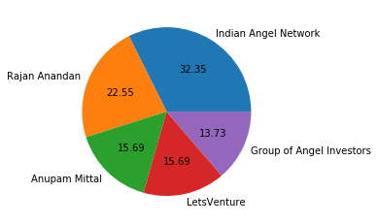
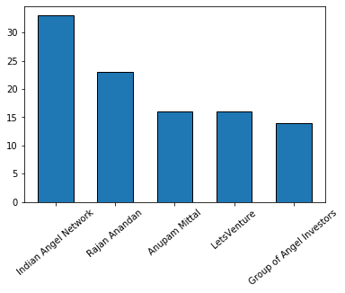

Due to your immense help, your friend startup successfully got seed funding and it is on the operational mode. Now your friend wants to expand his startup and he is looking for new investors for his startup. Now you again come as a saviour to help your friend and want to create a list of probable new new investors. Before moving forward you remember your investor friend advice that finding the investors by analysing the investment type. Since your friend startup is not in early phase it is in growth stage so the best-suited investment type is Private Equity. Find the top 5 investors who have invested in a different number of startups and their investment type is Private Equity. Correct spelling of investment types are - "Private Equity", "Seed Funding", "Debt Funding", and "Crowd Funding". Keep an eye for any spelling mistake. You can find this by printing unique values from this column.There are many errors in startup names. Ignore correcting all, just handle the important ones - Ola, Flipkart, Oyo and Paytm.
In [41]:
import numpy as np
import pandas as pd
import csv
import matplotlib.pyplot as plt

invest_count = {}
with open('startup_funding.csv', encoding='utf8') as obj:
file_data = csv.DictReader(obj, skipinitialspace=True)
for row in file_data:
investors = row['InvestorsName']
startup = row['StartupName']
inves_type = row['InvestmentType']
if not pd.isnull(investors) and investors!='' and not pd.isnull(startup) and startup!='' and not pd.isnull(inves_type):
if inves_type=='Private Equity' or inves_type=='PrivateEquity':
lwr_str = startup.lower()
l1 = lwr_str.split() # to chk against oyo rooms
l2 = lwr_str.split('.') # To chk against flipkart.com

#if 'ola' in s_name.lower(): # can't do like that bcz it will also include startups like kolabro which is not ola

if 'ola' in l1 or 'ola' in l2 or 'olacabs' in l1:
req_startup = 'Ola'
elif 'flipkart' in l1 or 'flipkart' in l2:
req_startup = 'Flipkart'
elif 'oyo' in l1 or 'oyo' in l2 or 'oyorooms' in l1:
req_startup = 'Oyo'
elif 'paytm' in l1 or 'paytm' in l2:
req_startup = 'Paytm'
else:
req_startup = startup

inves_list = [investr.strip() for investr in investors.split(',')]
for i in inves_list:
if i=='' or i=='Undisclosed Investors' or i=='Undisclosed investors':
continue
if invest_count.get(i,-1) == -1:
invest_count[i] = set()
invest_count[i].add(req_startup)

invest_count_arr = list(invest_count.items())
#print(invest_count_arr)
invest_count_arr.sort(key=lambda x: len(x[1]))
req_arr = invest_count_arr[::-1]
for i in range(5):
print(req_arr[i][0], len(req_arr[i][1]))

arr = [len(req_arr[i][1]) for i in range(5)]
invstrs = [req_arr[i][0] for i in range(5)]
plt.pie(arr, labels=invstrs, autopct='%.2f')
plt.show()
plt.bar(invstrs, arr, width=0.6, edgecolor='black')
plt.xticks(rotation=40)
plt.show()
Sequoia Capital 45
Accel Partners 43
Kalaari Capital 35
Blume Ventures 27
SAIF Partners 24
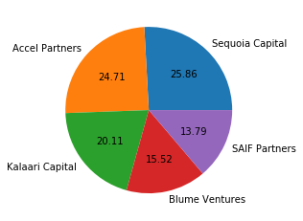
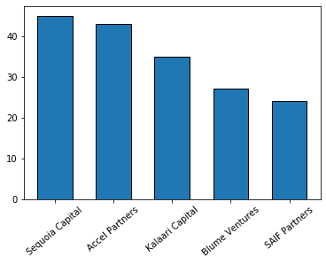
In [17]:
d = {1:{4,5,4,4,4}, 'abc':{'ghi'}, 3:{3,4,5}}
arr = list(d.items())
print(arr)
arr.sort(key=lambda x : len(x[1]))
print(arr)
rev_arr = arr[::-1]
print(rev_arr)
[(1, {4, 5}), ('abc', {'ghi'}), (3, {3, 4, 5})]
[('abc', {'ghi'}), (1, {4, 5}), (3, {3, 4, 5})]

