

DEPARTMENTAL STORE MANAGEMENT SYSTEM



Project Tittle:

Departmental Store Management System

|  |  |
| --- | --- |
| ***Course Details*** | |
| ***Course Name*** | ***Introduction to Database*** |
| ***Section: I*** | |
| ***Submitted to :***  ***Md. Saif Ullah Miah*** | |
| ***Submitted by :***  ***Chowdhury, Arnab***  ***ID: 16-32507-2*** | |

Tables of Contents :

|  |
| --- |
| 1.Introduction |
| 2.Features of database |
| 3.Problem Statements |
| 4.ER Diagram |
| 5.Normalization |
| 6.Schema |
| 7.Queries |
| 7.01 DDL |
| 7.02 DML |
| * 1. Solution to problem statements |

1. **Introduction :**

It is a database of departmental store. Departmental store is a large retailer who stocks and sells product like groceries, cosmetics, food, drinks etc. It is very large supermarkets or shop selling household goods. People of our country like departmental store because they can buy any kind of product from departmental store. This database system gives management an efficient way to handle their information about products and customers. This database stores any kind of information about product, customers, supplier, admin.

This database

1. Stores information of products
2. Stores customers details
3. Stores supplier information who supplies any kind of product
4. Stores admin information who insert any kind of product
5. Stores information of all customer who buys which product

1. **Features of database :**

* Add and maintain records of available products.
* Add and maintain customer details.
* Add and maintain description of new products.
* All details about admin.
* All details about supplier.
* All details about customer who buys which products.

1. **Problem Statements :**
2. Display customer name, product name, quantity, price, total price for all customer
3. Display supplier number, supplier name, product name who supplies product ‘apple’
4. Display admin number, admin name, product name who insert product ‘hilsha’
5. Display product number, product name, quantity, price for product ‘dove’
6. **ER Diagram**

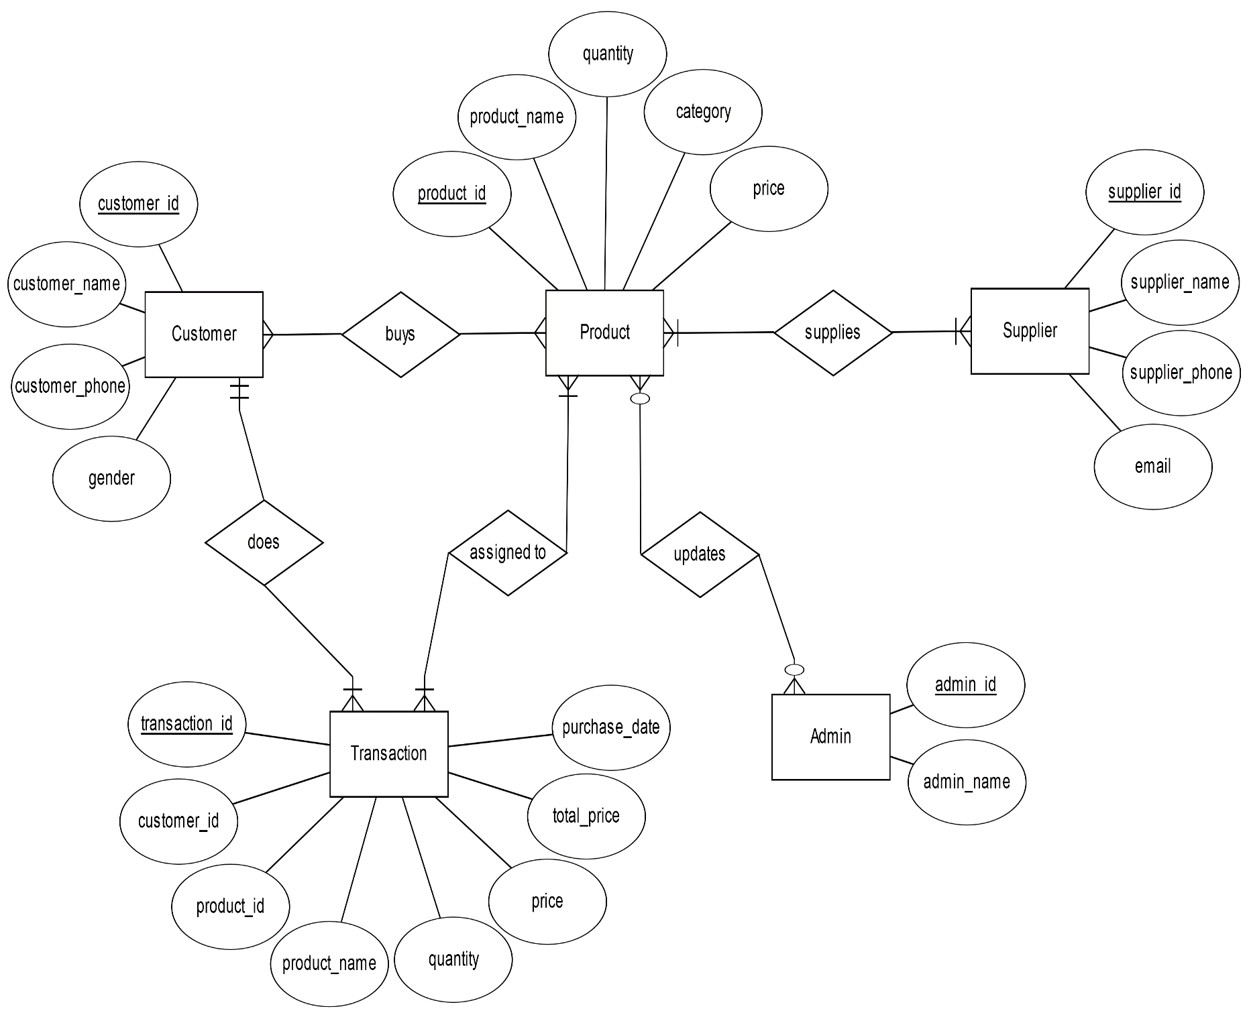

1. **Normalization :**

The normalization is given below from 1NF up to 3NF

1NF:

Product_details :

|  |  |  |  |  |
| --- | --- | --- | --- | --- |
| customer_id | customer_name | customer_phone | gender | product_id |
| product_name | quantity | category | price |  |

Supplier :

|  |  |  |  |
| --- | --- | --- | --- |
| supplier_id | supplier_name | supplier_phone | email |

Transaction :

|  |  |  |  |
| --- | --- | --- | --- |
| customer_id | customer_name | customer_phone | gender |
| product_id | product_name | quantity | category |

Admin :

|  |  |
| --- | --- |
| admin_id | admin_name |

2NF :

Customer :

|  |  |  |  |
| --- | --- | --- | --- |
| customer_id | customer_name | customer_phone | gender |
| product_id | product_name | quantity | category |

Product :

|  |  |  |
| --- | --- | --- |
| product_id | product_name | price |

3NF :

Transaction :

|  |  |  |  |  |  |
| --- | --- | --- | --- | --- | --- |
| transaction_id | customer_id | product_id | product_name | total_price | purchase_date |

Product :

|  |  |  |
| --- | --- | --- |
| product_id | quantity | category |

Customer :

|  |  |  |  |  |
| --- | --- | --- | --- | --- |
| customer_id | customer_name | customer_phone | gender | product_id |

Admin_Product :

|  |  |  |
| --- | --- | --- |
| admin_id | admin_name | product_id |

Supplier_Product :

|  |  |  |  |  |
| --- | --- | --- | --- | --- |
| supplier_id | supplier_name | supplier_phone | email | product_id |

1. **Schema :**

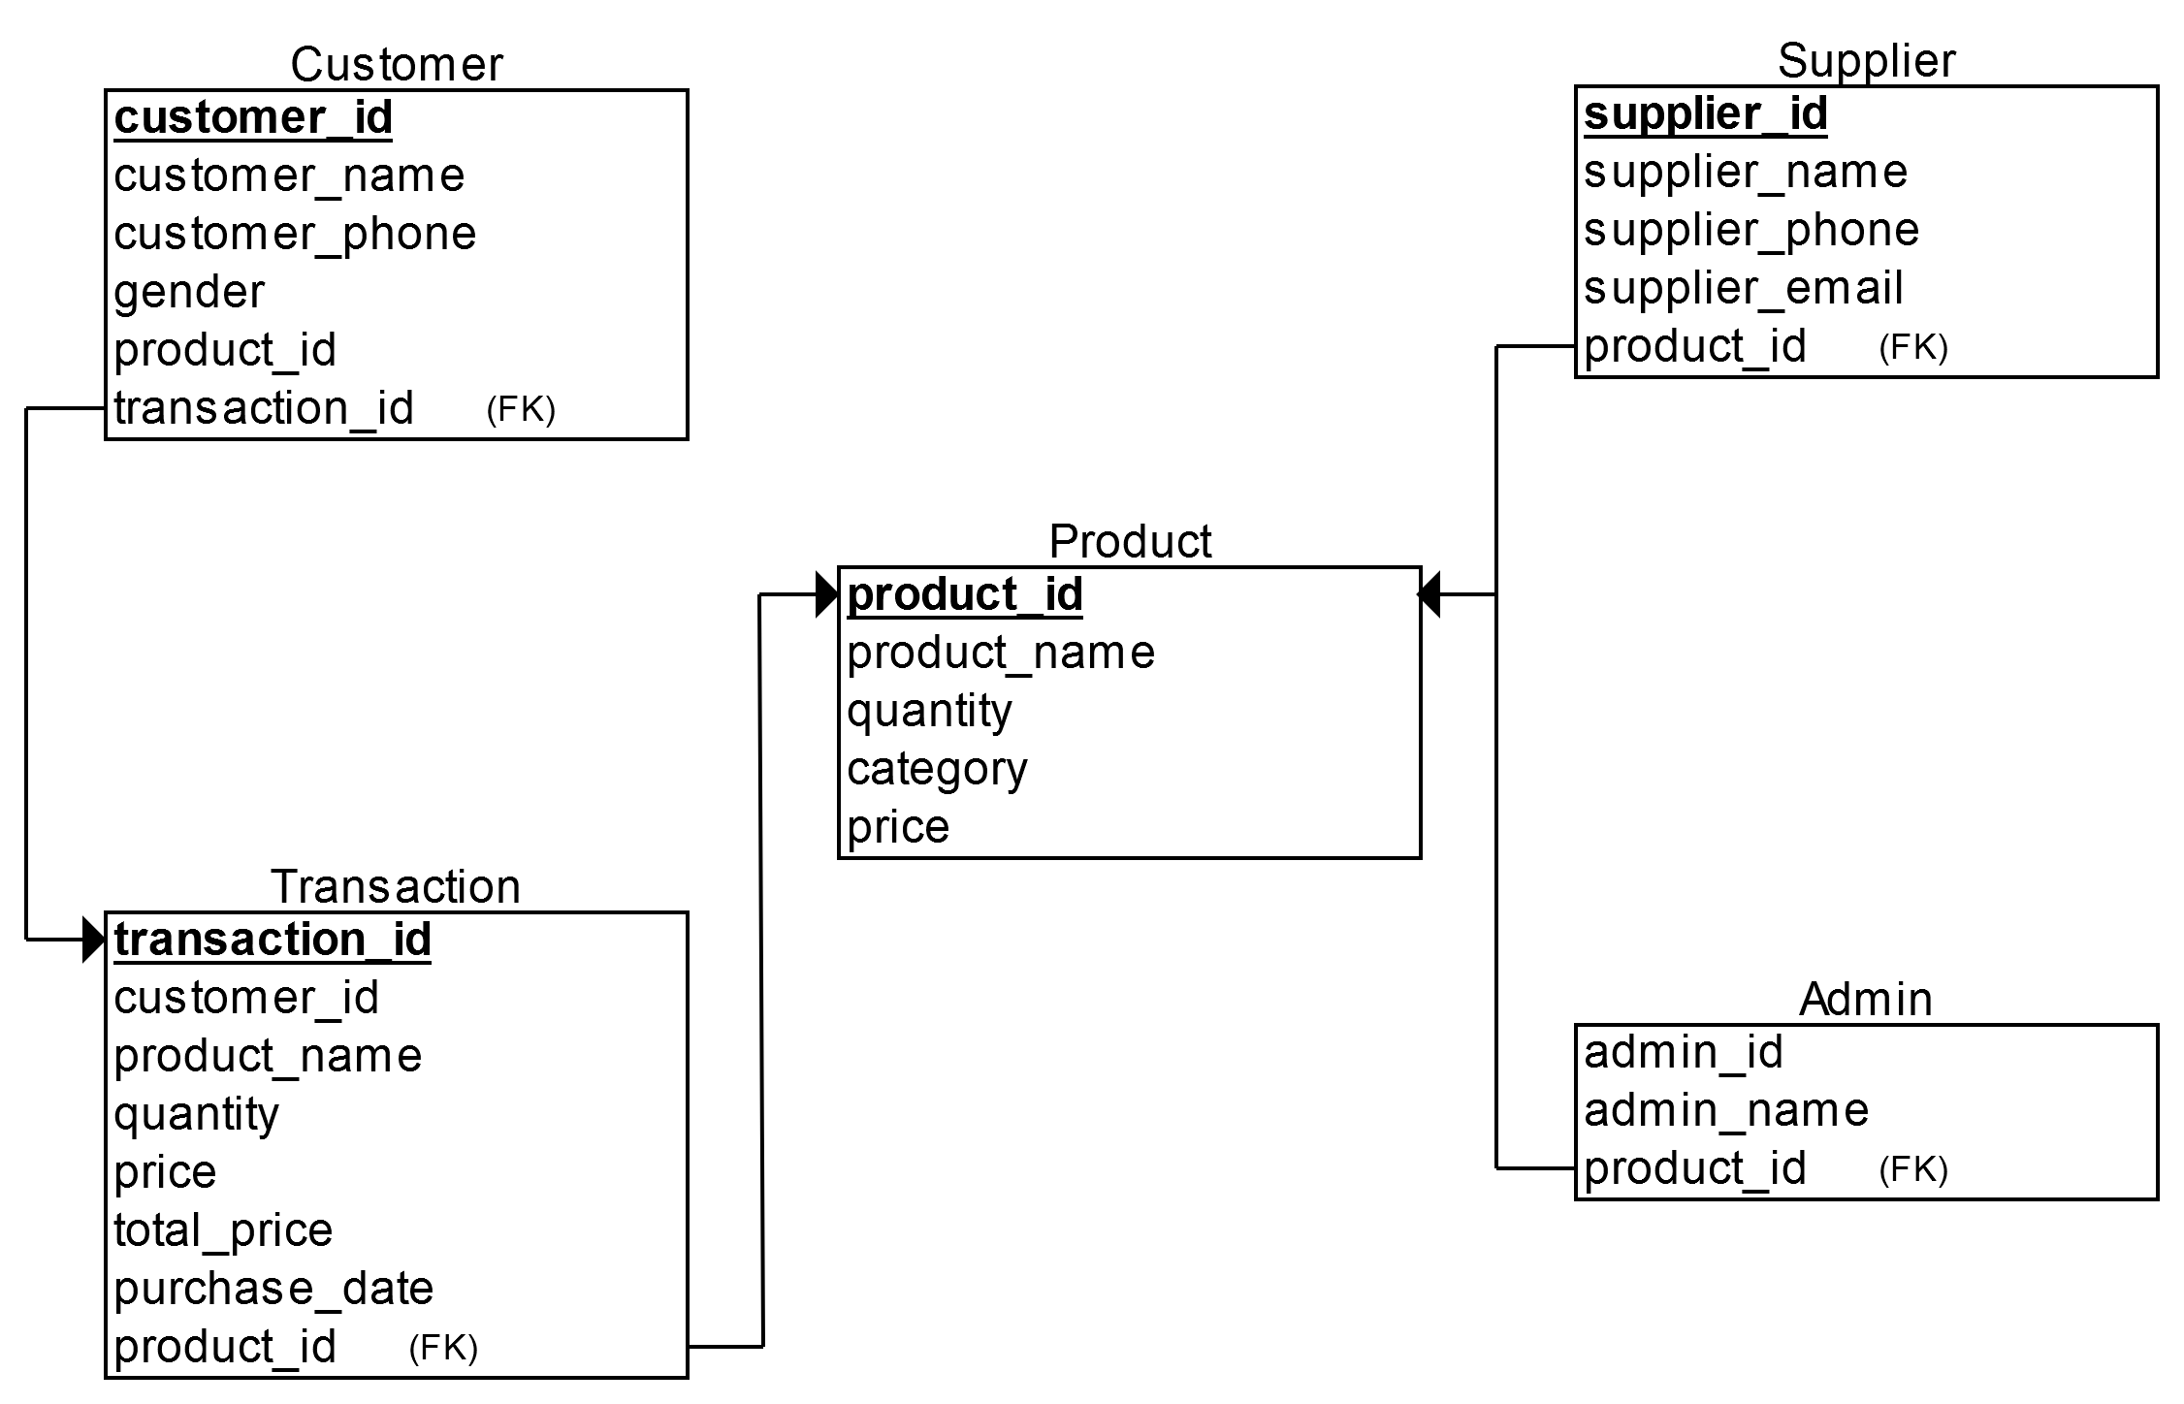

1. **Queries:**

7.01 DDL:

1. Creating Customer table

Create table customer(customer_id number(10) primary key, customer_name varchar2(20), phone number(20), gender varchar2(10), product_id number(10), transaction_id number(20));

2. Creating Product table

Create table product(product_id number(10) primary key, product_name varchar2(20), quantity varchar2(20), category varchar2(20), price number(20));

3. Creating Supplier table

Create table supplier(supplier_id number(10) primary key, supplier_name varchar2(20), supplier_phone number(20), supplier_email varchar2(20), product_id number(10));

4. Creating Transaction table

Create table transaction(transaction_id number(10) primary key, customer_id number(10), product_id number(10), product_name varchar2(20), quantity varchar2(20), price number(20), total_price number(20),purchase_date date sysdate);

5. Creating Admin table

Create table admin(admin_id number(10) primary key, admin_name varchar2(20), product_id number(10));

7.02 DML

1. Customer table

insert into customer

values(1001,’Arnab’,12345,’Male’,11,101);

2. Product table

insert into product

values(11,’Apple’,’10kg’,’Food’,150);

3. Supplier table

insert into supplier

values(101,'Aditya',987456,'aditya@gmail.com',11);

4. Transaction table

insert into transaction

values(101,1001,11,'Apple','5kg',150,750,'17-JAN-17');

5. Admin table

insert into admin

values(10001,'Dipto',11);

7.03 Solutions to problem statements

7.03.01 Display customer name, product name, quantity, price, total price for all customer

select c.customer_name,t.product_name,t.quantity,t.price,t.total_price

from customer c join transaction t

on c.customer_id=t.customer_id;

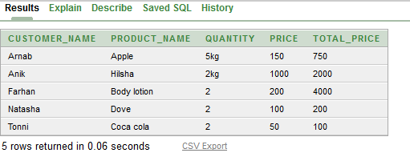

7.03.02 Display supplier number, supplier name, product name who supplies product ‘apple’

select s.supplier_id,s.supplier_name,p.product_name

from supplier s join product p

on s.product_id=p.product_id

and p.product_name='Apple';

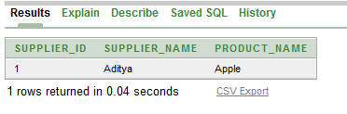

7.03.03 Display admin number, admin name, product name who insert product ‘hilsha’

select a.admin_id,a.admin_name,p.product_name

from admin a join product p

on a.product_id=p.product_id

and p.product_name='Hilsha'

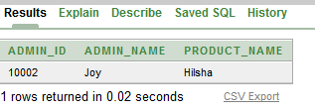

7.03.04 Display product number, product name, quantity, price for product ‘dove’

select product_id,product_name,quantity,price

from product

where product_id=(select product_id

from product

where product_name='Dove');

