Codebook for data

Autogenerated data summary from dataMaid

2018-04-27 22:41:58

# Data report overview

The dataset examined has the following dimensions:

|  |  |
| --- | --- |
| Feature | Result |
| Number of observations | 10299 |
| Number of variables | 68 |

# Codebook summary table

|  |  |  |  |  |  |
| --- | --- | --- | --- | --- | --- |
| Label | Variable | Class | # unique values | Missing | Description |
|  | **subject** | Integer | 30 | 0.00 % |  |
|  | **v1** | Numeric | 10292 | 0.00 % |  |
|  | **v2** | Numeric | 10299 | 0.00 % |  |
|  | **v3** | Numeric | 10293 | 0.00 % |  |
|  | **v4** | Numeric | 10295 | 0.00 % |  |
|  | **v5** | Numeric | 10297 | 0.00 % |  |
|  | **v6** | Numeric | 10297 | 0.00 % |  |
|  | **v41** | Numeric | 10296 | 0.00 % |  |
|  | **v42** | Numeric | 10298 | 0.00 % |  |
|  | **v43** | Numeric | 10299 | 0.00 % |  |
|  | **v44** | Numeric | 10288 | 0.00 % |  |
|  | **v45** | Numeric | 10293 | 0.00 % |  |
|  | **v46** | Numeric | 10296 | 0.00 % |  |
|  | **v81** | Numeric | 10299 | 0.00 % |  |
|  | **v82** | Numeric | 10299 | 0.00 % |  |
|  | **v83** | Numeric | 10299 | 0.00 % |  |
|  | **v84** | Numeric | 10290 | 0.00 % |  |
|  | **v85** | Numeric | 10296 | 0.00 % |  |
|  | **v86** | Numeric | 10293 | 0.00 % |  |
|  | **v121** | Numeric | 10298 | 0.00 % |  |
|  | **v122** | Numeric | 10299 | 0.00 % |  |
|  | **v123** | Numeric | 10297 | 0.00 % |  |
|  | **v124** | Numeric | 10292 | 0.00 % |  |
|  | **v125** | Numeric | 10296 | 0.00 % |  |
|  | **v126** | Numeric | 10296 | 0.00 % |  |
|  | **v161** | Numeric | 10295 | 0.00 % |  |
|  | **v162** | Numeric | 10299 | 0.00 % |  |
|  | **v163** | Numeric | 10298 | 0.00 % |  |
|  | **v164** | Numeric | 10292 | 0.00 % |  |
|  | **v165** | Numeric | 10295 | 0.00 % |  |
|  | **v166** | Numeric | 10291 | 0.00 % |  |
|  | **v201** | Numeric | 10296 | 0.00 % |  |
|  | **v202** | Numeric | 10294 | 0.00 % |  |
|  | **v214** | Numeric | 10296 | 0.00 % |  |
|  | **v215** | Numeric | 10294 | 0.00 % |  |
|  | **v227** | Numeric | 10292 | 0.00 % |  |
|  | **v228** | Numeric | 10294 | 0.00 % |  |
|  | **v240** | Numeric | 10298 | 0.00 % |  |
|  | **v241** | Numeric | 10298 | 0.00 % |  |
|  | **v253** | Numeric | 10293 | 0.00 % |  |
|  | **v254** | Numeric | 10297 | 0.00 % |  |
|  | **v266** | Numeric | 10295 | 0.00 % |  |
|  | **v267** | Numeric | 10292 | 0.00 % |  |
|  | **v268** | Numeric | 10295 | 0.00 % |  |
|  | **v269** | Numeric | 10294 | 0.00 % |  |
|  | **v270** | numeric | 10297 | 0.00 % |  |
|  | **v271** | numeric | 10296 | 0.00 % |  |
|  | **v345** | numeric | 10293 | 0.00 % |  |
|  | **v346** | numeric | 10296 | 0.00 % |  |
|  | **v347** | numeric | 10294 | 0.00 % |  |
|  | **v348** | numeric | 10291 | 0.00 % |  |
|  | **v349** | numeric | 10294 | 0.00 % |  |
|  | **v350** | numeric | 10290 | 0.00 % |  |
|  | **v424** | numeric | 10297 | 0.00 % |  |
|  | **v425** | numeric | 10296 | 0.00 % |  |
|  | **v426** | numeric | 10297 | 0.00 % |  |
|  | **v427** | numeric | 10297 | 0.00 % |  |
|  | **v428** | numeric | 10293 | 0.00 % |  |
|  | **v429** | numeric | 10295 | 0.00 % |  |
|  | **v503** | numeric | 10296 | 0.00 % |  |
|  | **v504** | numeric | 10298 | 0.00 % |  |
|  | **v516** | numeric | 10290 | 0.00 % |  |
|  | **v517** | numeric | 10296 | 0.00 % |  |
|  | **v529** | numeric | 10297 | 0.00 % |  |
|  | **v530** | numeric | 10296 | 0.00 % |  |
|  | **v542** | numeric | 10293 | 0.00 % |  |
|  | **v543** | numeric | 10292 | 0.00 % |  |
|  | **activity** | character | 6 | 0.00 % |  |

# Variable list

## subject

|  |  |
| --- | --- |
| Feature | Result |
| Variable type | integer |
| Number of missing obs. | 0 (0 %) |
| Number of unique values | 30 |
| Median | 17 |
| 1st and 3rd quartiles | 9; 24 |
| Min. and max. | 1; 30 |

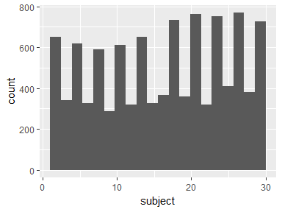

## v1

|  |  |
| --- | --- |
| Feature | Result |
| Variable type | numeric |
| Number of missing obs. | 0 (0 %) |
| Number of unique values | 10292 |
| Median | 0.28 |
| 1st and 3rd quartiles | 0.26; 0.29 |
| Min. and max. | -1; 1 |

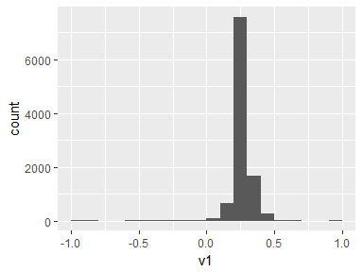

## v2

|  |  |
| --- | --- |
| Feature | Result |
| Variable type | numeric |
| Number of missing obs. | 0 (0 %) |
| Number of unique values | 10299 |
| Median | -0.02 |
| 1st and 3rd quartiles | -0.02; -0.01 |
| Min. and max. | -1; 1 |

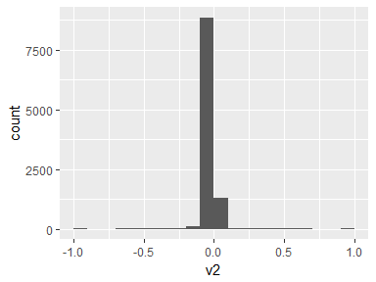

## v3

|  |  |
| --- | --- |
| Feature | Result |
| Variable type | numeric |
| Number of missing obs. | 0 (0 %) |
| Number of unique values | 10293 |
| Median | -0.11 |
| 1st and 3rd quartiles | -0.12; -0.1 |
| Min. and max. | -1; 1 |

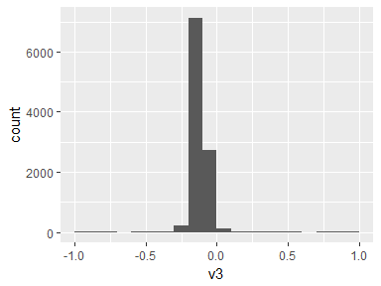

## v4

|  |  |
| --- | --- |
| Feature | Result |
| Variable type | numeric |
| Number of missing obs. | 0 (0 %) |
| Number of unique values | 10295 |
| Median | -0.94 |
| 1st and 3rd quartiles | -0.99; -0.25 |
| Min. and max. | -1; 1 |

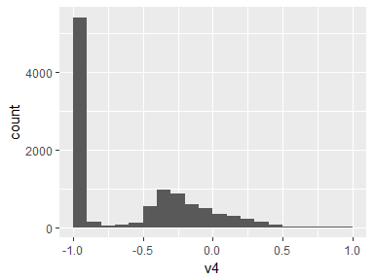

## v5

|  |  |
| --- | --- |
| Feature | Result |
| Variable type | numeric |
| Number of missing obs. | 0 (0 %) |
| Number of unique values | 10297 |
| Median | -0.84 |
| 1st and 3rd quartiles | -0.98; -0.06 |
| Min. and max. | -1; 1 |

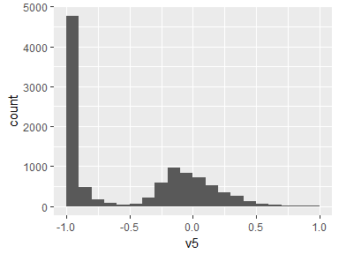

## v6

|  |  |
| --- | --- |
| Feature | Result |
| Variable type | numeric |
| Number of missing obs. | 0 (0 %) |
| Number of unique values | 10297 |
| Median | -0.85 |
| 1st and 3rd quartiles | -0.98; -0.28 |
| Min. and max. | -1; 1 |

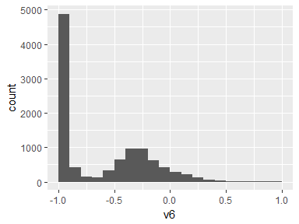

## v41

|  |  |
| --- | --- |
| Feature | Result |
| Variable type | numeric |
| Number of missing obs. | 0 (0 %) |
| Number of unique values | 10296 |
| Median | 0.92 |
| 1st and 3rd quartiles | 0.81; 0.95 |
| Min. and max. | -1; 1 |

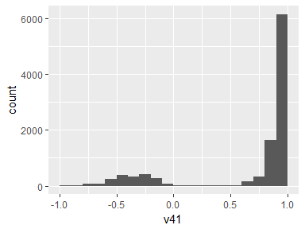

## v42

|  |  |
| --- | --- |
| Feature | Result |
| Variable type | numeric |
| Number of missing obs. | 0 (0 %) |
| Number of unique values | 10298 |
| Median | -0.14 |
| 1st and 3rd quartiles | -0.24; 0.12 |
| Min. and max. | -1; 1 |

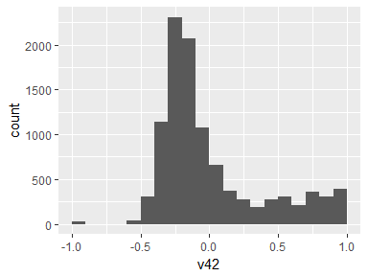

## v43

|  |  |
| --- | --- |
| Feature | Result |
| Variable type | numeric |
| Number of missing obs. | 0 (0 %) |
| Number of unique values | 10299 |
| Median | 0.04 |
| 1st and 3rd quartiles | -0.12; 0.22 |
| Min. and max. | -1; 1 |

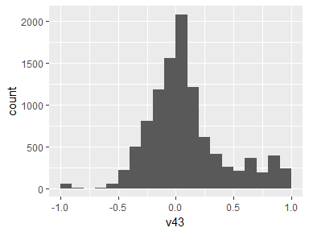

## v44

|  |  |
| --- | --- |
| Feature | Result |
| Variable type | numeric |
| Number of missing obs. | 0 (0 %) |
| Number of unique values | 10288 |
| Median | -0.98 |
| 1st and 3rd quartiles | -0.99; -0.96 |
| Min. and max. | -1; 1 |

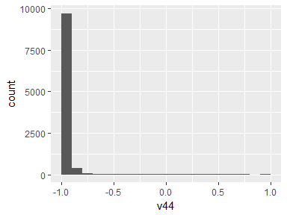

## v45

|  |  |
| --- | --- |
| Feature | Result |
| Variable type | numeric |
| Number of missing obs. | 0 (0 %) |
| Number of unique values | 10293 |
| Median | -0.98 |
| 1st and 3rd quartiles | -0.99; -0.95 |
| Min. and max. | -1; 1 |

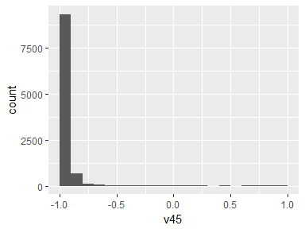

## v46

|  |  |
| --- | --- |
| Feature | Result |
| Variable type | numeric |
| Number of missing obs. | 0 (0 %) |
| Number of unique values | 10296 |
| Median | -0.97 |
| 1st and 3rd quartiles | -0.99; -0.93 |
| Min. and max. | -1; 1 |

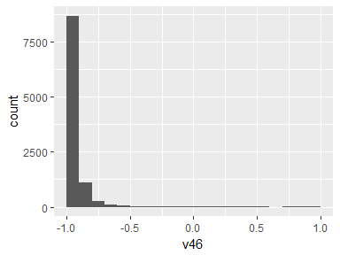

## v81

|  |  |
| --- | --- |
| Feature | Result |
| Variable type | numeric |
| Number of missing obs. | 0 (0 %) |
| Number of unique values | 10299 |
| Median | 0.08 |
| 1st and 3rd quartiles | 0.06; 0.09 |
| Min. and max. | -1; 1 |

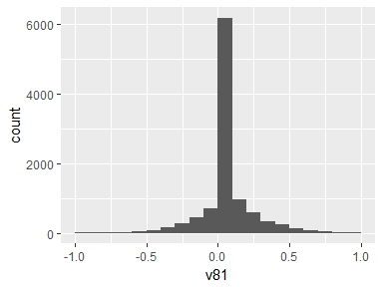

## v82

|  |  |
| --- | --- |
| Feature | Result |
| Variable type | numeric |
| Number of missing obs. | 0 (0 %) |
| Number of unique values | 10299 |
| Median | 0.01 |
| 1st and 3rd quartiles | -0.02; 0.03 |
| Min. and max. | -1; 1 |

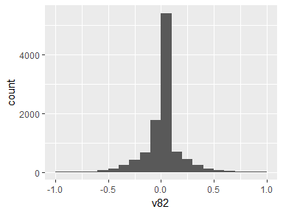

## v83

|  |  |
| --- | --- |
| Feature | Result |
| Variable type | numeric |
| Number of missing obs. | 0 (0 %) |
| Number of unique values | 10299 |
| Median | 0 |
| 1st and 3rd quartiles | -0.03; 0.02 |
| Min. and max. | -1; 1 |

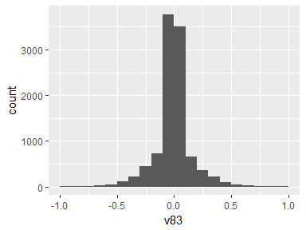

## v84

|  |  |
| --- | --- |
| Feature | Result |
| Variable type | numeric |
| Number of missing obs. | 0 (0 %) |
| Number of unique values | 10290 |
| Median | -0.95 |
| 1st and 3rd quartiles | -0.99; -0.29 |
| Min. and max. | -1; 1 |

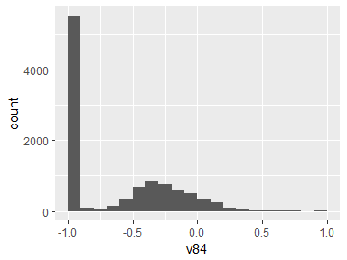

## v85

|  |  |
| --- | --- |
| Feature | Result |
| Variable type | numeric |
| Number of missing obs. | 0 (0 %) |
| Number of unique values | 10296 |
| Median | -0.93 |
| 1st and 3rd quartiles | -0.99; -0.22 |
| Min. and max. | -1; 1 |

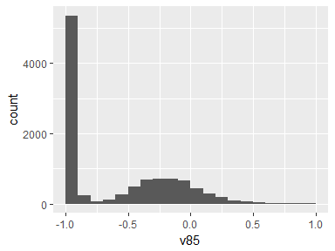

## v86

|  |  |
| --- | --- |
| Feature | Result |
| Variable type | numeric |
| Number of missing obs. | 0 (0 %) |
| Number of unique values | 10293 |
| Median | -0.95 |
| 1st and 3rd quartiles | -0.99; -0.55 |
| Min. and max. | -1; 1 |

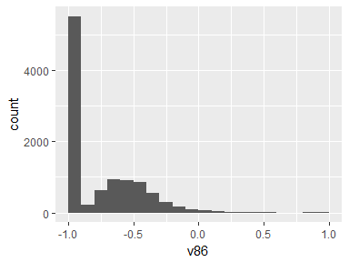

## v121

|  |  |
| --- | --- |
| Feature | Result |
| Variable type | numeric |
| Number of missing obs. | 0 (0 %) |
| Number of unique values | 10298 |
| Median | -0.03 |
| 1st and 3rd quartiles | -0.05; -0.01 |
| Min. and max. | -1; 1 |

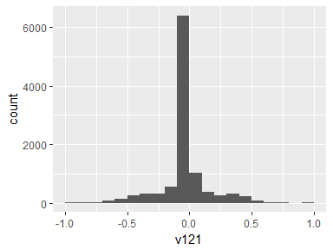

## v122

|  |  |
| --- | --- |
| Feature | Result |
| Variable type | numeric |
| Number of missing obs. | 0 (0 %) |
| Number of unique values | 10299 |
| Median | -0.07 |
| 1st and 3rd quartiles | -0.1; -0.05 |
| Min. and max. | -1; 1 |

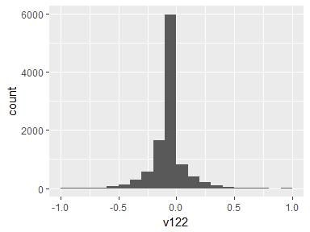

## v123

|  |  |
| --- | --- |
| Feature | Result |
| Variable type | numeric |
| Number of missing obs. | 0 (0 %) |
| Number of unique values | 10297 |
| Median | 0.09 |
| 1st and 3rd quartiles | 0.06; 0.11 |
| Min. and max. | -1; 1 |

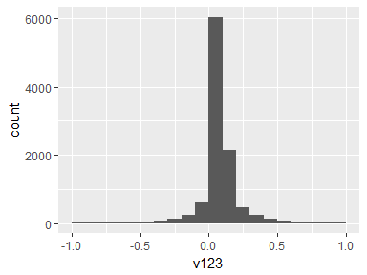

## v124

|  |  |
| --- | --- |
| Feature | Result |
| Variable type | numeric |
| Number of missing obs. | 0 (0 %) |
| Number of unique values | 10292 |
| Median | -0.9 |
| 1st and 3rd quartiles | -0.99; -0.48 |
| Min. and max. | -1; 1 |

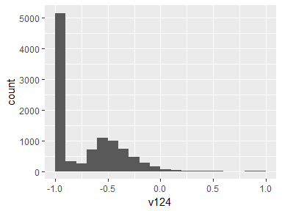

## v125

|  |  |
| --- | --- |
| Feature | Result |
| Variable type | numeric |
| Number of missing obs. | 0 (0 %) |
| Number of unique values | 10296 |
| Median | -0.91 |
| 1st and 3rd quartiles | -0.98; -0.45 |
| Min. and max. | -1; 1 |

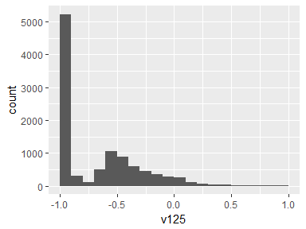

## v126

|  |  |
| --- | --- |
| Feature | Result |
| Variable type | numeric |
| Number of missing obs. | 0 (0 %) |
| Number of unique values | 10296 |
| Median | -0.88 |
| 1st and 3rd quartiles | -0.99; -0.34 |
| Min. and max. | -1; 1 |

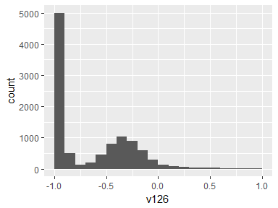

## v161

|  |  |
| --- | --- |
| Feature | Result |
| Variable type | numeric |
| Number of missing obs. | 0 (0 %) |
| Number of unique values | 10295 |
| Median | -0.1 |
| 1st and 3rd quartiles | -0.12; -0.08 |
| Min. and max. | -1; 1 |

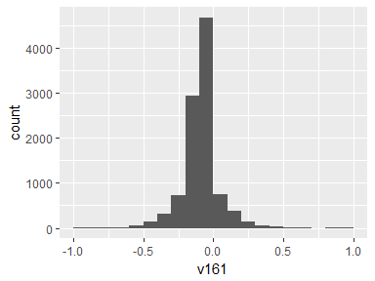

## v162

|  |  |
| --- | --- |
| Feature | Result |
| Variable type | numeric |
| Number of missing obs. | 0 (0 %) |
| Number of unique values | 10299 |
| Median | -0.04 |
| 1st and 3rd quartiles | -0.06; -0.03 |
| Min. and max. | -1; 1 |

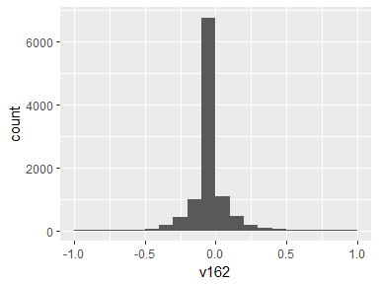

## v163

|  |  |
| --- | --- |
| Feature | Result |
| Variable type | numeric |
| Number of missing obs. | 0 (0 %) |
| Number of unique values | 10298 |
| Median | -0.05 |
| 1st and 3rd quartiles | -0.08; -0.03 |
| Min. and max. | -1; 1 |

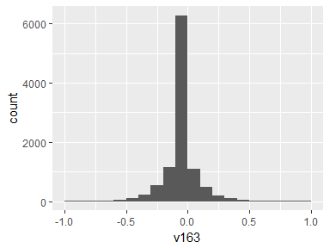

## v164

|  |  |
| --- | --- |
| Feature | Result |
| Variable type | numeric |
| Number of missing obs. | 0 (0 %) |
| Number of unique values | 10292 |
| Median | -0.93 |
| 1st and 3rd quartiles | -0.99; -0.49 |
| Min. and max. | -1; 1 |

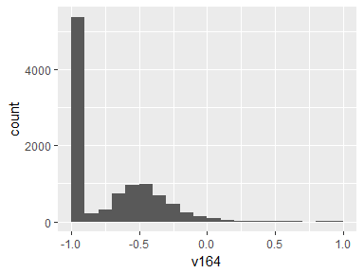

## v165

|  |  |
| --- | --- |
| Feature | Result |
| Variable type | numeric |
| Number of missing obs. | 0 (0 %) |
| Number of unique values | 10295 |
| Median | -0.95 |
| 1st and 3rd quartiles | -0.99; -0.63 |
| Min. and max. | -1; 1 |

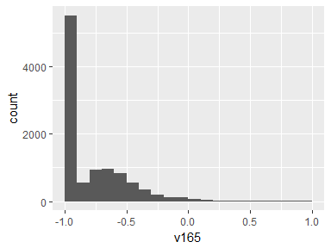

## v166

|  |  |
| --- | --- |
| Feature | Result |
| Variable type | numeric |
| Number of missing obs. | 0 (0 %) |
| Number of unique values | 10291 |
| Median | -0.95 |
| 1st and 3rd quartiles | -0.99; -0.51 |
| Min. and max. | -1; 1 |

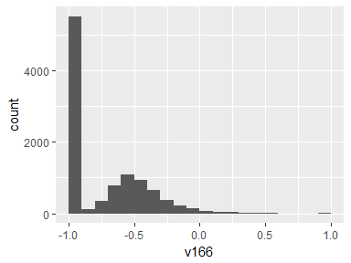

## v201

|  |  |
| --- | --- |
| Feature | Result |
| Variable type | numeric |
| Number of missing obs. | 0 (0 %) |
| Number of unique values | 10296 |
| Median | -0.87 |
| 1st and 3rd quartiles | -0.98; -0.12 |
| Min. and max. | -1; 1 |

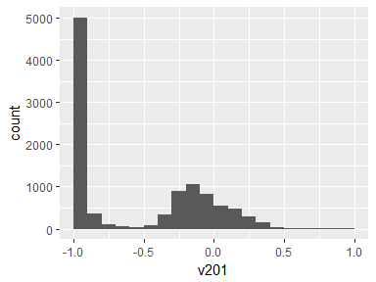

## v202

|  |  |
| --- | --- |
| Feature | Result |
| Variable type | numeric |
| Number of missing obs. | 0 (0 %) |
| Number of unique values | 10294 |
| Median | -0.84 |
| 1st and 3rd quartiles | -0.98; -0.24 |
| Min. and max. | -1; 1 |

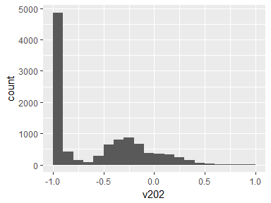

## v214

|  |  |
| --- | --- |
| Feature | Result |
| Variable type | numeric |
| Number of missing obs. | 0 (0 %) |
| Number of unique values | 10296 |
| Median | -0.87 |
| 1st and 3rd quartiles | -0.98; -0.12 |
| Min. and max. | -1; 1 |

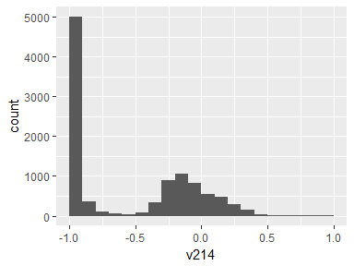

## v215

|  |  |
| --- | --- |
| Feature | Result |
| Variable type | numeric |
| Number of missing obs. | 0 (0 %) |
| Number of unique values | 10294 |
| Median | -0.84 |
| 1st and 3rd quartiles | -0.98; -0.24 |
| Min. and max. | -1; 1 |

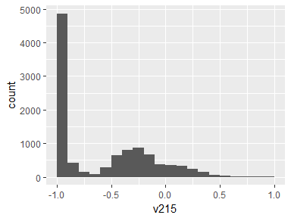

## v227

|  |  |
| --- | --- |
| Feature | Result |
| Variable type | numeric |
| Number of missing obs. | 0 (0 %) |
| Number of unique values | 10292 |
| Median | -0.95 |
| 1st and 3rd quartiles | -0.99; -0.3 |
| Min. and max. | -1; 1 |

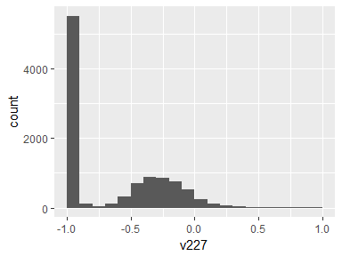

## v228

|  |  |
| --- | --- |
| Feature | Result |
| Variable type | numeric |
| Number of missing obs. | 0 (0 %) |
| Number of unique values | 10294 |
| Median | -0.93 |
| 1st and 3rd quartiles | -0.99; -0.27 |
| Min. and max. | -1; 1 |

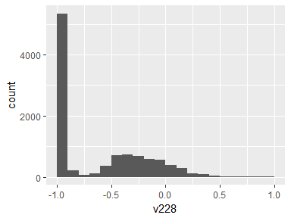

## v240

|  |  |
| --- | --- |
| Feature | Result |
| Variable type | numeric |
| Number of missing obs. | 0 (0 %) |
| Number of unique values | 10298 |
| Median | -0.82 |
| 1st and 3rd quartiles | -0.98; -0.25 |
| Min. and max. | -1; 1 |

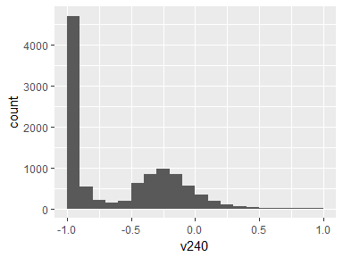

## v241

|  |  |
| --- | --- |
| Feature | Result |
| Variable type | numeric |
| Number of missing obs. | 0 (0 %) |
| Number of unique values | 10298 |
| Median | -0.83 |
| 1st and 3rd quartiles | -0.98; -0.39 |
| Min. and max. | -1; 1 |

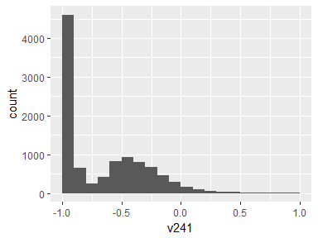

## v253

|  |  |
| --- | --- |
| Feature | Result |
| Variable type | numeric |
| Number of missing obs. | 0 (0 %) |
| Number of unique values | 10293 |
| Median | -0.96 |
| 1st and 3rd quartiles | -0.99; -0.55 |
| Min. and max. | -1; 1 |

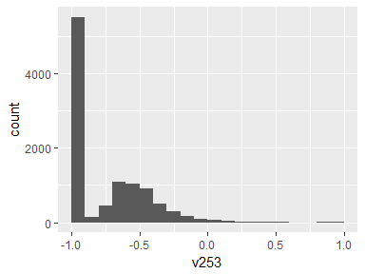

## v254

|  |  |
| --- | --- |
| Feature | Result |
| Variable type | numeric |
| Number of missing obs. | 0 (0 %) |
| Number of unique values | 10297 |
| Median | -0.94 |
| 1st and 3rd quartiles | -0.99; -0.61 |
| Min. and max. | -1; 1 |

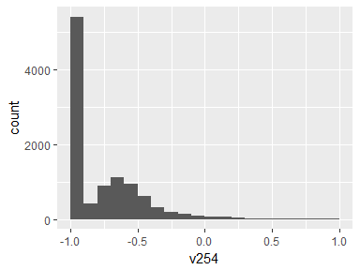

## v266

|  |  |
| --- | --- |
| Feature | Result |
| Variable type | numeric |
| Number of missing obs. | 0 (0 %) |
| Number of unique values | 10295 |
| Median | -0.95 |
| 1st and 3rd quartiles | -0.99; -0.26 |
| Min. and max. | -1; 1 |

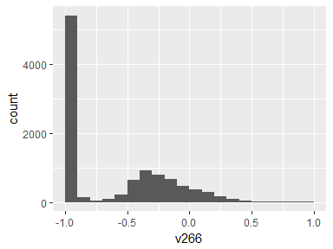

## v267

|  |  |
| --- | --- |
| Feature | Result |
| Variable type | numeric |
| Number of missing obs. | 0 (0 %) |
| Number of unique values | 10292 |
| Median | -0.86 |
| 1st and 3rd quartiles | -0.98; -0.1 |
| Min. and max. | -1; 1 |

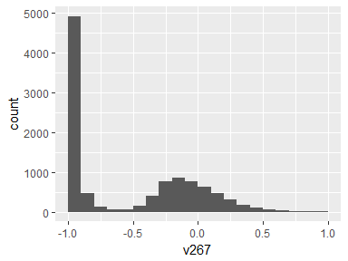

## v268

|  |  |
| --- | --- |
| Feature | Result |
| Variable type | numeric |
| Number of missing obs. | 0 (0 %) |
| Number of unique values | 10295 |
| Median | -0.9 |
| 1st and 3rd quartiles | -0.98; -0.37 |
| Min. and max. | -1; 1 |

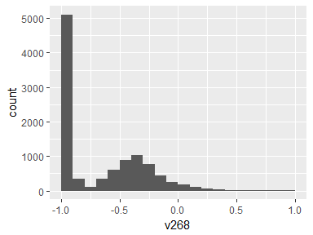

## v269

|  |  |
| --- | --- |
| Feature | Result |
| Variable type | numeric |
| Number of missing obs. | 0 (0 %) |
| Number of unique values | 10294 |
| Median | -0.94 |
| 1st and 3rd quartiles | -0.99; -0.25 |
| Min. and max. | -1; 1 |

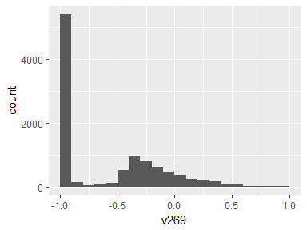

## v270

|  |  |
| --- | --- |
| Feature | Result |
| Variable type | numeric |
| Number of missing obs. | 0 (0 %) |
| Number of unique values | 10297 |
| Median | -0.83 |
| 1st and 3rd quartiles | -0.98; -0.09 |
| Min. and max. | -1; 1 |

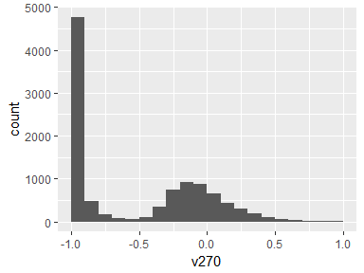

## v271

|  |  |
| --- | --- |
| Feature | Result |
| Variable type | numeric |
| Number of missing obs. | 0 (0 %) |
| Number of unique values | 10296 |
| Median | -0.84 |
| 1st and 3rd quartiles | -0.98; -0.3 |
| Min. and max. | -1; 1 |

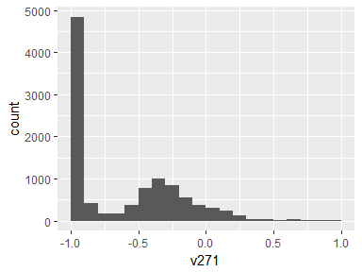

## v345

|  |  |
| --- | --- |
| Feature | Result |
| Variable type | numeric |
| Number of missing obs. | 0 (0 %) |
| Number of unique values | 10293 |
| Median | -0.95 |
| 1st and 3rd quartiles | -0.99; -0.33 |
| Min. and max. | -1; 1 |

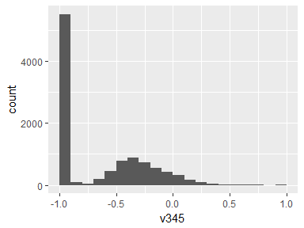

## v346

|  |  |
| --- | --- |
| Feature | Result |
| Variable type | numeric |
| Number of missing obs. | 0 (0 %) |
| Number of unique values | 10296 |
| Median | -0.93 |
| 1st and 3rd quartiles | -0.98; -0.26 |
| Min. and max. | -1; 1 |

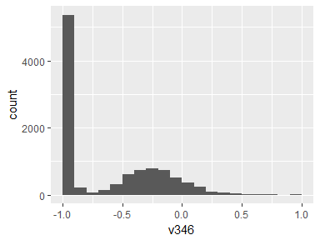

## v347

|  |  |
| --- | --- |
| Feature | Result |
| Variable type | numeric |
| Number of missing obs. | 0 (0 %) |
| Number of unique values | 10294 |
| Median | -0.95 |
| 1st and 3rd quartiles | -0.99; -0.51 |
| Min. and max. | -1; 1 |

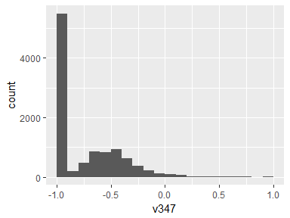

## v348

|  |  |
| --- | --- |
| Feature | Result |
| Variable type | numeric |
| Number of missing obs. | 0 (0 %) |
| Number of unique values | 10291 |
| Median | -0.96 |
| 1st and 3rd quartiles | -0.99; -0.32 |
| Min. and max. | -1; 1 |

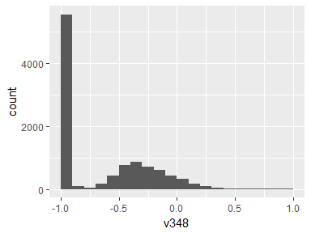

## v349

|  |  |
| --- | --- |
| Feature | Result |
| Variable type | numeric |
| Number of missing obs. | 0 (0 %) |
| Number of unique values | 10294 |
| Median | -0.93 |
| 1st and 3rd quartiles | -0.99; -0.24 |
| Min. and max. | -1; 1 |

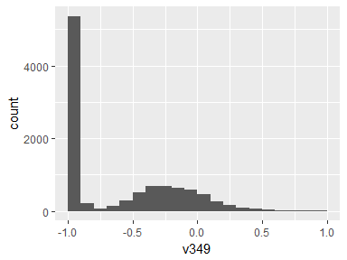

## v350

|  |  |
| --- | --- |
| Feature | Result |
| Variable type | numeric |
| Number of missing obs. | 0 (0 %) |
| Number of unique values | 10290 |
| Median | -0.96 |
| 1st and 3rd quartiles | -0.99; -0.59 |
| Min. and max. | -1; 1 |

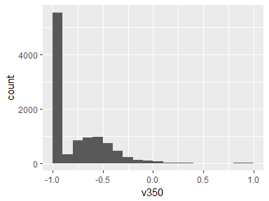

## v424

|  |  |
| --- | --- |
| Feature | Result |
| Variable type | numeric |
| Number of missing obs. | 0 (0 %) |
| Number of unique values | 10297 |
| Median | -0.89 |
| 1st and 3rd quartiles | -0.99; -0.38 |
| Min. and max. | -1; 1 |

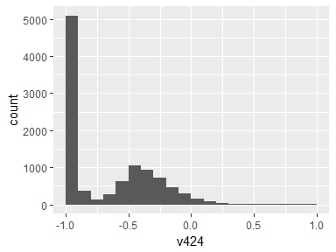

## v425

|  |  |
| --- | --- |
| Feature | Result |
| Variable type | numeric |
| Number of missing obs. | 0 (0 %) |
| Number of unique values | 10296 |
| Median | -0.92 |
| 1st and 3rd quartiles | -0.98; -0.47 |
| Min. and max. | -1; 1 |

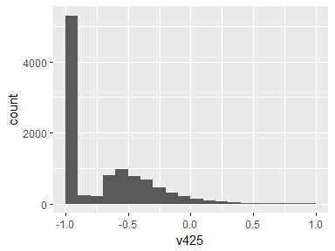

## v426

|  |  |
| --- | --- |
| Feature | Result |
| Variable type | numeric |
| Number of missing obs. | 0 (0 %) |
| Number of unique values | 10297 |
| Median | -0.89 |
| 1st and 3rd quartiles | -0.99; -0.32 |
| Min. and max. | -1; 1 |

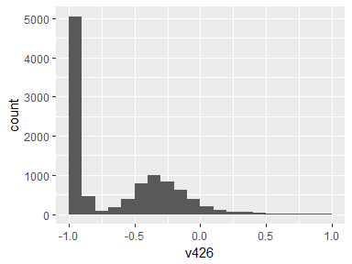

## v427

|  |  |
| --- | --- |
| Feature | Result |
| Variable type | numeric |
| Number of missing obs. | 0 (0 %) |
| Number of unique values | 10297 |
| Median | -0.91 |
| 1st and 3rd quartiles | -0.99; -0.52 |
| Min. and max. | -1; 1 |

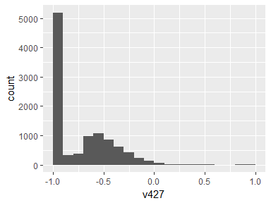

## v428

|  |  |
| --- | --- |
| Feature | Result |
| Variable type | numeric |
| Number of missing obs. | 0 (0 %) |
| Number of unique values | 10293 |
| Median | -0.91 |
| 1st and 3rd quartiles | -0.98; -0.44 |
| Min. and max. | -1; 1 |

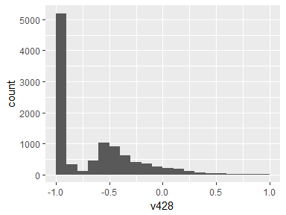

## v429

|  |  |
| --- | --- |
| Feature | Result |
| Variable type | numeric |
| Number of missing obs. | 0 (0 %) |
| Number of unique values | 10295 |
| Median | -0.89 |
| 1st and 3rd quartiles | -0.99; -0.42 |
| Min. and max. | -1; 1 |

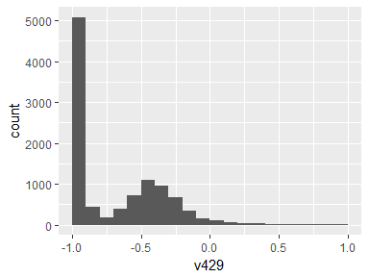

## v503

|  |  |
| --- | --- |
| Feature | Result |
| Variable type | numeric |
| Number of missing obs. | 0 (0 %) |
| Number of unique values | 10296 |
| Median | -0.88 |
| 1st and 3rd quartiles | -0.98; -0.22 |
| Min. and max. | -1; 1 |

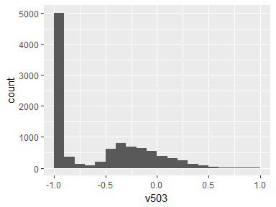

## v504

|  |  |
| --- | --- |
| Feature | Result |
| Variable type | numeric |
| Number of missing obs. | 0 (0 %) |
| Number of unique values | 10298 |
| Median | -0.85 |
| 1st and 3rd quartiles | -0.98; -0.38 |
| Min. and max. | -1; 1 |

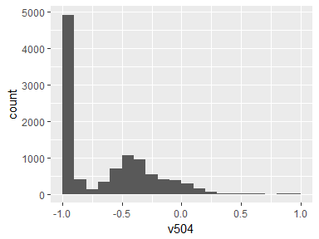

## v516

|  |  |
| --- | --- |
| Feature | Result |
| Variable type | numeric |
| Number of missing obs. | 0 (0 %) |
| Number of unique values | 10290 |
| Median | -0.93 |
| 1st and 3rd quartiles | -0.99; -0.26 |
| Min. and max. | -1; 1 |

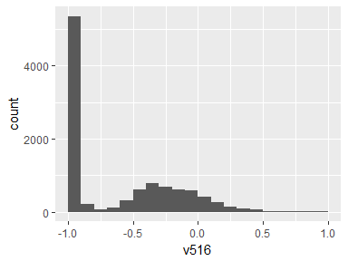

## v517

|  |  |
| --- | --- |
| Feature | Result |
| Variable type | numeric |
| Number of missing obs. | 0 (0 %) |
| Number of unique values | 10296 |
| Median | -0.93 |
| 1st and 3rd quartiles | -0.99; -0.31 |
| Min. and max. | -1; 1 |

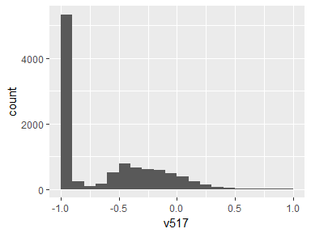

## v529

|  |  |
| --- | --- |
| Feature | Result |
| Variable type | numeric |
| Number of missing obs. | 0 (0 %) |
| Number of unique values | 10297 |
| Median | -0.88 |
| 1st and 3rd quartiles | -0.98; -0.45 |
| Min. and max. | -1; 1 |

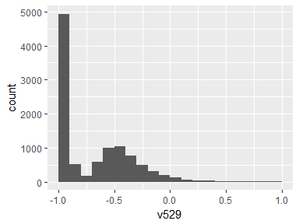

## v530

|  |  |
| --- | --- |
| Feature | Result |
| Variable type | numeric |
| Number of missing obs. | 0 (0 %) |
| Number of unique values | 10296 |
| Median | -0.83 |
| 1st and 3rd quartiles | -0.98; -0.47 |
| Min. and max. | -1; 1 |

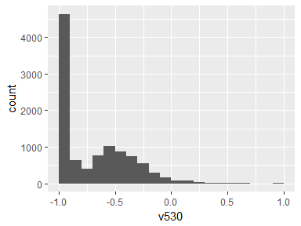

## v542

|  |  |
| --- | --- |
| Feature | Result |
| Variable type | numeric |
| Number of missing obs. | 0 (0 %) |
| Number of unique values | 10293 |
| Median | -0.95 |
| 1st and 3rd quartiles | -0.99; -0.61 |
| Min. and max. | -1; 1 |

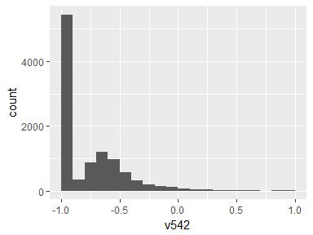

## v543

|  |  |
| --- | --- |
| Feature | Result |
| Variable type | numeric |
| Number of missing obs. | 0 (0 %) |
| Number of unique values | 10292 |
| Median | -0.94 |
| 1st and 3rd quartiles | -0.99; -0.64 |
| Min. and max. | -1; 1 |

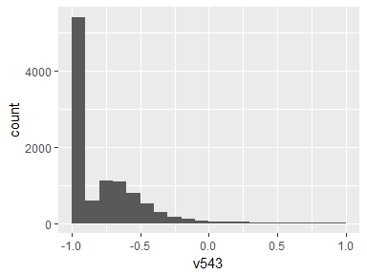

## activity

|  |  |
| --- | --- |
| Feature | Result |
| Variable type | character |
| Number of missing obs. | 0 (0 %) |
| Number of unique values | 6 |
| Mode | “laying” |

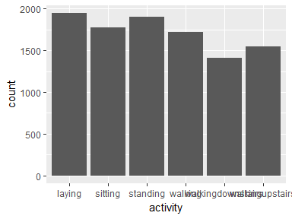

* Observed factor levels: "laying", "sitting", "standing", "walking", "walkingdownstairs", "walkingupstairs".

Report generation information:

* Created by Bhattacharjee, Arnab
* Report creation time: Fri Apr 27 2018 22:43:09
* dataMaid v1.1.0 [Pkg: 2018-02-06 from CRAN (R 3.4.4)]
* R version 3.4.3 (2017-11-30).
* Platform: x86_64-w64-mingw32/x64 (64-bit)(Windows >= 8 x64 (build 9200)).
* Function call: makeDataReport(data = data, mode = c("summarize", "visualize", "check"), smartNum = FALSE, file = normalizeFileName(paste0("codebook_", dfname, vol, ".Rmd")), checks = setChecks(character = list("showAllFactorLevels"), factor = list("showAllFactorLevels"), labelled = list("showAllFactorLevels"), numeric = NULL, integer = NULL, Date = NULL, logical = NULL), listChecks = FALSE, maxProbVals = Inf, codebook = TRUE, reportTitle = paste0("Codebook for ", dfname))