**Authentication Procedures:**

**MFA, SSO, Federation, SAML, OAUTH, OpenID Connect**

Authentication means whether the user is allowed to login or not

Authorization means what are the things that user can perform

**MFA: -** Multi factor authentication checks for another set of authentications along with username, password (preferably hardware token or software token)

Earlier Centralized user access was controlled via LDAP. But every time the user wants to access a set of application it will ask for username and password. In this case if the user accessed HR and after that if he wants to access payroll then he has to provide the username or password again.

TO avoid this SSO was introduced , in this process the user enters the password once and the identity provider provides a token number , so next time if the user wants to use payroll application he doesn’t have to enter credentials again as long as the token is valid

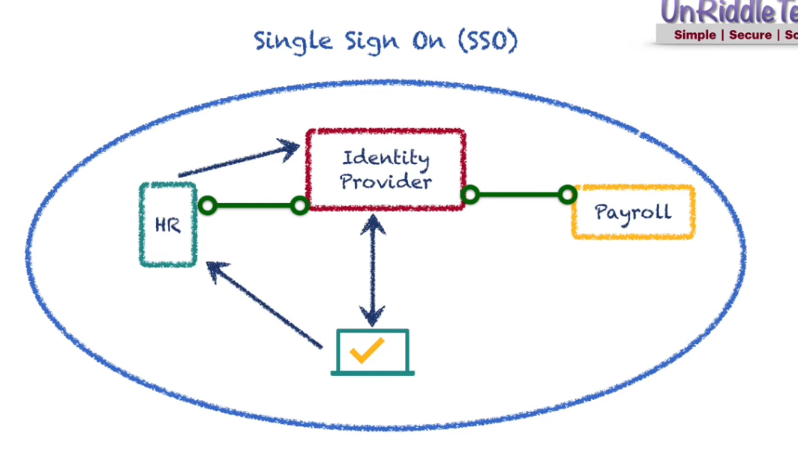

**Federation SAML (Secure Assertion Mark-up Language)**

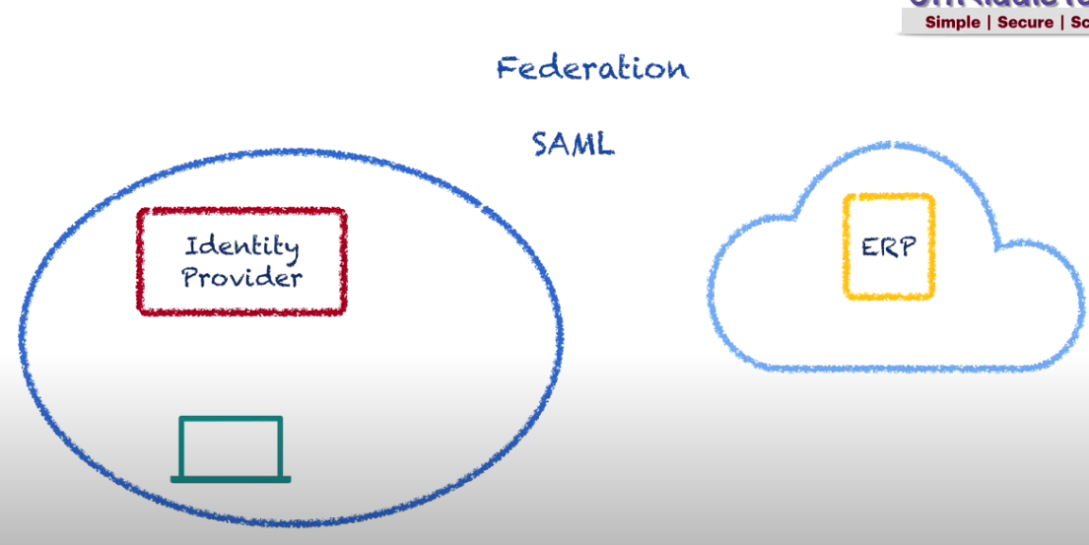

In this case, the user will be trying to access an application hosted on Public cloud. Now User will login to ERP and ERP will redirect it to Identity provider and identity provider will prompt for username and password. Once the user has successfully signed in it will generate a token which will be shared with the public cloud and as long as the token is valid it wont prompt for username/password

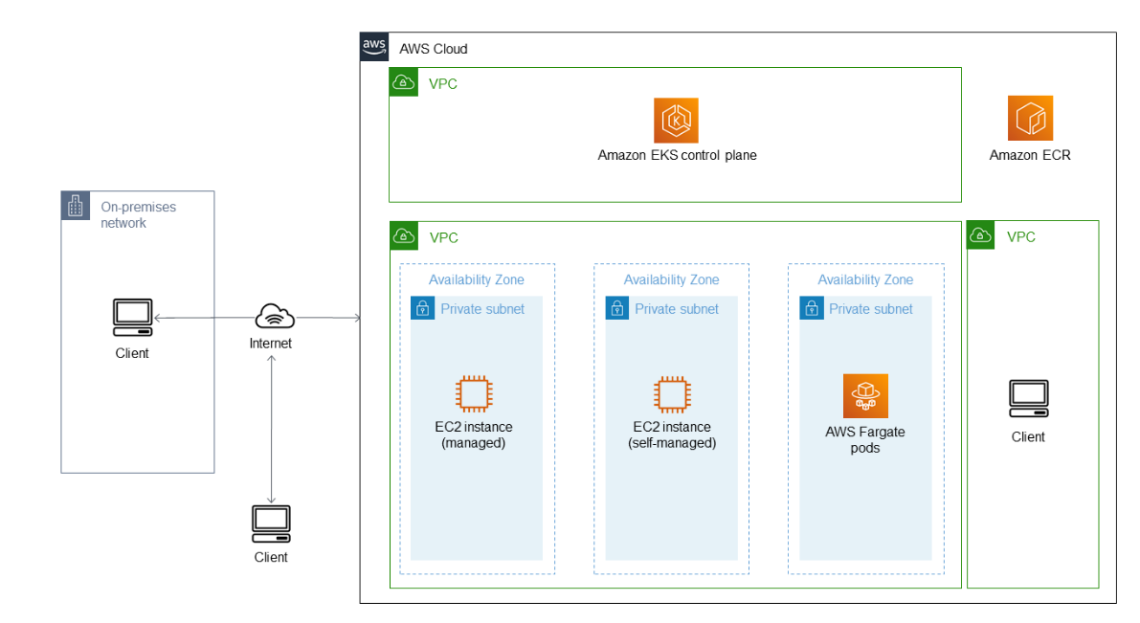

Sample Kubernetes Yaml File

Main parts are apiversion,spec,template,kind

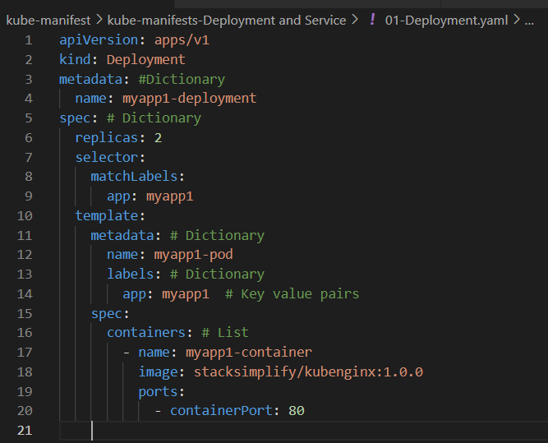

### Terraform Remote Data Source Concept: -

### We can reference terraform state file as data source for other kubernetes deployments

### 