NFS Dynamic Provisioning

**STEP 1: - Create NFS Server**

**My NFS Server IP: - 192.168.205.158**

**NFS Server’s Directory: - /srv/nfs/kubedata**

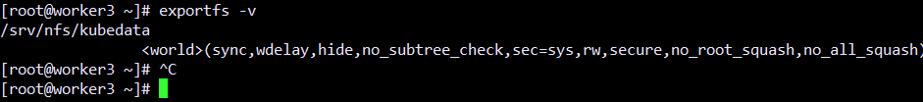

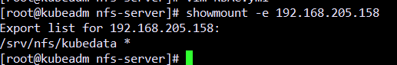

**# Create RBAC, Storage Class and Deployment**

**Check the log files of the container**

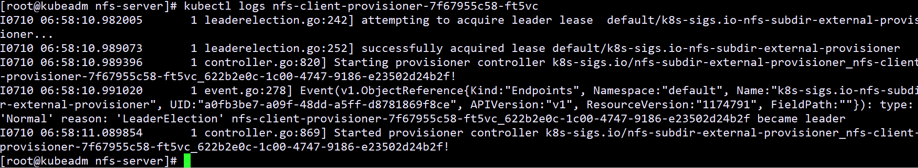

**Create the PVC**

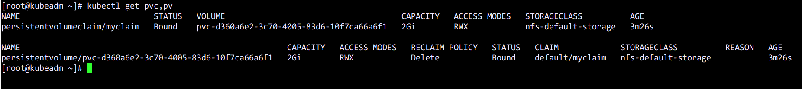

**Create a pod with this volume**

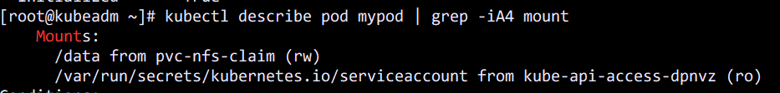

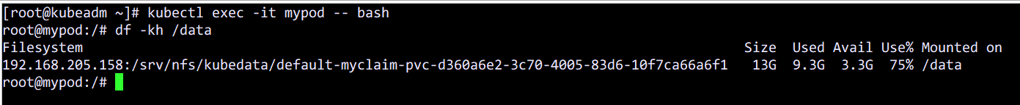

**Try to write some data inside the container**

