Line Following Robot

Frank Bruno James Ihrig

University of Central Florida University of Central Florida  
4000 Central Florida Blvd 4000 Central Florida Blvd

Orlando, Florida, 32816 Orlando, Florida, 32816

fbruno13@knights.ucf.edu JEIhrig@gmail.com

Abstract

The abstract will talk about the project as a whole in no more than 150 words.

# Introduction (0.5 - 1 page) F

This is the introduction section. It should talk about our project in general and the goals, motivation, and real life applications of this project.

Goals:

SPEED

LOW ERROR

LOW COST

# Related Work (0.5 - 1 pages) F

This is the related work section. It should talk about the work being done that relates to this project, such as, other designs for line following robots, learning techniques, and controller methods.

# Method (2-4 total pages)

This section should talk about what we are using to make this project.

Hardware (2 pages) F

This section discusses the hardware used to make the line following robot. The focus of this section is on the design decisions made while constructing the robot such as what parts were used in creation of the robot including sensors, microcontroller (MCU), Wireless Command and Reporting, Power, and Motors. It will also cover some of the hardware limitations and the cost of the robot.

Chassis

As discussed in the related work, many line following robots are small RC car like robots. They can have 2 or more wheels. The smaller and lighter the robot the more speed the robot will have. The body of the line following robot will consist of a Pololu 5" Robot Chassis RRC04A Solid Blue base with a Pololu 3pi Expansion Kit without Cutouts – Black mounted to it (Input height) inches above. The expansion kit is essentially a prototyping board the same dimensions as the base. This chassis allows for the most flexibility to design the rest of the robot and is very light weight. Additionally, the base comes with cutouts for the wheels and many predrilled holes. This design does limit the amount of wheels to 2, but given the light weight design 2 wheels should be sufficient. Since the robot is using only 2 wheels, a Pololu Ball Caster with 3/8" Metal Ball will be used with a counter weight to keep the robot balanced. The ball will just roll as it makes contact with the surface.

Sensors

As discussed in the related work, many line following robots simply use some form of an IR led and a Photodiode used to measure the reflectance from the surface directly below the robot. This combination will output a voltage based on the level of reflectance from the surface. This voltage will be close to zero when on a white surface and close to the voltage of the input source when on a black surface. A very important choice that needs to be made is how many IR led and Photodiode pairs (sensors) will be used. This is mainly dependent on the size of the robot and the width of the tape. Ideally, the amount of sensors is as many as possible to spread across the width of the robot without the sensors interfering with each other. Since the track is made using (INPUT WIDTH OF) electrical tape, see Figure 1, the ideal width is smaller than the tape. This way more than one sensor would be able to see the tape at a time. Also, the sensor array shouldn’t be much longer than the robot which is 5 inches. Given these specifications, the ideal amount of sensors is 8 or at the worst 6.

With these specifications in mind, there are two easy choices for the sensor array the Pololu QTR-8A Reflectance Sensor Array and Pololu QTR-8RC Reflectance Sensor Array. With a good price point of only 15 dollars each, both are very good choices. The QTR-8 comes with 8 IR/Photodiode pairs and can be run at either 5 or 3.3 volts, very common voltage ratings. The spacing between each sensor is 0.375 inches. This falls in line with the required specifications. The only difference between them is the RC can be hooked up to any digital I/O and the A must be hooked up to an analog input only. Since either of them are good choices the choice of the MCU will determine, which sensor array will be chosen based on the number of analog inputs.

Motors

The motors are a very important since they will be the driving force propelling the robot forward. An important goal of this project is to create a line following robot that is very fast. Therefore, a variety of motors were researched from Pololu. All of these motors have a voltage rating of 6 volts, but will work with any voltages between 3 and 9 volts. So, they are compatible with the already chosen sensor array. Additionaly, these motors are small 0.94" x 0.39" x 0.47" and 0.35 oz. The first of which is a 50:1 Micro Metal Gearmotor HP with Extended Motor Shaft. This motor is very fast with 625 RPM, they use 100 mA when free running and 1.6 A at stall. *****This motor can 15 oz-in.***** The second is a 50:1 Micro Metal Gearmotor with Extended Motor Shaft. This motor is much slower than the previous with only 250 RPM, but they use just 40 mA when free running and 360 mA at stall. *****This motor can 6 oz-in.***** The last motor reviewed is a 100:1 Micro Metal Gearmotor with Extended Motor Shaft. This motor is the slowest of the motors reviewed with 120 RPM, they use 40 mA when free running and 360 mA at stall. *****This motor can 10 oz-in.***** Although, they are the slowest they provide more torque than the 50:1 standard motors. The ideal choice is the 50:1 HP motors because it meets our specifications better than the others, but it requires a power source that can provide up to 3.2 A if the wheels stall, and a MCU that can output at least 100mA and up to 1.6 A per motor. Since Pololu offers brackets and wheels that will fit any of the motors reviewed, the wheels for the line following robot were chosen to be a pair Pololu Wheels which are 42x19mm and the pair of brackets chosen were the Pololu Micro Metal Gearmotor Bracket Extended.

Robot Controller

With the sensors and motors chosen, the next choice is what will receive the input from the sensors and use this data to drive our motors to achieve the goal of line following. The Pololu Baby Orangutan B-328P was chosen as our robot controller. This decision was based on the fact that this robot controller uses an 8-bit Atmega328p microcontroller in a 24-pin form factor complete with headers for an easy to manage prototyping environment, which is ideal given that a prototyping board is being used. The Atmeg328p comes with the ability to drive two independent motors with a continuous current supply of 1 Amp per motor with a peak current at 3 Amps per motor. This falls in line with any motor that was discussed. Therefore, the 50:1 HP motors will be used since they provide the most speed. In addition, this MCU comes with 8 analog inputs, which is exactly how many we need for the 8 sensor inputs. Therefore, the QTR8-A sensor array will be used. Also, the recommended input voltage is between 5 – 13.5 volts.

Power

In order to power these devices, a power supply must be chosen. Additionally, the voltage must be regulated using a voltage regulator. This insures no spikes from a battery will cripple any of the components. Since all of the components have support for an input of 5 volts, 5 volts is used as the voltage for the robot. The LT1963ET voltage regulator from linear technologies is used to do the job of regulating the voltage. It can receive input voltages of ± 20 V and supply 1.5 A to the robot at any voltage from 1.21 V to 20 V. Our ideal choice for a battery is a 9 V, but due to the large supply of current required from the motors a single 9 V cannot be used. So, instead the robot uses a 12 V ??????? with capacity ????? mA/h. This allows the robot to run for a few hours.

Wireless Command and Reporting

The wireless command and reporting feature is an optional feature that helped the debug process and created a more accurate evaluation this robot. A pair of XBee-PRO 900 extended range modules were used to communicate between a laptop and the robot. This allowed for on the fly debugging and the reporting of run data including the total error for that lap around the track. This could also be used to send commands to the robot wirelessly. Many of the uses of this feature will be discussed further in the evaluation section of this paper. Unfortunately, these modules only run at 3.3 V and in order to use this module an AnyVolt Micro Universal DC-DC Converter is used to bring the output voltage down to 3.3 V for this part only. Since this is an optional feature the cost of these parts will be deduced from the total cost to build, but the price will be include for reference.

Cost

The cost of each of the major components is listed in Table 1 and the optional components are listed in Table 2.

|  |  |  |  |
| --- | --- | --- | --- |
| Product | Cost | Quantity | Total Price |
| Pololu Wheel 42x19mm Pair | $6.98 | 1 | $6.98 |
| Pololu Micro Metal Gearmotor Bracket Extended Pair | $4.99 | 1 | $4.99 |
| Baby Orangutan B-328 + USB AVR Programmer Combo | $31.95 | 1 | $31.95 |
| Pololu 5" Robot Chassis RRC04A Solid Blue | $7.95 | 1 | $7.95 |
| Pololu Ball Caster with 3/8" Metal Ball | $2.99 | 1 | $2.99 |
| 3pi Expansion Kit without Cutouts - Black | $19.95 | 1 | $19.95 |
| LT1963ET | $3.00 | 1 | $3.00 |
| QTR-8A Reflectance Sensor Array | $14.95 | 1 | $14.95 |
| 50:1 Micro Metal Gearmotor HP with Extended Motor Shaft | $16.95 | 2 | $33.90 |
| Grand Total |  |  | $126.66 |

Table 1 - Bill of Materials

|  |  |  |  |
| --- | --- | --- | --- |
| Product | Cost | Quantity | Total Price |
| AnyVolt Micro Universal DC-DC Converter | $19.99 | 1 | $19.99 |
| XBee-PRO 900 extended range module w/ wire antenna | $39.00 | 1 | $39.00 |
| 50:1 Micro Metal Gearmotor with Extended Motor Shaft | $16.95 | 2 | $33.90 |
| 100:1 Micro Metal Gearmotor with Extended Motor Shaft | $16.95 | 2 | $33.90 |

Table 2 - Optional Parts

PID controller (1 page) J

This section should talk about the PID controller and how it works. It should include Explanation of the controller and terms include pseudo-code and the control system loop. Explain how we are calculating error and how the manual tuning process works for us. As well as, the values of P, I, and D we used for our default values that yielded good results.

Learning PID values (0.5 – 1 page) J

This section should talk about the learning technique used to find PID values.

# Evaluation (2 total pages)

Performance based on speed being 75% and the total accuracy being 25%. So, the speed will take priority over the error, but still allow for more accurate values to overcome the speed.

Comparison between Controllers (1 page) F

A PID controller to a P, PI, and PD controller will be tested with similar values. This will show the benefit to having each of the terms and how they affect the performance.

|  |  |  |  |  |  |
| --- | --- | --- | --- | --- | --- |
| Run | P | I | D | Error | Time |
| 1 | 20 | 0 | 0 |  |  |
| 2 | 20 | 0 | 10 |  |  |
| 3 | 20 | 0 | 15 |  |  |
| 4 | 20 | 0.05 | 0 |  |  |
| 5 | 20 | 0.05 | 10 |  |  |
| 6 | 20 | 0.05 | 15 |  |  |
| 7 | 20 | 0.1 | 0 |  |  |
| 8 | 20 | 0.1 | 10 |  |  |
| 9 | 20 | 0.1 | 15 |  |  |
| 10 | 25 | 0 | 0 |  |  |
| 11 | 25 | 0 | 10 |  |  |
| 12 | 25 | 0 | 15 |  |  |
| 13 | 25 | 0.05 | 0 |  |  |
| 14 | 25 | 0.05 | 10 |  |  |
| 15 | 25 | 0.05 | 15 |  |  |
| 16 | 25 | 0.1 | 0 |  |  |
| 17 | 25 | 0.1 | 10 |  |  |
| 18 | 25 | 0.1 | 15 |  |  |
| 19 | 30 | 0 | 0 |  |  |
| 20 | 30 | 0 | 10 |  |  |
| 21 | 30 | 0 | 15 |  |  |
| 22 | 30 | 0.05 | 0 |  |  |
| 23 | 30 | 0.05 | 10 |  |  |
| 24 | 30 | 0.05 | 15 |  |  |
| 25 | 30 | 0.1 | 0 |  |  |
| 26 | 30 | 0.1 | 10 |  |  |
| 27 | 30 | 0.1 | 15 |  |  |

Table – Experiments with Different PID Values

Comparison of PID Values (1 page) J

The PID values found in the method section will be tested against the learned PID values. This will show the benefit of the learned PID values over the user set values.

# Conclusion (0.5 – 1 page) F J

This section should be concluding remarks about the project talking about the strengths, weaknesses, and possible improvements.

# References

Pololu Baby Orangutan B Users Guide. Available from http://www.pololu.com/docs/pdf/0J14/baby_orangutan_b.pdf.

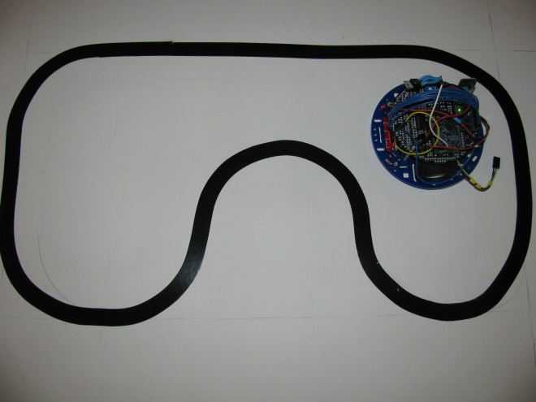

Figure 1 – The line following robot and the track it will be running on.

Figure - Voltage Regulator

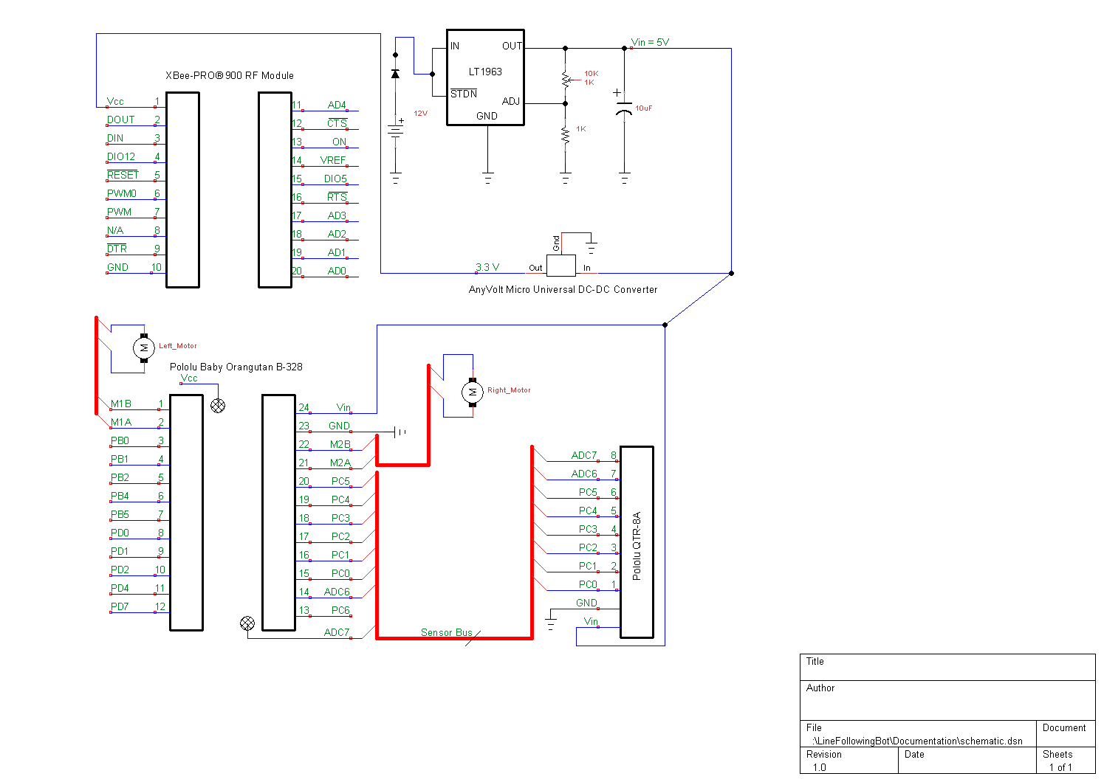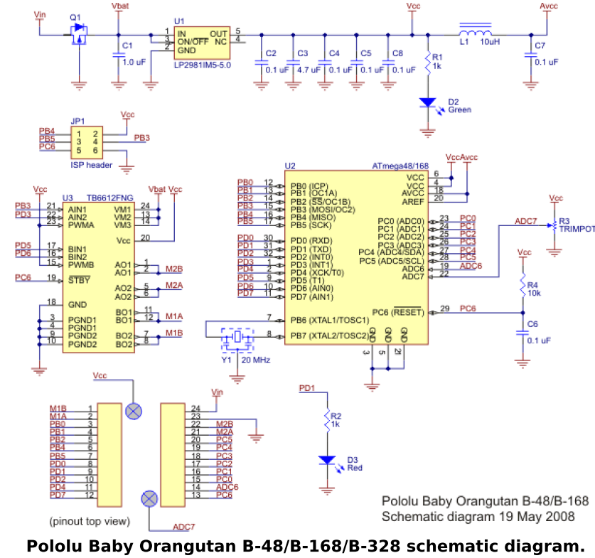

Figure 3 - Pololu Baby Orangutan B-328 Schematic diagram (Pololu Baby Orangutan B Users Guide)