### How Sqoop Works

Sqoop provides a pluggable mechanism for optimal connectivity to external systems. The Sqoop extension API provides a convenient framework for building new connectors which can be dropped into Sqoop installations to provide connectivity to various systems. Sqoop itself comes bundled with various connectors that can be used for popular database and data warehousing systems.

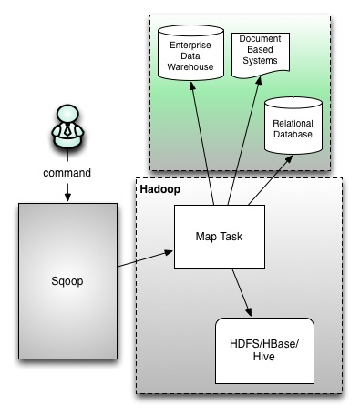

Apache Sqoop efficiently transfers bulk data between Apache Hadoop and structured datastores such as relational databases. Sqoop helps offload certain tasks (such as ETL processing) from the EDW to Hadoop for efficient execution at a much lower cost. Sqoop can also be used to extract data from Hadoop and export it into external structured datastores. Sqoop works with relational databases such as Teradata, Netezza, Oracle, MySQL, Postgres, and HSQLDB

